Game Design Document

Fill up the following document

1. Write the title of your project.

Border game

1. What is the goal of the game?

An Indian soldier is assigned to protect our country from the enemy soldiers.

1. Write a brief story of your game.

The Indian soldier can move up and down and since there are various enemy soldiers each get destroyed with 1 shot to balance the game.

1. Which are the playing characters of this game?

* Playing characters are the ones who respond to the user based on the input from the user.
* Cars, monkeys, dinos, wizards, etc., are the playing characters in the game.

|  |  |  |
| --- | --- | --- |
| Number | Character Name | What can this character do? |
| 1 | Indian soldier | Move up and down, fire bullets at the enemy soldier. |
| 2 |  |  |
| 3 |  |  |
| 4 |  |  |
| 5 |  |  |
| 6 |  |  |
| 7 |  |  |
| 8 |  |  |

1. Which are the Non-Playing Characters of this game?

* Non-Playing characters are the ones that don't have an action or behavior when the user interacts with the game.
* Hurdles, stones, bananas, coins, etc., are non-playing characters in the game.

|  |  |  |
| --- | --- | --- |
| Number | Character Name | What can this character do? |
| 1 | Enemy soldiers | There are numerous enemy soldiers, they fire bullets at the Indian soldier but each get destroyed with just 1 shot. |
| 2 |  |  |
| 3 |  |  |
| 4 |  |  |
| 5 |  |  |
| 6 |  |  |
| 7 |  |  |
| 8 |  |  |

Draw your imagination of this game. What does this game look like?

* Draw the game either on your computer or on paper.
* Add images of the game scenes to show each of the playing and non-playing characters at least once.

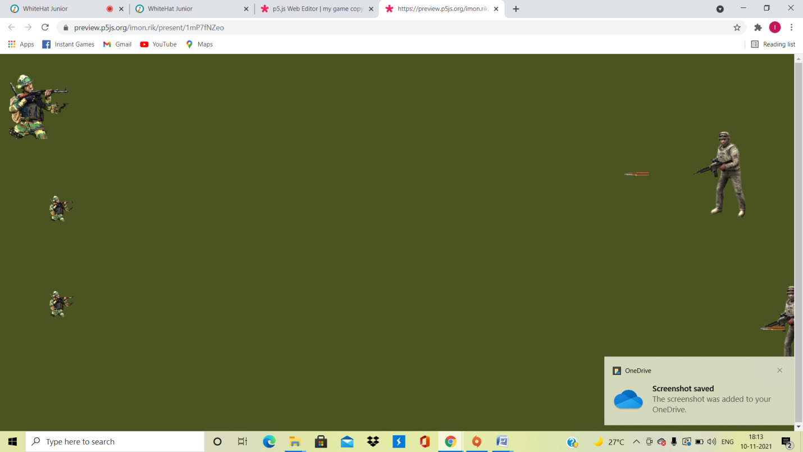

How do you plan to make your game engaging?

The Indian soldier is allowed to move up and down and can destroy each enemy soldier with 1 bullet, there are multiple soldiers who will be protecting the Indian soldier and the Indian soldier will only fight once the guards are killed.