Tech Stack :

Frontend - React (Vite)

Libraries – Tailwind , Axios , PapaParse

Backend – SpringBoot

Database – Remote PostGres Services (Neon Db)

Platforms – AWS(S3 bucket) , Render(Server Deploy) , Vercel (Frontend Deploy)

DB Structure :

DB - LuxySmile-Dashboard

Tables:

organizations – id(int) , orgname(varchar) , orgloc(varchar) , orgid(int)

teams – id(int) , unitno(varchar) , department(varchar) , orgid(int)

users – id(int) , name(text) , unitno(text) , department(text) , orgname(text) , indvid(int) , orgid(int)

userspersonals – id(int) , indvid(text) , name(text) , gender(text) , age(text) , bld(text) , orgid(int)

usersuploads – id(int) , imgname(text) , pdfname(text) , indvid(int)

Note: - Both in S3 bucket and DB the imgname and pdfname are stored in the format - indvid_filename

Basic Workflow : 1st Part: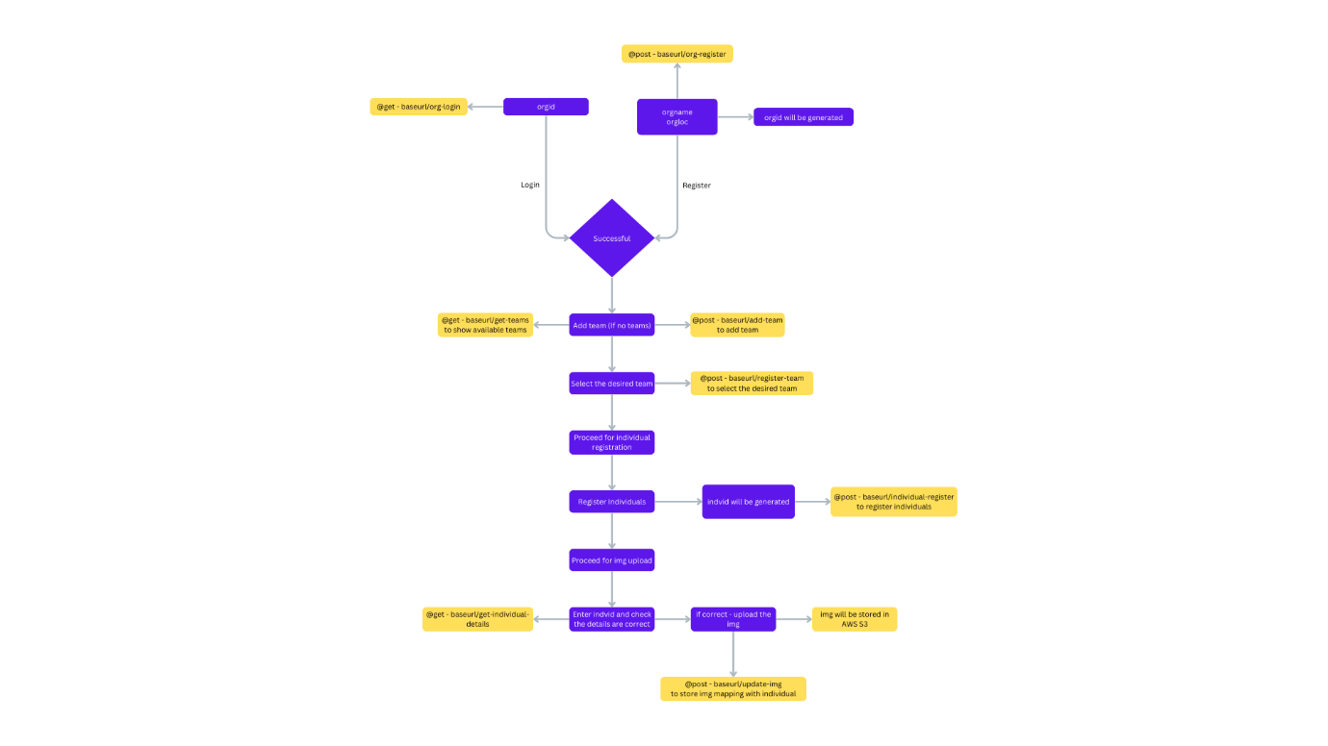

2nd Part:

