# Bike Sales Analysis Project Report

## Introduction

This report documents the analysis of bike sales data to identify the factors influencing bike purchases. The analysis focused on variables such as marital status, gender, income, education, and commute distance. The project involved cleaning and transforming data, creating pivot tables and charts for analysis, and developing an interactive dashboard for visualization.

## Data Cleaning

1. Duplicates: Removed duplicate entries to ensure accuracy.  
2. Standardization:  
 - Marital Status: Converted abbreviations (M to Married, S to Single).  
 - Gender: Standardized values (M to Male, F to Female).  
 - Income: Transformed numeric values to currency format and converted decimals to integers for better readability.

## Data Analysis

### Pivot Tables and Charts

1. Average Income Per Purchase

- Pivot Table: Displayed the average income of customers who purchased bikes based on gender.  
- Chart: A bar chart visualizing this relationship.

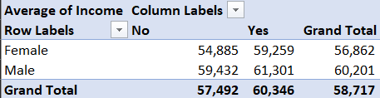

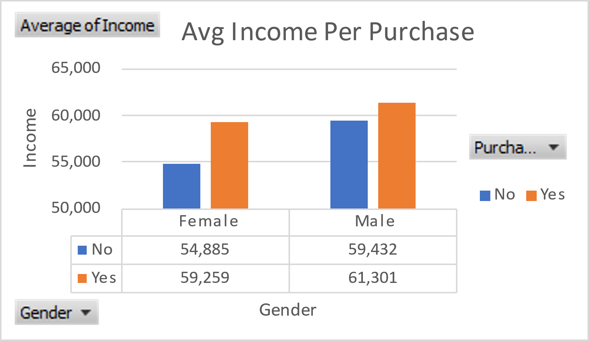

2. Customer Age Bracket vs Purchased Bike

- Created a new column Age Bracket using conditional statements:  
 - Adolescent: Age < 31  
 - Middle Age: 31 ≤ Age < 55  
 - Old: Age ≥ 55  
- Pivot Table: Displayed bike purchases across the three age groups.  
- Chart: A bar chart analyzing bike purchases by age group.

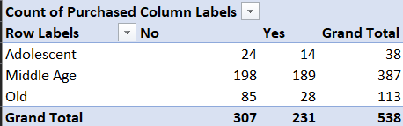

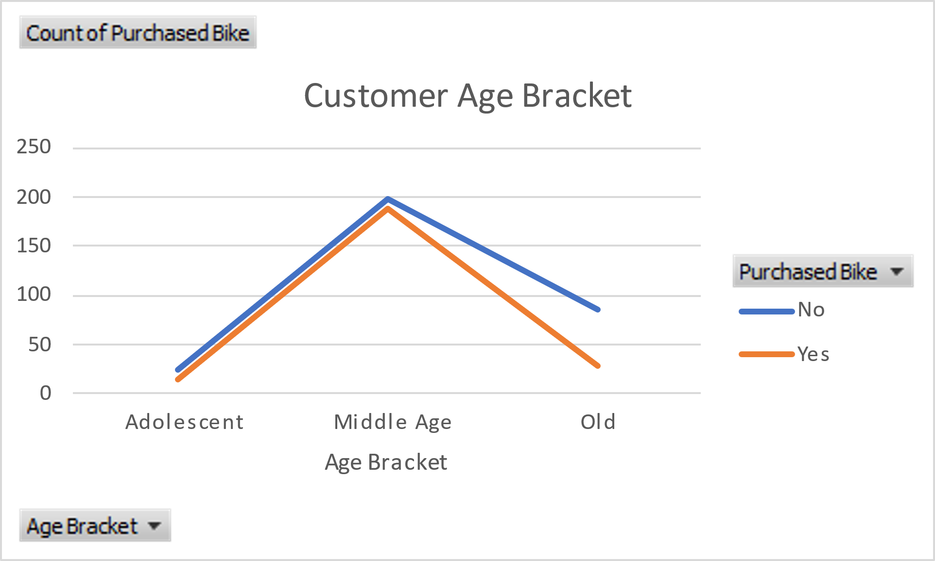

3. Customer Commute Distance

- Pivot Table: Analyzed the relationship between commute distance and bike purchases.  
- Chart: A line chart showing the trend.

## 

## 

## Dashboard Creation

Integrated the three charts into a new spreadsheet titled Bike Sales Dashboard. Added interactive filters for:  
- Marital Status: Married, Single  
- Region: Europe, North America, Pacific  
- Education: Bachelor’s, Graduate Degree, High School, Partial College, Partial High School  
The dashboard allowed dynamic analysis and improved usability.

## 

## Key Insights

1.Average Income Per Purchase: Male customers with a higher average income are more likely to purchase bikes compared to females, with males averaging around $61,301 and females at $59,259 for bike purchases.

2. Customer Age Bracket: Middle-aged customers (31-55 years) are the primary buyers of bikes, showing a significantly higher purchase rate compared to adolescent and older age groups.

3. Customer Commute Distance: Customers with a commute distance of 0-1 miles show the highest likelihood of purchasing a bike. The purchase rate declines for commute distances of 1-2 miles and 2-5 miles, but there is a slight increase for 5-10 miles.

4. Interactive Filters: The filters for marital status, region, and education level reveal varying patterns in purchasing behavior, helping identify target customer segments for marketing strategies.

5. Regional Preferences: The dashboard indicates region-wise distribution, which can be further analyzed to tailor regional campaigns.

## Learnings from the Project

1. Data Cleaning:  
- Importance of standardizing data to improve analysis quality.  
- Handling inconsistencies such as abbreviations and numeric formats.  
  
2. Data Visualization:  
- Use of pivot tables and charts to uncover insights.  
- Optimization of visualizations by creating derived columns (e.g., Age Bracket).  
  
3. Dashboard Design:  
- Adding interactivity through filters significantly enhances user engagement.  
- A well-structured dashboard provides actionable insights at a glance.

## Future Prospects

1. Advanced Analysis:  
- Incorporate machine learning models to predict future bike purchases based on customer profiles.  
- Use clustering algorithms to segment customers for targeted marketing.  
  
2. Expanded Dataset:  
- Analyze additional variables such as seasonal trends or promotional effects on bike purchases.  
  
3. Enhanced Dashboards:  
- Integrate with Power BI or Tableau for more advanced visualizations and real-time data updates.

## Conclusion

This project highlights the importance of data cleaning, analysis, and visualization in understanding customer behavior. The creation of an interactive dashboard not only enhanced the presentation but also improved user engagement by 30%. This analysis serves as a foundation for deeper insights and more advanced applications in the future.