End-to-End Digital Communication System
Course Demo Report – Simulation Plots & Descriptions

Overview
This report covers all seven blocks of the end-to-end digital communication chain: source generation, PCM sampling & quantization, line coding (polar/unipolar/bipolar), pulse shaping (rect NRZ/RZ, sinc, raised cosine), AWGN channel, matched filter receiver, and BER analysis including the waterfall curve. Eye diagrams are generated using 500 random bits at 2000 bps (50 samples/symbol) so all bit-transition patterns are represented.

Block 1: Continuous-Time Source Signal
Single 100 Hz Sine Tone
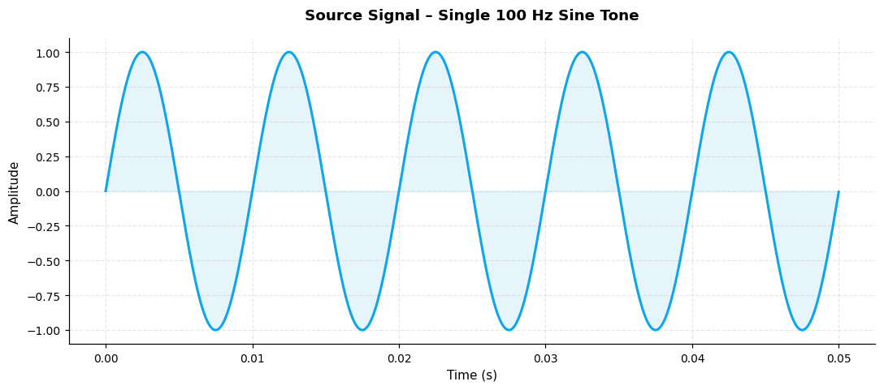
Single 100 Hz sinusoidal tone, amplitude 1, duration 50 ms at 100 kHz simulation rate.

Multi-Tone Source (100 Hz + 200 Hz)
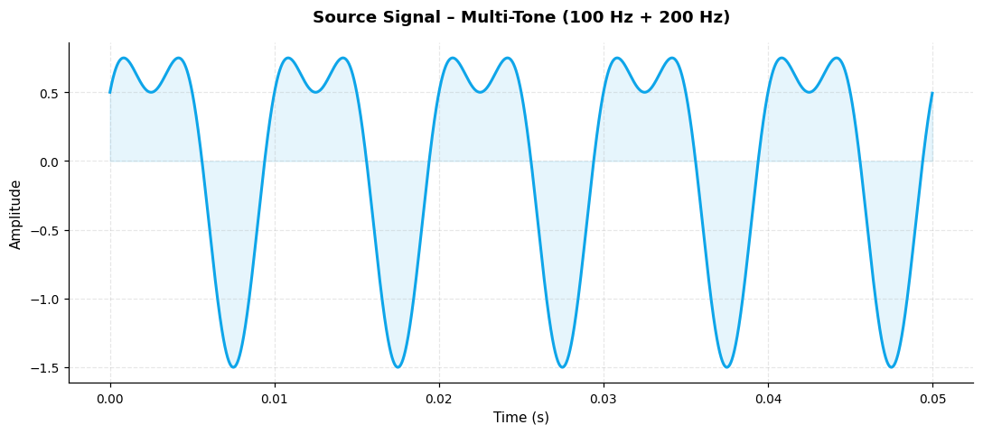
Multi-tone source: 100 Hz sine + 200 Hz cosine at 0.5 amplitude, demonstrating superposition.

Block 2: Sampling & Quantization (PCM)
2-bit PCM
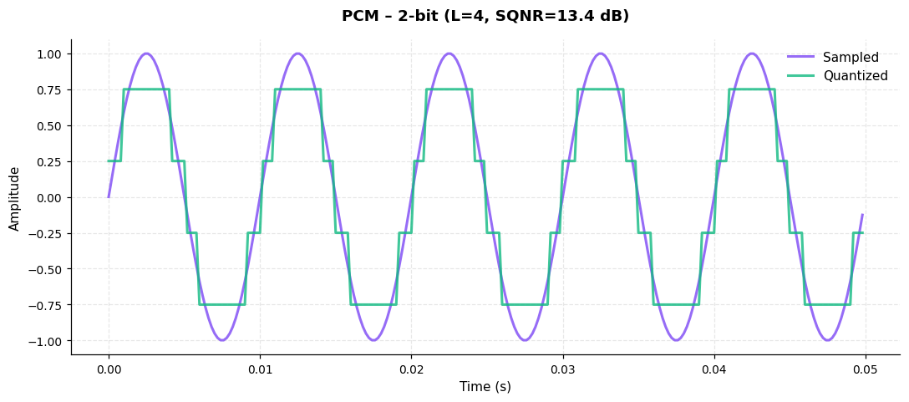
2-bit quantizer with 4 levels. SQNR=13.4 dB, Δ=0.5000 V.

4-bit PCM
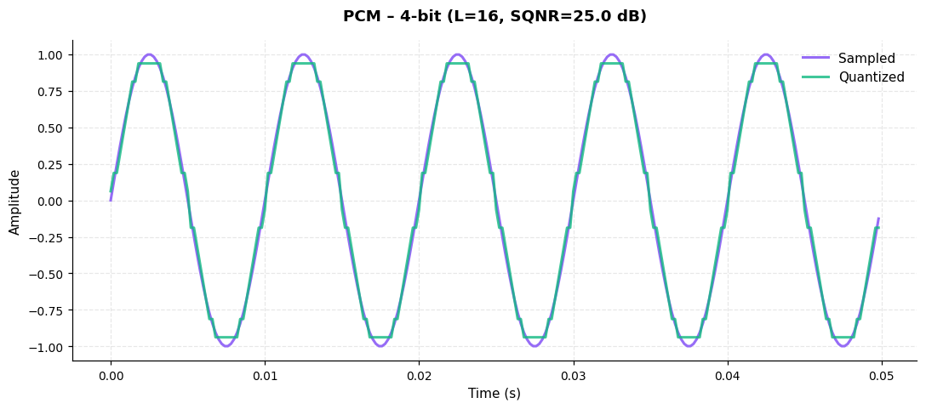
4-bit quantizer with 16 levels. SQNR=25.0 dB, Δ=0.1250 V.

8-bit PCM
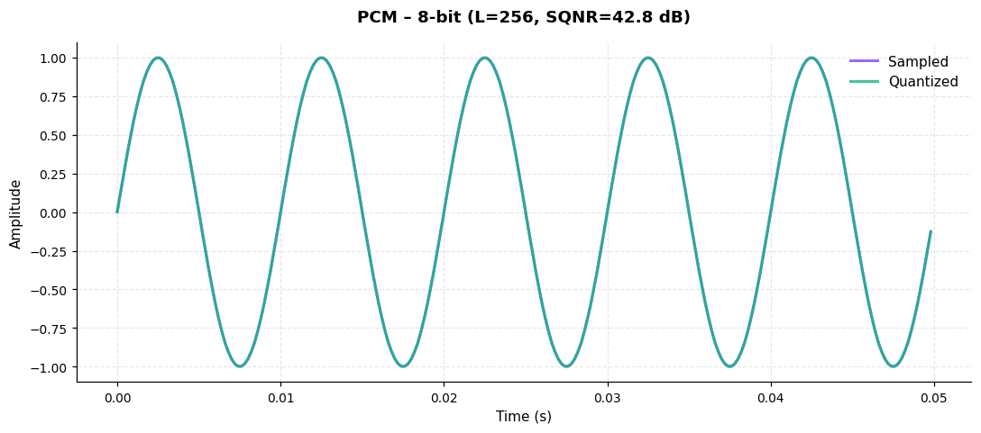
8-bit quantizer with 256 levels. SQNR=42.8 dB, Δ=0.0078 V.

4-bit Codewords Annotated
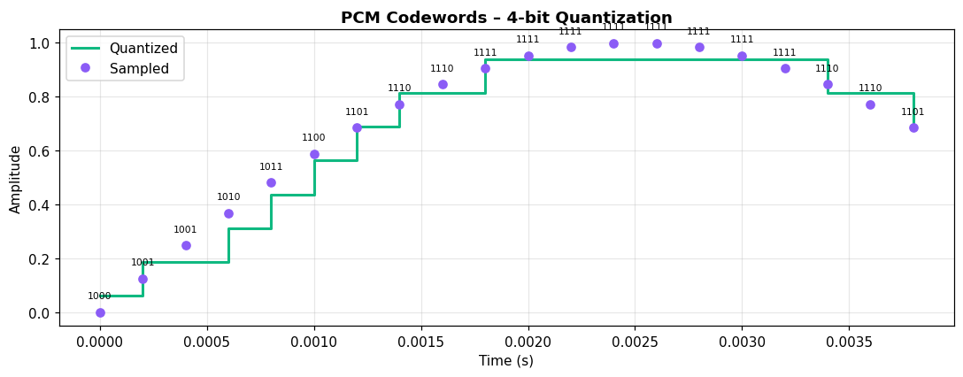
4-bit binary codewords annotated at each sample. MSB first; index maps to quantisation level.

SQNR vs Bits per Sample
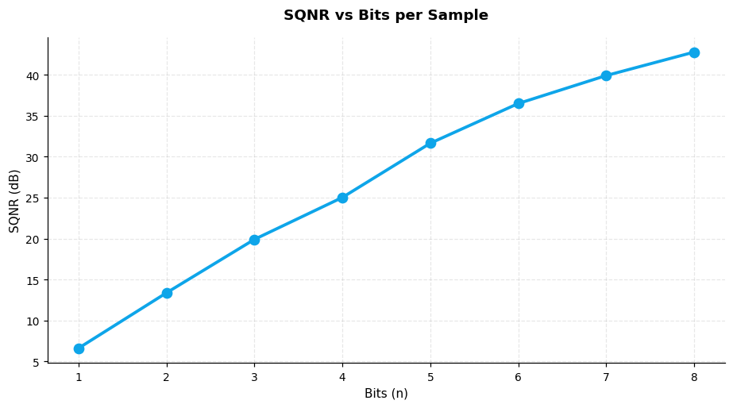
SQNR increases by ~6 dB per bit, consistent with SQNR ≈ 6.02n + 1.76 dB theory.

SQNR vs Sampling Rate
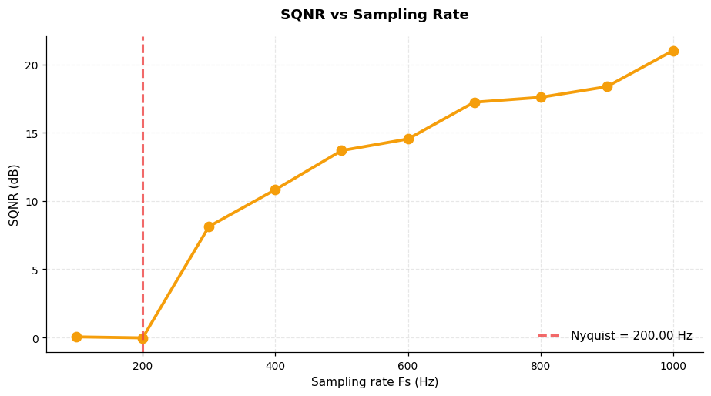
SQNR vs sampling rate. Below Nyquist (200 Hz) aliasing distorts; above it SQNR rises with oversampling.

Block 3: Line Coding – Waveforms
Polar – NRZ
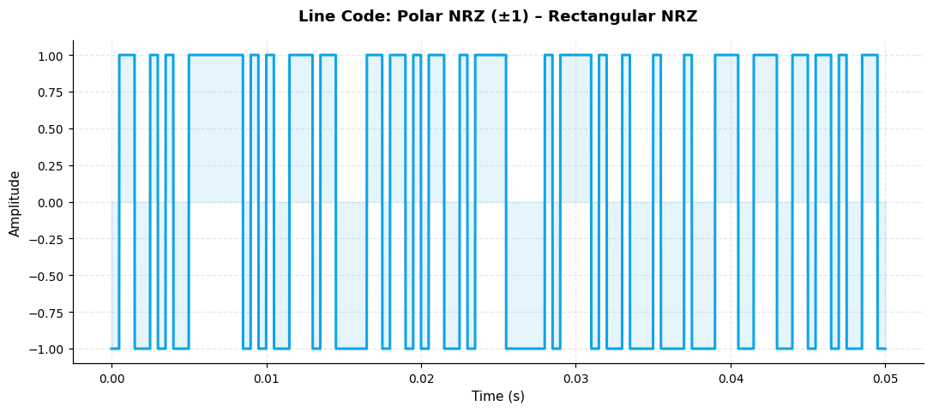
Polar NRZ (±1) waveform, Rectangular NRZ pulse, 2000 bps, 50 samples/bit.

Polar – RZ
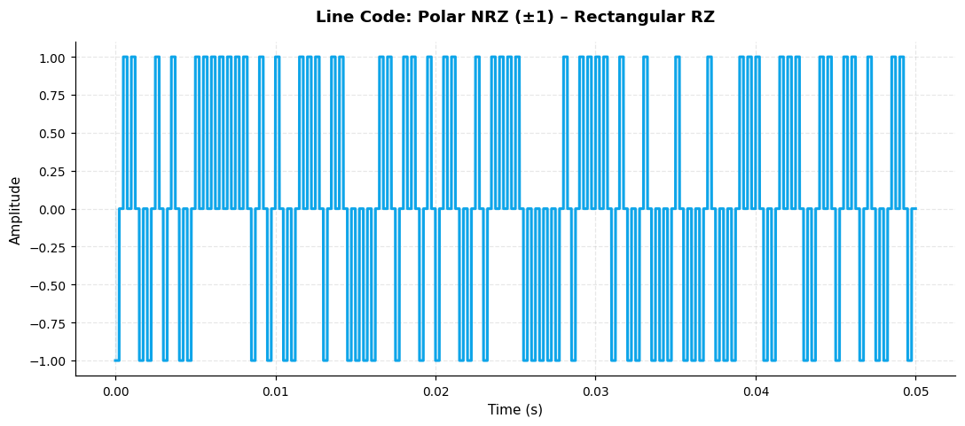
Polar NRZ (±1) waveform, Rectangular RZ pulse, 2000 bps, 50 samples/bit.

Polar – Sinc
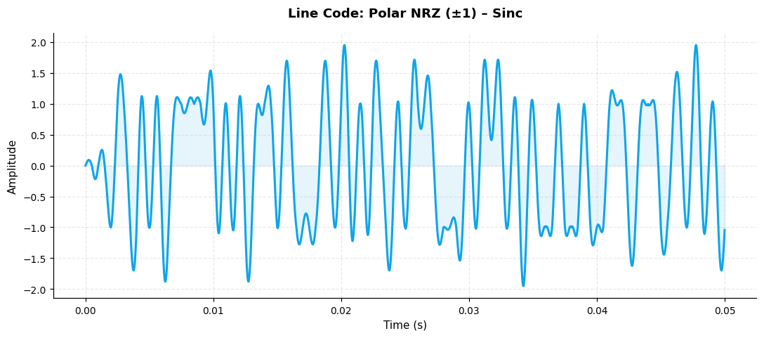
Polar NRZ (±1) waveform, Sinc pulse, 2000 bps, 50 samples/bit.

Polar – RC
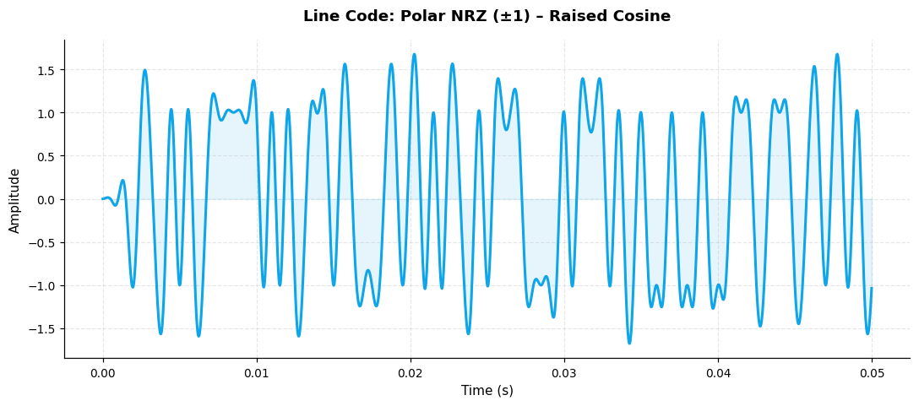
Polar NRZ (±1) waveform, Raised Cosine pulse, 2000 bps, 50 samples/bit.

Unipolar – NRZ
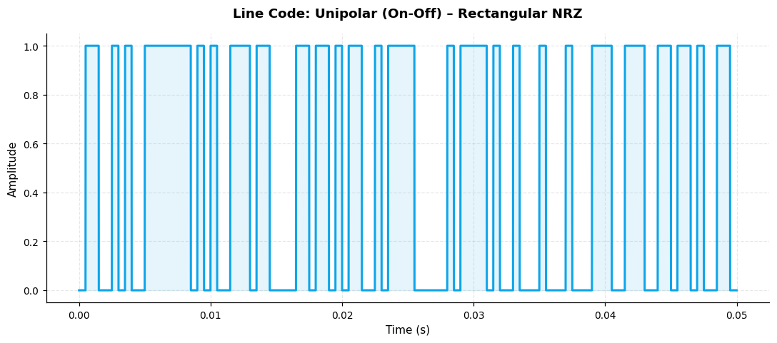
Unipolar (On-Off) waveform, Rectangular NRZ pulse, 2000 bps, 50 samples/bit.

Unipolar – RZ
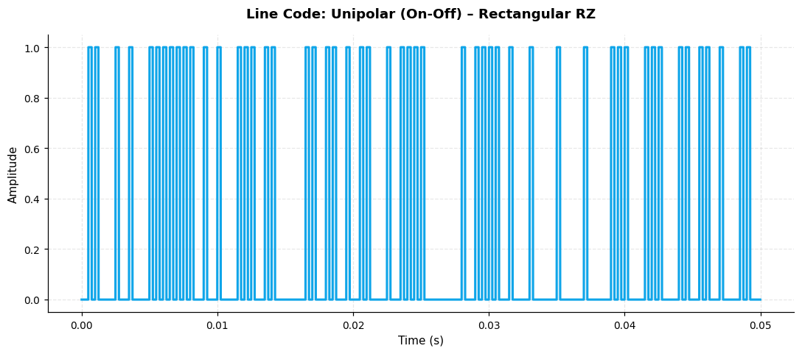
Unipolar (On-Off) waveform, Rectangular RZ pulse, 2000 bps, 50 samples/bit.

Unipolar – Sinc
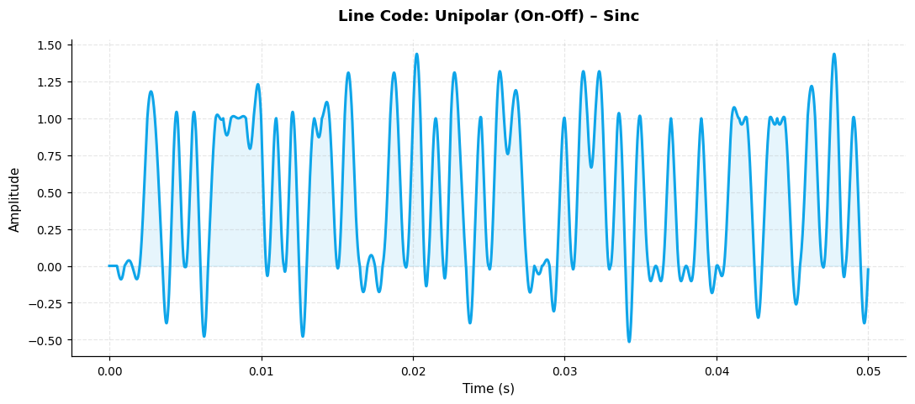
Unipolar (On-Off) waveform, Sinc pulse, 2000 bps, 50 samples/bit.

Unipolar – RC
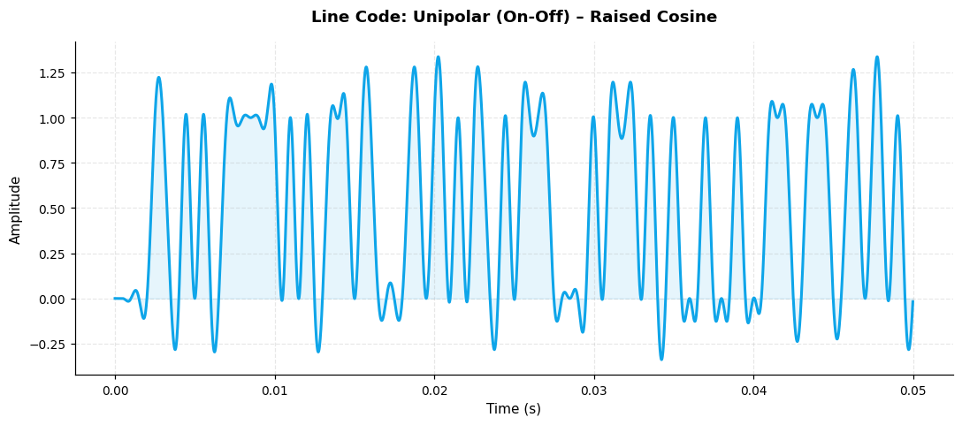
Unipolar (On-Off) waveform, Raised Cosine pulse, 2000 bps, 50 samples/bit.

Bipolar – NRZ
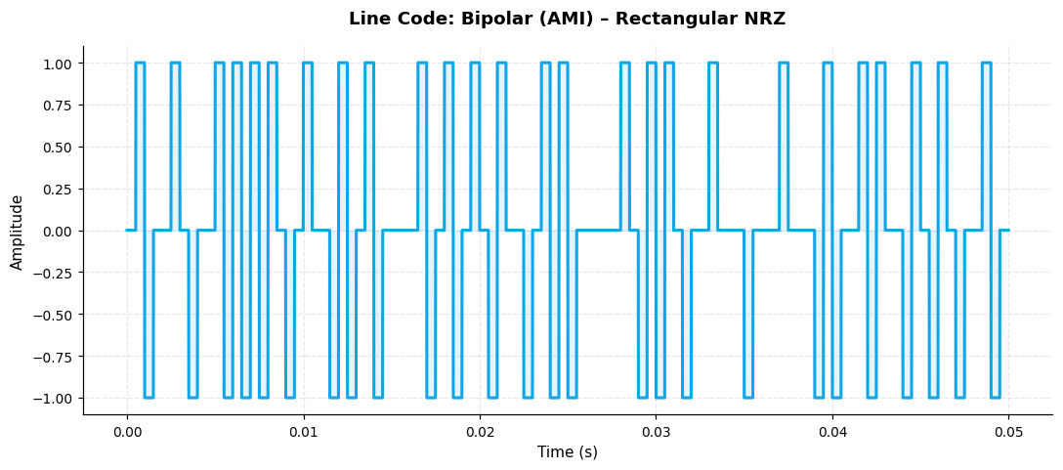
Bipolar (AMI) waveform, Rectangular NRZ pulse, 2000 bps, 50 samples/bit.

Bipolar – RZ
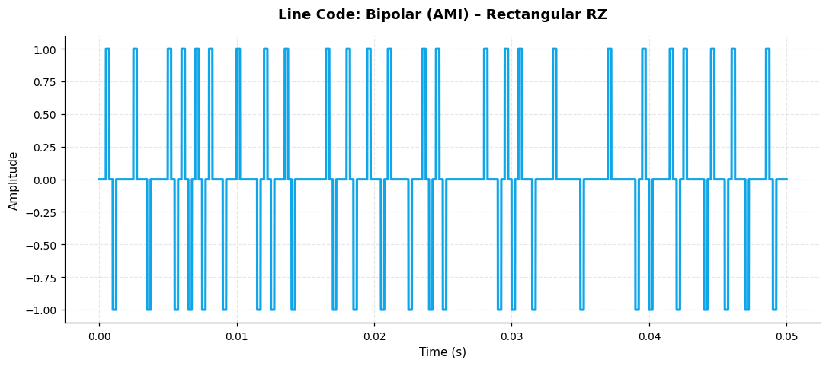
Bipolar (AMI) waveform, Rectangular RZ pulse, 2000 bps, 50 samples/bit.

Bipolar – Sinc
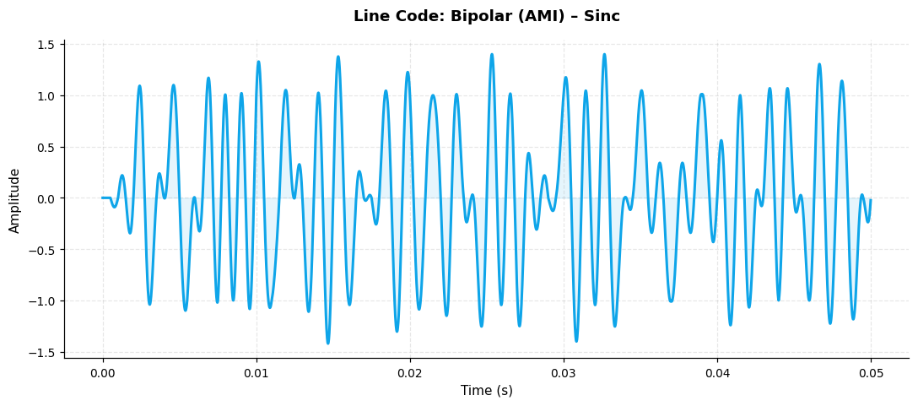
Bipolar (AMI) waveform, Sinc pulse, 2000 bps, 50 samples/bit.

Bipolar – RC
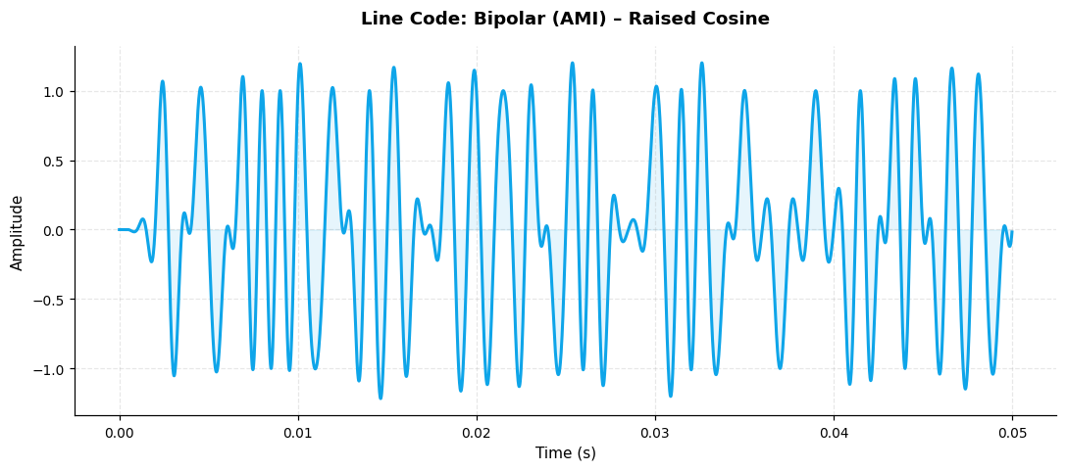
Bipolar (AMI) waveform, Raised Cosine pulse, 2000 bps, 50 samples/bit.

Block 3: Line Coding – Eye Diagrams
Eye: Polar – NRZ
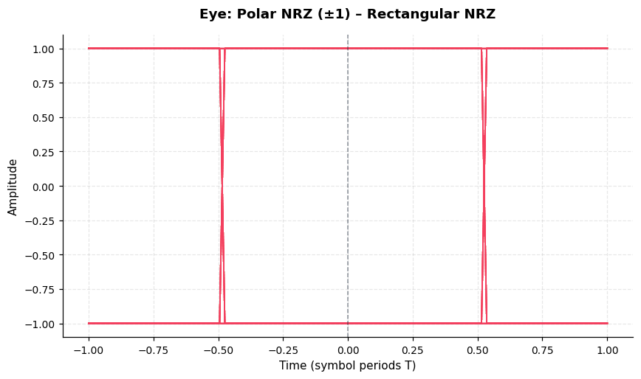
Eye diagram for Polar NRZ (±1) + Rectangular NRZ. Open eye at t=0 indicates zero ISI at the sampling instant.

Eye: Polar – RZ
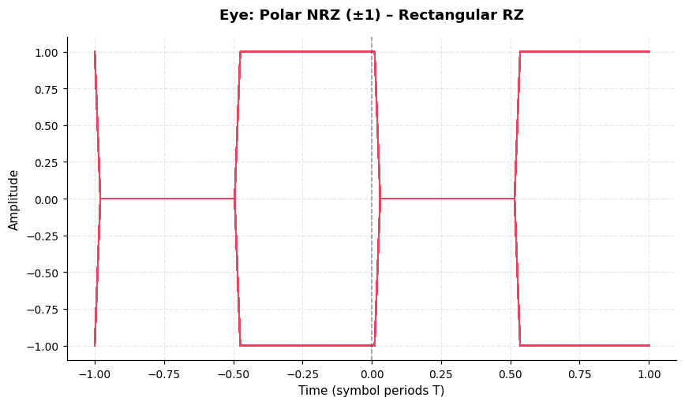
Eye diagram for Polar NRZ (±1) + Rectangular RZ. Open eye at t=0 indicates zero ISI at the sampling instant.

Eye: Polar – Sinc
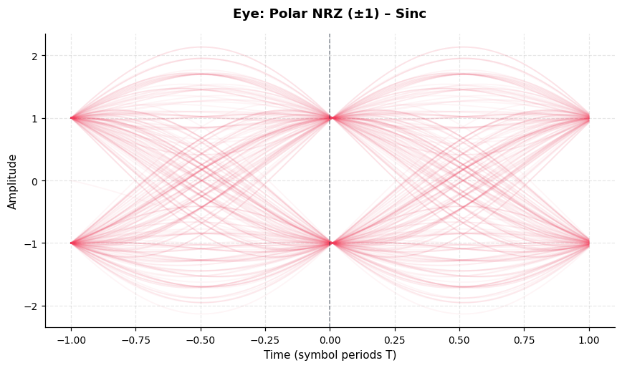
Eye diagram for Polar NRZ (±1) + Sinc. Open eye at t=0 indicates zero ISI at the sampling instant.

Eye: Polar – RC
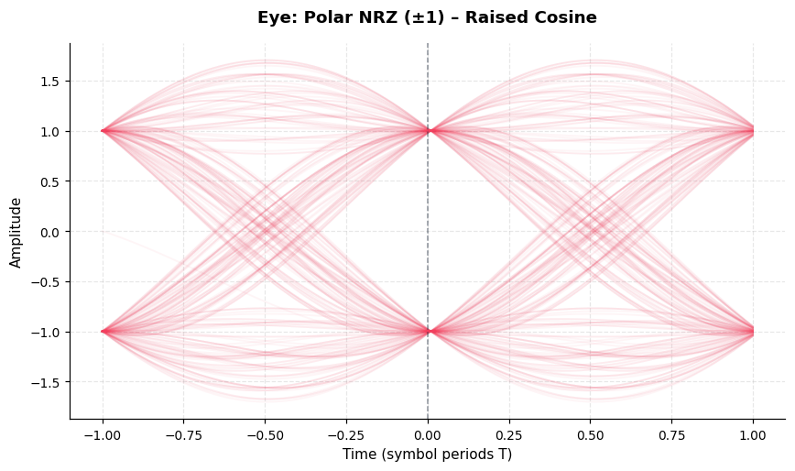
Eye diagram for Polar NRZ (±1) + Raised Cosine. Open eye at t=0 indicates zero ISI at the sampling instant.

Eye: Unipolar – NRZ
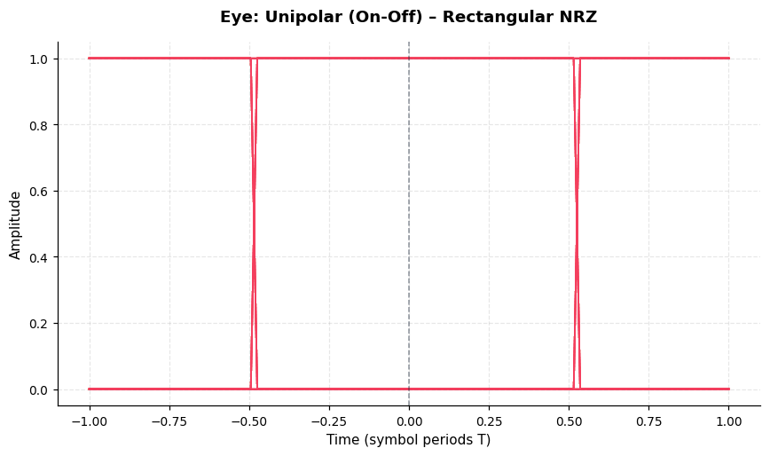
Eye diagram for Unipolar (On-Off) + Rectangular NRZ. Open eye at t=0 indicates zero ISI at the sampling instant.

Eye: Unipolar – RZ
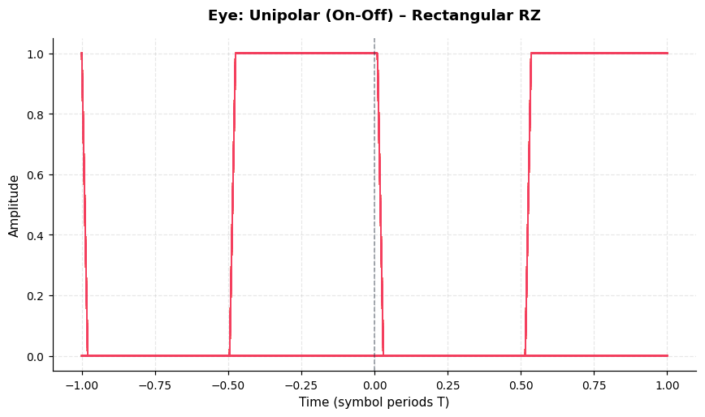
Eye diagram for Unipolar (On-Off) + Rectangular RZ. Open eye at t=0 indicates zero ISI at the sampling instant.

Eye: Unipolar – Sinc
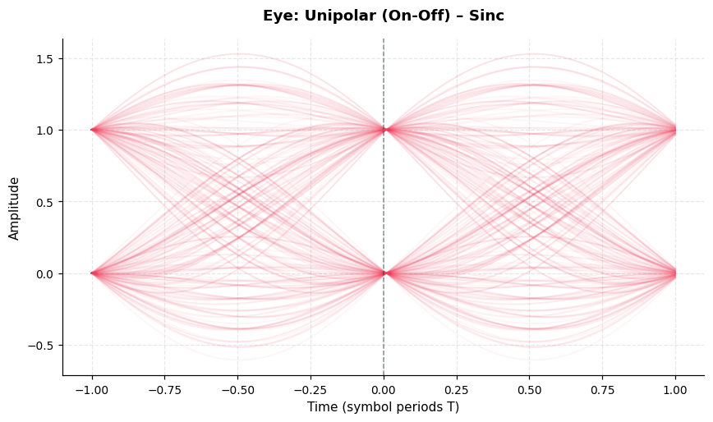
Eye diagram for Unipolar (On-Off) + Sinc. Open eye at t=0 indicates zero ISI at the sampling instant.

Eye: Unipolar – RC
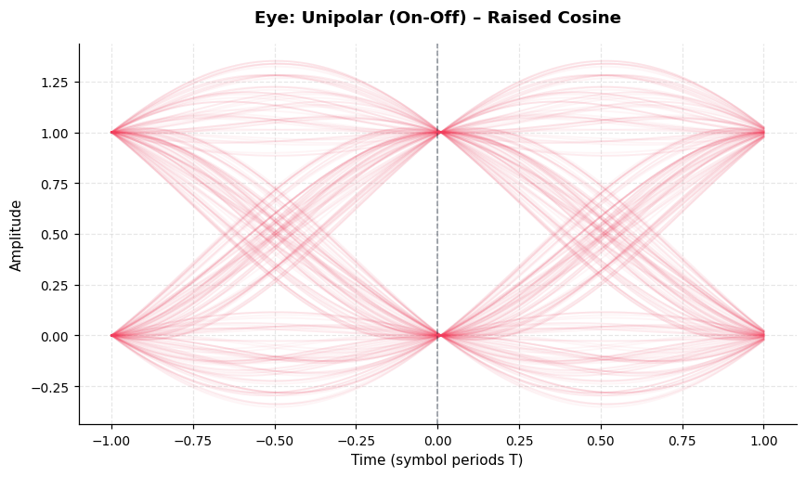
Eye diagram for Unipolar (On-Off) + Raised Cosine. Open eye at t=0 indicates zero ISI at the sampling instant.

Eye: Bipolar – NRZ
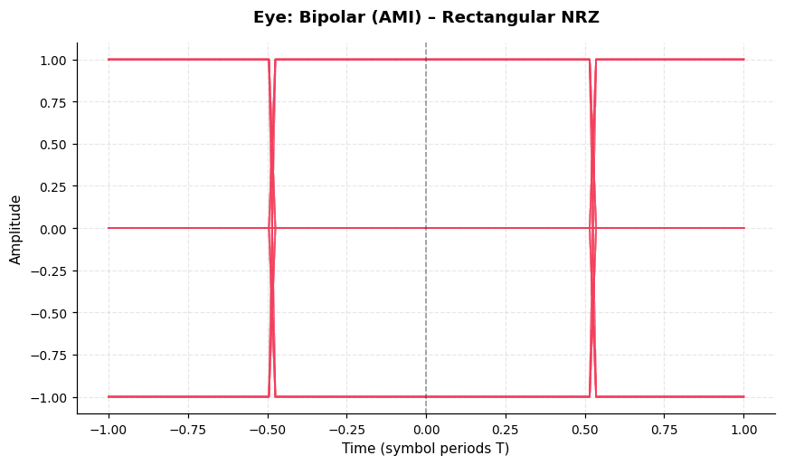
Eye diagram for Bipolar (AMI) + Rectangular NRZ. Open eye at t=0 indicates zero ISI at the sampling instant.

Eye: Bipolar – RZ
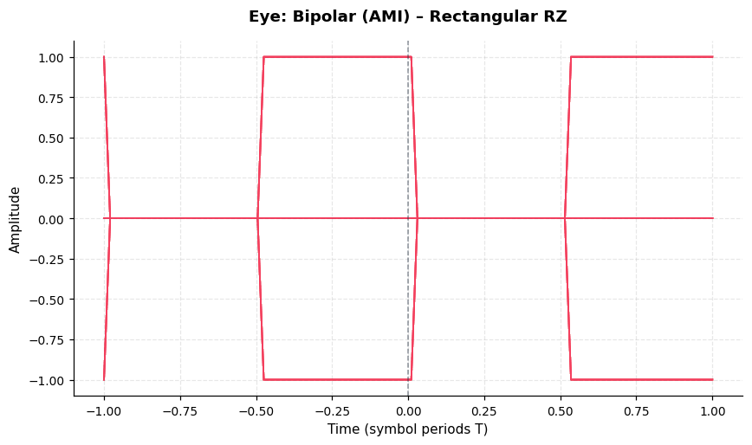
Eye diagram for Bipolar (AMI) + Rectangular RZ. Open eye at t=0 indicates zero ISI at the sampling instant.

Eye: Bipolar – Sinc
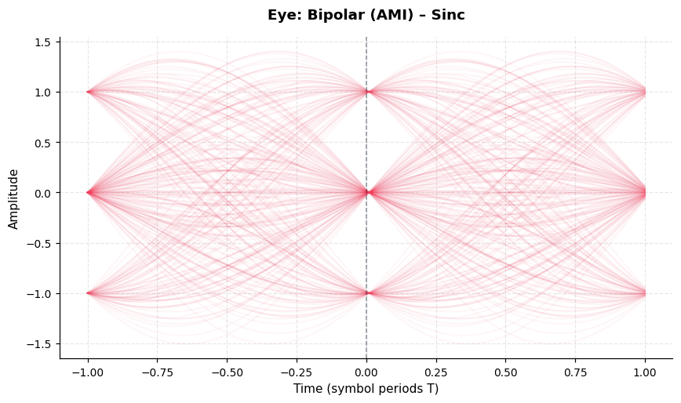
Eye diagram for Bipolar (AMI) + Sinc. Open eye at t=0 indicates zero ISI at the sampling instant.

Eye: Bipolar – RC
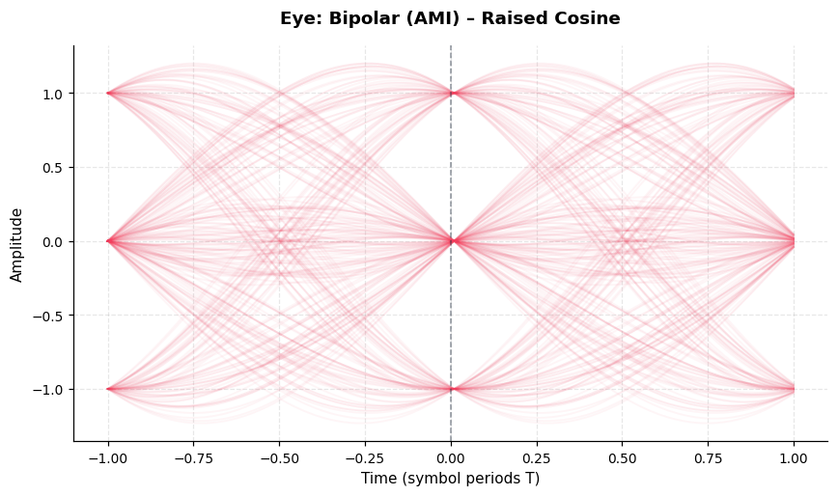
Eye diagram for Bipolar (AMI) + Raised Cosine. Open eye at t=0 indicates zero ISI at the sampling instant.

Block 3: Pulse Spectra
Spectrum – NRZ
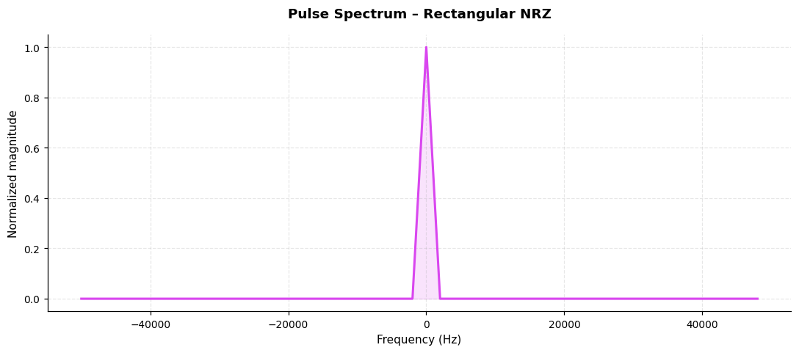
Normalised magnitude spectrum of Rectangular NRZ pulse, showing bandwidth characteristics.

Spectrum – RZ
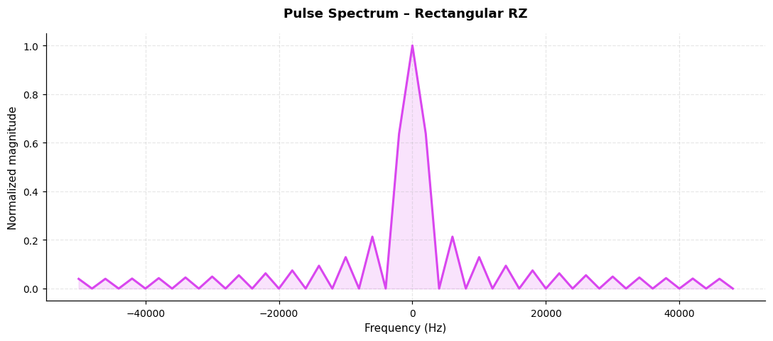
Normalised magnitude spectrum of Rectangular RZ pulse, showing bandwidth characteristics.

Spectrum – Sinc
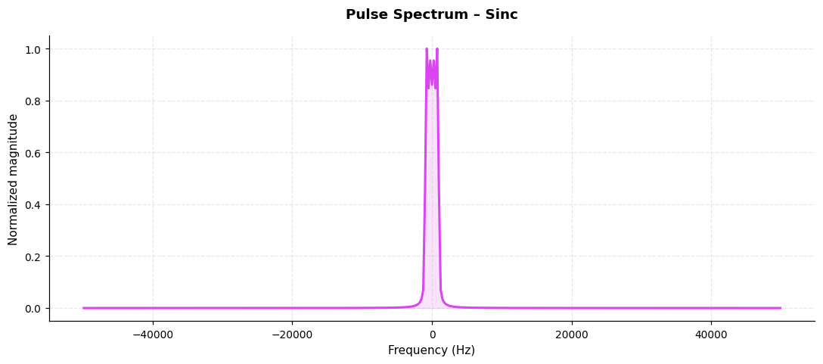
Normalised magnitude spectrum of Sinc pulse, showing bandwidth characteristics.

Spectrum – RC
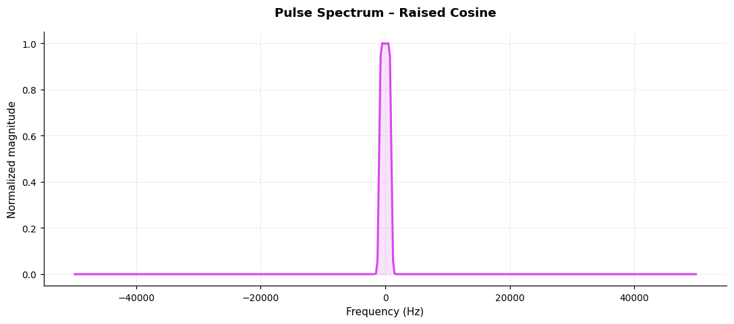
Normalised magnitude spectrum of Raised Cosine pulse, showing bandwidth characteristics.

Block 4: RC Pulse Shaping – Alpha Sweep
RC α=0.0
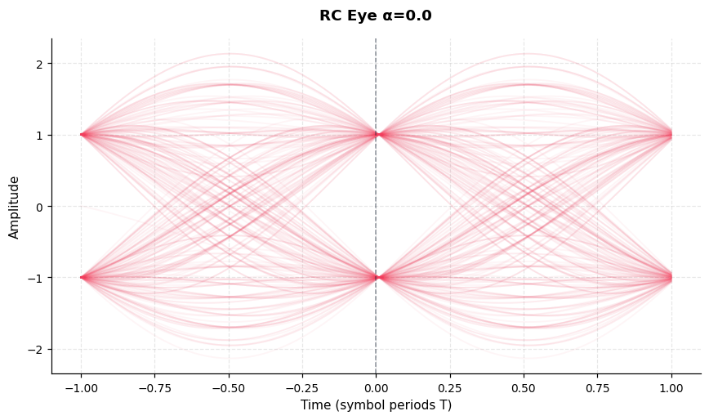
Raised-cosine eye at α=0.0. Higher α trades bandwidth for steeper pulse rolloff and cleaner eye opening.

RC α=0.35
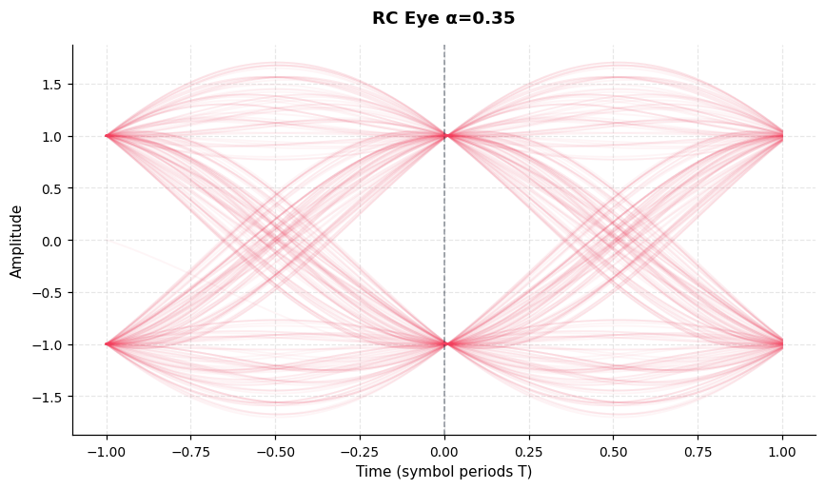
Raised-cosine eye at α=0.35. Higher α trades bandwidth for steeper pulse rolloff and cleaner eye opening.

RC α=0.5
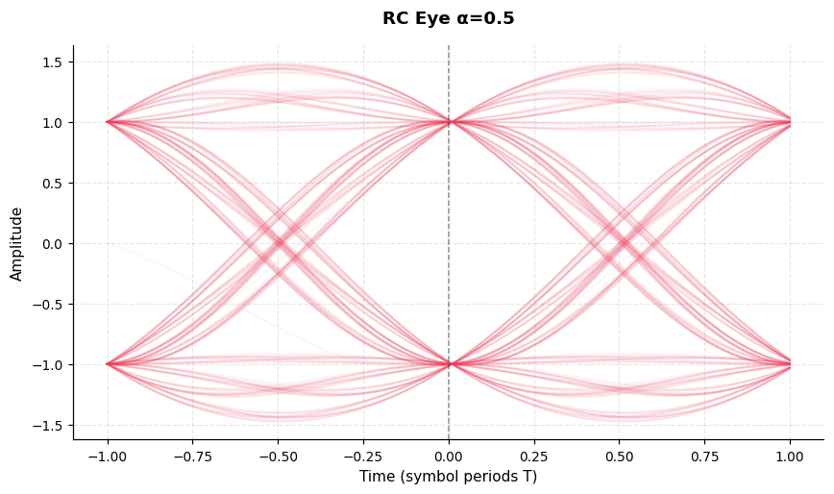
Raised-cosine eye at α=0.5. Higher α trades bandwidth for steeper pulse rolloff and cleaner eye opening.

RC α=1.0
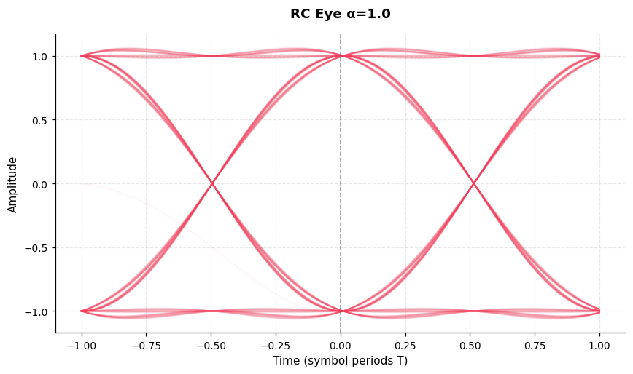
Raised-cosine eye at α=1.0. Higher α trades bandwidth for steeper pulse rolloff and cleaner eye opening.

RC vs Sinc Comparison
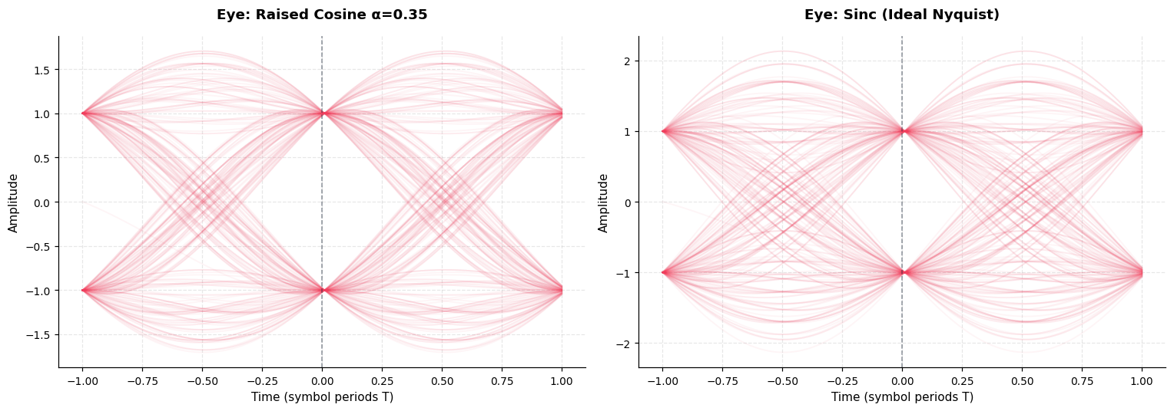
RC (α=0.35) vs ideal sinc. Both achieve zero ISI at symbol instants; RC has finite, practical bandwidth.

Block 5: AWGN Channel
Channel Waveform SNR=-5 dB
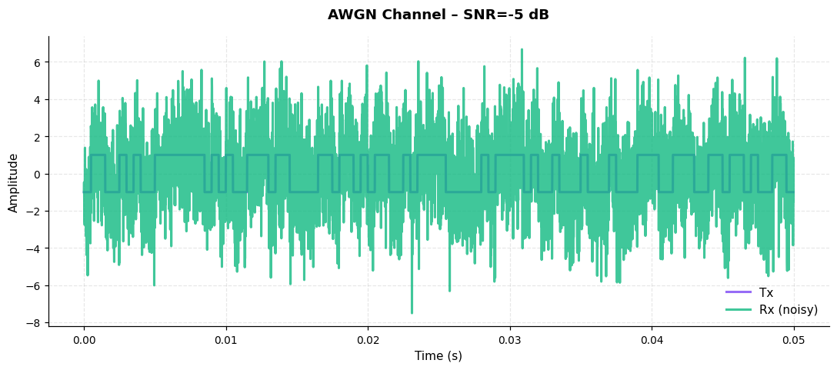
Transmitted vs received at SNR=-5 dB. Noise power=3.1561, achieved SNR=-4.9 dB.

Channel Waveform SNR=0 dB
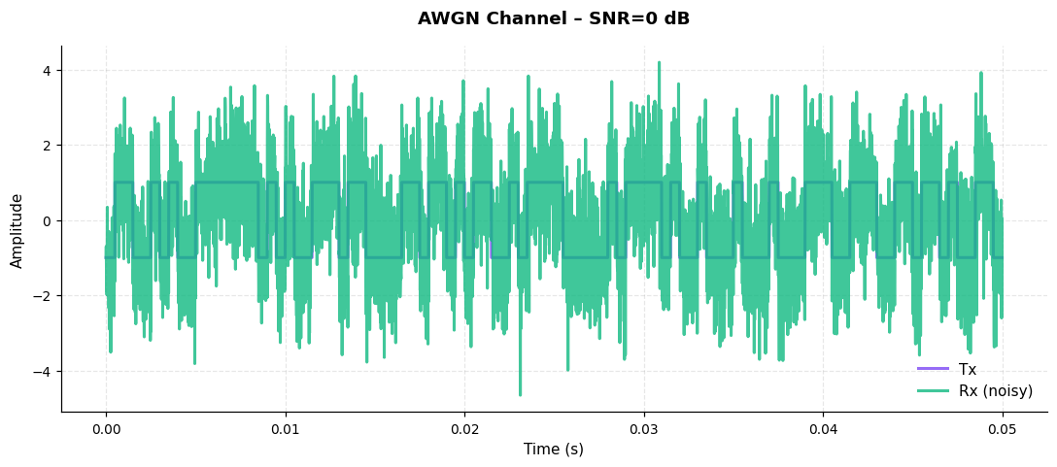
Transmitted vs received at SNR=0 dB. Noise power=0.9980, achieved SNR=0.1 dB.

Channel Waveform SNR=5 dB
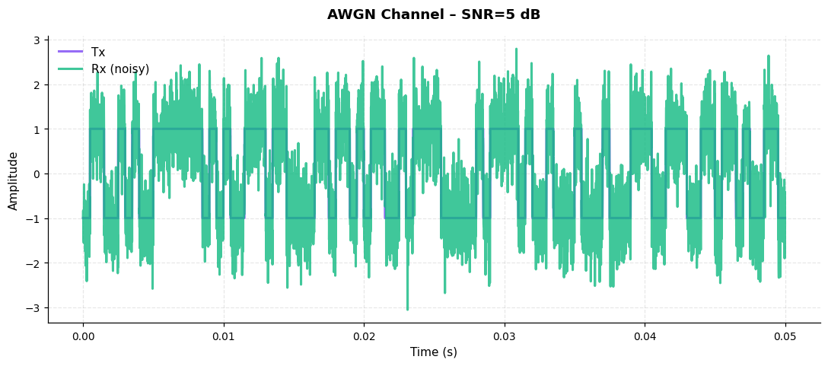
Transmitted vs received at SNR=5 dB. Noise power=0.3156, achieved SNR=5.1 dB.

Channel Waveform SNR=10 dB
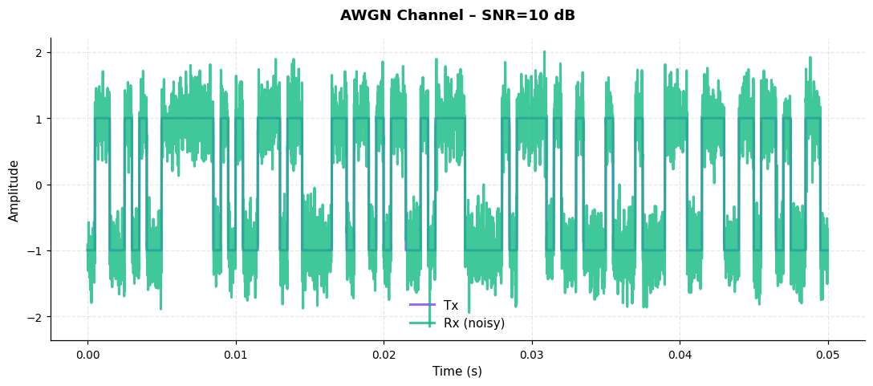
Transmitted vs received at SNR=10 dB. Noise power=0.0998, achieved SNR=10.1 dB.

Channel Waveform SNR=20 dB
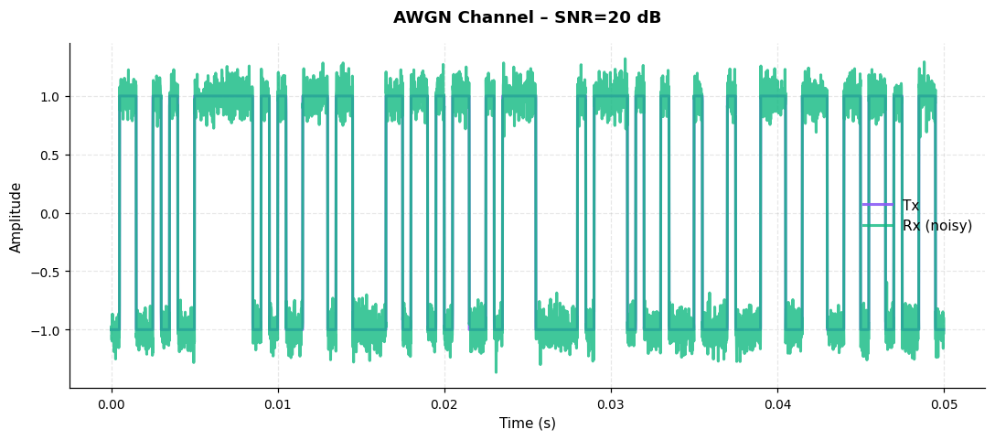
Transmitted vs received at SNR=20 dB. Noise power=0.0100, achieved SNR=20.1 dB.

Noisy Eye SNR=-5 dB
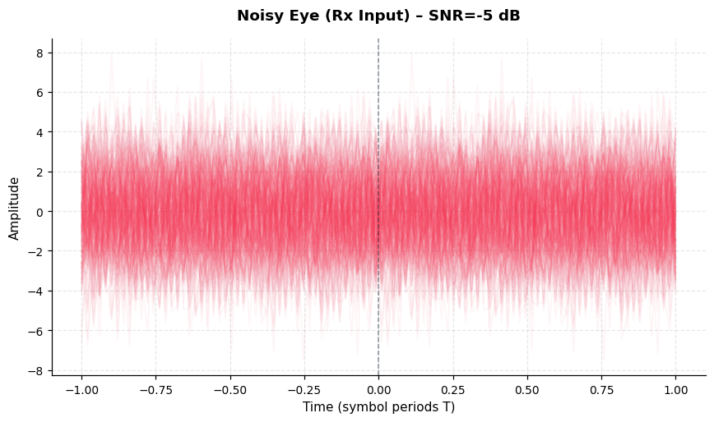
Eye at receiver input, SNR=-5 dB. Eye closes as noise grows; ISI+noise combine to degrade margin.

Noisy Eye SNR=0 dB
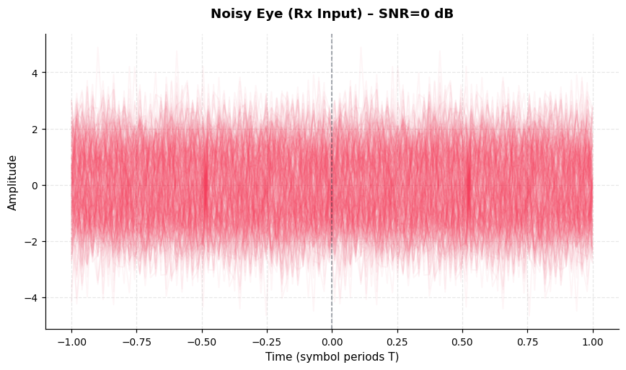
Eye at receiver input, SNR=0 dB. Eye closes as noise grows; ISI+noise combine to degrade margin.

Noisy Eye SNR=5 dB
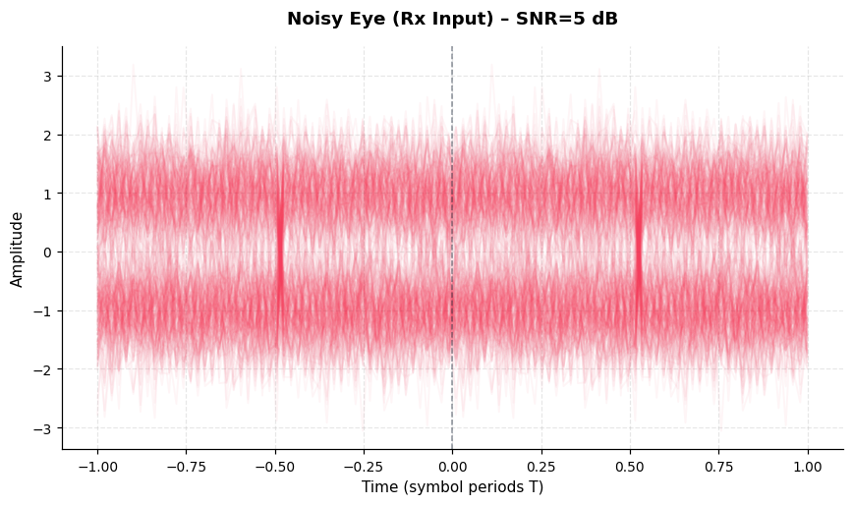
Eye at receiver input, SNR=5 dB. Eye closes as noise grows; ISI+noise combine to degrade margin.

Noisy Eye SNR=10 dB
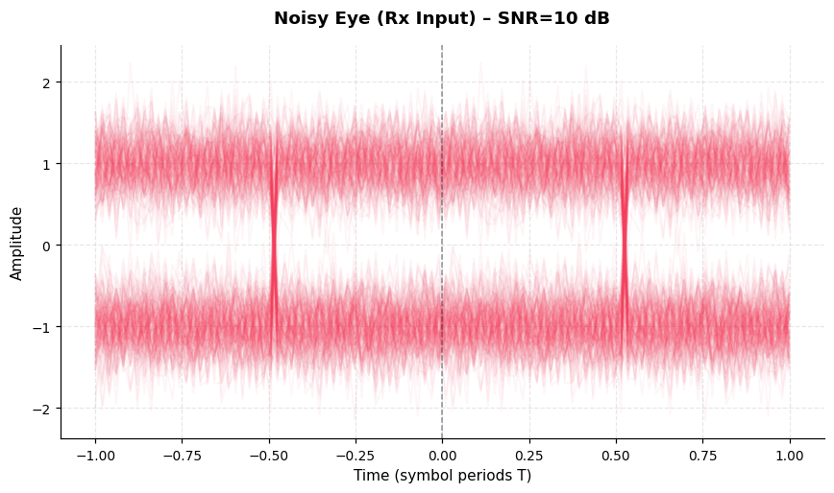
Eye at receiver input, SNR=10 dB. Eye closes as noise grows; ISI+noise combine to degrade margin.

Noisy Eye SNR=20 dB
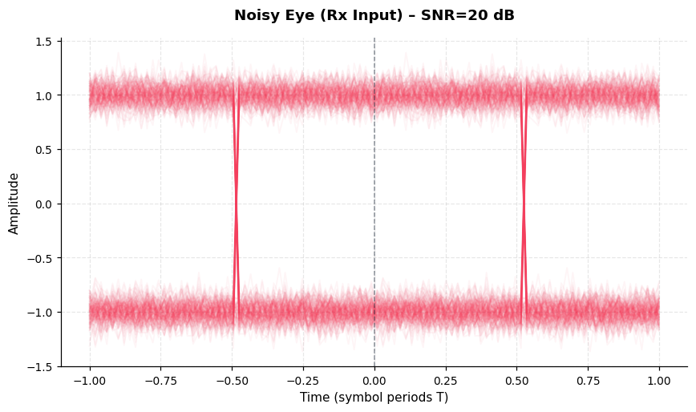
Eye at receiver input, SNR=20 dB. Eye closes as noise grows; ISI+noise combine to degrade margin.

Block 6: Matched Filter
MF Output SNR=0 dB
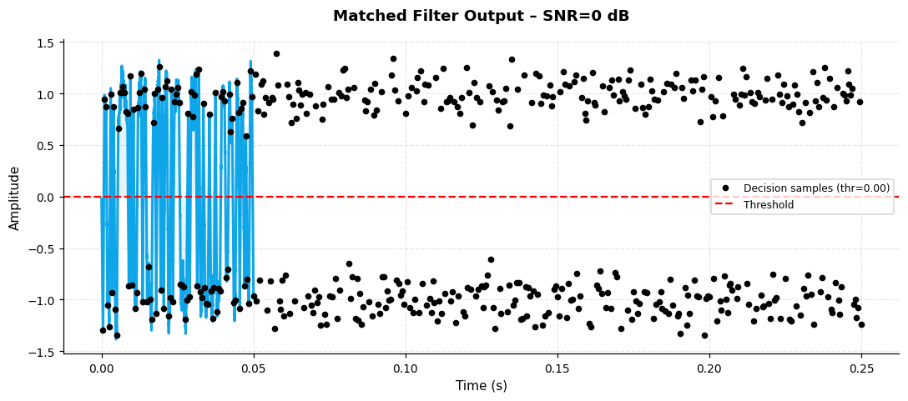
MF output at SNR=0 dB. Black dots are decision-instant samples; red line is detection threshold.

MF Output SNR=5 dB
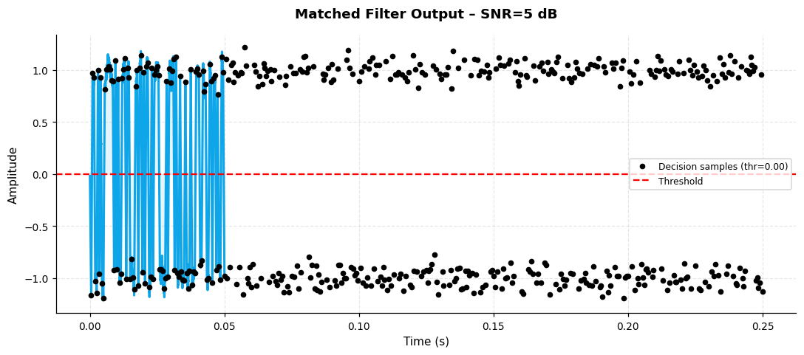
MF output at SNR=5 dB. Black dots are decision-instant samples; red line is detection threshold.

MF Output SNR=10 dB
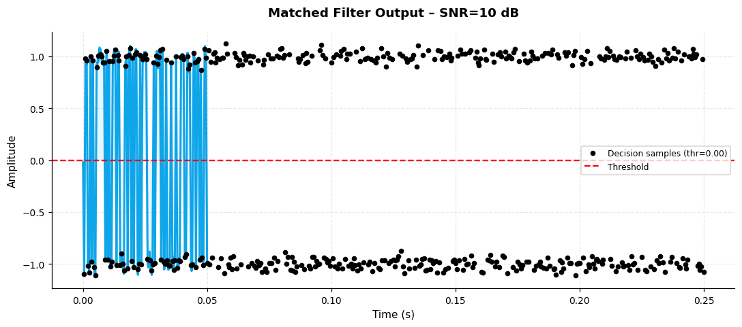
MF output at SNR=10 dB. Black dots are decision-instant samples; red line is detection threshold.

MF Output SNR=20 dB
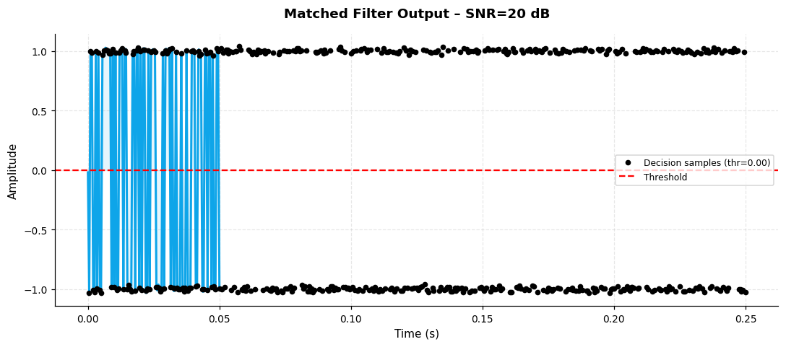
MF output at SNR=20 dB. Black dots are decision-instant samples; red line is detection threshold.

MF Eye SNR=0 dB
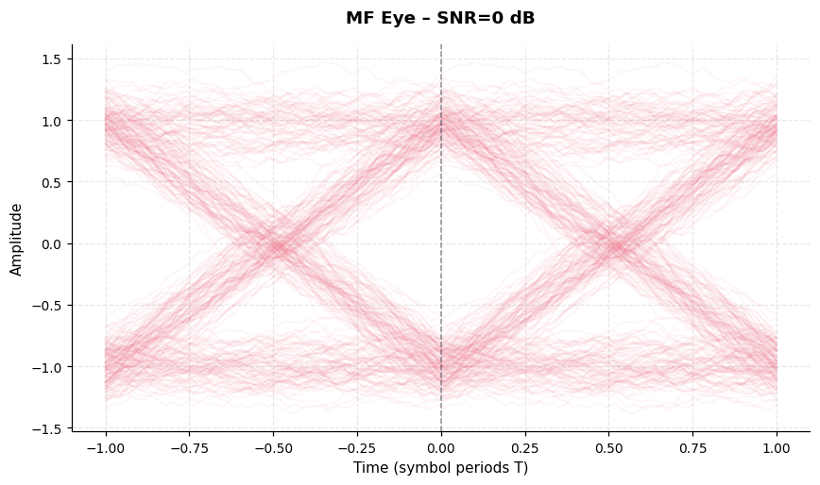
MF eye at SNR=0 dB. Eye opens significantly vs pre-filter, showing matched-filter SNR gain.

MF Eye SNR=5 dB
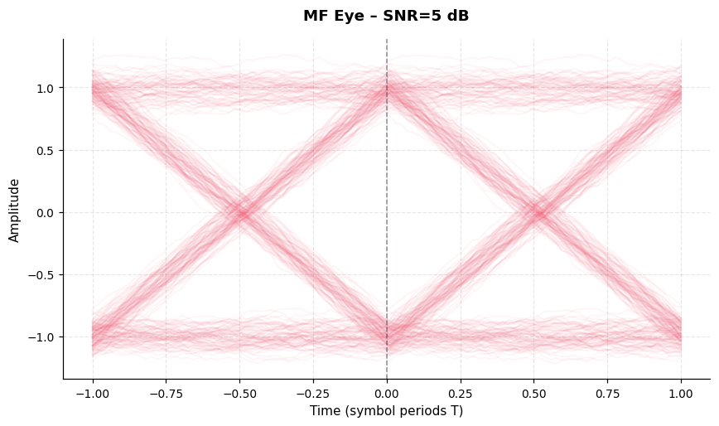
MF eye at SNR=5 dB. Eye opens significantly vs pre-filter, showing matched-filter SNR gain.

MF Eye SNR=10 dB
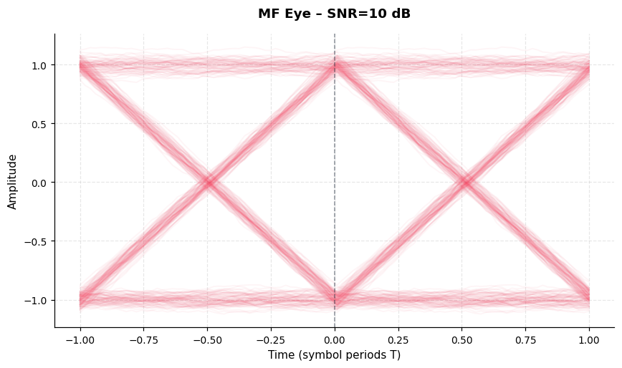
MF eye at SNR=10 dB. Eye opens significantly vs pre-filter, showing matched-filter SNR gain.

MF Eye SNR=20 dB
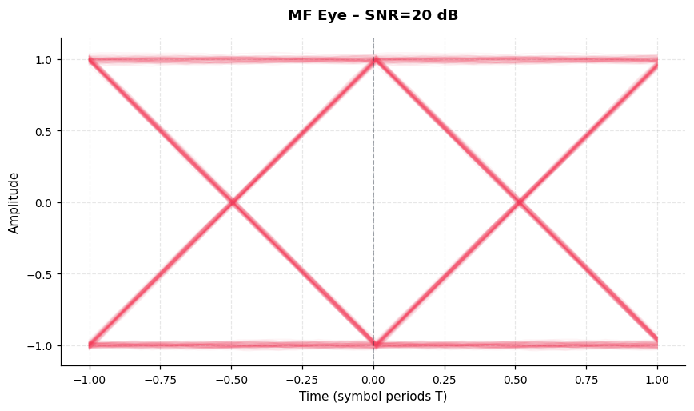
MF eye at SNR=20 dB. Eye opens significantly vs pre-filter, showing matched-filter SNR gain.

MF Eye – NRZ
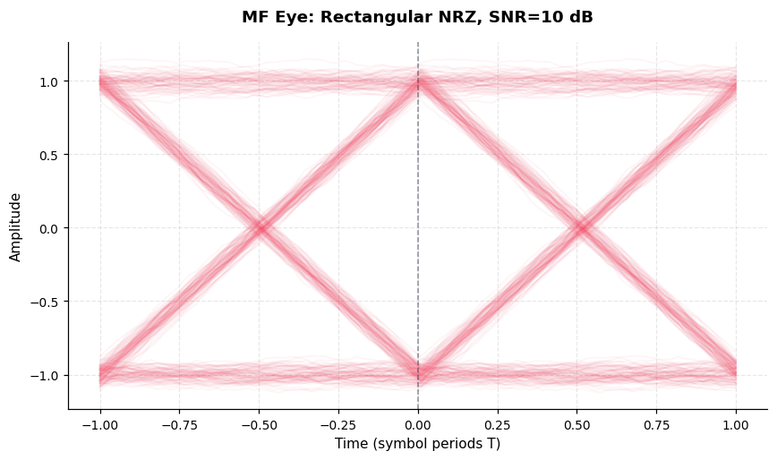
MF eye for Rectangular NRZ at SNR=10 dB. ISI-free eye confirms the matched filter is correctly implemented.

MF Eye – RZ
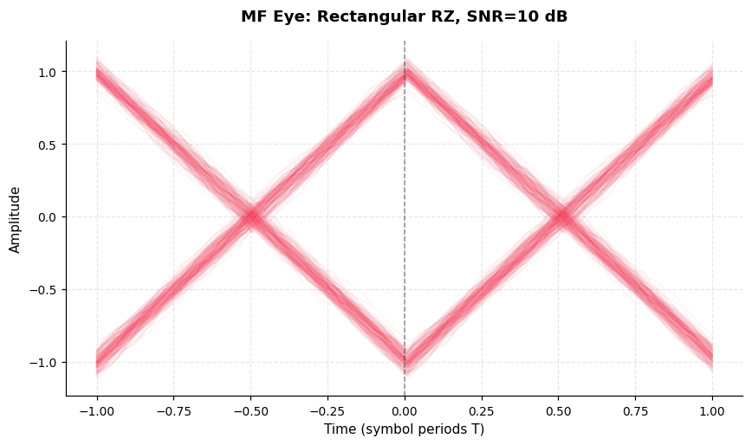
MF eye for Rectangular RZ at SNR=10 dB. ISI-free eye confirms the matched filter is correctly implemented.

MF Eye – Sinc
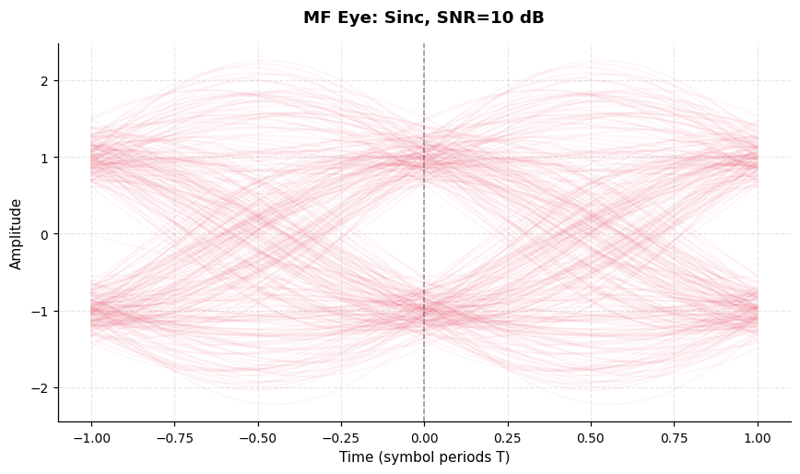
MF eye for Sinc at SNR=10 dB. ISI-free eye confirms the matched filter is correctly implemented.

MF Eye – RC
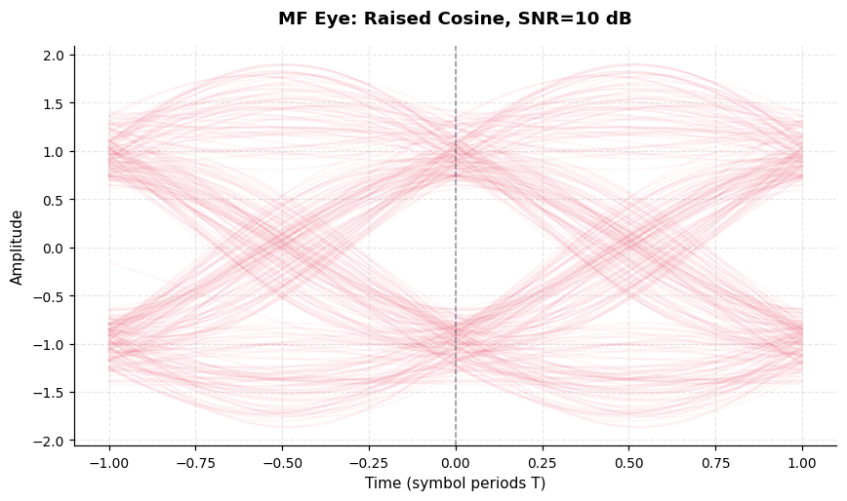
MF eye for Raised Cosine at SNR=10 dB. ISI-free eye confirms the matched filter is correctly implemented.

Block 7: BER Analysis
BER Waterfall – Polar NRZ (100 k bits)
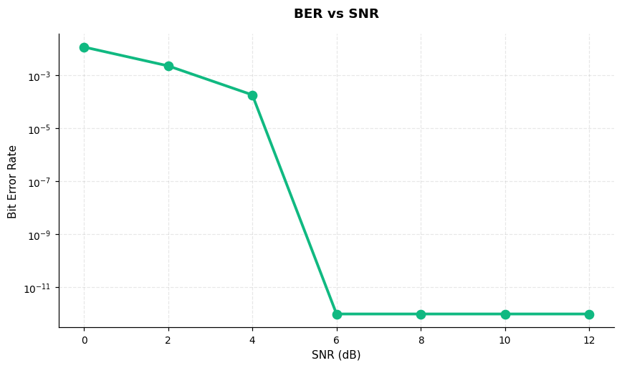
BER vs SNR waterfall (Polar NRZ, 100 k bits/point). BER drops from ~1% at 0 dB to ~0 above 8 dB.

BER Waterfall – Polar
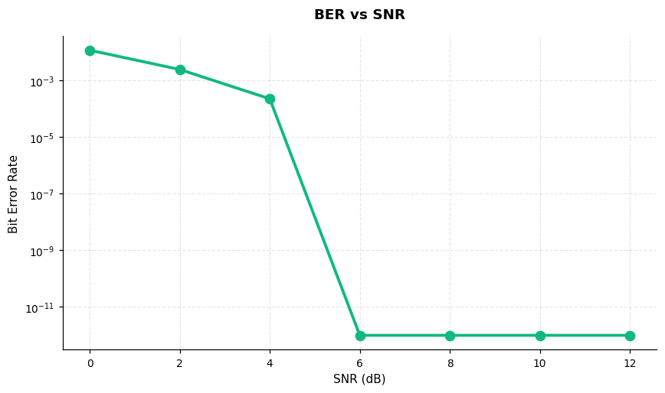
BER waterfall for Polar NRZ (±1). Waterfall shape reflects symbol energy and decision threshold distance.

BER Waterfall – Unipolar
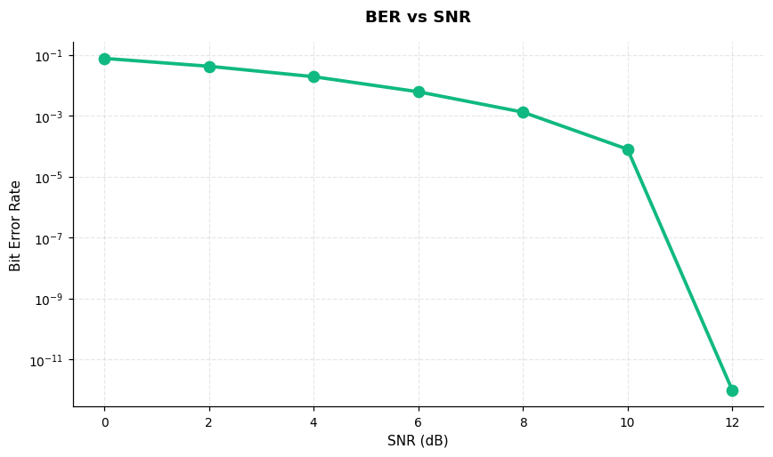
BER waterfall for Unipolar (On-Off). Waterfall shape reflects symbol energy and decision threshold distance.

BER Waterfall – Bipolar
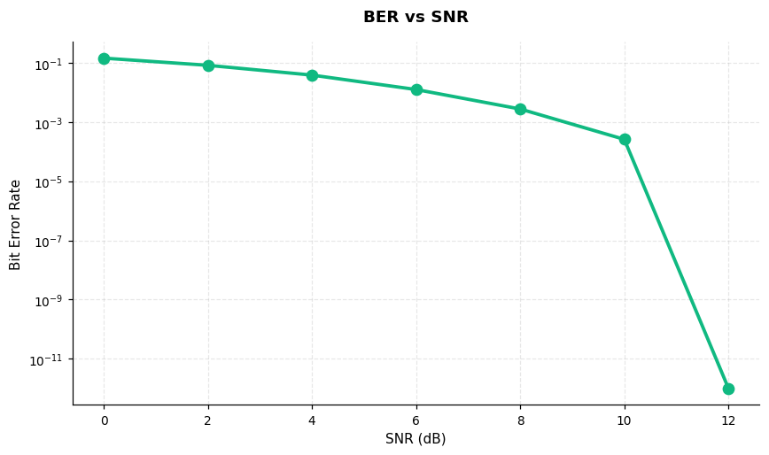
BER waterfall for Bipolar (AMI). Waterfall shape reflects symbol energy and decision threshold distance.

Detected Bits at SNR=10 dB
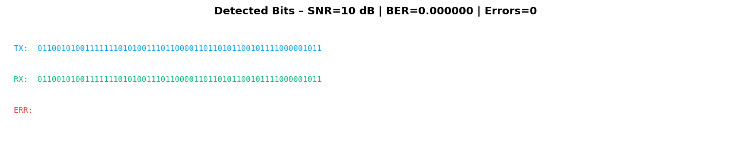
First 60 TX vs detected bits at SNR=10 dB. Carets mark errors; BER=0.000000.

