IICS to OIC Modernization



Submitted by
YASH Technologies, Inc.
USA | United Kingdom | Europe| Middle East | Asia
19th August 2026
Submitted to

This document and any attachments submitted with it are confidential and intended solely for the use of M.A MORTENSON Company or entity to which it is addressed. If you are not the intended recipient, you are hereby notified that any use, dissemination, forwarding, printing, copying or other use of this document, any attached documents, and the information these documents contain, is strictly prohibited. If you have received this by mistake, please advise the sender immediately and destroy/invalidate the document.
ImPORTANT NOTICE

Document Details:
Document Type | Process Document
IICS Architecture | Informatica Intelligent Cloud
OIC Architecture | Oracle Integration Cloud
Integration Name | tf_HUB_CONCUR_EMPLOYEE_DETAILS_OUTBOUND _FIN_I_HR001 (Employee Details HUB To Concur)
Business Process | IICS to OIC Migration
Business Process Name | Finance Solutions – Concur
Upstream App Owner | Finance Group (Informatica Hub Owner)
Downstream App Owner | Finance (Concur Owner)
Version History:
Version | Create / Modified Date | Version Scope | Owner/Changed by
1.1 | 24-08-2026 | 1 | Shrinivas Kathale

Validity: The information submitted in this document will be valid for a period of 30 days from the Response Date

Table of Contents
IICS ‘AS-IS’ Status 1
1 Integration Purpose/Objective: 2
2. AS IS Analysis 2
2.1 Integration Identification- 2
2.2 Business process supported 2
2.3 Upstream Dependency 2
2.4 Down Stream Dependency 2
2.5 Source-to-Target Data Flow 2
2.6 Mapping / Transformation 2
2.7 Connections and Security 2
2.8 Schedule and Trigger 2
2.9 Parameter/Configurations 2
2.10 File /API/ Database 2
2.11 Operational and Error Handling 2
2.12 Monitoring and Alert 2
2.13 Failure Recovery Mechanism 2

IICS ‘AS-IS’ Status

Integration Purpose/Objective:
Analysis and migration of all IICS (Informatica Intelligent Cloud Services) Integrations to OIC (Oracle Integration Cloud).

AS IS Analysis

2.1 Integration Identification-
Attribute | Details
Integration Name / ID | Employee Details HUB To Concur
Folder / Project | Concur
Integration Type (Mapping / Taskflow / API / Process) | API Based for Existing Application (API on Single End) - Single API Calls & Transformations
Trigger Type (Schedule, Event or Ad Hoc) | Schedule
Integration Pattern (Sync, Async, Batch or File) | Batch
Description / Business Purpose | Loads employee data from a source file, applies business validations and transformations, and generates a concurrent processing output file for downstream consumption.
Business Owner | Finance
Technical Owner | Finance Solutions – Concur
Current Status | Active
Criticality (High / Medium / Low) | Medium
Environment(s) | DEV, TEST, UAT, PROD
Last Reviewed Date | 24-Aug-2026

Business process supported
Informatica Hub to Concur

Upstream Dependency
# | Source Asset | Connection / Protocol | Source Object / File / API | Dependency Type | Notes
1 | fit_ARCHIVE_LOCAL_FF_CONCUR_PM_ENDDATED_DETAILS | Source: Local Folder | Source Directory: D:\ESS_INBOUND\Concur_Employee_Outbound_Details\Input  File Pattern: Wildcard: *.* | - | -
2 | fit_ERP_EXTRACT_CONCUR_LOCAL_FF_UNZIP_PM_DETAILS | Source: Local Folder  Archive Directory: D:\ESS_ARCHIVE | Source Directory: D:\ESS_INBOUND\Concur_Employee_Outbound_Details  File Pattern: Wildcard:*.zip | - | Unzip PM End Dated Details from ERP ESS
3 | fit_LOCAL_FF_ARCHIVE_CONCUR_EMPLOYEE_DETAILS | Source: Local Folder | Source Directory: D:\LOCAL_FF\CONCUR_FF\Concur_Employee_Outbound_Details\Input  File Pattern: Wildcard: *.* | - | Archive Concur Employee details post successful run
4 | fit_LOCAL_FF_CONCUR_SFTP_EMPLOYEE_DETAILS | Source: Local Folder | Source Directory: D:\LOCAL_FF\CONCUR_FF\Concur_Employee_Outbound_Details\Input  File Pattern: Wildcard: EMPLOYEE_t0028229unfm_*txt | - | -
5 | mct_DUMMY_CONCUR_EMPLOYEE_OUTBOUND_GET_PARAM | cn_STAGING1 | select 1 from DUAL | - | Get Param values from parameter file for Concur Employee Org Outbound
6 | mct_ERP_ESS_EXTRACT_CONCUR_PM_END_DATE_DETAILS | cn_Oracle_Financials_Cloud | Operation: OracleERP/CustomExtract  Outbound Output Directory: D:\ESS_INBOUND\Concur_Employee_Outbound_Details | - | To extract PM End Date Details from ERP using ESS
7 | File | cn_ESS_INBOUND_1 | Concur_Employee_Outbound_Details/Input/CONCUR__PM_END_DATED_DETAILS_LIST.txt | Source | -
8 | - | cn_ESS_INBOUND_1 | LND_LKP_PROJECTS_TOPIC | Source | -
9 | - | cn_STAGING1 | LND_ERP_CONCUR_PM_ENDDATE_DATA | Source | -

Down Stream Dependency

# | Task Name | Connection / Protocol | Target Object / File / API | Dependency Type | Notes/ Description
1 | fit_ARCHIVE_LOCAL_FF_CONCUR_PM_ENDDATED_DETAILS | Connection Type: Local Folder | Target Directory: D:\ESS_ARCHIVE | If file exists: Overwirte | Runtime Env: TWAPPINFMTC01  Desc: Archive Concur PM End Dated Details  Action: File Operation-> Rename
2 | fit_ERP_EXTRACT_CONCUR_LOCAL_FF_UNZIP_PM_DETAILS | Connection Type: Local Folder | Target Directory: D:\ESS_INBOUND\Concur_Employee_Outbound_Details\Input | If file exists: Overwirte | Unzip PM End Dated Details from ERP ESS  Action: Unzip
3 | fit_LOCAL_FF_ARCHIVE_CONCUR_EMPLOYEE_DETAILS | Source: Local Folder | Target Directory: D:\ESS_ARCHIVE | If file exists: Overwirte | Archive Concur Employee details post successful run
4 | fit_LOCAL_FF_CONCUR_SFTP_EMPLOYEE_DETAILS | Connection type: Advanced SFTP V2  Connection: cn_SFTP_Concur_TEST | Target Directory:  /in | If file exists: Overwrite | Host:  mft-us2.concursolutions.com  Port:  22  Action: PGPEncrypt
5 | mct_DUMMY_CONCUR_EMPLOYEE_OUTBOUND_GET_PARAM | cn_LOCAL_FF | Directory: D:\LOCAL_FF | Target Object: DUMMY_PARAM_CONCUR_HR002.dat | Get Param values from parameter file for Concur Employee Org Outbound
6 | mct_ERP_ESS_EXTRACT_CONCUR_PM_END_DATE_DETAILS | cn_LOCAL_FF | Directory:  D:\LOCAL_FF | Target Object: dummy_ess_extract_concur_emp_pm_details.dat | To extract PM End Date Details from ERP using ESS

Source-to-Target Data Flow
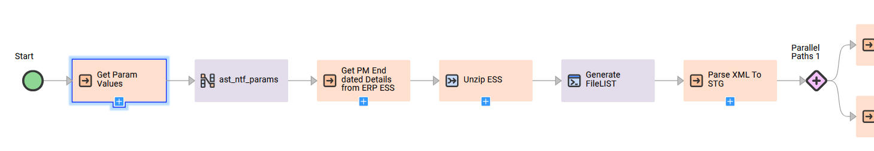
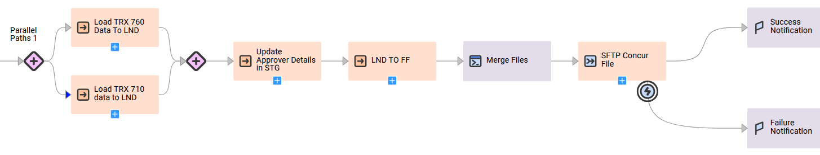
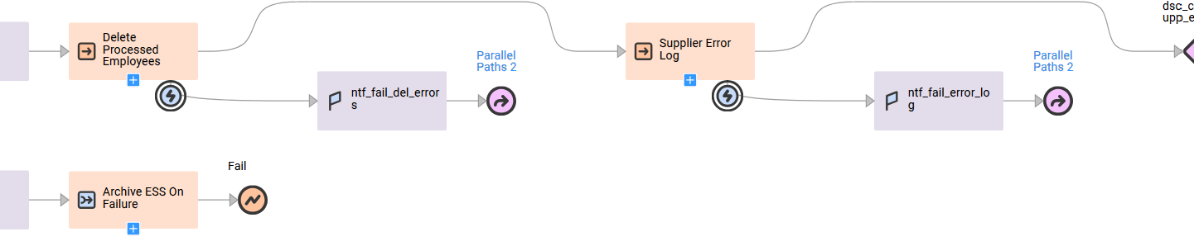

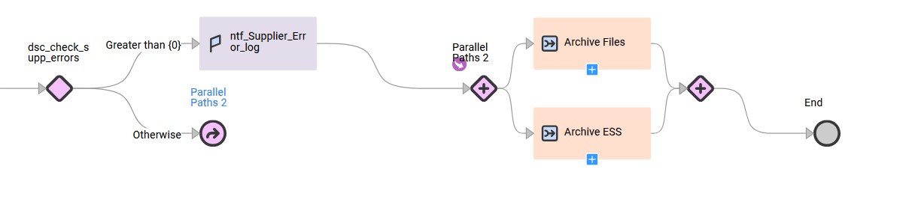

Mapping / Transformation

Parse XML To STG:
src_ERP_ESS_CONCUR_PM_FILE_LIST-> HierarchyParser->exp_data_conv-> tgt_LND_ERP_CONCUR_PM_ENDDATE_DATA

Load TRX 760 Data To LND:
src_pm_endated_details->exp_data_Conv-> Router->tgt1: tgt_MOR_EMPLOYEE_OUTBOUND_TRX_760
tgt2: tgt_FUTURE_EMPLOYEE_OUTBOUND_TRX_760
Load TRX 710 data to LND: Mapping to load projects data for TRX 710 - Concur Employee Outbound
Unconnected Lookup: lkp_project_unit
src_LND_LKP_PROJECTS_TOPIC->exp_trx710_conv->tgt_MOR_EMPLOYEE_OUTBOUND_TRX_710
Load TRX 710 data to LND:
src_LND_LKP_PROJECTS_TOPIC->exp_trx710_conv->tgt_MOR_EMPLOYEE_OUTBOUND_TRX_710
Update Approver Details in STG:
Unconnected Lookups: lkp_supervisor, lkp_pm_check
Source->Expression->Target
LND TO FF: To generate txt file for concur employee outbound
src_mor_emp_outbound_trx100->tgt_mor_emp_outbound_trx100
src_mor_emp_outbound_trx305->tgt_mor_emp_outbound_trx305
src_mor_emp_outbound_trx710->Aggregator->Sorter->tgt_mor_emp_outbound_trx710
src_mor_employee_outbound_trx_760->tgt_MORTENSON_Employee_OutboundTRX_760
Delete Processed Employees: Mapping to Delete Processed Employee Records from Error Log
src_CONCUR_ERP_EMPLOYEE_ERROR_LOG->lkp_ERP_EMPLOYEE_RECORDS->exp_set_flag->Filter->TGT_DELETE_PROCESSED_EMPLOYEES
Supplier Error Log: Mapping To generate Log file with Employee Details with Null Supplier IDs, LOGINIDs and ORG_UNIT_1 For Concur
sec_mor_employee_outbound_trx_305->exp_set_counts->tgt1: tgt_CONCUR_EMPLOYEE_SUPPLIER_ERROR_LOG
tgt2: tgt_dummy

Supporting Document:

Connections and Security
Mentioned Source, lookup and target connection wherever required.

Schedule and Trigger
Scheduled on Daily basis and Triggers around 3:00 AM PDT

Parameter/Configurations
Get Param Values: Get Param values from parameter file for Concur Employee Org Outbound
mct_DUMMY_CONCUR_EMPLOYEE_OUTBOUND_GET_PARAM
p_Email Path: mct-DUMMY-CONCUR-EMPLOYEE-OUTBOUND-GET-PARAM-bYaXaMWIgCocDIAqEztwey → Inout → p_Email
p_Env Path: mct-DUMMY-CONCUR-EMPLOYEE-OUTBOUND-GET-PARAM-bYaXaMWIgCocDIAqEztwey → Inout → p_Env

File /API/ Database (spreadsheet of all API- sample request and response)
API Based for Existing Application (API on Single End) - Single API Calls & Transformations

Operational and Error Handling
On warning – Suspend Taskflow
In Error – Suspend Taskflow

Monitoring and Alert
- Notification groups
- Alert recipients
- Monitoring dashboards
- Escalation process

Failure Recovery Mechanism
- Retry logic
- Reprocessing steps
- Manual intervention steps
- Data reconciliation process

