

CS223: Software Engineering

Submitted By:-

Amol Thakur (B15CS006)

Anurag (B15CS041)

Submitted To:-

Dr. Chiranjoy Chattopadhyay

Revision History

|  |  |  |  |
| --- | --- | --- | --- |
| **Date** | **Version** | **Description** | **People** |
| 16 Jan 2017 | 1.0 | First draft | Amol Thakur  Anurag |
| 1 Feb 2017 | 2.0 | Second draft | Amol Thakur  Anurag |
| 1 March 2017 | 3.0 | Third Draft | Amol Thakur  Anurag |

Table of Contents

1. Introduction 4

1.1 Purpose 4

1.2 Scope 4

1.3 Constraints 4

1.4 Assumptions and Dependencies 4

1.5 Definitions, Acronyms and Abbreviations 4

1.6 References 4

1.7 Organization of the Document 4

2. Overall Description 4

2.1 Product Functions 4

2.1.1.1 Use Case Diagram

2.1.1.2 Class Diagram

2.1.1.3 Sequence Diagram

2.1.1.4 Activity Diagram

2.2 User Characteristics 4

3. Specific Requirements 5

3.1 Use case description 5

Software Requirements Specification

# Introduction

## Purpose:-

The purpose of this SRS document is to provide detailed overview of the Guest House Management system, its parameters, constraints and goals. This SRS document will be used in the future stages of the project which will help for the development of correct software for the end user. This document clearly mentions the expectations and requirements of the client and the resources available to them.

## Scope:-

This software’s main objective is to provide a system for a guest house to automate its major operations. The software automatically reserves 80% of the total rooms on first come first serve basis and rest of the 20% rooms are allotted on priority basis, which is decided manually by the Admin.

## Constraints

* Server should support Django (Python framework for Web Development)
* Server should support one of sqlite or mysql databases
* Availability of Internet Connection
* Limited Server Space
* Security considerations
* Only Users with valid institute membership can login

## Assumptions and Dependencies

* Total rooms to be decided by the admin
* The payment portal will not be included in this software as payment is assumed to occur externally

## Definitions, Acronyms and Abbreviations

|  |  |
| --- | --- |
| **Term** | **Definition** |
| SRS | Software Requirements Specification |
| GHMS | Guest House Management System |
| Admin | The person from Guest House who will have the authority to make final decisions |
| User | Any member of the Institute, be it student, faculty member, staff member or any other official who would use the system for room booking |
| GNR | Guest Name Record – automatically generated Unique Id which can be used for checking booking status |
| Client | The Guest house authority which uses this software for automating its operations |

## References

[1] IEEE. *IEEE Std 830-1998 IEEE Recommended Practice for Software Requirements Specifications.* IEEE Computer Society, 1998.

## Organization of the Document

This SRS document is organized into two main sections. The first is overall description and the second is specific requirements. The overall description will describe the requirements of GHMS from user’s point of view. The specific description section contains the detailed requirement from technical point of view.

# Overall Description

## Product Functions

### Functional Requirements

* Functions For User(s)
  + Login
  + Search for Rooms
  + Request Room Booking
  + Payment/Refund
  + Check Booking Status
  + Cancel Booking
* Functions For Admin
  + Confirm/Cancel Booking
  + Add/Delete Rooms
  + Add/Delete User

#### Use Case Diagram



#### Class Diagram











#### Sequence Diagram























#### Activity Diagram

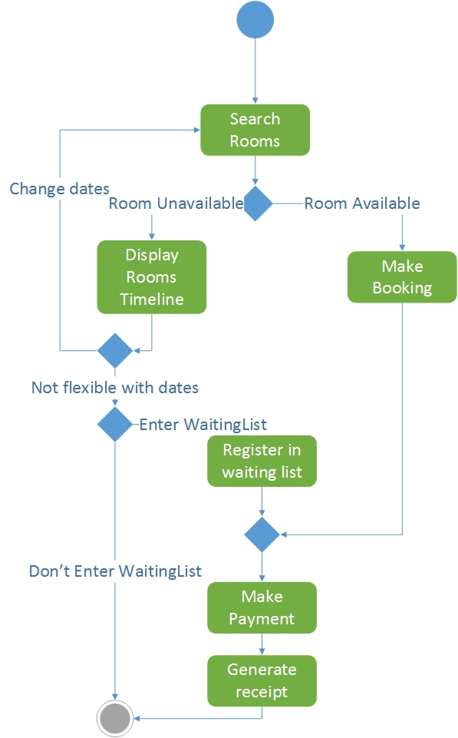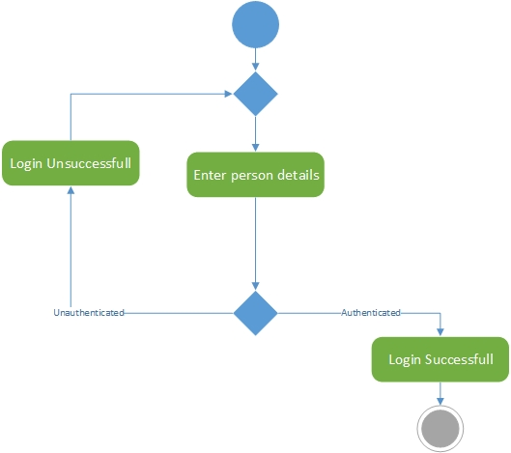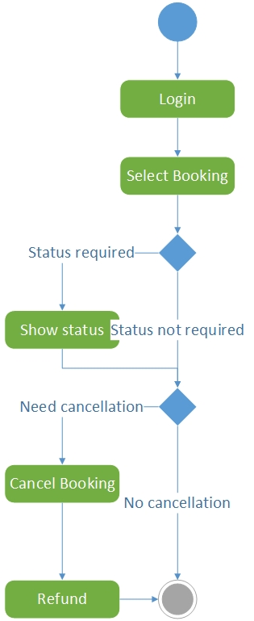

### Non-Functional Requirements

* Usability
* Efficiency
* Correctness
* Maintainability
* Testability
* Reusability
* Portability

## User Characteristics

This is a web based software and it does not require any specific prerequisites from the end user.

* User should be a member of institute
* User must have basic skills such as:
* Knowledge of English
* Familiarity with computer and internet.

# Specific Requirements

## Use case description

### Search for rooms

|  |  |
| --- | --- |
| Name: | Search for rooms |
| Short description | A user gives check in and check out date for rooms |
| Precondition | User is logged into the system |
| Post condition | A room is reserved for the user |
| Error Situations | No free room available |
| System state in the event of error | User is added to the waiting list |
| Actors | User |
| Triggers | User requires a room |
| Standard process | 1)User enters the check in and check out date  2)System finds a free room  3)The system books room for the user |
| Alternate Process | 2’)GHMS does not finds a free room  3’)User modifies the check in check out dates  4’)Else the user is added to the waiting list |

### Request room booking

|  |  |
| --- | --- |
| Name: | Request room booking |
| Short description | On user request GHMS creates a new booking |
| Precondition | A user has searched for available rooms |
| Post condition | A new booking object is created |
| Error Situations | No free available |
| System state in the event of error | Booking status is updated to waiting |
| Actors | GHMS |
| Triggers | User requests room booking |
| Standard process | 1)System finds a free room  2)The system books room for the user |
| Alternate Process | 1’)GHMS does not finds a free room  2’)User modifies the check in check out dates  3’)Else the user is added to the waiting list |

### Requests for food

|  |  |
| --- | --- |
| Name: | Requests for food |
| Short description | User makes request for food while booking |
| Precondition | User has initiated the room booking process |
| Post condition | User pays for the food and completes the booking |
| Error Situations | Payment unsuccessful |
| System state in the event of error | Bookings stands void |
| Actors | User |
| Triggers | User requests for food while room booking |
| Standard process | 1)User selects room  2)User selects food  3)User completes his booking |
| Alternate Process | 2’)User does not orders food  3’)User completes/not completes his booking |

### Payment

|  |  |
| --- | --- |
| Name: | Payment |
| Short description | User makes payment to complete his booking |
| Precondition | User has initiated booking |
| Post condition | User completes booking |
| Error Situations | Payment unsuccessful |
| System state in the event of error | Booking stands void |
| Actors | User |
| Triggers | User proceeds to payment portal |
| Standard process | 1)User initiates booking  2)User proceeds to payment portal  3)User completes his payment |
| Alternate Process | 3’)payment unsuccessful  4’)user tries after some time |

### Check booking status

|  |  |
| --- | --- |
| Name: | Check booking status |
| Short description | User requests GHMS to provide current booking status |
| Precondition | User has made a booking |
| Post condition | GHMS provides booking status |
| Error Situations | Booking does not exist |
| System state in the event of error | User gets error message |
| Actors | User |
| Triggers | User requests for booking status |
| Standard process | 1)User selects booking  2)User selects check status option  3)GHMS returns booking status |
| Alternate Process | 3’)GHMS prints error message |

### Cancel booking

|  |  |
| --- | --- |
| Name: | Cancel booking |
| Short description | Person Initiates cancellation process |
| Precondition | Person had made successful payment |
| Post condition | Refund process is initiated |
| Error Situations | Booking did not exist |
| System state in the event of error | GHMS returns error message |
| Actors | Person |
| Triggers | Person requests cancellation |
| Standard process | 1)Person selects booking  2)Person selects cancel option  3)Refund process initiated |
| Alternate Process |  |

### Refund

|  |  |
| --- | --- |
| Name: | Refund |
| Short description | User is provided refund after cancellation |
| Precondition | Person should cancel the booking |
| Post condition | User’s payment is refunded |
| Error Situations | External error in transactions |
| System state in the event of error | Error message |
| Actors | User |
| Triggers | User cancels booking |
| Standard process | 1)User selects booking  2)User cancels booking  3)GHMS initiates refund process  4)User gets his refund |
| Alternate Process | 4’)User did not receive his refund  5’)Refund process stopped  6’)Refund process initiated after some time |

### Login

|  |  |
| --- | --- |
| Name: | Login |
| Short description | Person uses his credentials to access GHMS |
| Precondition | Person should be a member of institute |
| Post condition | Person is granted access to GHMS |
| Error Situations | Invalid credentials used |
| System state in the event of error | Person is redirected to the login page |
| Actors | Person |
| Triggers | Person submits login form |
| Standard process | 1)Person enters his credentials  2)Database verifies the credentials  3)GHMS provides access to the system |
| Alternate Process | 2’)Credentials not verified  3’)Person is redirected to the login page |

### Confirm booking

|  |  |
| --- | --- |
| Name: | Confirm booking |
| Short description | Admin confirms the booking from waiting list |
| Precondition | A booking should have been added to the waiting list |
| Post condition | Booking status confirmed |
| Error Situations | Admin does not approves the booking |
| System state in the event of error | Booking is cancelled and the refund is initiated |
| Actors | Admin |
| Triggers | Admin chooses a booking for confirmation |
| Standard process | 1. Admin requests the database for waiting list 2. Admin chooses a booking for confirmation 3. Admin confirms booking |
| Alternate Process | 3’) Admin cancels booking |

### Add room

|  |  |
| --- | --- |
| Name: | Admin |
| Short description | Admin adds a room to the database |
| Precondition | Space should be available in the guest house |
| Post condition | Room is added |
| Error Situations | Space not available in the guest house to add a room |
| System state in the event of error | Room not added |
| Actors | Admin |
| Triggers | Admin wants to add a room |
| Standard process | 1)Space should be available in the guest house  2)Admin creates a new room  3)Admin adds room details  4)A new room is added to the database |
| Alternate Process | 1’)Space not available in the guest house  2)Return error message |

### Delete room

|  |  |
| --- | --- |
| Name: | Delete room |
| Short description | Admin deletes a room from the database |
| Precondition | Room temporarily unavailable |
| Post condition | Room deleted from the database |
| Error Situations | Room already deleted |
| System state in the event of error | Admin receives error message |
| Actors | Admin |
| Triggers | Admin wants to delete a room |
| Standard process | 1)Admin selects a room for deletion  2)Room deleted from the database |
| Alternate Process | 1’)No room available for deletion  2’)Return error message |

### Add user

|  |  |
| --- | --- |
| Name: | Admin |
| Short description | Admin adds a user to the database |
| Precondition | User be a member of institute |
| Post condition | User is added |
| Error Situations | User not a member of institute |
| System state in the event of error | User not added |
| Actors | Admin |
| Triggers | Admin wants to add a user |
| Standard process | 1) User be a member of institute  2)Admin creates a new user  3)Admin adds user details  4)A new user is added to the database |
| Alternate Process | 1’) User not a member of institute  2)Return error message |

### Delete user

|  |  |
| --- | --- |
| Name: | Delete user |
| Short description | Admin deletes a user from the database |
| Precondition | User should be in the database |
| Post condition | User deleted from the database |
| Error Situations | User not found in the database |
| System state in the event of error | Admin receives error message |
| Actors | Admin |
| Triggers | Admin wants to delete a user |
| Standard process | 1)Admin selects a user for deletion  2)User deleted from the database |
| Alternate Process | 1’)No user available for deletion  2)Return error message |