Parallel Computing Assignment

**Roll No. -**  160123005 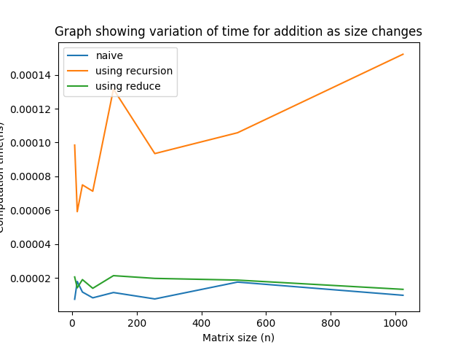

|  |  |  |  |
| --- | --- | --- | --- |
| Size(n) | naiveOutput | recursiveOutput | reduceOutput |
| 8.0 | 7.327995e-06 | 9.848698e-05 | 2.052498e-05 |
| 16.0 | 1.7849e-05 | 5.912202e-05 | 1.4071e-05 |
| 32.0 | 1.159401e-05 | 7.494501e-05 | 1.894802e-05 |
| 64.0 | 8.167e-06 | 7.121501e-05 | 1.381e-05 |
| 128.0 | 1.130402e-05 | 0.000131602 | 2.1279e-05 |
| 256.0 | 7.515016e-06 | 9.346e-05 | 1.9664e-05 |
| 512.0 | 1.7477e-05 | 0.000105784 | 1.865299e-05 |
| 1024.0 | 9.680982e-06 | 0.000152194 | 1.318799e-05 |