Observation on Trapezoidal Rule using OpenMP

Function used f(x) = x²
Domain of integration [a,b] = [1,50]
n : number of partitions in domain
To optimize over naive method I have splitted the calculation of work between processes by calling area calculating function parallely. Each process calculating area for different part of domain.

Number of partition vs execution time
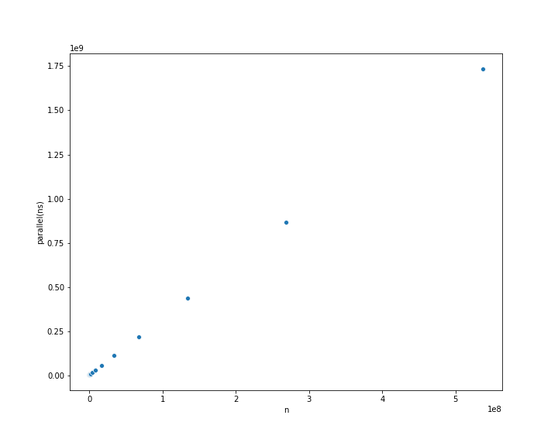
Below two graphs show relation between number of partitions Vs time required for parallel(1.a) and serial(1.b) execution
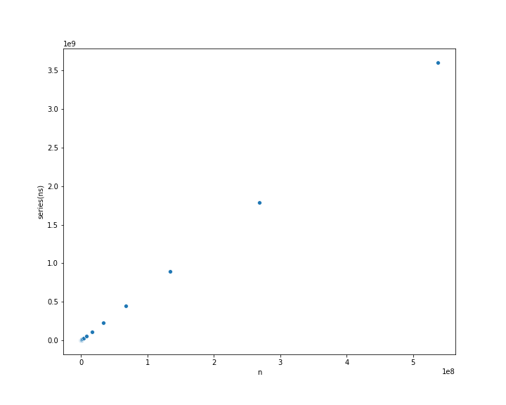

1.a 1.b
from above it can be seen that increasing parition will increase calculation in both parallel and serial execution and so the excution time will increase and we can see that both graphs are increasing.

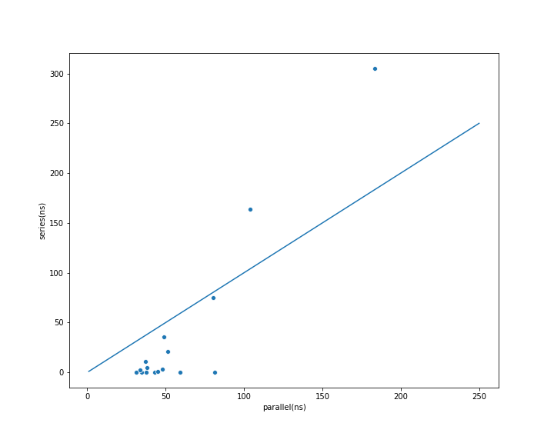
Is parallel execution time smaller than serial
Below graph shows how execution time of parallel and serial code compares

we would have expected a smaller time in parallel execution than in serial execution but seems like graph is below(x=y) in left and above(x=y) in right region. Right region(where serial execution time is more than parallel) is behaving how we expected it to but the left region were we have small value of n show opposite behaviour. The region may be the fact the that finding free thread from thread pool and assigning them to parallel processes or combining them the setup time may dominate the execution time so for small n the setup time make the execution time of parallel code higher than serial where we don’t need that kind of setup time.But once execution time exides setup time our plot start going above(x=y) and thats what we were expecting.

Is error in answer same for both parallel and series execution
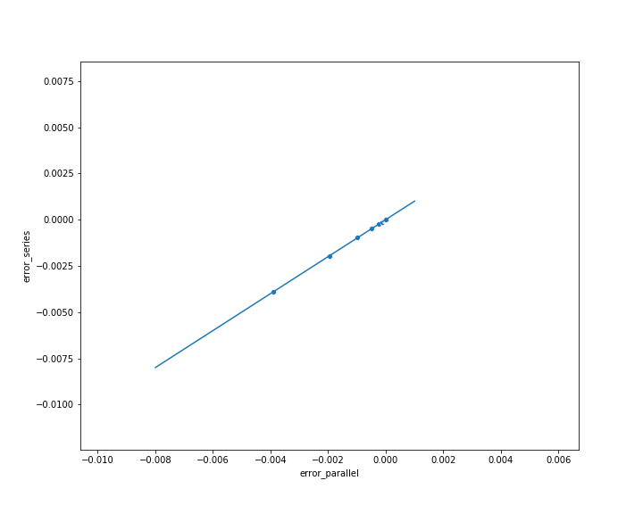

since both execution differe in only one fact and that is number of processes doing the calculation but in the end same thing is calculating in both in exact same manner suggesting that error in both cases should be same.The grpah shown above support our argument since plot between errors in both case overlape with x=y line.

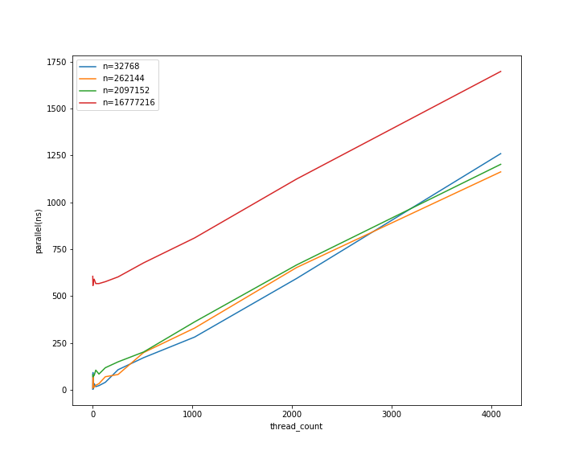
what happens to execution time of parallel on changing number of threads

2.a

increasing thread_count should deacrease execution time but we see a increase in above graph the reason may be due to setup time dominating execution time.But if that’s the case then for smallest thread_count execution time should be smallest.But that is also not that straight in region of small thread_count we see small fluctuation in values but we can see that there is a deep in the graph on increaing thread_count. The deep may be the point where we have a perfect balance between setup time and execution time. Before this point execution time is more than expected(due to dominating setup time) and after this point thier is a scope of parallelsim left we can increase threads to optimise the required time.

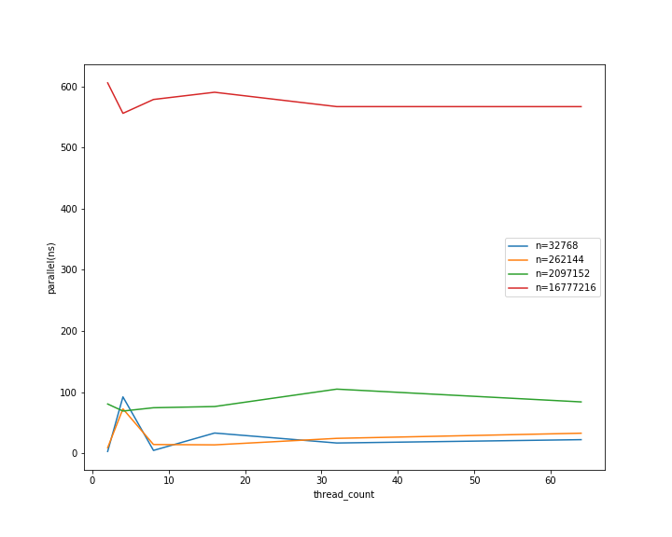

2.b(zoom of 2.a for small values)

