Polynomial Multiplication with Pthreads

(naive method mentioned is the school method)
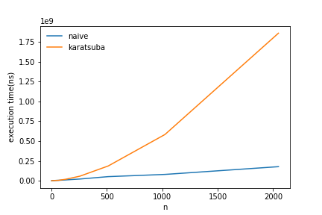
As the problem size increases time required for multiplication increases and thats what we expected.

Although karatsuba method is supposed to perform better than naive but from graph it doesn’t look that way. This may be due to high creation time for threads.

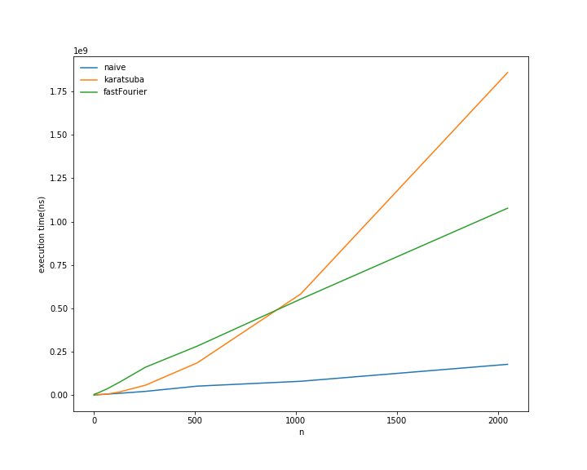
For small value of n its expected to have a better performance in naive method ,since less number of threads are formed but in both other methods more threads will be formed and setup time will dominate the execution time. But comparing karatsuba and fast fourier we see there is intersection point between the lines. The resaon may be that for n before intersection the karatsuba endup calling naive method asbase case very early and perfoming better than fast fourier where no such base case is present it ‘s base case is polynomial of size 1. But after this intersection point karatsuba start lagging since now the time before base case arrive is increasing but fast fourier still performing the same and showing it’s efficiency.

