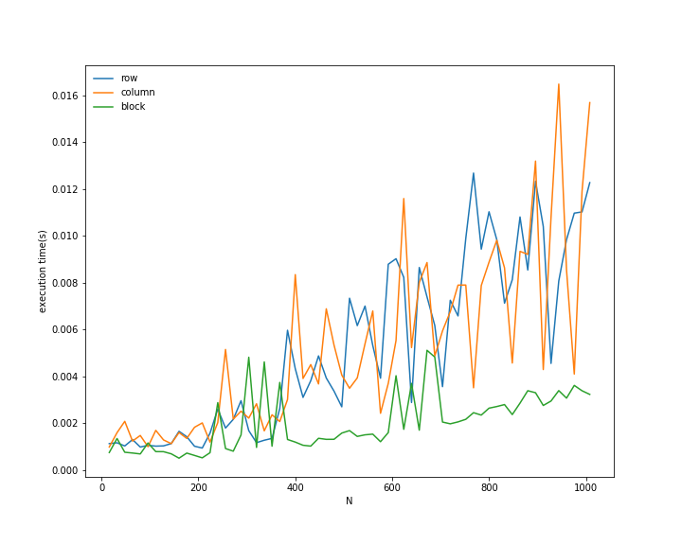
Row and Column striped multiplication are going up and down no general trend about which performs better. But the plot for blockwise multiplication is performing better than both in general.
This is what we were expecting as 2-D partitioning perform better than 1-D partitioning.

