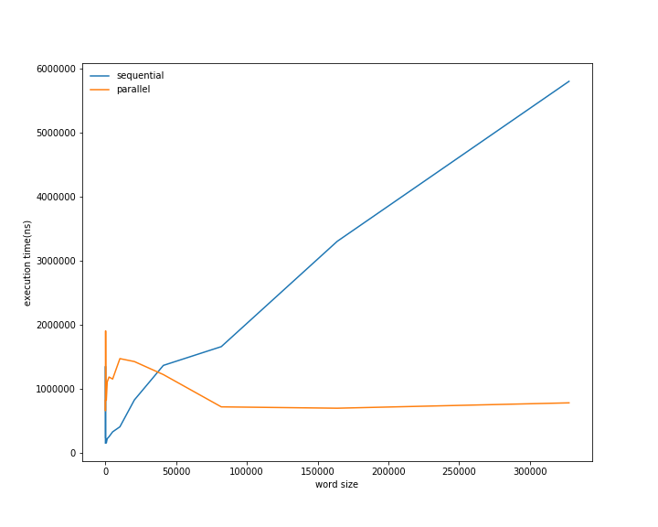
In the above graph we can see that plot for parallel execution intersects with plot for sequential execution. Explaination of this can be that before intersection point the computation time was dominated by setup time of threads which gives a higher time for parallel execution. But as we increase word size computation time will increase and now computation time will dominate setup time. After this point we can see how parallelism give benift.

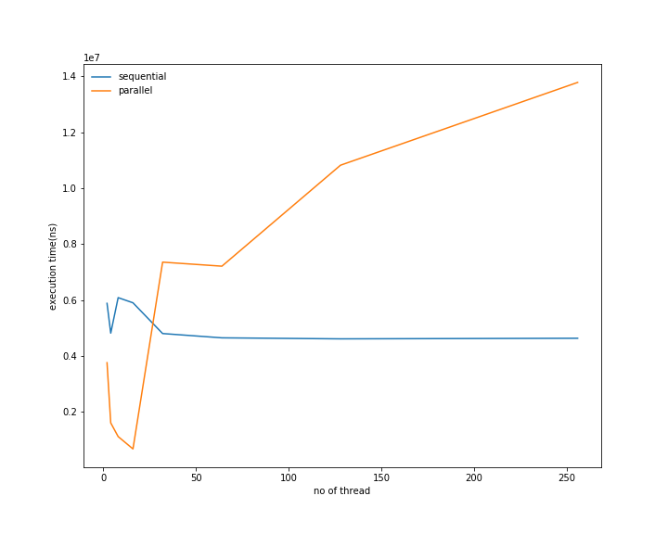

The above graph shows effect on changin number of threads while keeping word size constant(262144). We see that parallel execution time is small then sequential for small thread count. But after some point it crosses sequential execution time. On increasing to much threads computation time by each thread maybe dominated by there setup time so increasing thread beyond intersection point is not benefitial. To take advantage of more threads we should increase word size.

