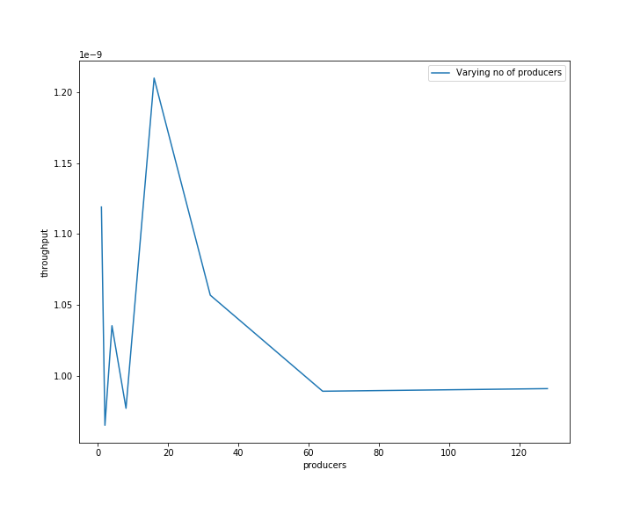

As we have seen that increase in number of producers does not affect throughput after some time which was expected.As change in number of producers doesn’t cast thereis not processing time (sleep) so increasing producers should not cause change in throughput.
In the begning the fluctuating part may be due to the increasing in time required by thread setup and as producers increases and increase in producer will increase supply for consumer to increase throughput of system.But after a time increasing producer don’t give benefit to consumers as they are already full can’t do extra consumption so decrease in throughput observed and then curve gets flat.

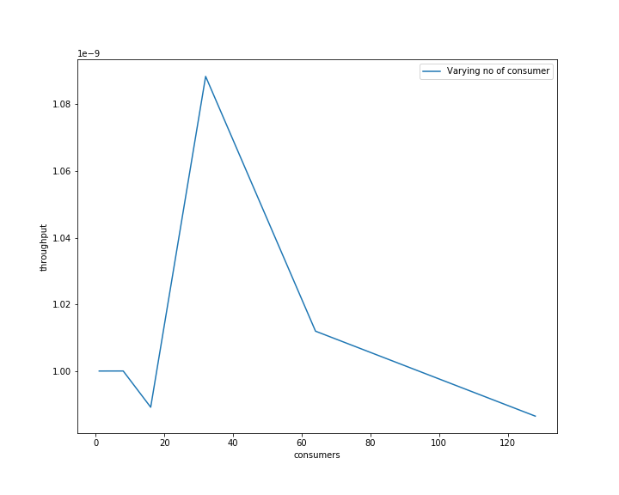

In the above graph varying no of consumers first increases throughput and then decreases
reason may be that in start consumers were not able to consume all data generate by producers and producers are waiting ideally.But as we increase consumers produces start gettin busy and througput increases.After some time throughput deacreases reason maybe beacause that producer are already at full capacity they are busy all the time consumers are waiting since producers are less so inflow is less than outflow which unnecessary increase total time.

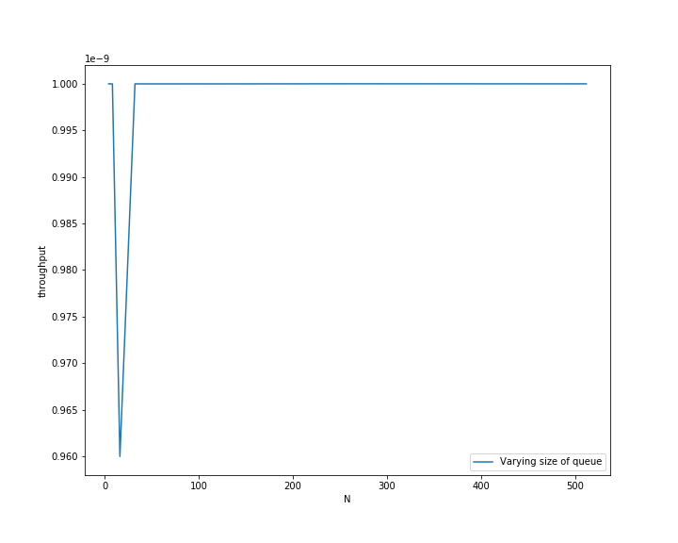

After a time increase in size doesn’t affect throughput remains same reason maybe that the producers and consumers are already at their full capacity. For small N increase in N increases throughtput because they prouders are being ideal due to low capacity of queue.

