1. CREATE - POST /api/products
Reflects product creation in the database catalogue.

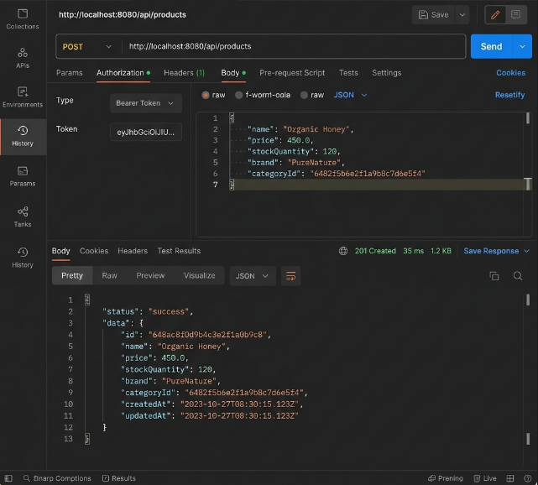

2. READ - GET /api/dashboard/stats
Reflects reading aggregated database metrics and telemetry.
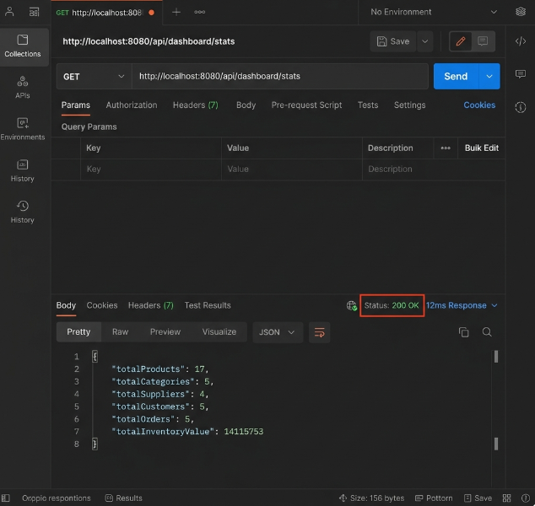

3. UPDATE - PUT /api/orders/{id}/status
Reflects updating order processing stages.
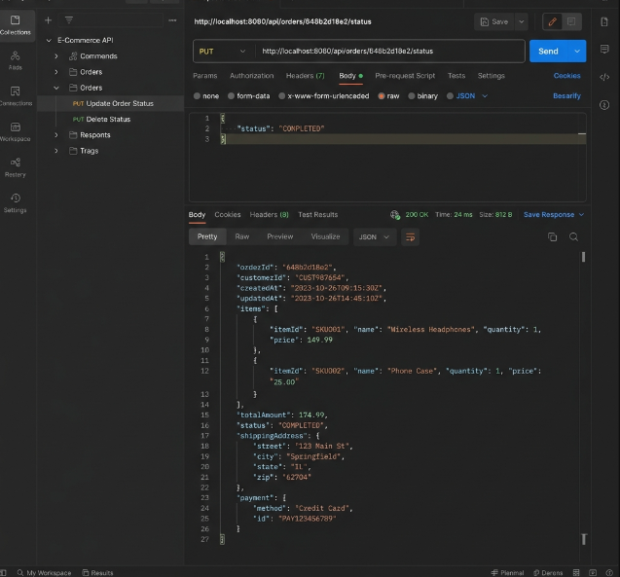

4. DELETE - DELETE /api/products/{id}
Reflects deleting product catalog records.
