CODE FOR SQL CONNECTIVITY AND CRUD OPERATIONS

//DB_Connection
package CRUD;
import java.sql.Connection;
import java.sql.DriverManager;
public class DB_Connection {
public static void main(String[] args) {
DB_Connection obj_DB_Connection=new DB_Connection();
System.out.println(obj_DB_Connection.get_connection());
}
public Connection get_connection(){
Connection connection=null;
try {
Class.forName("com.mysql.jdbc.Driver");
connection = DriverManager.getConnection("jdbc:mysql://localhost:3306/crud","root", "root123");
} catch (Exception e) {
System.out.println(e);
}
return connection;
}
}
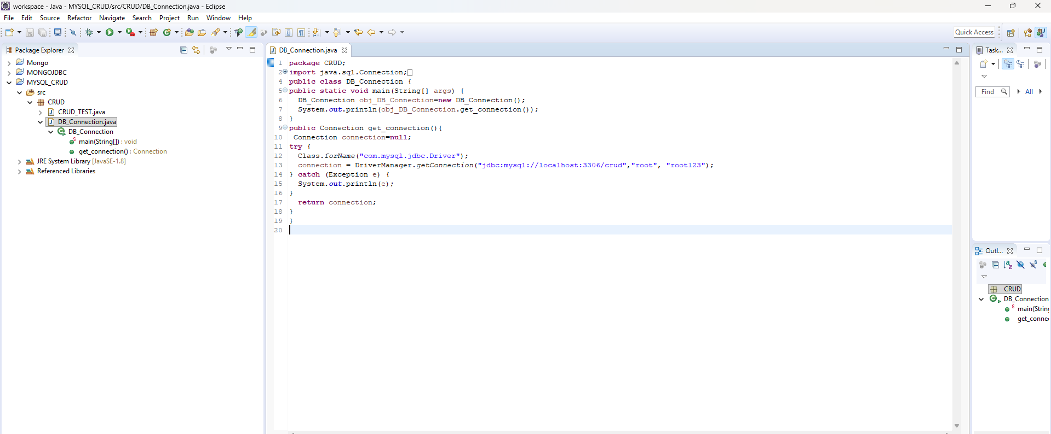

//CRUD_TEST
package CRUD;

import java.sql.Connection;
import java.sql.PreparedStatement;
import java.sql.ResultSet;

public class CRUD_TEST {

public static void main(String[] args) {

CRUD_TEST objTest = new CRUD_TEST();

// Uncomment ONE method at a time while testing

// CREATE
// objTest.create_data("1", "jinu", "jinu@gmail.com");

// READ ALL
objTest.read_data();

// READ ONE
// objTest.edit_data("1");

// UPDATE
// objTest.update_data("1", "11", "jinu_updated", "jinu@gmail.com");

// DELETE
// objTest.delete_data("1");

// ALTER TABLE
// objTest.alter_table();

// TRUNCATE TABLE
// objTest.truncate_data();
}

// CREATE
public void create_data(String sl_no, String name, String email) {

DB_Connection obj_DB_Connection = new DB_Connection();
Connection connection = obj_DB_Connection.get_connection();

try {
String query = "insert into user(sl_no,name,email) values (?,?,?)";

PreparedStatement ps = connection.prepareStatement(query);

ps.setString(1, sl_no);
ps.setString(2, name);
ps.setString(3, email);

System.out.println(ps);

ps.executeUpdate();

System.out.println("Record inserted successfully.");

} catch (Exception e) {
System.out.println(e);
}
}

// READ ALL
public void read_data() {

DB_Connection obj_DB_Connection = new DB_Connection();
Connection connection = obj_DB_Connection.get_connection();

try {
String query = "select * from user";

PreparedStatement ps = connection.prepareStatement(query);

ResultSet rs = ps.executeQuery();

while (rs.next()) {
System.out.println("Sl no - " + rs.getString("sl_no"));
System.out.println("Name - " + rs.getString("name"));
System.out.println("Email - " + rs.getString("email"));
System.out.println("--------------------");
}

} catch (Exception e) {
System.out.println(e);
}
}

// READ ONE RECORD
public void edit_data(String sl_no) {

DB_Connection obj_DB_Connection = new DB_Connection();
Connection connection = obj_DB_Connection.get_connection();

try {
String query = "select * from user where sl_no=?";

PreparedStatement ps = connection.prepareStatement(query);

ps.setString(1, sl_no);

ResultSet rs = ps.executeQuery();

if (rs.next()) {
System.out.println("Sl no - " + rs.getString("sl_no"));
System.out.println("Name - " + rs.getString("name"));
System.out.println("Email - " + rs.getString("email"));
System.out.println("--------------------");
}

} catch (Exception e) {
System.out.println(e);
}
}

// UPDATE
public void update_data(String sl_no, String new_sl_no, String name, String email) {

DB_Connection obj_DB_Connection = new DB_Connection();
Connection connection = obj_DB_Connection.get_connection();

try {
String query = "update user set sl_no=?, name=?, email=? where sl_no=?";

PreparedStatement ps = connection.prepareStatement(query);

ps.setString(1, new_sl_no);
ps.setString(2, name);
ps.setString(3, email);
ps.setString(4, sl_no);

System.out.println(ps);

ps.executeUpdate();

System.out.println("Record updated successfully.");

} catch (Exception e) {
System.out.println(e);
}
}

// DELETE
public void delete_data(String sl_no) {

DB_Connection obj_DB_Connection = new DB_Connection();
Connection connection = obj_DB_Connection.get_connection();

try {
String query = "delete from user where sl_no=?";

PreparedStatement ps = connection.prepareStatement(query);

ps.setString(1, sl_no);

System.out.println(ps);

ps.executeUpdate();

System.out.println("Record deleted successfully.");

} catch (Exception e) {
System.out.println(e);
}
}

// TRUNCATE TABLE
public void truncate_data() {

DB_Connection obj_DB_Connection = new DB_Connection();
Connection connection = obj_DB_Connection.get_connection();

try {
String query = "truncate table user";

PreparedStatement ps = connection.prepareStatement(query);

System.out.println(ps);

ps.executeUpdate();

System.out.println("All records deleted successfully.");

} catch (Exception e) {
System.out.println(e);
}
}

// ALTER TABLE
public void alter_table() {

DB_Connection obj_DB_Connection = new DB_Connection();
Connection connection = obj_DB_Connection.get_connection();

try {
String query = "alter table user add address varchar(20)";

PreparedStatement ps = connection.prepareStatement(query);

System.out.println(ps);

ps.executeUpdate();

System.out.println("Column added successfully.");

} catch (Exception e) {
System.out.println(e);
}
}
}

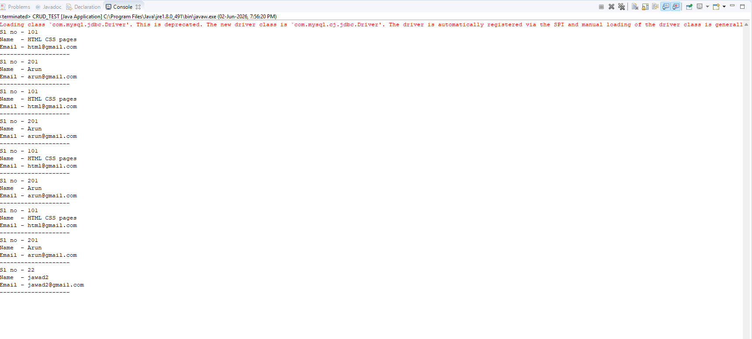

CODE FOR MONGODB CONNECTIVITY

import com.mongodb.client.MongoClient;
import com.mongodb.client.MongoClients;
import com.mongodb.client.MongoDatabase;

public class MongoDBConnection {

public static void main(String[] args) {

String connectionString = "mongodb://localhost:27017";

try (MongoClient mongoClient = MongoClients.create(connectionString)) {

MongoDatabase database = mongoClient.getDatabase("collegedb");

System.out.println("Connected successfully to MongoDB!");
System.out.println("Database Name: " + database.getName());

} catch (Exception e) {
System.out.println("Connection failed: " + e.getMessage());
}
}
}

