**MIT School of Computing**

**Department of INFORMATION TECHNOLOGY**

**Project Synopsis**

**Group ID: SY_IT_03**

**Project Title: EduStake: Centralized College Resource Sharing Platform**

**Group Members: 4**

|  |  |  |  |  |
| --- | --- | --- | --- | --- |
| **Enrollment Number** | **Roll No.** | **Name of student** | **Email Id** | **Contact Number** |
| **ADT23SOCB1630** | **61** | **Sahil Jirapure** | **sahiljirapure8@gmail.com** | **8888955675** |
| **ADT23SOCB1509** | **05** | **Anurag Bodkhe** | **Bodkheanurag235@gmail.com** | **9022977272** |
| **ADT23SOCB1629** | **60** | **Ujjwal Garud** | **Garudujjwal@gmail.com** | **9766499137** |
| **ADT23SOCBD207** | **67** | **Shreeniwal Bhore** | **shrinivasbhore6@gmail.com** | **8080343362** |

**Under the guidance of prof. Rahul Rathod**



**DEPARTMENT OF INFORMATION TECHNOLOGY**

**MIT School OF COMPUTING**

**MIT Art, Design and Technology University**

**Rajbaug Campus, Loni-Kalbhor, Pune 412201**

**2024-25**

**Problem Statement**

In many colleges, students often face difficulties accessing quality academic resources such as notes, previous year question papers, lab manuals, and project reports. These resources are usually scattered across different platforms (e.g., WhatsApp, Google Drive, PDFs shared among peers), leading to inefficiency, loss of data, and lack of standardization. There is a need for a centralized platform where students and faculty can securely upload, access, and manage academic resources easily and systematically.

**Abstract**

**EduStake** is a centralized web-based platform designed to enhance academic collaboration by providing a common space for students and faculty to share educational resources. It aims to streamline the process of resource distribution, allowing users to upload, categorize, and retrieve notes, question papers, presentations, and more. The system ensures secure access, version control, and efficient searching of materials through a user-friendly interface. EduStake fosters a collaborative learning environment, reducing redundancy and improving knowledge sharing within educational institutions.

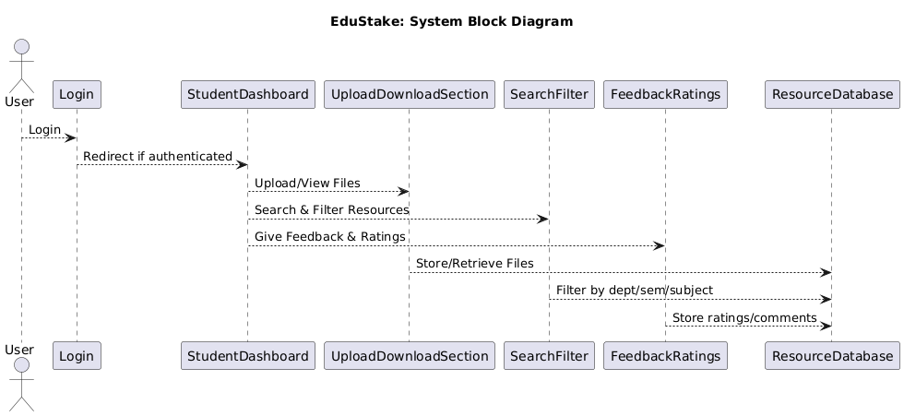

**Survey: Detail survey**

**Existing Systems**

* **WhatsApp/Telegram Groups:** Widely used for sharing notes and PDFs, but lack organization, search features, and long-term storage.
* **Google Drive/OneDrive:** Offer cloud storage but lack institutional structure, categorization, and user-based uploads tied to academic years and departments.
* **Learning Management Systems (e.g., Moodle):** Used by some colleges but often underutilized due to poor UI and complexity.
* **Classroom Portals (e.g., Google Classroom):** Good for teacher-student interaction but not suitable for student-student resource exchange.

**Gaps Identified**

* No proper classification or filtering based on course/year/department.
* No version control or structured moderation.
* Lack of collaboration features like ratings, feedback, or comments on materials.
* Data loss risk due to scattered sharing.

**User Survey (Optional for extra marks)**

* Conducted among 50 students across 3 departments.
* 80% students reported difficulty finding reliable past year papers and lab manuals.
* 70% of students prefer a centralized portal over social media groups for academic sharing.

**Proposed System (Block Diagram):**

### ****Key Features****

* User Authentication (Students and Faculty)
* Upload/Download Section for study materials
* Categorization by Department, Semester, Subject
* Search Functionality
* Rating and Comments on Resources
* Admin Dashboard for moderation
* Notifications/Updates for new uploads

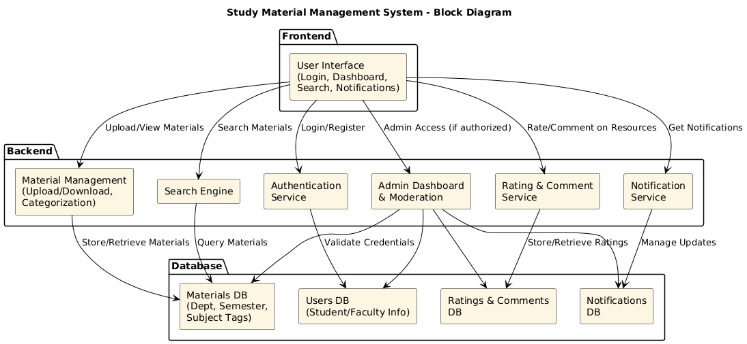

**Conclusion:**

EduStake offers a solution to the long-standing problem of decentralized and unorganized academic content sharing among college students. By centralizing and streamlining the process, it enhances learning efficiency, encourages collaboration, and provides a long-term archive of valuable educational content. The platform not only benefits students but also supports faculty in resource management, resulting in a more effective academic ecosystem.

**Reference**

1. Google Classroom – <https://classroom.google.com>
2. Moodle LMS – <https://moodle.org>
3. Research Paper: "A Study on Learning Resource Sharing Systems in Higher education" – IJERT, 2022
4. Bootstrap Framework – <https://getbootstrap.com>
5. Stack Overflow, GitHub discussions, and open-source student portal project

**Annexure**

### ****Tools and Technologies Used****

* **Frontend:** HTML, CSS, JavaScript, Bootstrap
* **Backend:** PHP / Node.js (based on choice)
* **Database:** MySQL / MongoDB
* **Hosting:** XAMPP / Localhost (for demo), can be deployed on Heroku or Vercel

### ****Roles and Responsibilities****

* **Frontend Team:** Designing the UI/UX, search bar, responsive layout
* **Backend Team:** User authentication, file upload logic, category filters
* **Database Team:** Structuring schema for departments, years, and user uploads

**Approval**

**Signatures:**

***(Space for Guide/Supervisor and Department Head)***

**Annexure II: Market and Financial Feasibility**

**Market Feasibility:**

* **Target Market: Colleges, universities, and online learning platforms.**
* **User Base: Students, instructors, and academic institutions.**
* **Use Cases: Group projects in any subject area, especially where team collaboration is essential.**
* **Adoption Potential: High, due to increasing demand for fairness and transparency in academic evaluation.**

**Financial Feasibility:**

* **Development Costs: Backend (database, logic), frontend (user interface), authentication, and analytics modules.**
* **Revenue Model:**
  + **Free version for students with limited features.**
  + **Subscription-based licensing for institutions (annual or semester-wise).**
  + **Premium analytics dashboard and LMS integrations as value-added services.**
* **Scalability: Cloud-based deployment allows for institution-wide adoption with minimal infrastructure requirements.**