Q.1) Write a Python program to count the even, odd numbers in a given array of integers using Lambda.

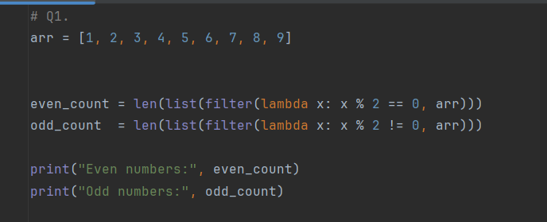
Output :-

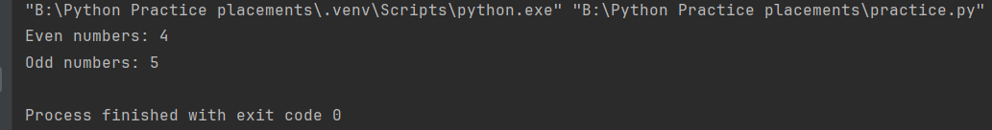

Q.4) Write a Python program to convert a byte string to a list of integers. Sample Input: “hello” Sample Output: [104, 101, 108, 108, 111]
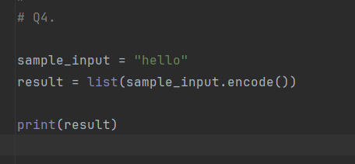

Output:-
