# HTTP/1.1&HTTP/2

**HTTP/1.1:**  HTTP is a top-level application protocol that exchanges information between a client computer and a local or remote web server. In this process, a client sends a text-based request to a server by calling a method like GET or POST. In response, the server sends a resource like an HTML page back to the client.

This request uses the GET method, which asks for data from the host server listed after Host:. In response to this request, the example.com web server returns an HTML page to the requesting client, in addition to any images, style sheets, or other resources called for in the HTML. Note that not all of the resources are returned to the client in the first call for data. The requests and responses will go back and forth between the server and client until the web browser has received all the resources necessary to render the contents of the HTML page on your screen.

You can think of this exchange of requests and responses as a single application layer of the internet protocol stack, sitting on top of the transfer layer (usually using the Transmission Control Protocol, or TCP) and networking layers (using the Internet Protocol, or IP).

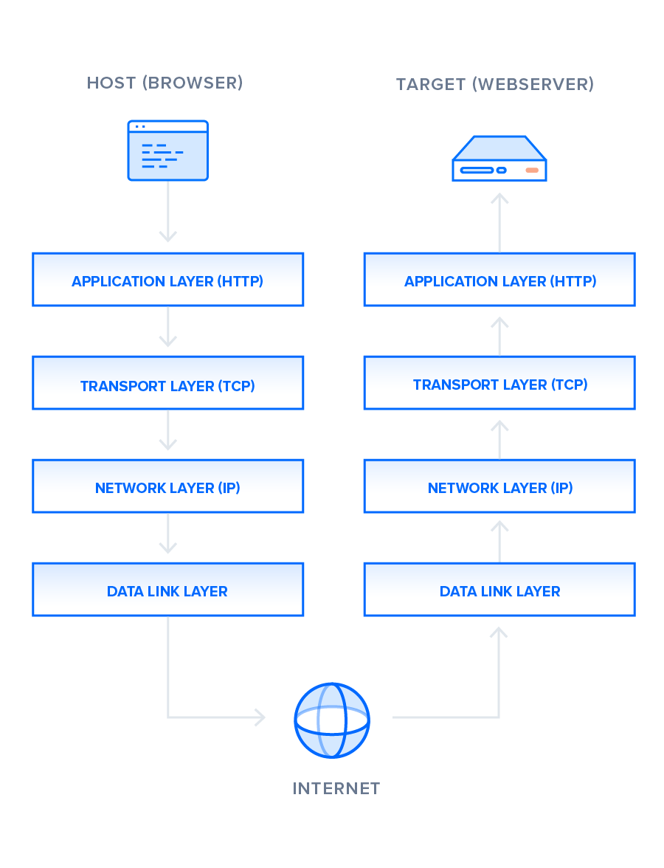

**HTTP\2:** From a technical point of view, one of the most significant features that distinguish HTTP/1.1 and HTTP/2 is the binary framing layer, which can be thought of as a part of the application layer in the internet protocol stack. As opposed to HTTP/1.1, which keeps all requests and responses in plain text format, HTTP/2 uses the binary framing layer to encapsulate all messages in binary format, while still maintaining HTTP semantics, such as verbs, methods, and headers. An application level API would still create messages in the conventional HTTP formats, but the underlying layer would then convert these messages into binary. This ensures that web applications created before HTTP/2 can continue functioning as normal when interacting with the new protocol.

The conversion of messages into binary allows HTTP/2 to try new approaches to data delivery not available in HTTP/1.1, a contrast that is at the root of the practical differences between the two protocols. The next section will take a look at the delivery model of HTTP/1.1, followed by what new models are made possible by HTTP/2.