Shoppy-globe-backend

Git hub link: <https://github.com/AnuragEnnippissery/Shoppy-Globe-backend>

Git hub link (frontend) : <https://github.com/AnuragEnnippissery/Shoppy-Globe>

Thunderclient screenshots

User registration

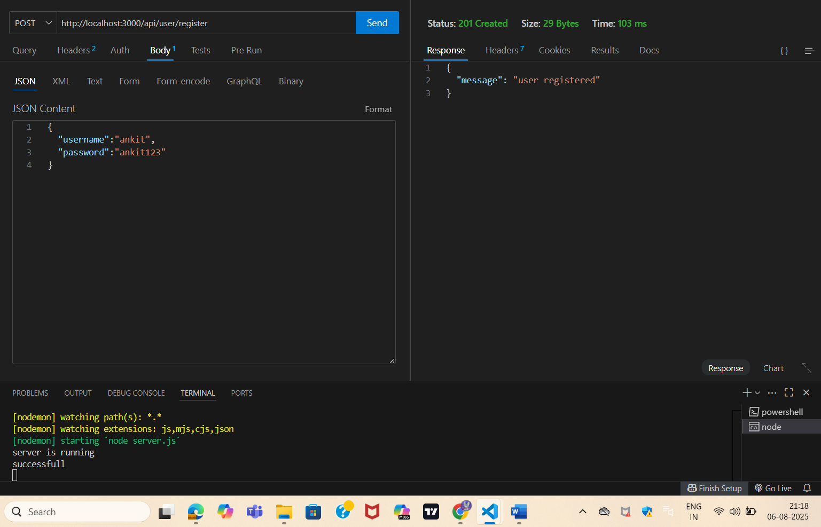

Login user

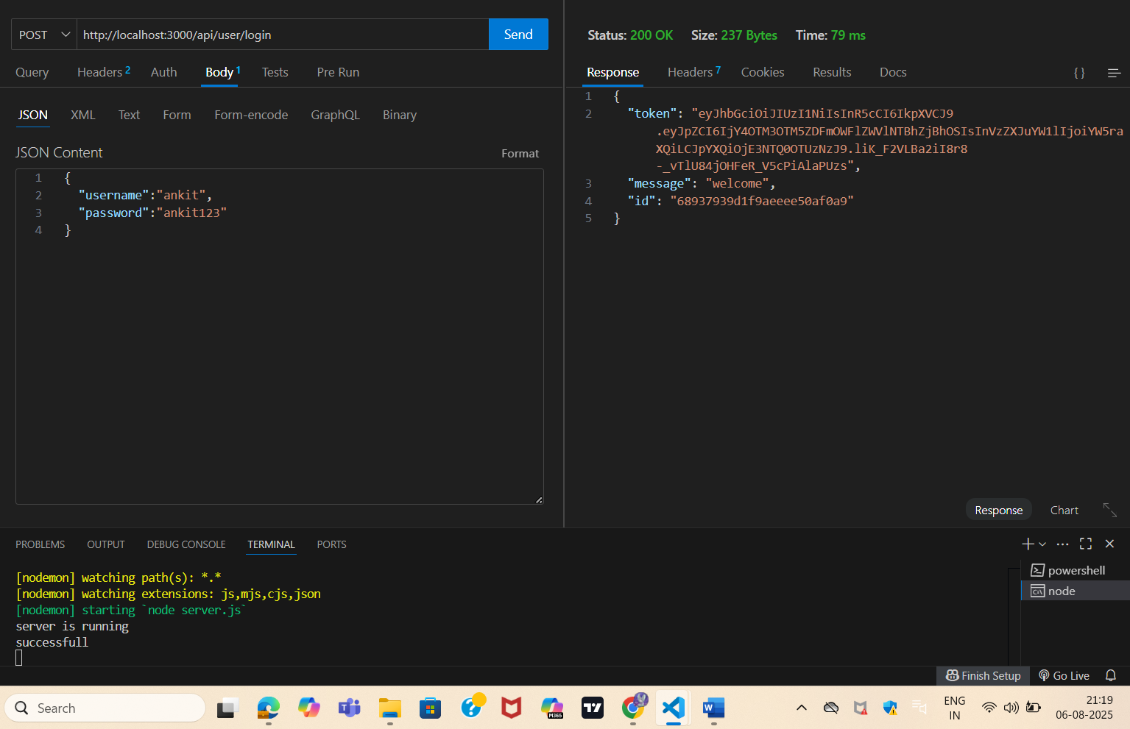

Adding product to cart

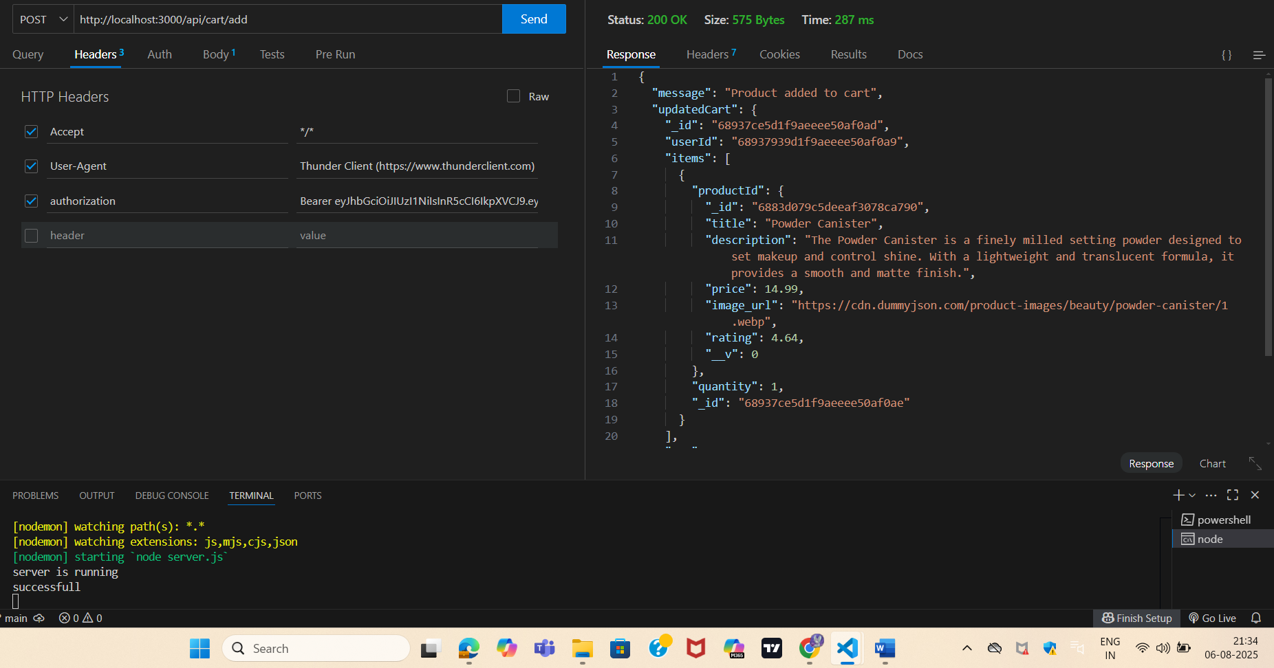

Incremented the product in the cart   
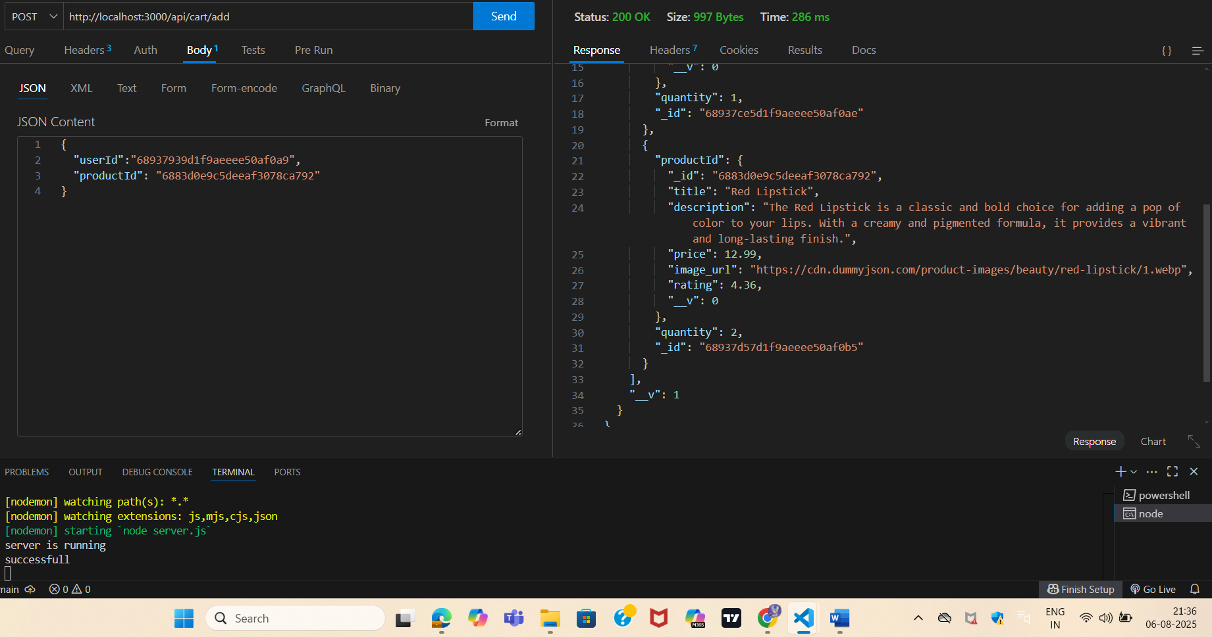

Decrement the product from the cart

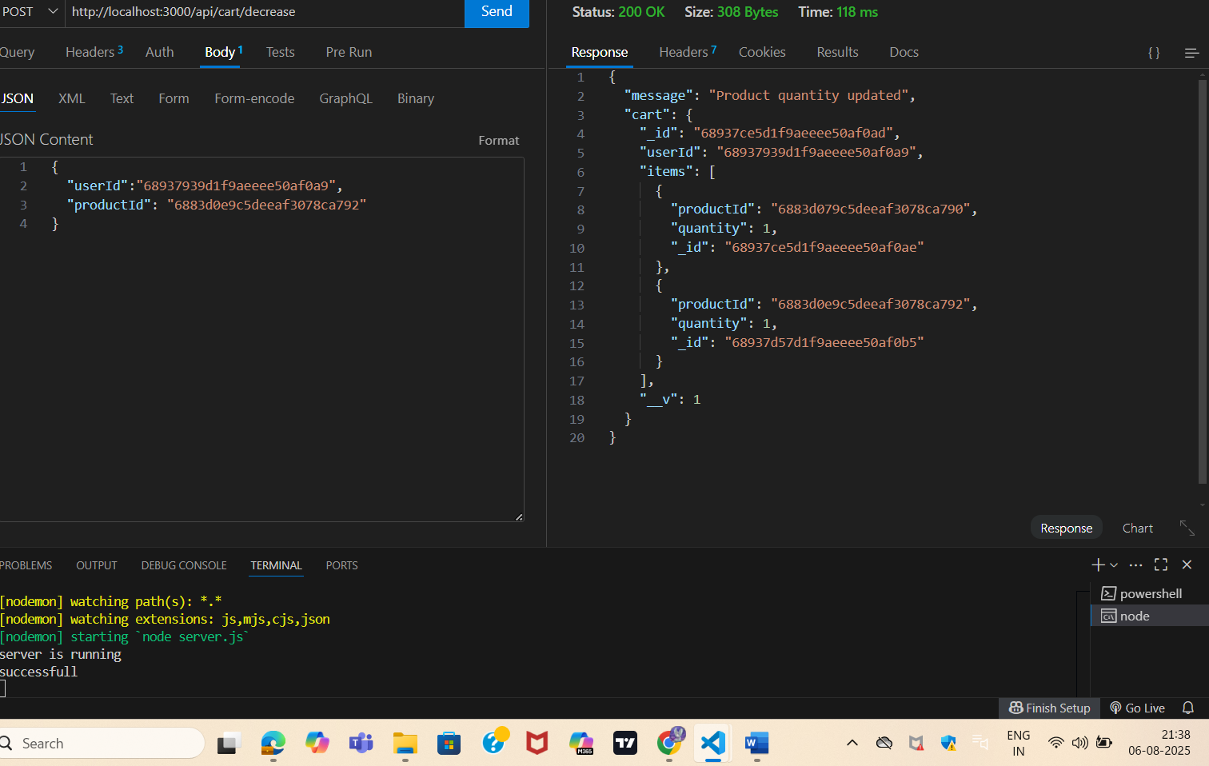

Fetching the whole cart

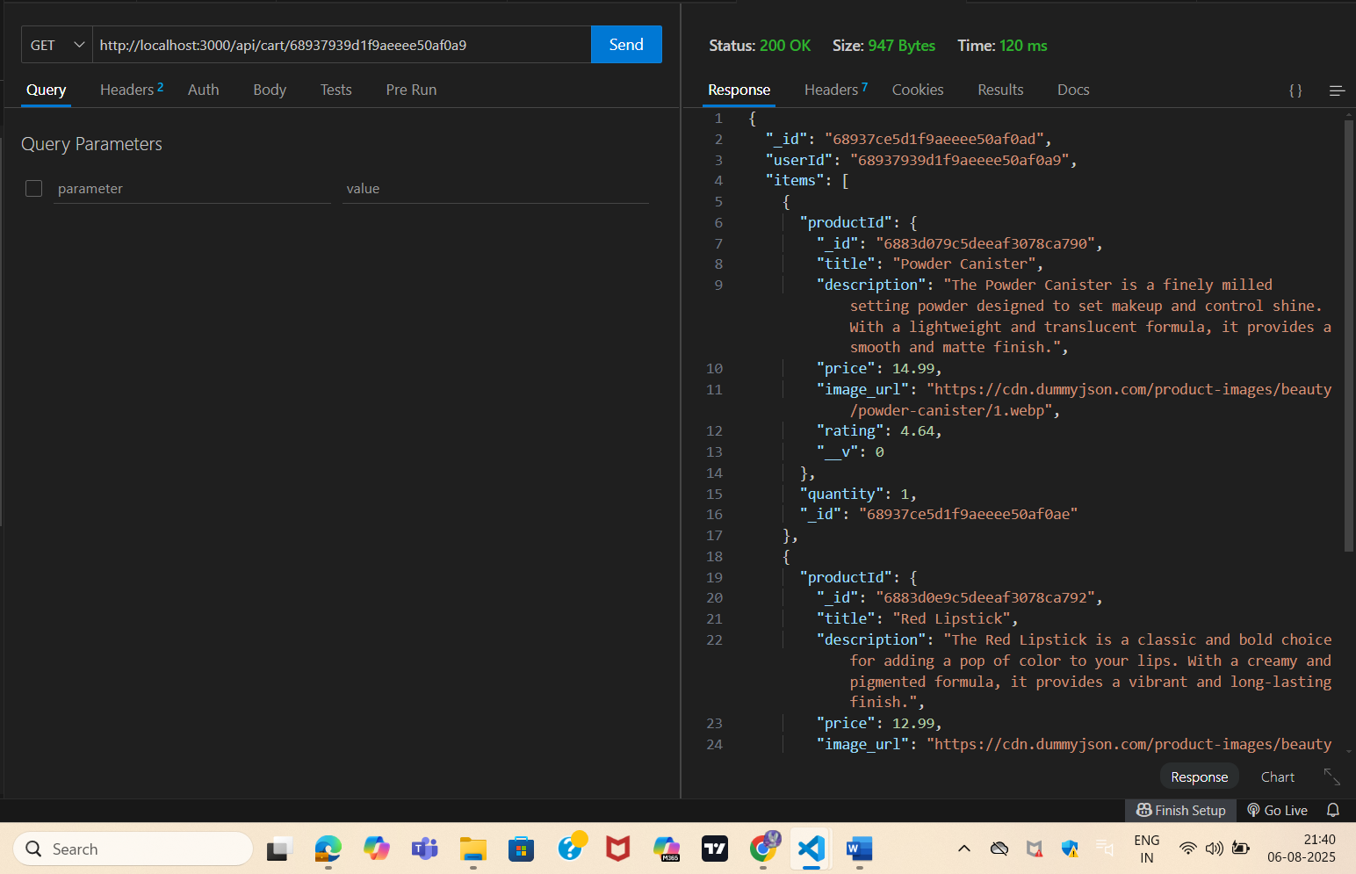

Deleting a product from the cart

