Single Sign-On (SSO) with Okta using SAML 2.0
Simplifying Access Management



Contents
1 Introduction of SSO 3
1.1 What is Single Sign On (SSO) 3
1.2 Advantage of SSO 3
2 Introduction to SAML 2.0 3
2.1 Explanation of SAML 2.0 3
2.2 Role of SAML in SSO 3
3 Understanding of OKTA 3
3.1 Introduction to OKTA 3
3.2 Key Aspects of OKTA as an Identity Provider (Idp) 3
3.3 Benefits of Using OKTA for SSO 3
4 Setting up SSO with OKTA 3
4.1 OKTA Identity Provider (IdP) Configuration 3
4.2 Service Provider (SP) Configuration 3
4.3 Initiating SSO 3

- Introduction of SSO:
1.1 What is Single Sign On (SSO):
Single Sign-On (SSO) is an authentication process that allows users to access multiple applications and services with a single set of login credentials. Instead of needing a separate username and password for each application, users log in once, typically using a username and password, and then gain access to a range of interconnected systems without the need to re-enter their credentials for each one.
The core concept of SSO Is to simplify the user experience and Improve security. This is achieved by centralizing authentication processes and utilizing secure protocols such as SAML (Security Assertion Markup Language), Oauth (Open Authorization) or OIDC.
1.2 Advantages of SSO:
Improved User Experience:
    - Users only need to remember one set of login credentials, making the authentication process more convenient and user-friendly.

    - Reduces the need to repeatedly enter usernames and passwords, which can be cumbersome and time-consuming.
Enhanced Productivity:
    - SSO reduces the time and effort spent on managing multiple usernames and passwords, allowing users to access applications and resources more quickly.

    - This productivity gain is particularly valuable in organizations with a large number of applications.
Enhanced Security:
    - Centralized authentication and user management provided by SSO can improve security by enforcing strong authentication methods and access control.

    - Reduces the likelihood of users resorting to weak or easily guessable passwords.

Password Fatigue:
    - Users often struggle with password fatigue, which leads to password reuse and weak security practices. SSO mitigates this issue by simplifying authentication.
Centralized Identity Management:
    - Organizations can manage user identities and access control from a single point, simplifying user provisioning, deprovisioning, and role management.
Compliance and Auditing:
    - SSO solutions often include reporting and auditing features, helping organizations maintain compliance with security and privacy regulations.

    - Easily track user access and behavior for security and regulatory purposes.
Streamlined IT Administration:
    - IT departments benefit from reduced administrative overhead as they can manage user access and accounts in one place.

    - Simplifies onboarding and offboarding processes.
Single Logout (SLO):
    - SSO often includes Single Logout (SLO) functionality, enabling users to log out of all connected applications in one action, enhancing security and user convenience.

- Introduction to SAML 2.0:
SAML, which stands for Security Assertion Markup Language, is an open standard protocol used for exchanging authentication and authorization data between parties, primarily for enabling single sign-on (SSO) and identity federation.

2.1 Explanation of SAML:
Authentication and Authorization:
At its core, SAML is used to exchange information related to authentication and authorization. It allows one system, known as the Identity Provider (IdP), to assert the identity of a user to another system, known as the Service Provider (SP), and communicate the permissions or attributes associated with that user.
XML-Based Language:
SAML uses Extensible Markup Language (XML) as the format for encoding its messages. These XML-based SAML assertions and requests are sent between the IdP and SP in a secure and standardized way.
Single Sign-On (SSO):
SAML is widely used to enable SSO, where a user logs in once with a trusted identity provider and gains access to multiple connected applications without needing to re-enter credentials.

2.1 Role of SAML in SSO:
User Authentication:
When a user attempts to access an application or service (SP), the SP redirects the user to the IdP for authentication. The SP acts as a relying party in this context.
SAML defines a standardized SSO protocol for web-based SSO scenarios, such as the Web Browser SSO protocol. The protocol includes request-response exchanges that enable the user to authenticate with the IdP.

Generation of SAML Assertions:
After successful user authentication, the IdP generates SAML assertions. These assertions contain information about the user's identity, attributes, and authentication status.
SAML assertions are XML-based statements and are digitally signed by the IdP to ensure their integrity.
Secure Transmission of Assertions:
SAML specifies secure transmission methods for assertions, typically using bindings like HTTP Redirect or HTTP POST. These bindings ensure that SAML assertions are transmitted in a secure and standardized manner between the IdP and the SP.
Assertion Verification:
Upon receiving the SAML assertion, the SP validates the assertion's digital signature to ensure its authenticity and integrity. If the assertion is valid, the SP proceeds with user access.
User Access to Multiple Services:
With the validated SAML assertion, the user gains access to the SP without needing to enter additional login credentials. This is the essence of SSO. The user's session is established with the SP.

- Understanding OKTA:

3.1 Introduction to Okta:
Okta is a cloud-based Identity Provider that provides a comprehensive set of services and tools for managing user identities, ensuring secure access to applications, and simplifying authentication and authorization processes. It is designed to help organizations of all sizes address identity and security challenges, enhance user experiences, and strengthen access control.

3.2 Key Aspects of OKTA as an Identity Provider:
Single Sign-On (SSO):
Okta is renowned for its Single Sign-On (SSO) capabilities, allowing users to log in once and access multiple applications without the need to remember and re-enter credentials. This streamlines the user experience and reduces password fatigue.
User Directory and Lifecycle Management:
Okta serves as a centralized user directory where organizations can store and manage user profiles, group memberships, and attributes. It simplifies user provisioning, deprovisioning, and user lifecycle management.
Multi-Factor Authentication (MFA):
Okta supports various MFA methods, including SMS, email, push notifications, and hardware tokens. This enhances security by requiring users to provide multiple authentication factors.
Fine-Grained Access Control:
Organizations can define detailed access control policies in Okta, ensuring that users have the appropriate level of access to resources. Access policies can be based on roles, groups, or specific attributes.
Extensive Integration Options:
Okta is compatible with a wide range of integration protocols, including SAML, OAuth, LDAP, SCIM, and more. Pre-built integrations and connectors are available for popular applications and platforms.

Security and Compliance:
Okta adheres to leading security and compliance standards, including SOC 2, HIPAA, GDPR, and more. It offers continuous monitoring, threat detection, and security enhancements to protect user identities and data.
Developer-Friendly Platform:
Okta provides a developer-friendly platform with APIs, SDKs, and developer tools, enabling customization and extension of its functionality. Developers can build custom authentication flows and integrate Okta into applications and systems.
Reporting and Monitoring:
Okta offers reporting and monitoring capabilities that allow administrators to track user activity, access patterns, and security events. Administrators can generate reports and set up alerts for suspicious activities.

3.3 Benefits of Using Okta for SSO:
- Improved user experience
- Enhanced security
- Centralized identity management
- Compatibility with a wide range of applications

- Setting Up SSO with OKTA:
Setting up Single Sign-On (SSO) with Okta involves configuring Okta as the Identity Provider (IdP) and integrating it with Service Provider (SP).
The process typically includes the following stages:
4.1 Okta Configuration
Log In to Okta:
Access the Okta Admin Console by logging in with your administrative credentials.
Add the Application:
    - Navigate to the "Applications" tab and click "Add Application."
    - Search for or select the application for which you want to set up SSO.
Application Setup:
Follow the setup wizard for the selected application. This typically includes specifying application-specific settings and options.
SAML Configuration:
Set up the SAML 2.0 integration for the application. This involves configuring SAML settings, such as the Identity Provider (IdP) entity ID, SAML endpoint URLs, and the IdP certificate.
Attribute Mapping:
Map user attributes in Okta to match the attributes expected by the application. This ensures that user data is correctly passed in SAML assertions.
Testing and Validation:
Conduct thorough testing to ensure that the SSO configuration is working as expected. Test both the SSO initiation and Single Logout (SLO), if supported.
User Assignment:
Assign users or groups to the application in Okta to grant them access. You can use Okta's user and group management features for this.
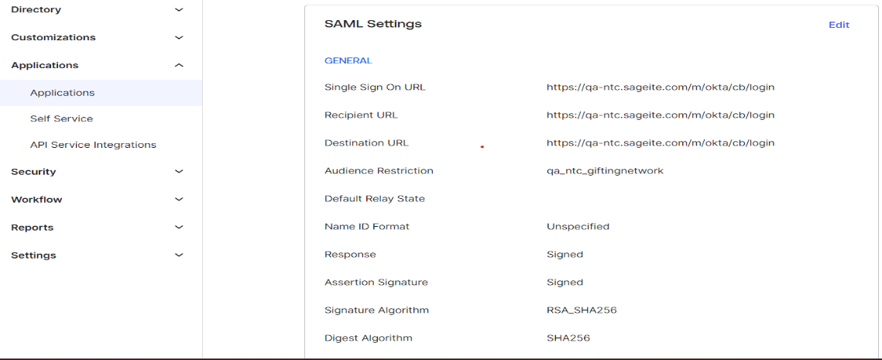
Idp (OKTA) Configuration

4.2 Service Provider Configuration:
Setting up a Service Provider (SP) to accept SAML assertions involves configuring the SP to recognize and process SAML assertions received from an Identity Provider (IdP) like Okta.
Below is an overview of the typical steps to set up the SP for SAML integration:

SAML Configuration in the SP:
Access the administrative interface or configuration settings of your SP application.
Look for the SAML settings or SAML configuration section. The location and options may vary based on the application.
Metadata Import:
If your IdP provides a SAML metadata file, you can import it into your SP configuration. Metadata contains key information about the IdP, making the setup process more efficient.

SAML Integration:
Start the SAML integration process by providing the necessary information received from the IdP (e.g., Okta). This information typically includes:
    - IdP Entity ID: A unique identifier for the IdP.
    - Single Sign-On URL (SSO URL): The endpoint to which SAML requests should be sent.
    - Single Logout URL (SLO URL): The endpoint for Single Logout (if supported).
    - X.509 Certificate: The IdP's public key certificate for verifying the digital signature on SAML assertions.
Attribute Mapping:
Configure the attribute mapping settings in the SP to define how user attributes provided in SAML assertions should be mapped to user profiles or roles within your application.
ACS (Assertion Consumer Service) URL:
Define the Assertion Consumer Service (ACS) URL in the SP configuration. This is the endpoint where the SP expects to receive SAML response.

Security Settings:
Configure security settings, including settings for verifying the digital signature on incoming SAML assertions.
Set up your SP's certificate for SAML message signing if required.
Error Handling:
Implement error handling mechanisms to deal with potential issues during SAML response processing. This includes scenarios where the SP receives an invalid response or the IdP is temporarily unavailable.
Testing:
Before making SSO live, conduct thorough testing to ensure the SP can correctly process SAML response from the IdP. This includes both authentication and, if supported, Single Logout (SLO).
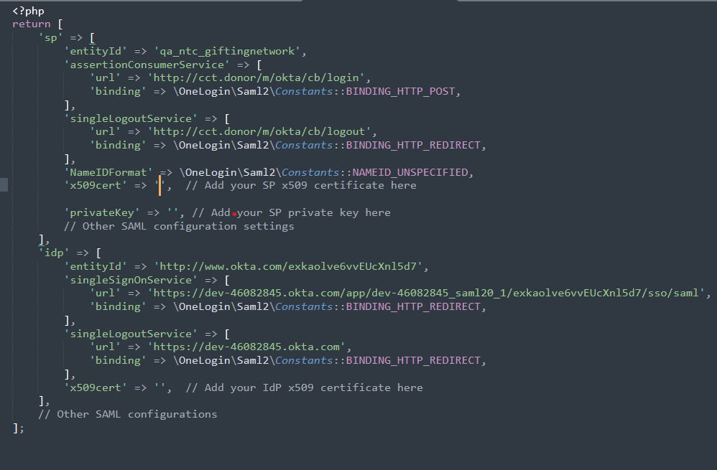
SP Configuration
4.3 Initiating SSO:
Single Sign-On (SSO) can be initiated in different ways, depending on the context and the technology being used.
There are generally two main types of SSO initiation:
- Service Provider (SP)-Initiated SSO:
- Identity Provider (IdP)-Initiated SSO:

Identity Provider (IdP)-Initiated SSO:
Identity Provider (IdP)-Initiated SSO is a method of authentication where the authentication process is initiated by the Identity Provider, allowing users to access multiple services or applications after a single login at the IdP's portal without needing to re-enter their credentials.

User Access to IdP Portal:
The SSO process begins when a user accesses a portal or webpage provided by the IdP. This portal serves as a centralized authentication and access point.
User Authentication:
The user is prompted to authenticate with the IdP. This typically involves providing their username and password.

SAML Response Generation:
After successful authentication, the IdP generates a SAML response containing authentication details.
SAML Response Sent to the SP:
The IdP sends the SAML Response to the Service Provider (SP). The SP is responsible for authenticating and authorizing the user for that specific application.
SAML Response Validation:
SP validates the received SAML Response to ensure its authenticity and integrity.
Verification includes checking the digital signature on the assertion and confirming that it was issued by a trusted IdP.

User Access Granted:
If the SAML assertion is valid, the SP grants the user access to the requested application. The user is now authenticated and authorized to use the application without having to enter separate login credentials.

