Laravel Naming Conventions
Laravel naming conventions dictate consistent and clear naming patterns for various elements in the framework.
Laravel Naming Conventions Table of contents

- Variables
- Naming database Tables
2.1 Tables
2.2 Table Columns Names
2.3 Primary Key
2.4 Foreign Keys
- Controllers
1.1 Naming Controllers
1.2 Method Naming Conventions in Controllers
- Models
2.1 Naming Models
2.2 Model Properties
2.3 Model Methods
- Blade Views
- Traits

- Variables:

- Normal variables should typically be in camelCase, with the first character lower case.
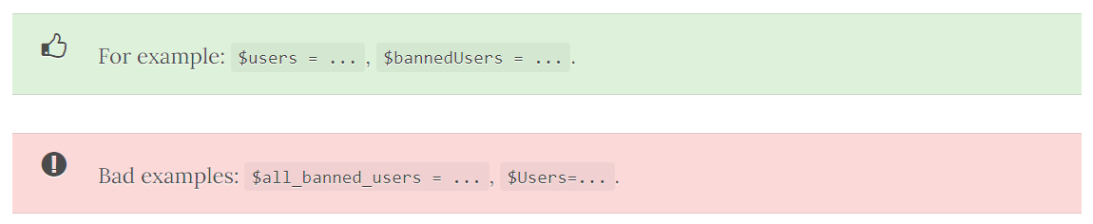
- If the variable contains an array or collection of multiple items then the variable name should be in plural. Otherwise, it should be in singular form.
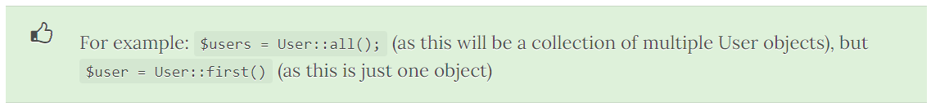

- Naming database Tables in Laravel:

- DB tables should be in lower case, with underscores to separate words (snake_case), and should be in plural form.
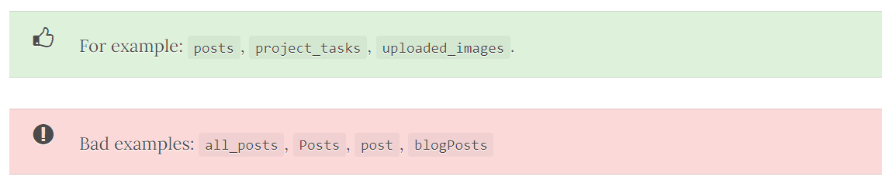
  - Tables:

- Pivot tables should be all lower case, each model in alphabetical order, separated by an underscore (snake_case).
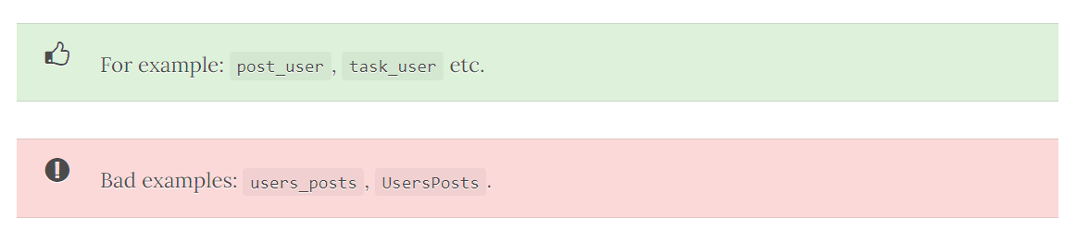
  - Table Columns Names:

- Table column names should be in snake_case (underscores between words) - in lower case. You shouldn't reference the table name.
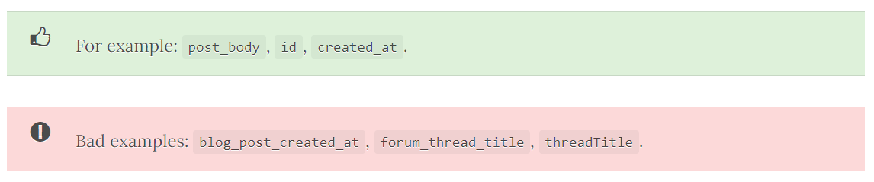

  - Primary Key:

- This should normally be id.

  - Foreign Key:

- Foreign keys should be the model name (singular), with '_id' appended to it (assuming the PK in the other table is 'id').
- Controllers:

  - Naming Controllers

- Controllers should be in PascalCase/CapitalCase.
- They should be in singular case, no spacing between words, and end with "Controller".
- Also, each word should be capitalised (i.e. BlogController, not blogcontroller).
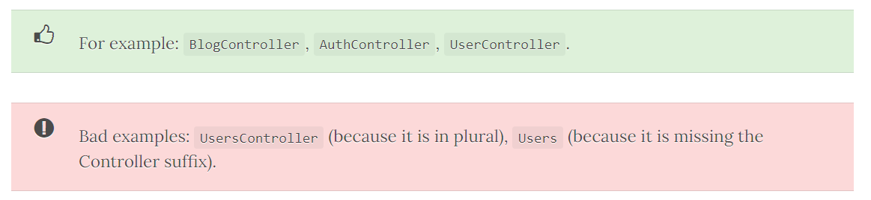
  - Method Naming Conventions in Controllers

- These should follow the same rules as model methods. I.e. camelCase (first character lowercase).
- In addition, for normal CRUD operations, they should use one of the following method names.
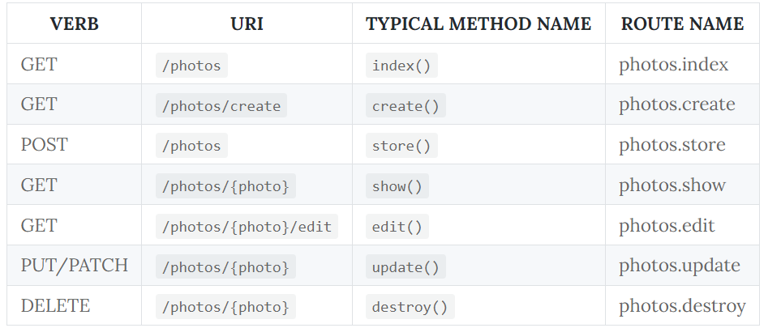

- Models:

  - Naming Models:

- A model should be in PascalCase/CapitalCase. They should be in singular, no spacing between words, and capitalised.
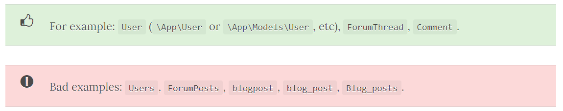
- Generally, your models should be able to automatically work out what database table it should use from the following method:
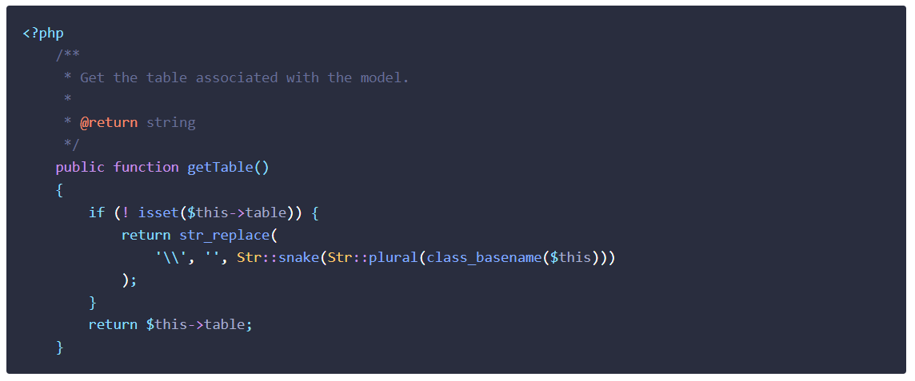
- But of course you can just set $this->table in your model. See the section below on table naming conventions.

- I recommend that you create models and migrations at the same time by running php artisan make:model -m ForumPost. This will auto-generate the migration file (in this case, for a DB table name of 'forum_posts').

  - Model Properties:

- These should be lower case, snake_case. They should also follow the same conventions as the table column names.
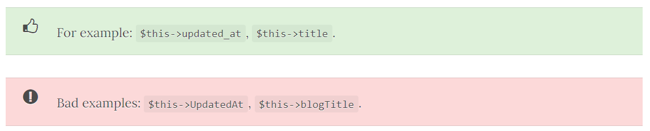
  - Model Methods

- Methods in your models in Laravel projects, like all methods in your Laravel projects, should be camelCase with the first character lower case.
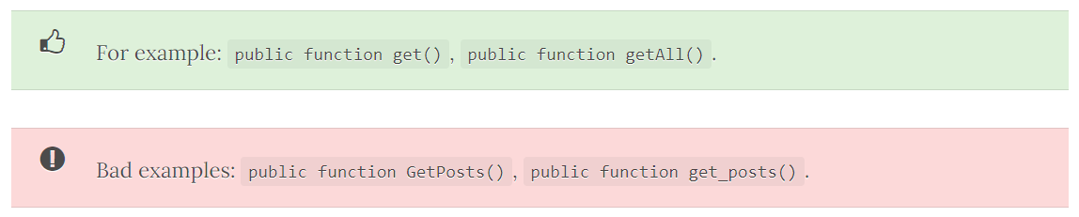
- Blade Views:

- Blade files should be in lower case, snake_case (underscore between words)
- Traits:

- Traits should be be adjective words

