Laravel Naming Conventions
Version 1.0


Laravel naming conventions dictate consistent and clear naming patterns for various elements in the framework.

Table of Contents
1. Variables: 3
2. Naming database Tables in Laravel: 3
2.1 Tables 3
2.2 Table Columns Names 4
2.3 Primary Key 4
2.4 Foreign Key 4
3. Controllers: 4
3.1 Naming Controllers 4
3.2 Method Naming Conventions in Controllers 4
4. Models: 5
4.1 Naming Models: 5
4.2 Model Properties: 6
4.3 Model Methods 6
5. Blaid Views 6
6. Traits 7

Variables:

Normal variables should typically be in camelCase, with the first character lower case.
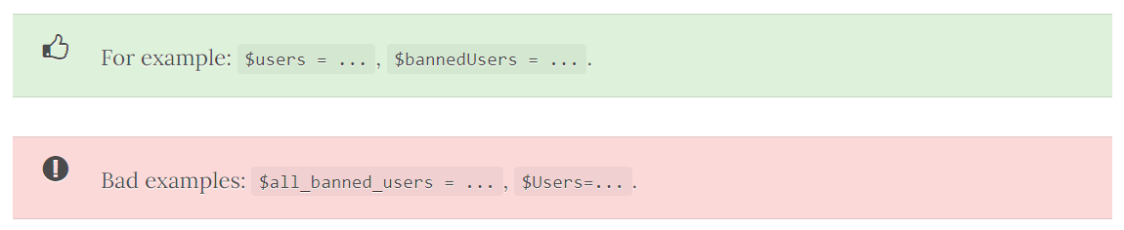
If the variable contains an array or collection of multiple items then the variable name should be in plural. Otherwise, it should be in singular form.
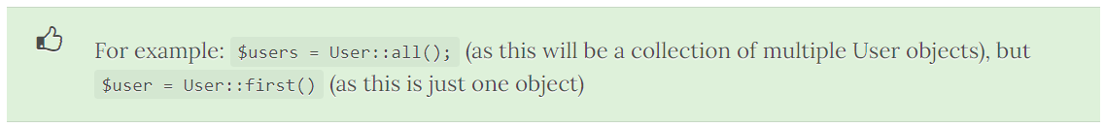

Naming database Tables in Laravel:

DB tables should be in lower case, with underscores to separate words (snake_case), and should be in plural form. 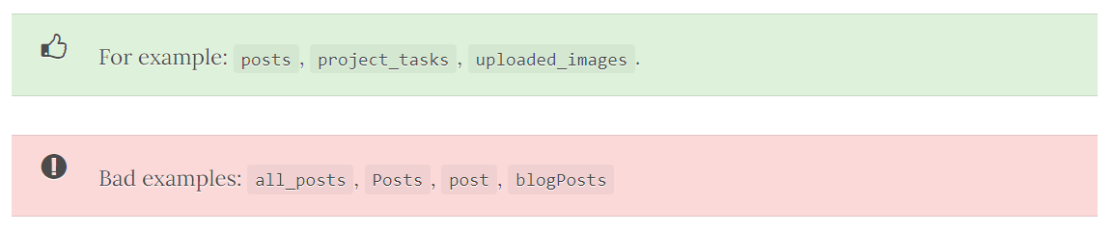

2.1 Tables
- Pivot tables should be all lower case, each model in alphabetical order, separated by an underscore (snake_case).
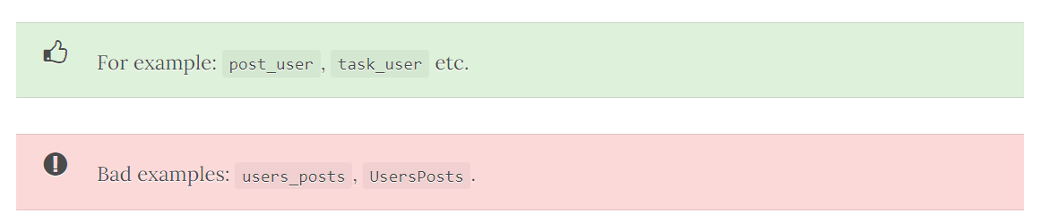

2.2 Table Columns Names
- Table column names should be in snake_case (underscores between words) - in lower case. You shouldn't reference the table name.
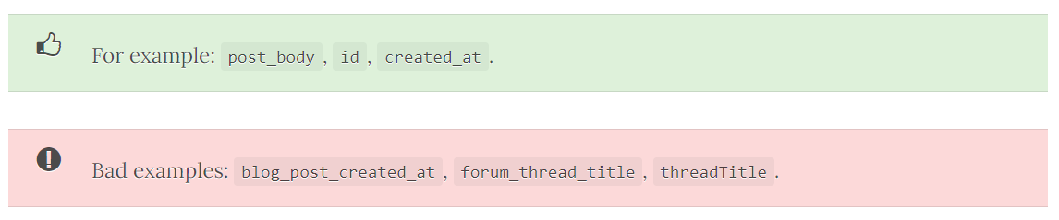

2.3 Primary Key
- This should normally be id.

2.4 Foreign Key
- Foreign keys should be the model name (singular), with '_id' appended to it (assuming the PK in the other table is 'id').

Controllers:

3.1 Naming Controllers
- Controllers should be in PascalCase/CapitalCase.
- They should be in singular case, no spacing between words, and end with "Controller".
- Also, each word should be capitalised (i.e. BlogController, not blogcontroller).
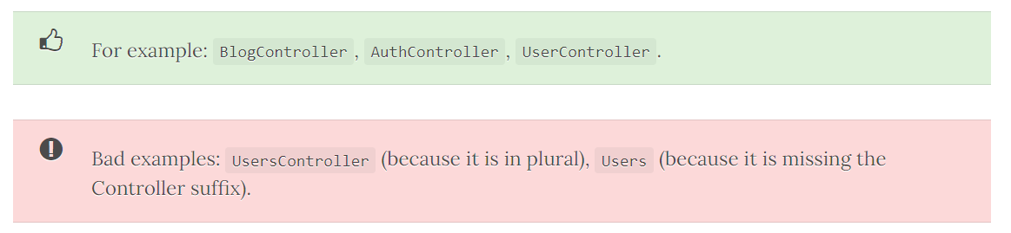

3.2 Method Naming Conventions in Controllers
- These should follow the same rules as model methods. I.e. camelCase (first character lowercase).
- In addition, for normal CRUD operations, they should use one of the following method names.
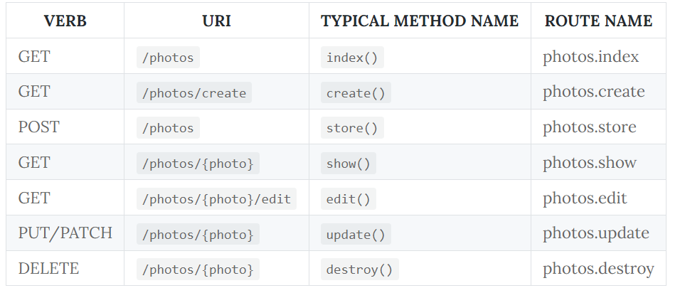

Models:

4.1 Naming Models:
- A model should be in PascalCase/CapitalCase. They should be in singular, no spacing between words, and capitalised.
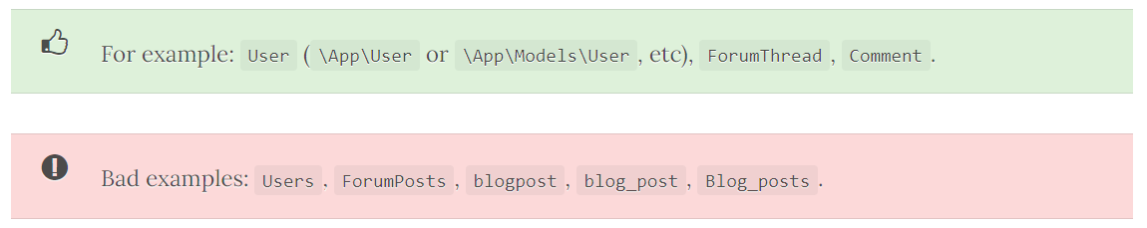
- Generally, your models should be able to automatically work out what database table it should use from the following method:
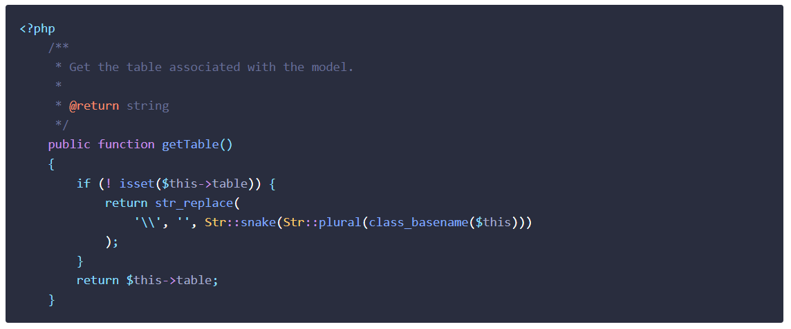
- But of course, you can just set $this->table in your model. See the section below on table naming conventions.

- I recommend that you create models and migrations at the same time by running php artisan make:model -m ForumPost. This will auto-generate the migration file (in this case, for a DB table name of 'forum_posts').

4.2 Model Properties:
- These should be lower case, snake_case. They should also follow the same conventions as the table column names.
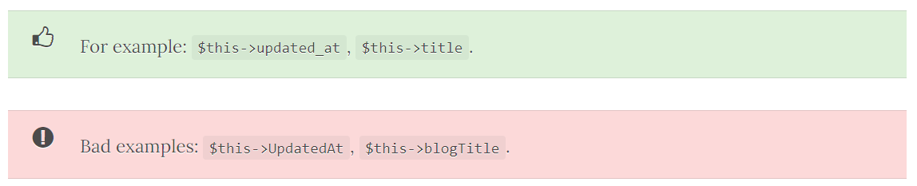

4.3 Model Methods
- Methods in your models in Laravel projects, like all methods in your Laravel projects, should be camelCase with the first character lower case.
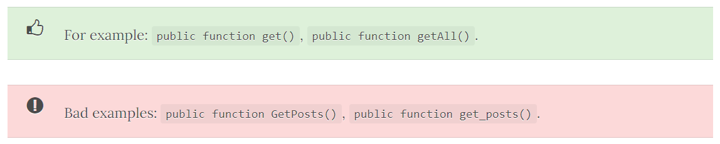

Blaid Views
- Blade files should be in lower case, snake_case (underscore between words)

Traits
- Traits should be adjective words

