Focus Financial Partners (FFP) Advisor Dashboard
Version 1.0



Contents
- Dashboard----------------------------------------------------------------------------------------------------------2
1.1. Objective of FA Dashboard: 3
1.2. Fund Balance : 5
1.2.1 Top Five Fund Balance: 5
1.2.2 Explore More: 5
1.3. Tickets : 7
1.3.1 Five Most Recently Opened Tickets: 7
1.3.2 Explore More: 7
1.4. Grants : 9
1.4.1 Top Five Grants: 7
1.4.2 Explore More: 7
1.5. Gifts : 9
1.5.1 Top Five Gifts: 7
1.5.2 Explore More: 7
2. Service Tickets-------------------------------------------------------------------------------------------------------7
3. Clients------------------------------------------------------------------------------------------------------------------7
3.1 Client Overview: 7
3.2 Client Profile: 7
4. Reports

- Dashboard:

Objective of FA Dashboard:
A Financial Advisor Dashboard aims to be a one-stop platform for advisors to quickly understand and manage their clients' finances. It provides a clear snapshot of key metrics, aiding advisors in making informed decisions, monitoring investments, and tracking progress towards financial goals.

Fund Balance:

2.1 Top Five Fund Balance:
The Financial Advisor Dashboard highlights the top five funds along with their fund balances in descending order by fund balance. This feature allows advisors to swiftly identify the most substantial contributions, aiding strategic decision-making and resource management.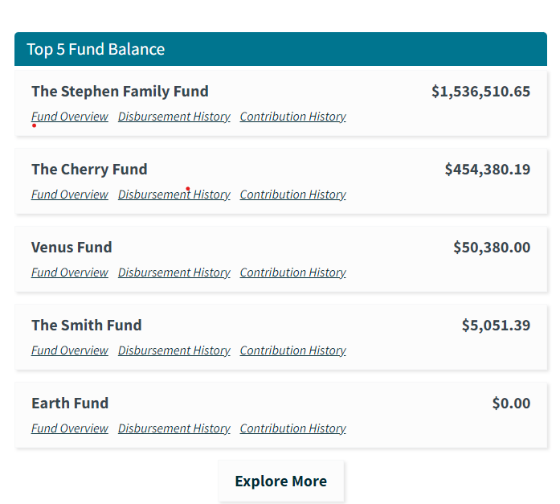

2.2 Explore More:
Upon clicking the "Explore More" button, a new page opens with the following details
- Highlights all funds related to financial advising, arranged in descending order based on their fund balances.
- Displays each fund along with its corresponding balance, emphasized through a graphical representation.
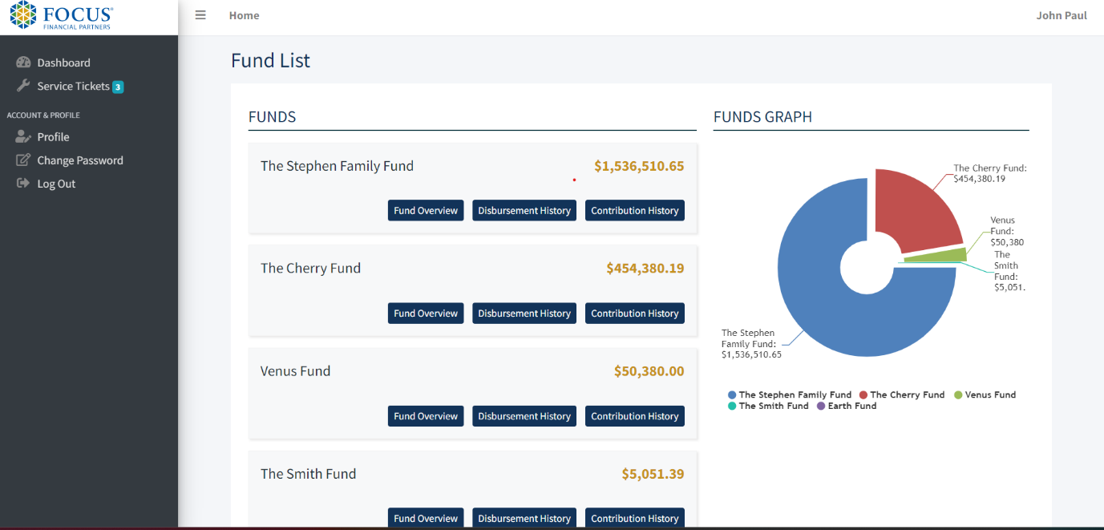

Tickets:

3.1 Five Most Recently Opened Tickets:
The Financial Advisor Dashboard highlights the five most recently opened tickets, providing details such as ticket type, priority, and creation date. Additionally, action buttons for editing, viewing, and deleting are available, enabling advisors to review details, make edits, and delete tickets as needed.
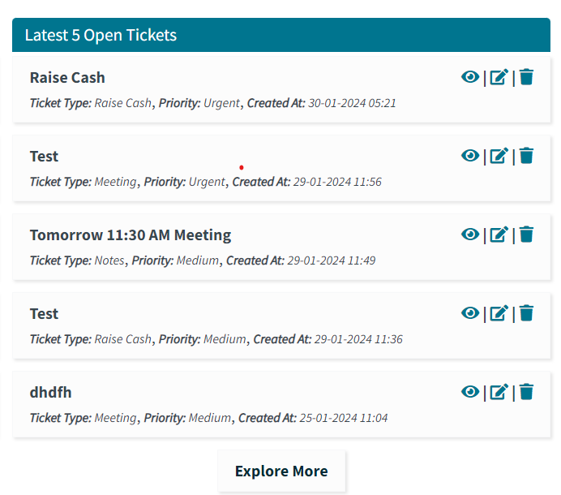

3.2 Explore More:
Upon clicking the "Explore More" button, a new page opens with the following details
- The ticket page showcases all tickets, including key details like type, priority, and creation date. Advisors can efficiently manage tickets with accessible action buttons for editing, viewing, and deleting, along with filters for status, priority, and ticket type for enhanced organization.

- Display tickets graphically based on their status, and ensure that the graph refreshes with each action taken on the page.
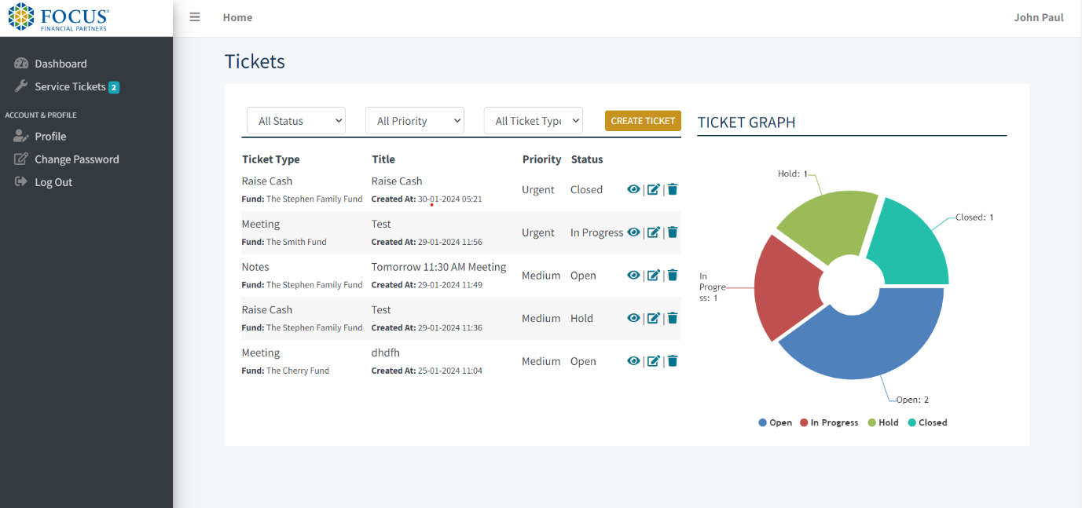

Grants:

4.1 Top Five Grants:
The Financial Advisor Dashboard highlights the top five funds and their grants in descending order, showcasing those with the most grant recommendations in the last 30 days.
Explanation:
- Each fund has a '+' icon that, when clicked, reveals a list of organizations and amounts, displaying entities receiving recommendations from that fund.
- Similarly, each organization has a '+' icon that, when clicked, displays a list of donors and amounts, showcasing entities providing grant recommendations to that organization.

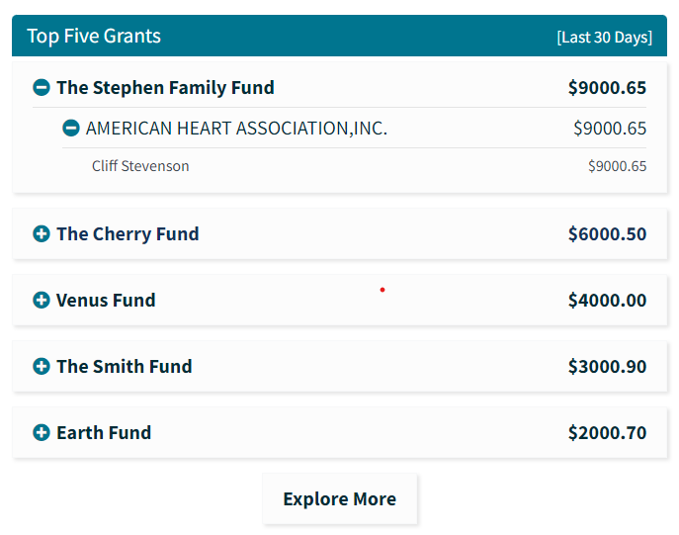

4.2 Explore More:
Upon clicking the "Explore More" button, a new page opens with the following details
- The Financial Advisor displays all funds and their grants in descending order, showcasing those with the most grant recommendations by default for the last 30 days.
- Advisors can categorize grants by Fund, Organization, and Donor.
- Advisors can categorize grants based on predefined periods (last 30 days, last month, last 3 months, last 6 months, last 1 year) or choose custom dates.
- Display all funds with their corresponding grants in a graph based on the applied filters.
- Clicking the '+' icon for each fund reveals a list of organizations with corresponding amounts, displaying entities receiving recommendations. The graph refreshes to show these organizations and amounts.
- Similarly, clicking the '+' icon for each organization reveals a list of donors with their corresponding grants, displaying entities offering grant recommendations. The graph refreshes to display these donors and grants.

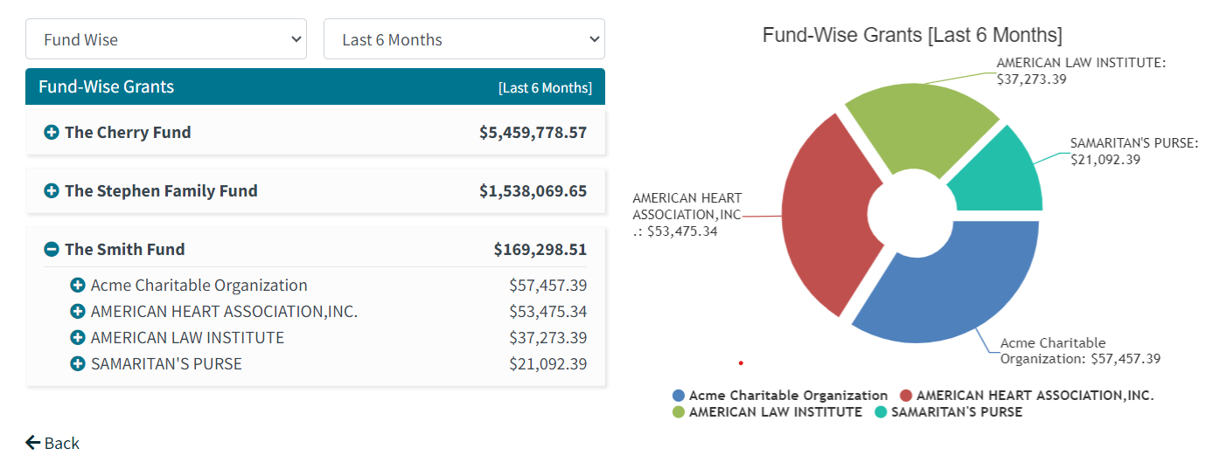

Gifts:

5.1 Top Five Gifts:
The Financial Advisor Dashboard highlights the top five funds and their contributions in descending order, showcasing those with the highest contribution in the last 30 days.
- Each fund has a '+' icon that, when clicked, displays a list of donors and amounts, showcasing entities contributing to that fund.
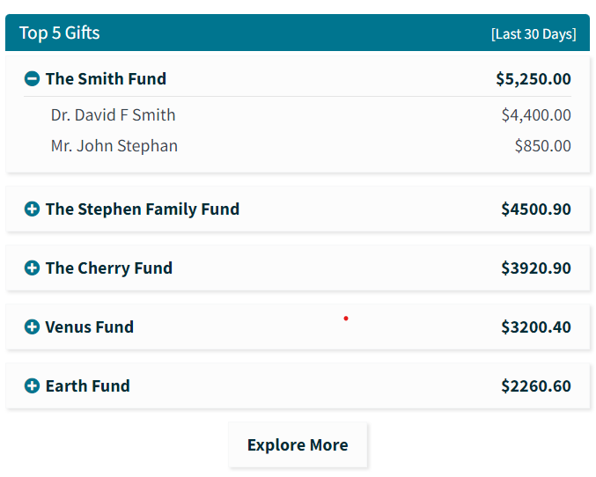

5.2 Explore More:
Upon clicking the "Explore More" button, a new page opens with the following details
- The Financial Advisor displays all funds and their contributions in descending order, showcasing those with the highest contributions by default for the last 30 days.
- Advisors can categorize contributions by Fund and Donor.
- Advisors can categorize contributions based on predefined periods (last 30 days, last month, last 3 months, last 6 months, last 1 year) or choose custom dates.
- Display all funds with their corresponding contributions in a graph based on the applied filters.
- Clicking the '+' icon for each fund reveals a list of donors with their corresponding contributions, displaying entities providing contributions. The graph refreshes to showcase these donors and contributions.
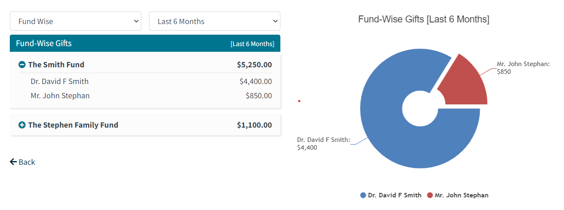
- Service Tickets:

- Clients:

3.1 Client Overview:
In the Client Section, display a list of clients associated with the logged-in advisor.
- The Advisor can view clients sorted by funds using a fund filter.
- On the client listing page, display client names, emails, and their last login times.
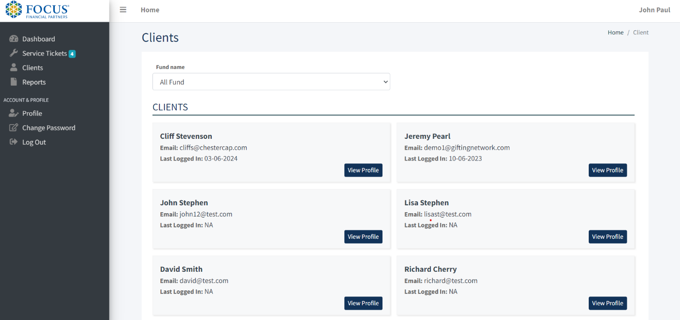

3.2 Client Profile:
Clicking on 'View Profile' opens a new page displaying client profile details and a list of their funds.
