ID CARD TEMPLATE

Front Side
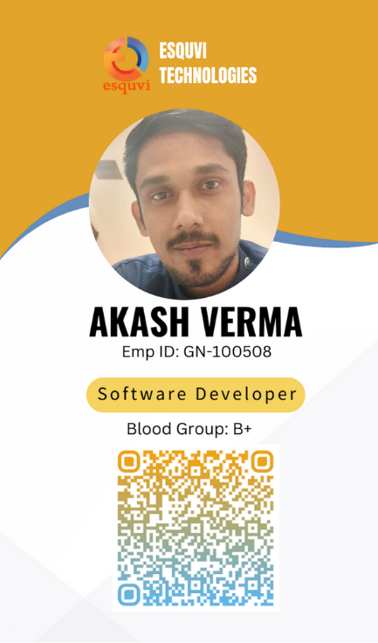

Back Side
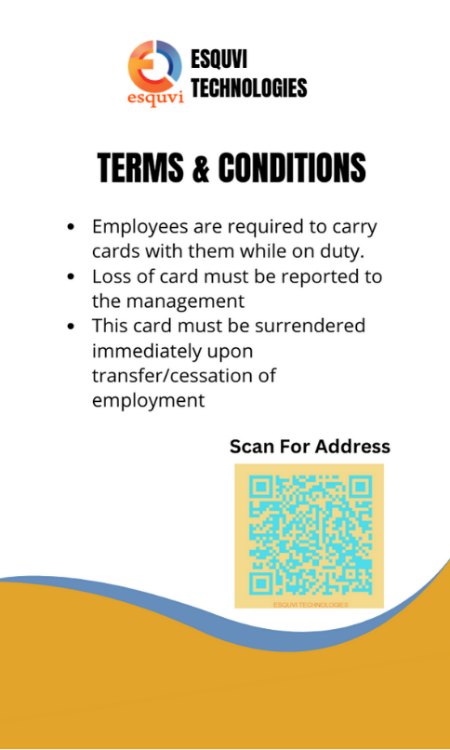

Front Side Details

Name: Pushyami Pullabhotla
Emp ID: GN-100506
Designation: Business Analyst
Blood Group: B+


Name: Lawkush Yadav
Emp ID: GN-100507
Designation: Software Engineer

Blood Group: B+

Name: Ashish Kumar
Emp ID: GN-100505
Designation: Quality Head
Blood Group: B+


Name: Akash Verma
Emp ID: GN-100508
Designation: Software Developer
Blood Group: B+


Name: Anurag Sinha
Emp ID: GN-100509
Designation: Software Developer
Blood Group: AB+


Name: Surya Jyoti Ashirwad
Emp ID: GN-100510
Designation: Software Developer
Blood Group: O+


Name: Rajan Kumar Tiwari
Emp ID: GN-100511
Designation: Senior Software Engineer
Blood Group: B+

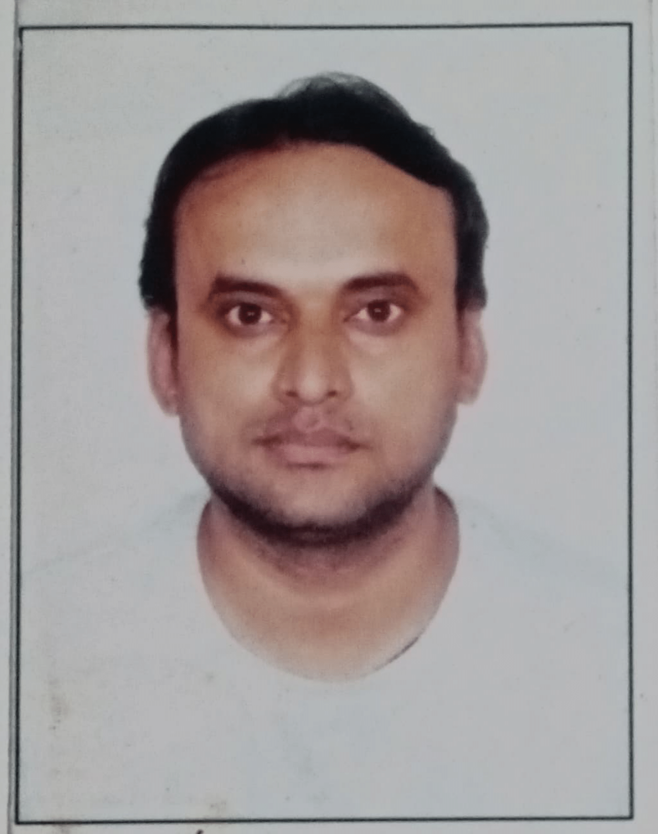
Name: Prashant Verma
Emp ID: GN-100513
Designation: Senior Software Developer
Blood Group: B+

Back Side Details
- Employees are required to carry cards with them while on duty.
- Loss of card must be reported to the management
- This card must be surrendered immediately upon transfer/cessation of employment

  - QR CODE FOR ADDRESS



  - LOGO



