` FOCUS FINANCIAL PARTNERS

Auto Ticket : Raise cash ticket to Advisor
When a donor creates grant recommendation but has insufficient funds in their account, ticket will be sent to the advisor to arrange the shortage amount.
Example:
If donor creates grant recommendation for $15,000 and have only $10,000 in their account, a ticket will be sent that there is a shortage of $5,000.
Implementations:
- Donor Side:
After adding a grant to the cart, “Proceed to Checkout”. Upon clicking 'Confirm & Submit' on the checkout page, internally verify if there's a fund shortage. If so, notify the advisor accordingly.
- Ticket Subject: Raise Cash.
- Message: Grant recommendation for an amount of $15,000 and have only $10,000 in The Smith Fund.

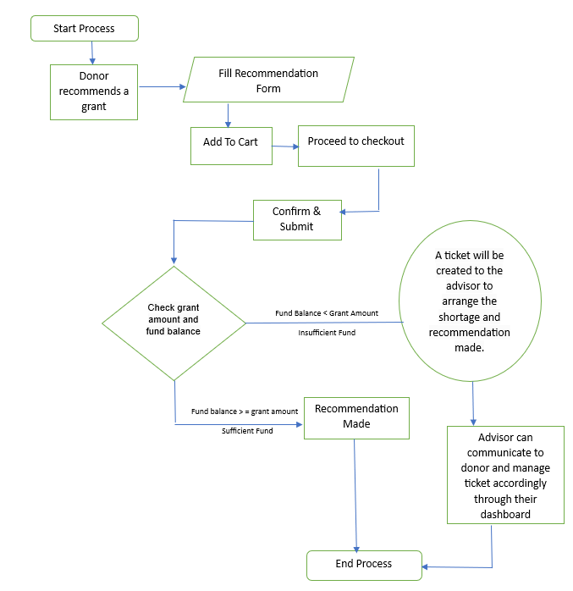

- Financial Advisor (FA) Side:
Raise cash ticket from donors will display on the financial advisor dashboard.
Each ticket includes ticket type, priority, creation time, with View, Edit, and Delete buttons.
View:
Click the "View" button to access ticket details on a new page.
- Our system supports two-way communication, allowing both advisors and donors to send and receive messages and share documents related to the ticket.
- You can check this checkbox to save records for your own purposes
- Clicking on the "Ticket History" button will display all the activities related to the particular ticket.
- The "Close" button is available to close the ticket.

Edit:
Click the "Edit" button to go to the edit page, where you can modify ticket details as needed.
Delete:
Clicking the delete button will soft remove the ticket.

Note: Check with Eric do we need to send any notification to donor for the same.

