Focus Financial Partners (FFP) Advisor Dashboard
Version 1.0

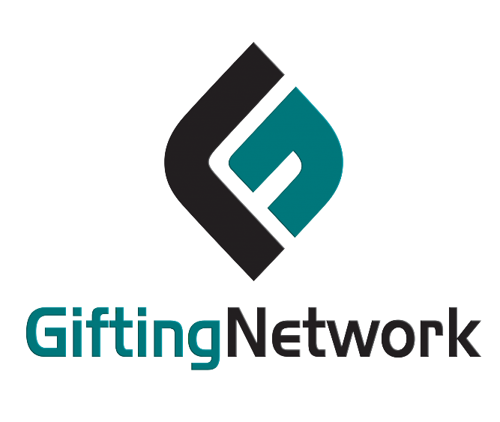

Contents

1. Dashboard: 3
1.1 Objective of FA Dashboard: 3
1.2 Fund Balance: 3
1.3 Tickets: 4
1.4 Grants: 6
1.5 Gifts: 7
2. Service Tickets: 9
3. Clients: 9
4. Report 10

Dashboard:

1.1 Objective of FA Dashboard:
A Financial Advisor Dashboard aims to be a one-stop platform for advisors to quickly understand and manage their clients' finances. It provides a clear snapshot of key metrics, aiding advisors in making informed decisions, monitoring investments, and tracking progress towards financial goals.

1.2 Fund Balance:
The Financial Advisor dashboard displays the top five funds by balance, helping advisors make strategic decisions and manage resources effectively.

Explore More:
Upon clicking the "Explore More" button, a new page opens with the following details.
- Highlights all funds related to financial advising, arranged in descending order based on their fund balances.
- Displays each fund along with its corresponding balance, emphasized through a graphical representation.

1.3 Tickets:
The Financial Advisor Dashboard shows the five latest tickets with type, priority, and creation date, providing buttons for editing, viewing, and deleting for simplified management.

Explore More:
Upon clicking the "Explore More" button, a new page opens with the following details.
- The ticket page displays all tickets with ID, subject, type, priority, status, and creation date, along with action buttons for easy management.
- Display tickets graphically based on their status, and ensure that the graph refreshes with each action taken on the page.
- Click "View" button to access ticket details on a new page.
- Our system supports two-way communication, enabling advisors and donors to exchange messages and attachments related to the ticket, with advisors able to add records for their own use.
- Use the "Close" button to close the ticket.
- Click "Ticket History" button to view all events related to this ticket.
- Click the "Edit" button to go to the edit page, where you can modify ticket details as needed.
- Clicking the “Delete” button will permanently remove the ticket.

1.4 Grants:
The Financial Advisor dashboard displays the top five funds and their grants in descending order, showcasing those with the most grant recommendations in the last 30 days.

- Clicking the '+' icon next to each fund shows organizations and amounts, displaying entities receiving recommendations from that fund.

- Similarly, clicking the '+' icon next to each organization displays a list of donors and amounts, showcasing entities providing grant recommendations to that organization.

Explore More:
Upon clicking the "Explore More" button, a new page opens with the following details.

- The Financial Advisor displays all funds and their grants in descending order based on the past 30 days.
- Advisors can sort grants by Fund, Organization, or Donor.
- Advisors can categorize grants by predefined periods or choose their own dates for sorting.
- Present all funds along with their associated grants in a graph based on the applied filters.

1.5 Gifts:
The Financial Advisor dashboard displays the top five funds and their contributions in descending order, showcasing those with the highest contribution in the last 30 days.

- Clicking the '+' icon next to each fund reveals a list of donors and their respective amounts, showcasing entities contributing to that fund.

Explore More:
Upon clicking the "Explore More" button, a new page opens with the following details.

- The Financial Advisor displays all funds and their contributions in descending order, showcasing those with the highest contributions by default for the last 30 days.
- Advisors can sort contributions by Fund or Donor.
- Advisors can categorize contributions by predefined periods or choose their own dates for sorting.
- Present all funds along with their associated contributions in a graph based on the applied filters.

Service Tickets:
The Service Ticket functionality for both Advisors and Donors includes features that improve communication, organization, and collaboration, making it easier to manage tasks effectively.
- Both advisors and donors have the option to create tickets, allowing them to initiate requests or report issues easily.
- Both advisors and donors can arrange tickets using search, type, priority, and status, making it easier to organize and find what they need.
- Display tickets graphically based on their status, and ensure that the graph refreshes with each action taken on the page.
- Click "View" button to access ticket details on a new page.
- Our system supports two-way communication, enabling advisors and donors to exchange messages and attachments related to the ticket, with advisors able to add records for their own use.
- Use the "Close" button to close the ticket.
- Click "Ticket History" button to view all events related to this ticket.
- Click the "Edit" button to go to the edit page, where you can modify ticket details as needed.
- Clicking the “Delete” button will permanently remove the ticket.

Clients:
In the Client Section, display a list of clients associated with the logged-in advisor.
- Advisors have the option to sort clients by fund.
- On the client listing page, display client names, emails, and their last login times.
- Clicking on 'View Profile' opens a new page displaying client profile details and a list of their funds.

Reports:
The report section in the advisor interface makes it easy to create and export CSV reports for four categories: Gift History, Grant History, Service Tickets, and Clients.

- Gift History:
The Gift History report gives a detailed record of gifts for the chosen fund, showing the gift date, donor information, amount, and any notes.

- Grant History:
This report gives an overview of the grant history for the selected fund. It includes details like the grant amount, recipient info, purpose, and important dates.

- Service Ticket:
The service ticket report gives a summary of service tickets related to the specified fund. It covers raised service requests, their status, assigned agents, resolution details, and timestamps.

- Clients:
This report focuses on the donors associated with the chosen funds. It provides a list of donors, along with their contact information, such as name, phone-number, email-address, gender and any relevant information of that contact.

