MANASTIK MEDICO
QA Testing Report
Android onboarding and verification testing

Candidate details
Field | Details
Name | Anurag Gupta
PRN | 22311959
College | Vishwakarma Institute of Information Technology, Pune
Branch | Information Technology
Application | Manastik Medico
Package | com.manastik.dadtmedico
Report date | 25 October 2026

GitHub repository: https://github.com/AnuragGupta2105/manastik-qa-automation

Purpose
This report records the test scenarios prepared, the app screens explored, the Maestro checks executed, and the evidence available at the time of writing. It separates confirmed automation results from scenarios that are defined but still need a recorded execution result.

1. Summary
Testing was performed on the supplied Android application using an emulator. The work produced nine manual test scenarios, six Maestro YAML flows, a README, a test-results log, a reusable bug-report template, and an initial GitHub commit. Three recorded automation checks passed for the verification-pending state. Because those checks overlap, they should not be counted as three independent end-to-end tests.
Area | Status at report time
Manual scenarios | 9 prepared (TC-01 to TC-09)
Maestro flows | 6 YAML files
Recorded PASS results | 3 screen-state assertion sets
Confirmed defects | No application bug claimed as confirmed
Automation coverage | Login/phone entry and verification-pending screen; full journey not automated
GitHub | Initial commit pushed to main

2. Objective and scope
The objective was to assess the onboarding path from the initial welcome/login screen through phone verification and the displayed verification status, while documenting input-validation and incorrect-OTP cases.
- Application launch and navigation to phone-number entry.
- Phone-number and OTP journey as captured in the manual evidence.
- Required personal details and professional-role selection.
- Onboarding progression, education/practice details, and required-field validation.
- Submission ending at the 'Verification in progress' screen.
- Expected error response for an incorrect OTP.

3. Test environment and tools
Component | Recorded details
OS / shell | Windows, PowerShell
Device | Android Emulator (emulator-5554)
Package | com.manastik.dadtmedico
App version | 3.21.5 (observed during setup)
Automation | Maestro CLI 2.11.0
Java | JDK 21
ADB | %LOCALAPPDATA%\Android\Sdk\platform-tools\adb.exe
Version control | Git and GitHub

4. Work completed
Workspace setup — Organized D:\Manastik-QA into tests, test cases, evidence, bug reports, README, and test results.
App exploration — Installed/opened the supplied APK in an emulator and inspected UI labels with Maestro hierarchy output.
Manual test design — Prepared TC-01 through TC-09 covering launch, phone entry, OTP, personal details, role selection, onboarding, practice details, submission, and incorrect OTP.
Automation — Created flows for welcome screen, phone entry, empty-phone interaction, app launch, verification-pending, and verification-status checks.
Execution log — Recorded three passing assertion sets; the log explicitly states that the pending-screen checks overlap.
Evidence — Collected screenshots of onboarding screens and console output; the proof document contains 13 embedded images.
Documentation — Prepared README setup instructions, test-results.txt, and a reusable bug-report template.
Git/GitHub — Committed 11 files in commit da76f78 and pushed branch main to the remote repository.

5. Manual test cases and results
The test-case source lists expected outcomes and includes screenshots for most of the onboarding path. The current result notes below do not assume a pass solely because a screenshot exists.
ID | Test scenario | Expected result | Current result / evidence note
TC-01 | Launch the app | Welcome screen appears | Screenshot in evidence; separate result not logged
TC-02 | Tap Get Started | Phone-number form appears | Screenshot in evidence; separate result not logged
TC-03 | Enter valid test number and OTP | Phone verification succeeds | Journey documented; no standalone automated PASS recorded
TC-04 | Submit personal details with required fields missing | User cannot proceed | Expected behavior documented; direct result not recorded
TC-05 | Select a professional role | Selected role reflected in next stage | Role screen captured; separate result not logged
TC-06 | Complete required onboarding details | App reaches appropriate next stage | Journey captured; full path not automated
TC-07 | Practice details with Specialised Procedure empty | Progress blocked with validation; valid input allows progress | Scenario and screenshots documented; no confirmed defect claimed
TC-08 | Submit onboarding | Verification status displayed | Pending screen observed and automation assertions passed
TC-09 | Enter incorrect OTP | Invalid security code displayed | Expected result documented; response not confirmed in recorded automation

6. Maestro automation results
Flow | Recorded result | What was asserted
verification-pending.yaml | PASS (previous successful run) | 'Verification in progress' heading is visible.
app-launch.yaml | PASS | App launches into its saved state; pending-verification heading is visible using a regex match.
verification-status.yaml | PASS | Pending heading and submission-confirmation message are visible.

Interpretation: these results verify the displayed pending-verification state. They do not verify final account approval, backend identity checks, or every onboarding step. Results may depend on the app's saved state.

7. Automation files and execution commands
- welcome-screen.yaml — checks the welcome screen.
- phone-entry.yaml — checks the login/phone-entry UI.
- empty-phone.yaml — taps Send OTP; this action alone does not prove validation behavior.
- verification-pending.yaml — checks the pending-verification heading.
- app-launch.yaml — launch smoke check for the pending-verification heading in the current saved state.
- verification-status.yaml — checks the heading and submission-confirmation message.
Prerequisites: Android Studio and a running emulator, supplied APK installed, Java JDK 21, Maestro CLI, and ADB.
adb devices
maestro --version
maestro test "tests/maestro/phone-entry.yaml"
maestro test "tests/maestro/verification-status.yaml"
maestro check-syntax "tests/maestro/verification-status.yaml"

8. Evidence register
The following figures are the original screenshots embedded in the supplied proof and test-case documents. They are included as supporting evidence, not as proof that every related test passed. The source screenshots have been kept in their original form so that the app UI and console output remain readable.

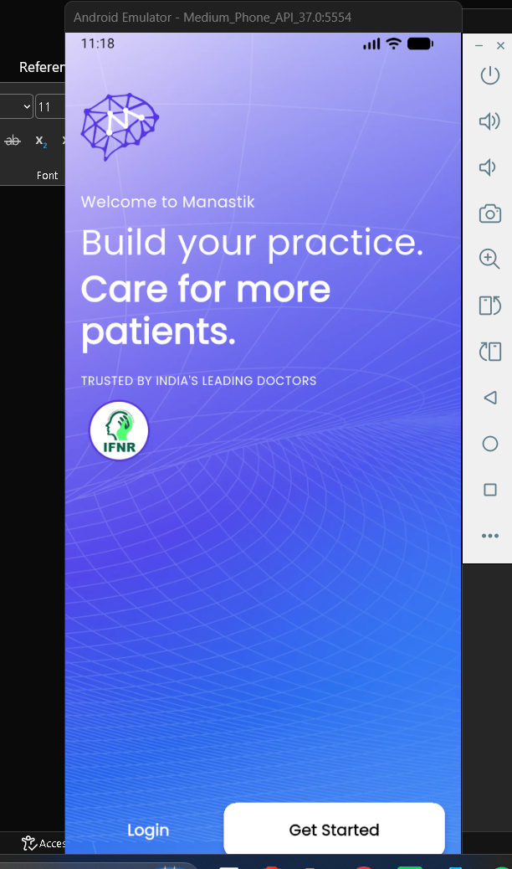
Evidence 01 — Welcome screen and Get Started action
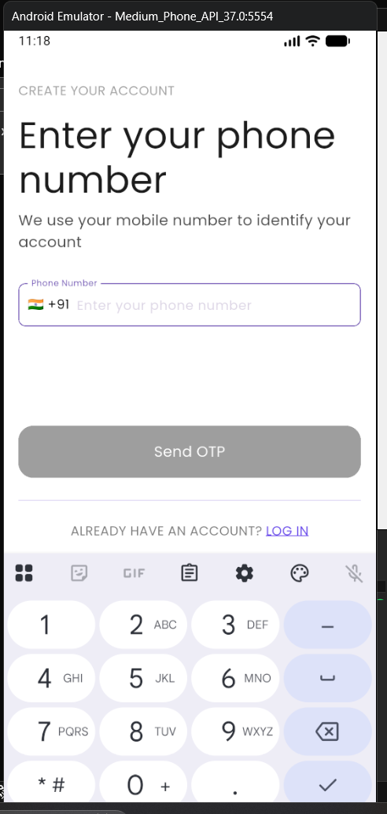
Evidence 02 — Phone-number entry form
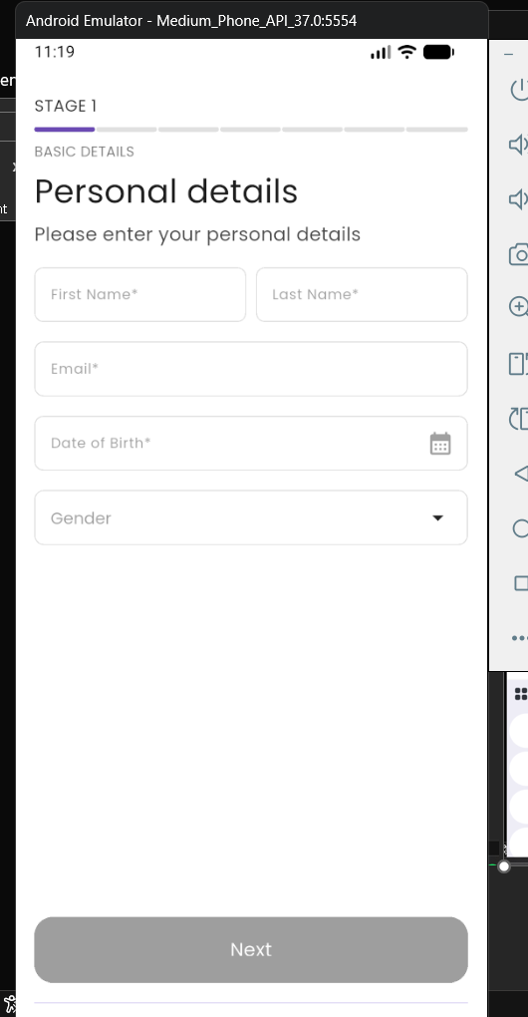
Evidence 03 — Personal details form
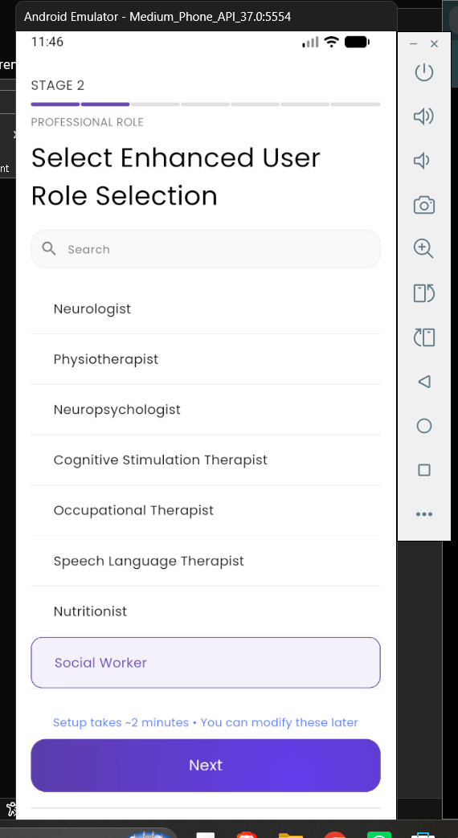
Evidence 04 — Professional-role selection

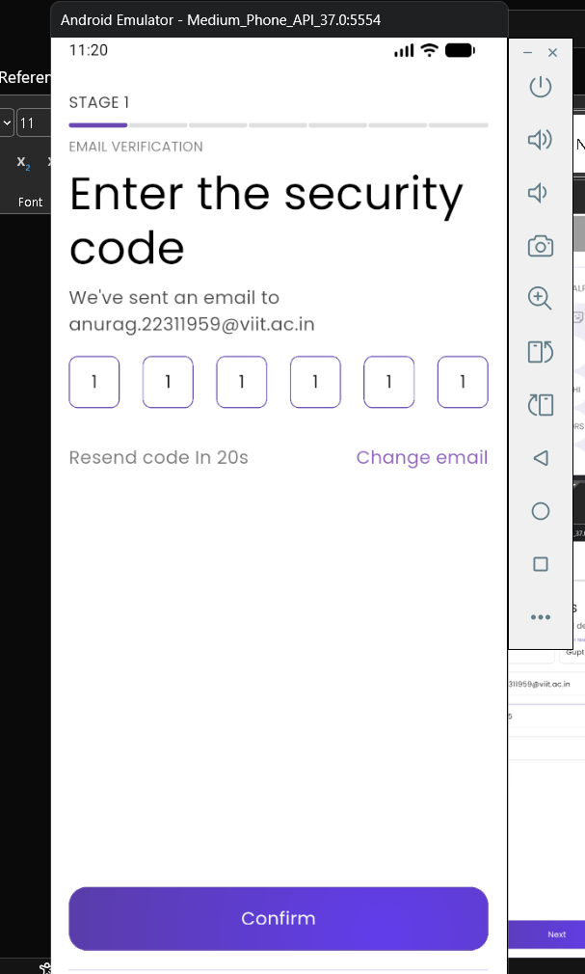
Evidence 05 — OTP / security-code screen
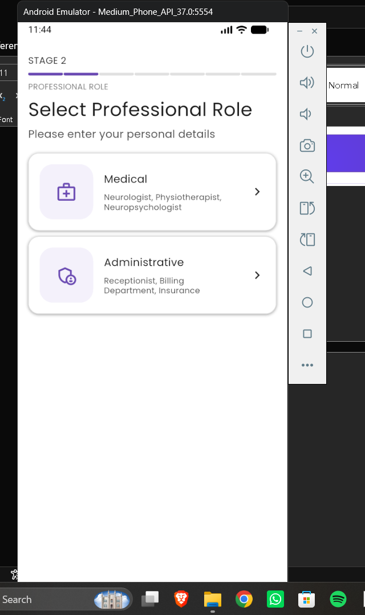
Evidence 06 — Education and qualification stage
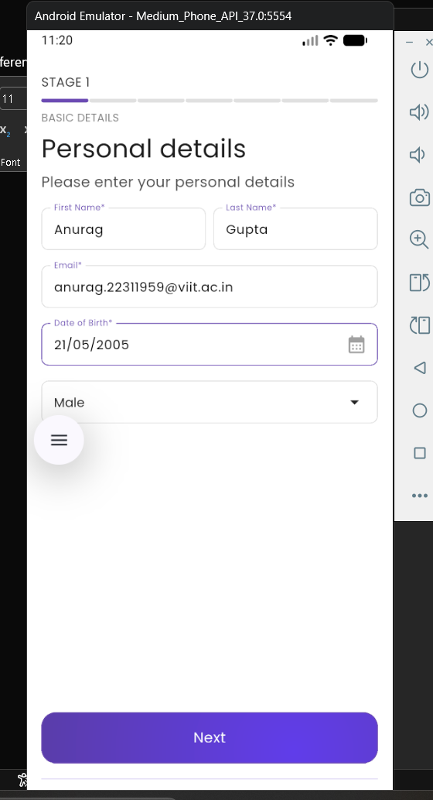
Evidence 07 — Institute / clinic selection
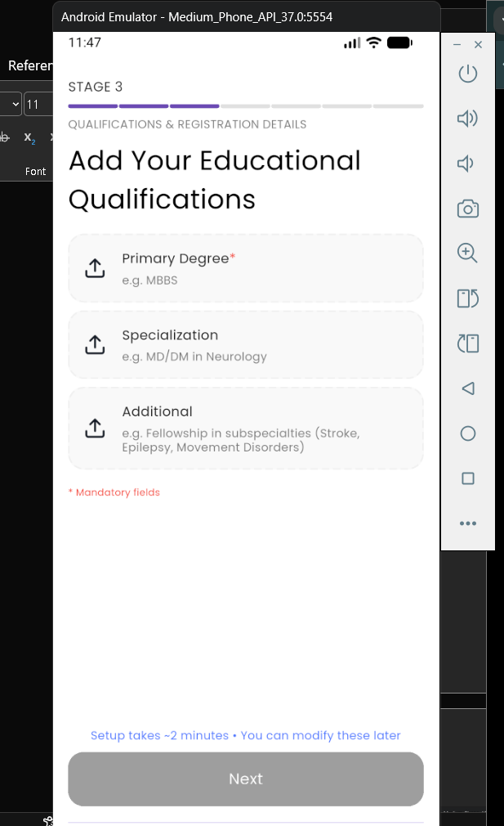
Evidence 08 — Practice details with procedure entered

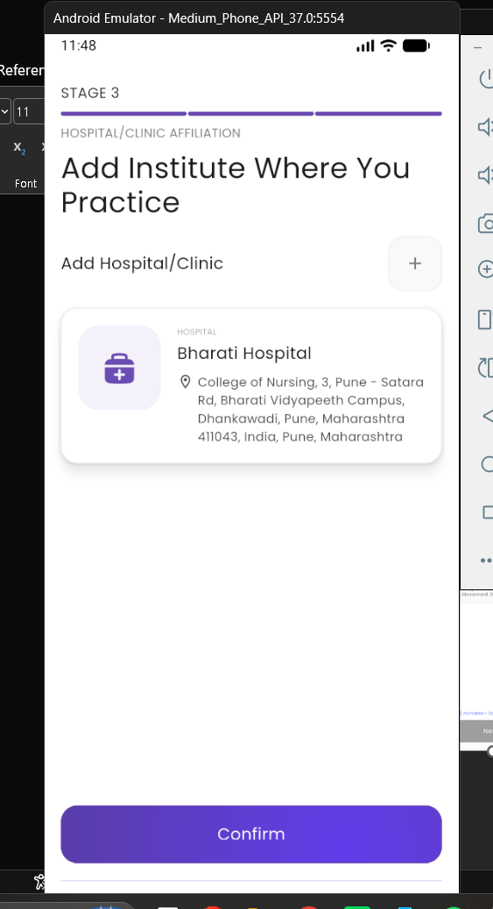
Evidence 09 — Practice details with the procedure field empty
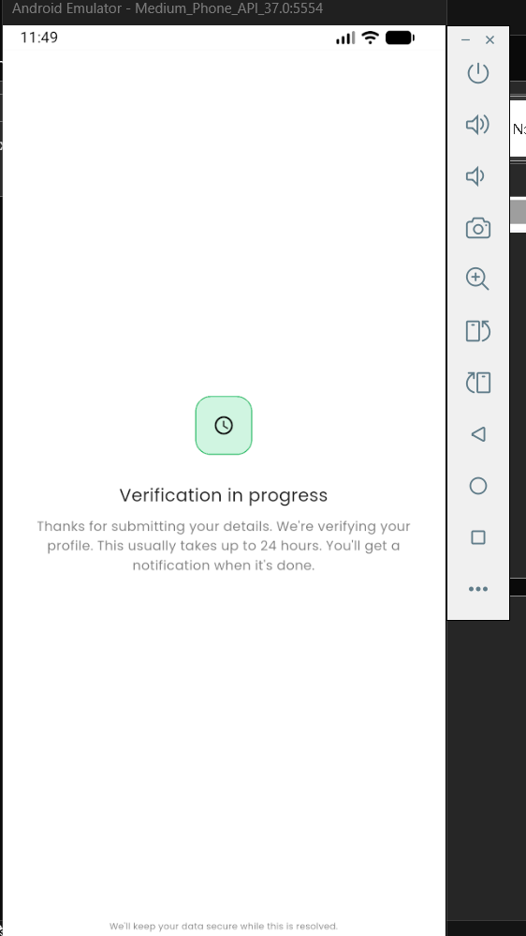
Evidence 10 — Verification in progress screen
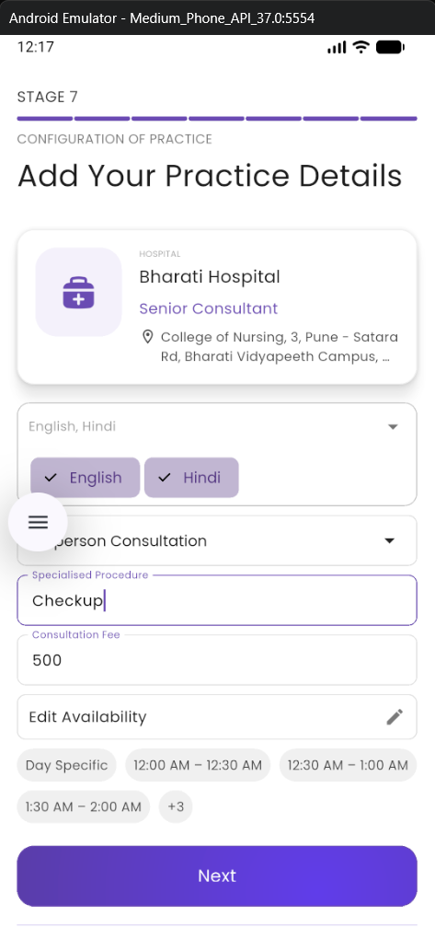
Evidence 11 — Supporting onboarding screen
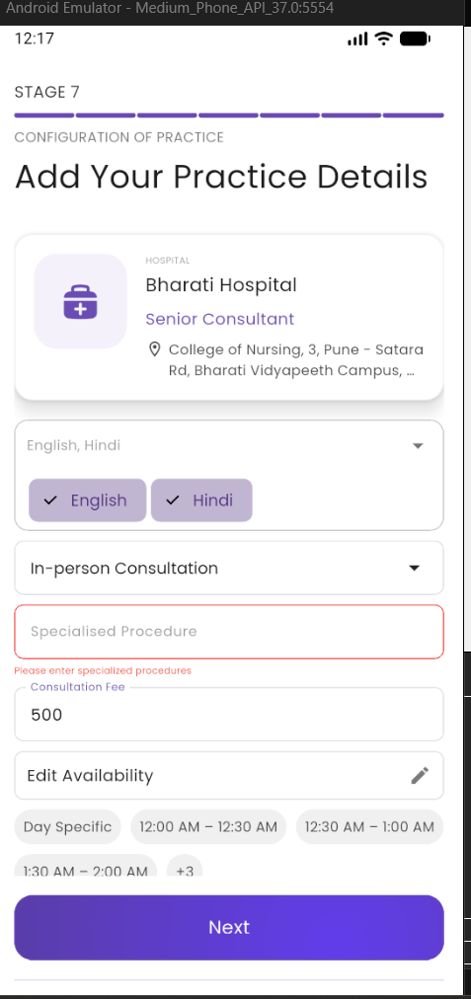
Evidence 12 — Additional screenshot from the supplied proof set

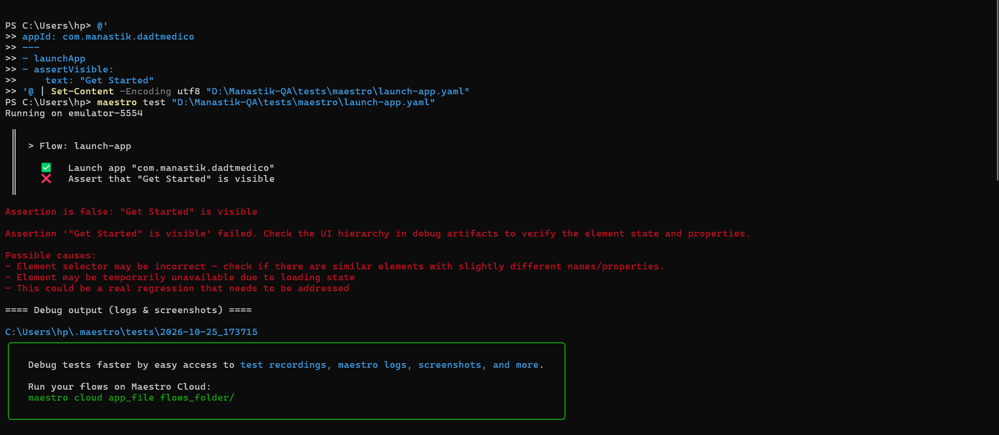
Evidence 13 — Maestro console output / execution evidence
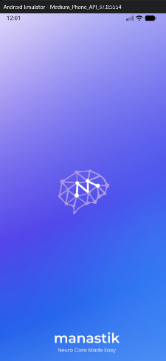
Evidence 14 — Screenshot from the supplied test materials
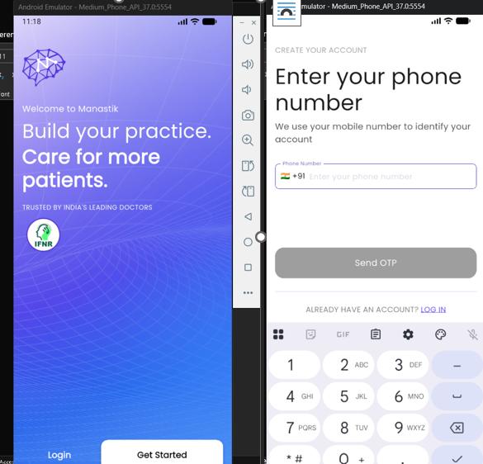
Evidence 15 — Screenshot from the supplied test materials
Evidence 16 — Screenshot from the supplied test materials
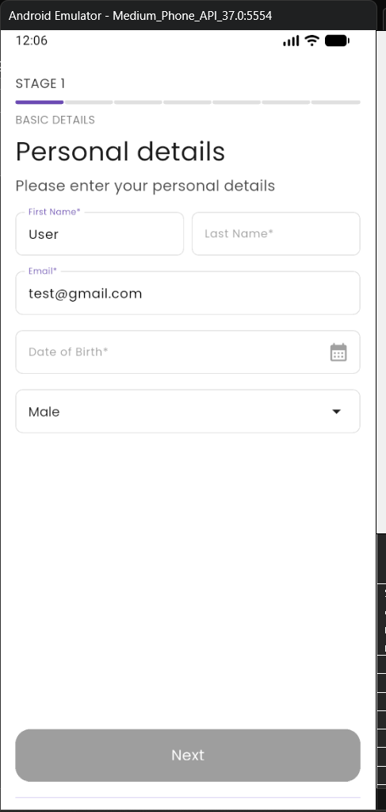
Evidence 17 — Screenshot from the supplied test materials
Evidence 18 — Screenshot from the supplied test materials
Evidence 19 — Screenshot from the supplied test materials
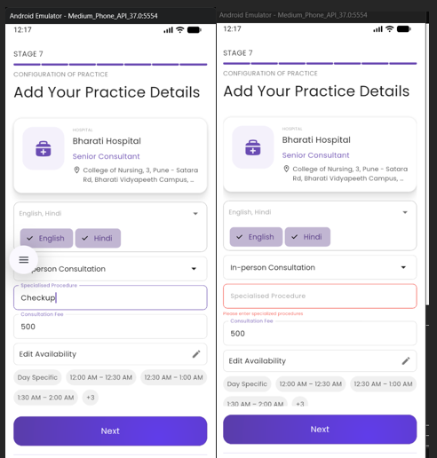
Evidence 20 — Screenshot from the supplied test materials
Evidence 21 — Screenshot from the supplied test materials
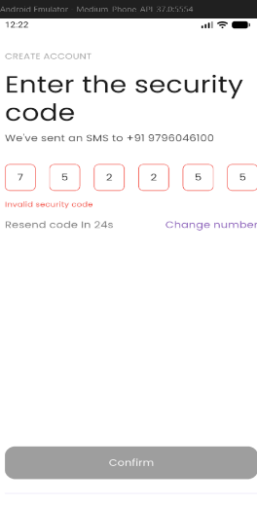
Evidence 22 — Screenshot from the supplied test materials

9. Bug reporting and findings
A reusable bug-report template is available in the repository. It requests the issue title, environment, preconditions, reproduction steps, expected result, actual result, severity/priority, evidence, and status. No confirmed app defect is reported in this document because the recorded notes do not establish a reproducible defect with a verified actual result.
TC-04 (required-field validation), TC-07 (practice-field validation), and TC-09 (incorrect OTP) should be executed directly and recorded with the exact observed message or state before concluding whether the app behaves correctly.

10. GitHub and version control
Item | Details
Repository | https://github.com/AnuragGupta2105/manastik-qa-automation
Branch | main
Initial commit | da76f78 — Add initial Manastik QA automation suite
Pushed content | README, .gitignore, results log, bug-report template, Maestro flows, and hierarchy dump
Not included in initial commit | evidence/ and test-cases/ were still untracked at the time of the push

11. Limitations and next steps
- Automate the full onboarding journey from a known clean state, with an assertion after every screen transition.
- Execute TC-04, TC-07, and TC-09 and record actual results, screenshots, and logs.
- For negative cases, assert the validation message or disabled state; a tap action alone is not sufficient evidence.
- Record the exact emulator Android/API version and build details in the results log.
- Review screenshots for personal/account details and redact them before wider distribution. Do not publish test credentials, OTPs, or private hiring-team material.
- Record a short screen demonstration showing how to run the flows and what each assertion checks.
- Revisit duplicate flows so each automated test has a distinct purpose and clear preconditions.

12. Conclusion
The initial QA baseline is in place: nine manual scenarios are documented, six Maestro flows are available, three recorded assertion sets pass for the verification-pending screen, and the initial GitHub commit has been pushed. The evidence set captures several onboarding screens and the console output. Full end-to-end automation and direct verification of negative validation cases remain the main outstanding work.
Prepared by Anurag Gupta
PRN: 22311959
Branch: Information Technology
Vishwakarma Institute of Information Technology, Pune

