**ECDC 2020**

ABSTRACT

Event Name: EMBEDDED

Team Name: IOTA Automations

Tech ID: 17228

Institute Name: MNNIT Allahabad

Team Leader’s Name: Anurag Gupta

Email of the leader: Anurock806@gmail.com

Members of the team: 4

|  |  |  |  |
| --- | --- | --- | --- |
| Sno. | Name | Email Id | Contact no. |
| 1. | Yaggya Garg | yaggya01@gmail.com | 9405971255 |
| 2. | Vedansh Singh Lodhi | vedanshsinghlodhi@gmail.com | 9170448552 |
| 3. | Sumit Singh | sumit.singhss194@gmail.com | 9997117473 |
| 4. | Anurag Gupta | Anurock806@gmail.com | 7393011475 |

**INTRODUCTION:**

In order to help maintain comfortable living conditions within a home, home monitoring and automation are utilized. The standards of human's comfort in homes can be categorized into several types. Among these categories, the most significant ones are the **thermal comfort**, which is related to temperature and humidity, followed by the **visual comfort**, related to colors and light, and **hygienic comfort**, associated with air quality. A system can be set to monitor these parameters to help maintain them within an acceptable range. Additionally, making the house smart is to allow for intelligent automatic executing of several commands after analyzing the collected data.

The main objective of this project is to develop a home automation system using an Arduino board configured with a wifi module (NodeMCU) which is remotely controlled by an Android app and website created for this specific purpose.

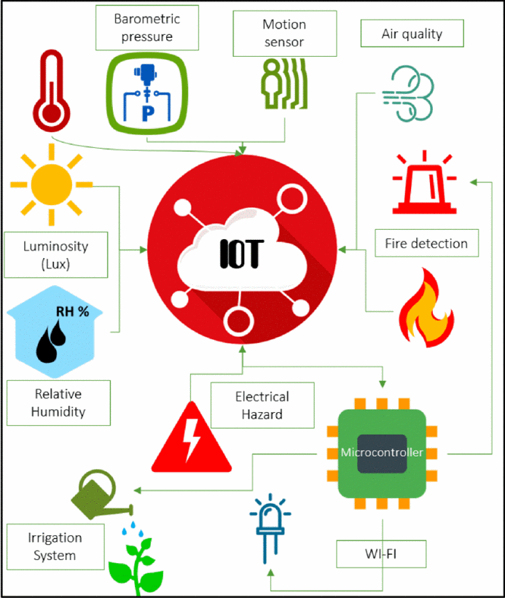

**COMPONENTS:**

1. Arduino Mega-2560 7. Humidity Sensor
2. Node MCU(ESP8266-12E) 8. Keypad
3. Relay Module 9. Laser +LDR
4. Smoke sensor 10. LCD with I2C
5. PIR sensor +IR sensors 11. Motors and wires
6. Temperature sensor 12. LEDs and Solar panel

**APPROACH:**

To accomplish the above task, our Home automation system consists of 4 Major steps:

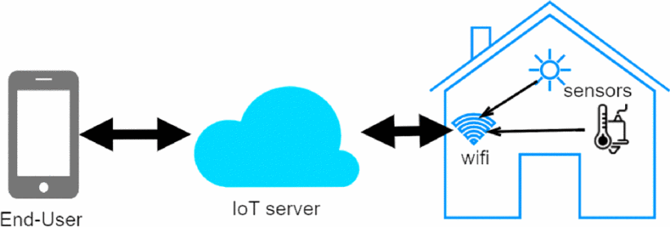

1. **Data Sensing and Acquisition**:-

The first part is the sensing and data acquisition part. This is done by placing sensors or devices, also called things, at several locations throughout the home to measure and gather desired information such as temperature, humidity, motion, etc. Several sensors such as PIR sensor, Humidity sensor, temperature sensor, … are used to obtain required data.

2. **Data Processing (Microcontrollers)**:-

The data collected in a home automation system is processed and managed by **Arduino Mega** which serial communicates with **NodeMCU** for data collection and controls the actuators and various functioning of the home. They are the control center for all the automation inside the home.

3. **Data Transmission (IOT Server)**:-

The most important feature of this Home Automation system is the implementation of **ThingSpeak** , an open-source Internet of Things(IoT) application and API to store and retrieve data from things using the HTTP and MQTT protocol over the Internet or via a Local Area Network. Using this, we store the status of various activities inside the home over the internet through Wi-Fi module connected to the internet. This data is used by the Android application and Website to provide live status of the devices inside the house.

4. **Data Display &User Interface**:-

The obtained data is displayed over the LCD display for convenient understanding of the status of the sensors inside the home.

An **Android App** and a **Website** is developed to remotely control the various actuators present inside the home such as Garage, Main gate, Lights, water pump, etc. via internet and thus implementing the “Internet” part of the Internet Of Things.

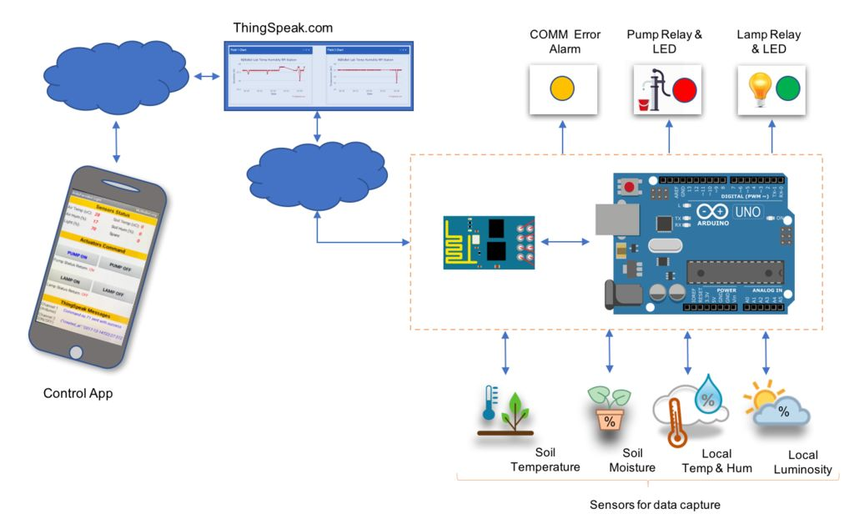

**Technical Specification of the Project:**

1. Our smart home implements some key features such as Automated Gate and Garage, Lighting control ,Hazard alert, Intruder alert, Lawn/Garden management, Weather alert and various Security features.
2. Gate is opened /closed with the help of a Security Pin known only to the owner of the house.
3. Garage is automated according to the vehicle detection.
4. Lighting system is controlled according to the weather and the presence of people inside the home.
5. Sensors are installed in the kitchen to alert the user in case of fire or gas detection according to which necessary precautions are taken to minimize the loss of property.
6. Bedroom and Bedroom are automated to provide luxury to the residents.
7. Solar Panel is used to provide clean and safe energy that is used to light up the LEDs inside the home.

**Conclusion:**

The proposed design of the smart home is very flexible and can be easily expanded and applied to larger buildings by increasing the number of sensors, measured parameters, and control devices. More functionality and smartness could be also added to the existing system for making the house automation system grow, adapt, and evolve by itself using advanced artificial intelligence. Moreover, many security features can also be implemented on larger buildings using CCTVs and other surveillance systems, increasing the effectiveness of a smart home, providing an extra layer of luxury and security to the residents.

**References:**

1. [www.quora.com](http://www.quora.com)
2. Google Images
3. [www.ieee.org](http://www.ieee.org)
4. Wikipedia