# Create Account

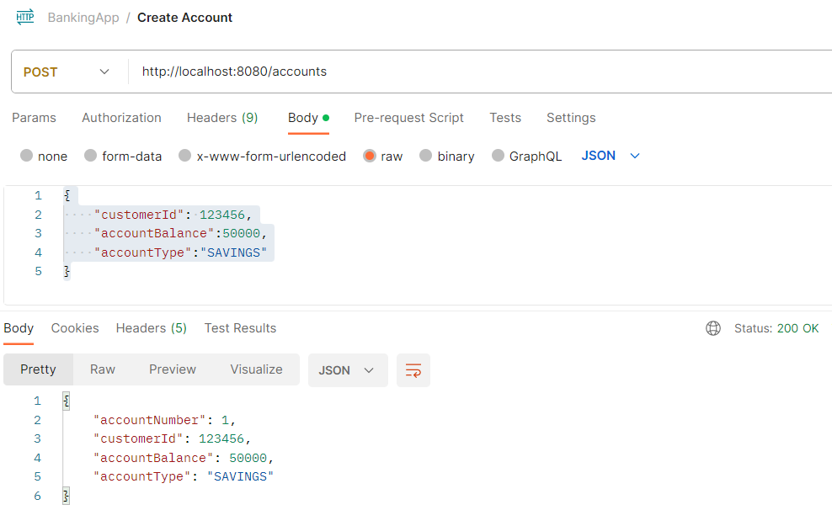

# Initiate Transaction:-

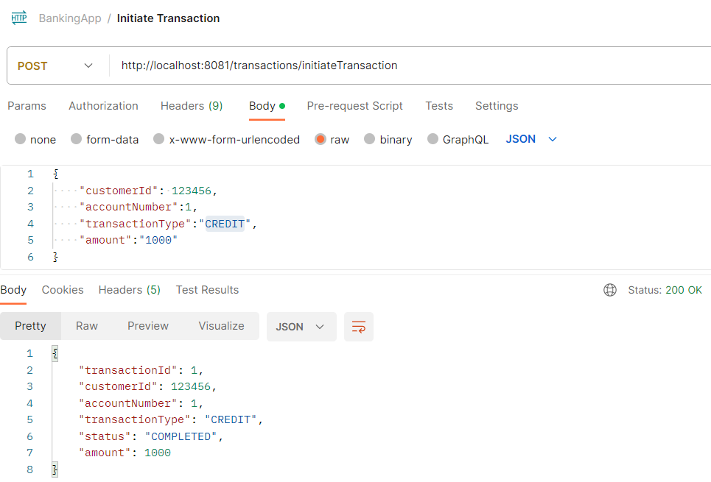

# Kafka Transaction Completed Topic:-

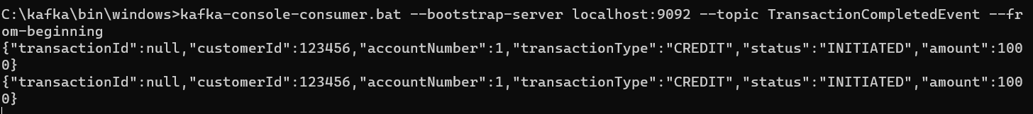

# Updated Account

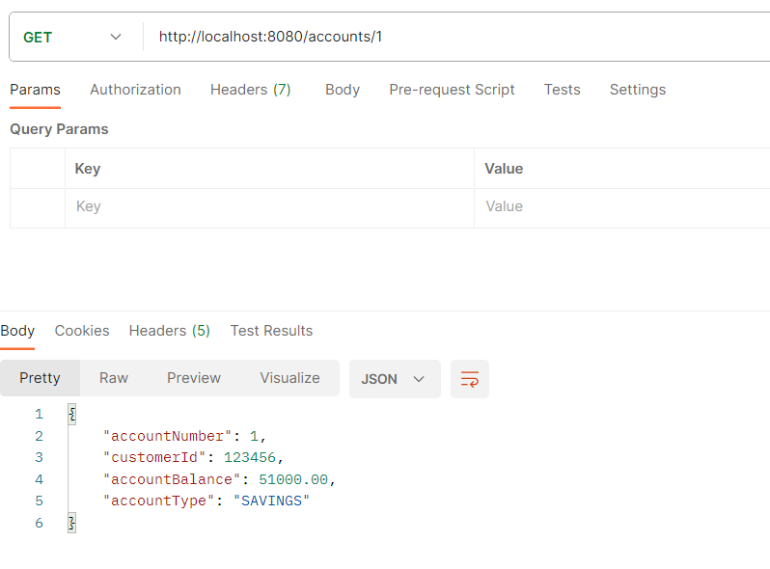

# Initiate another Transaction

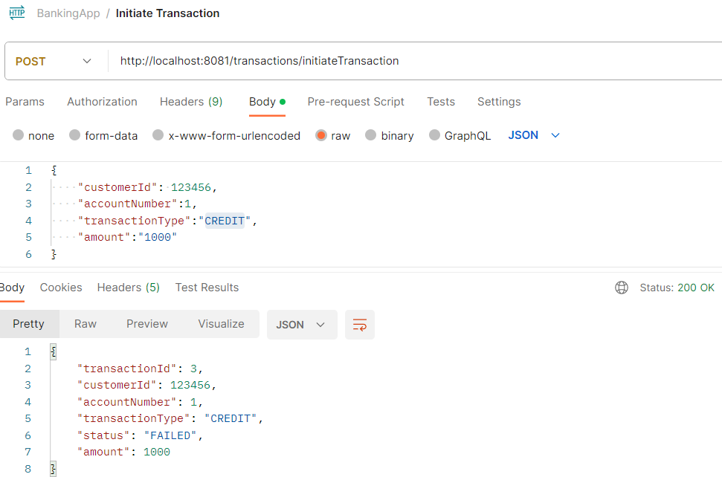

# Transaction Failed Topic



# Account amount reverted:

# 

# Task 2

# Initiate Suspicious Transaction with Amount > 50000

# 

## Fraud Service listens TransactionCompletedEvent and Analyses Transaction

## If transaction is more than 50000, it generates a SuspiciousActivityEvent

Transaction Completed Topic

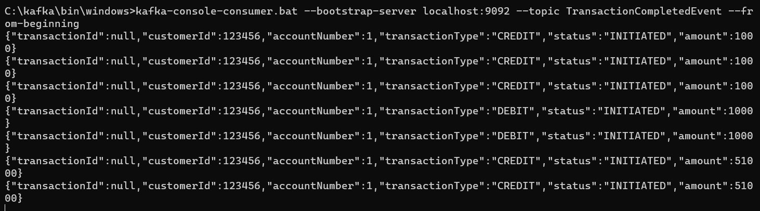

Suspicious Activity Topic

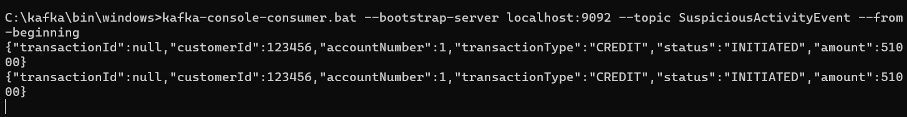

# Notification Service Sends Email for Suspicious Activity

