# Create Product Inventory

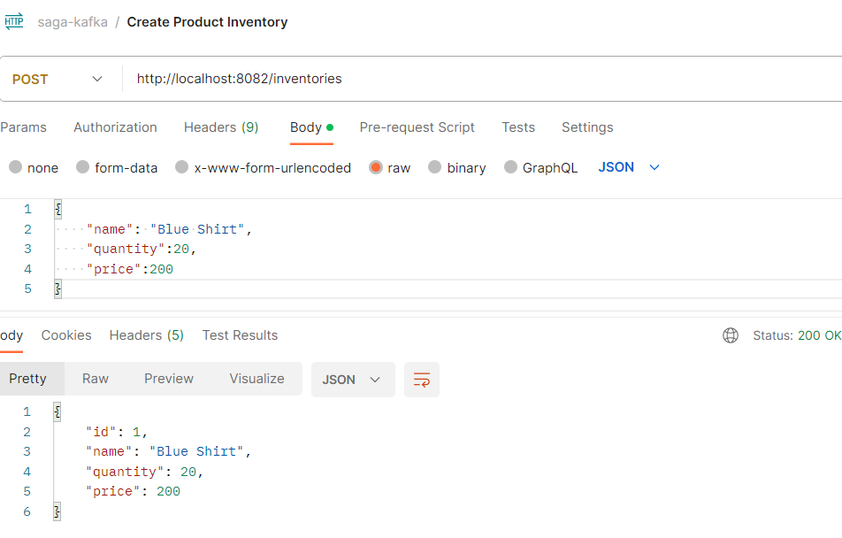

# Create Order

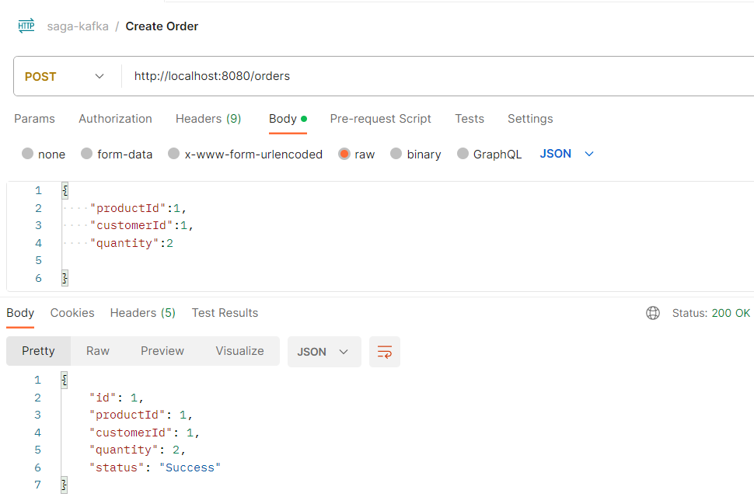

# Kafka Order Placed topic after 6 Orders processed by Order Service

# 

# Kafka Topic Inventory Reserved After 6 Orders process by Inventory

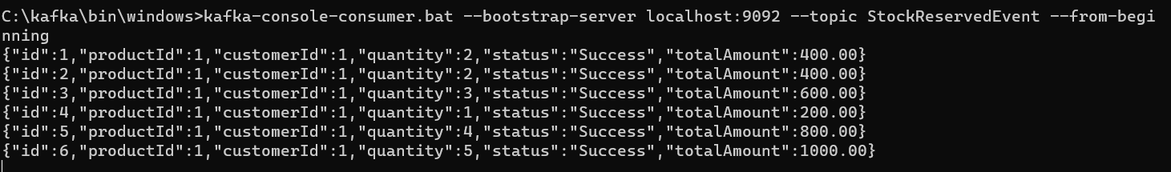

# Kafka Topic Payment Failed and Success Events After 6 Orders

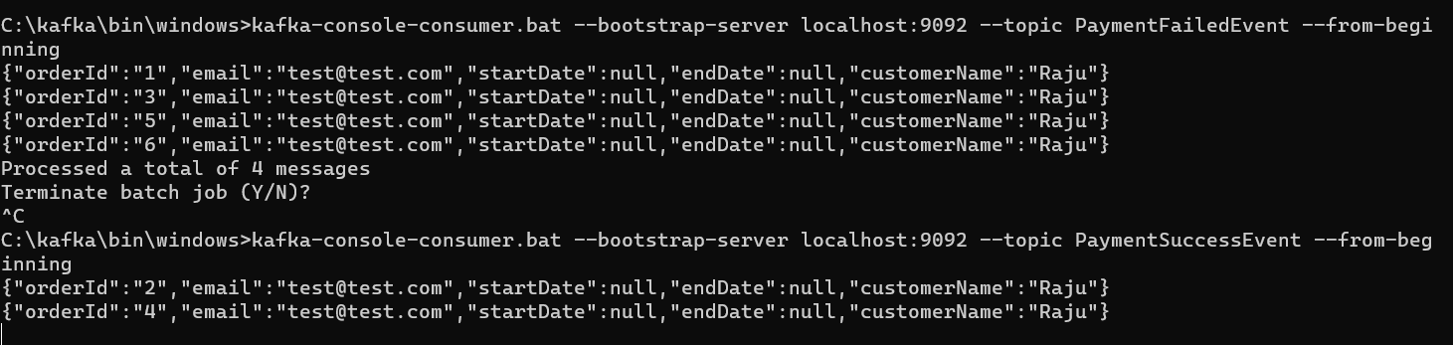

# Order Cancelled via Saga Pattern If Payment Failed Otherwise Success

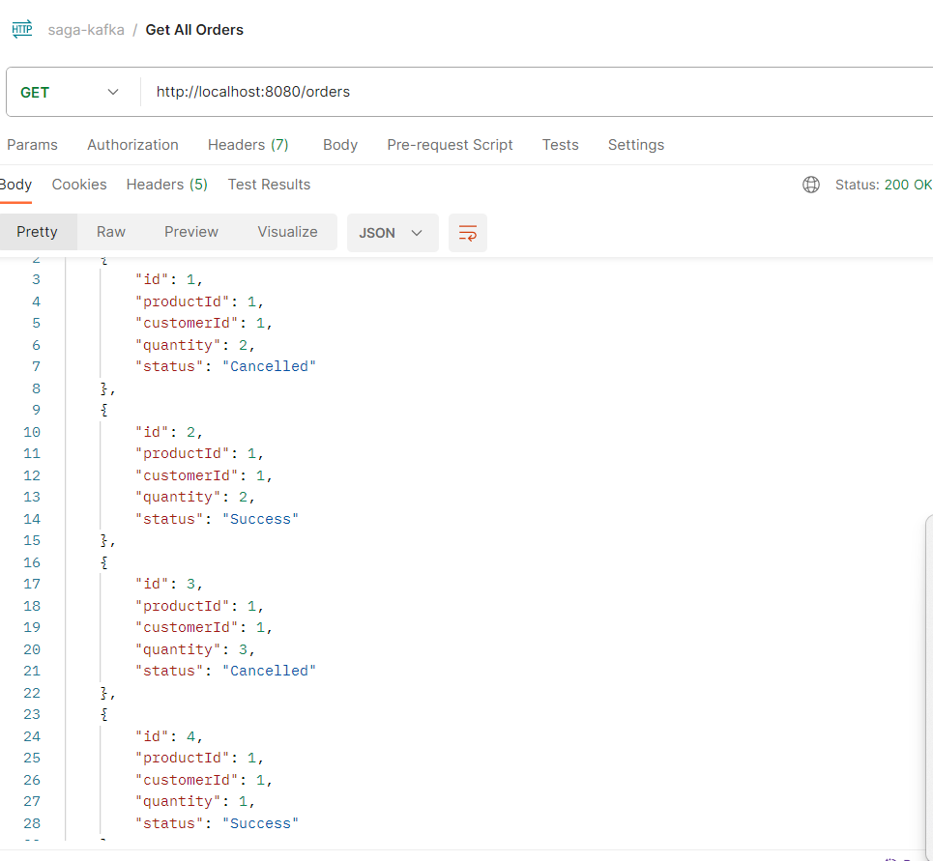

# Order Confirmation/Cancellation Notifications

