JMeter Performance Testing Report
SIP & NAV Allocation Engine
Endpoint #1 — GET /api/v1/funds
Purpose: Retrieve all mutual funds.
Test 1 — High Concurrency
Configuration | Value
HTTP Method | GET
Endpoint | /api/v1/funds
Threads | 1000
Loop Count | 100
Total Requests | 100,000
Ramp-Up | 10 sec
Request Body | None
JMeter Test Evidence — Test 1
HTTP Request Configuration
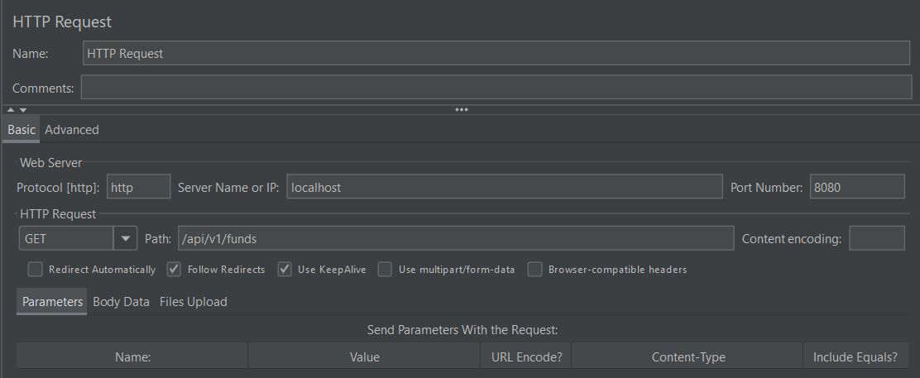
Summary Report
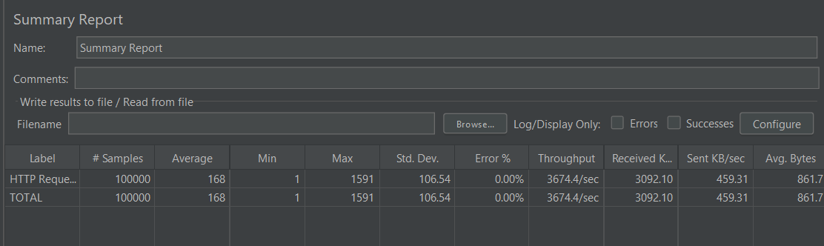
Aggregate Report
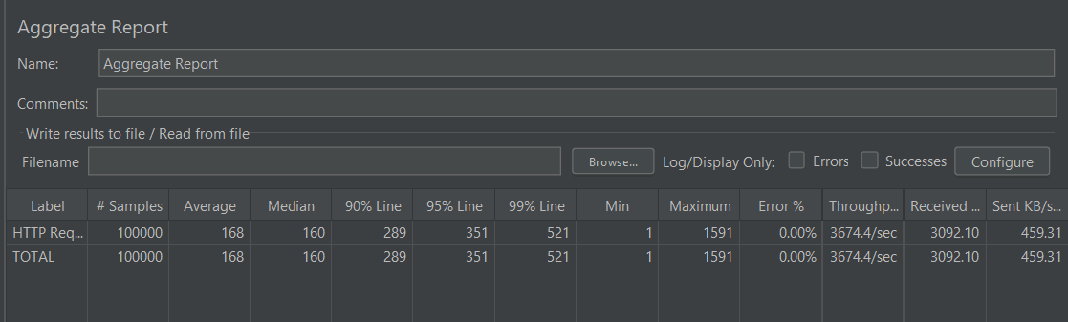
Performance Results
Metric | Result
Samples | 100,000
Average | 168 ms
Median | 160 ms
P90 | 289 ms
P95 | 351 ms
P99 | 521 ms
Minimum | 1 ms
Maximum | 1,591 ms
Std. Deviation | 106.54 ms
Error % | 0.00%
Throughput | 3,674.4 req/sec
Received | 3,092.10 KB/sec
Sent | 459.31 KB/sec
Avg. Bytes | 861.7 bytes
Result: 100,000/100,000 successful
Test 2 — High Iteration
Configuration | Value
HTTP Method | GET
Endpoint | /api/v1/funds
Threads | 100
Loop Count | 1,000
Total Requests | 100,000
Ramp-Up | 10 sec
Request Body | None
JMeter Test Evidence — Test 2
HTTP Request Configuration
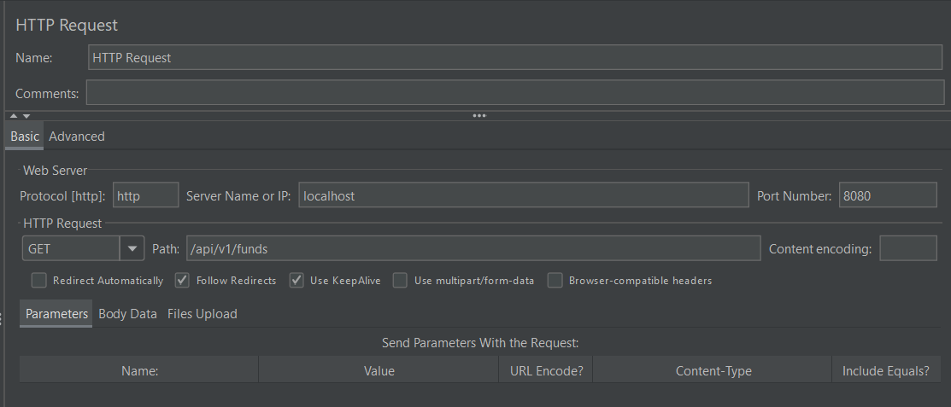
Summary Report
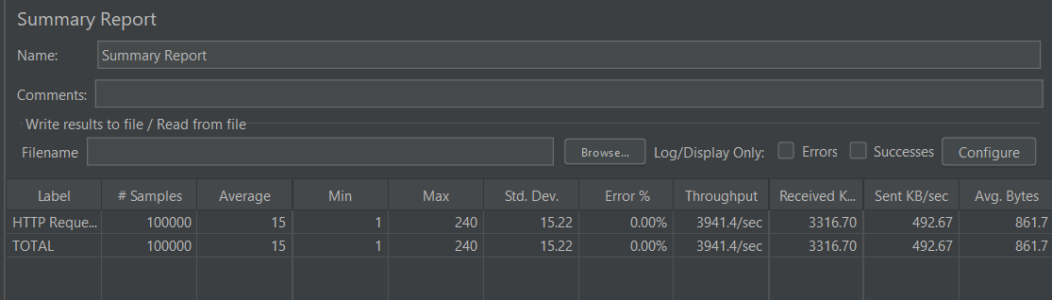
Aggregate Report
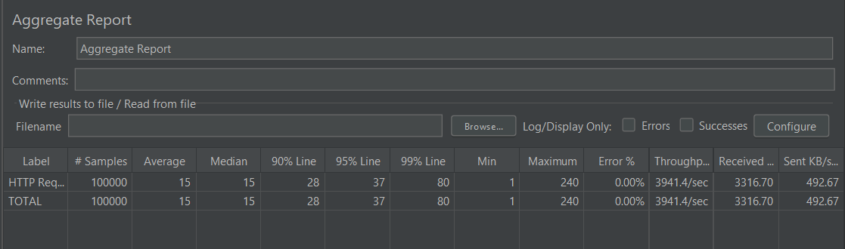
Performance Results
Metric | Result
Samples | 100,000
Average | 15 ms
Median | 15 ms
P90 | 28 ms
P95 | 37 ms
P99 | 80 ms
Minimum | 1 ms
Maximum | 240 ms
Std. Deviation | 15.22 ms
Error % | 0.00%
Throughput | 3,941.4 req/sec
Received | 3,316.70 KB/sec
Sent | 492.67 KB/sec
Avg. Bytes | 861.7 bytes
Result: 100,000/100,000 successful
Test Comparison
Metric | High Concurrency | High Iteration | Better
Threads | 1000 | 100 | —
Loops | 100 | 1000 | —
Total Requests | 100,000 | 100,000 | —
Average | 168 ms | 15 ms | High Iteration
Median | 160 ms | 15 ms | High Iteration
P90 | 289 ms | 28 ms | High Iteration
P95 | 351 ms | 37 ms | High Iteration
P99 | 521 ms | 80 ms | High Iteration
Min | 1 ms | 1 ms | =
Max | 1,591 ms | 240 ms | High Iteration
Std. Dev. | 106.54 ms | 15.22 ms | High Iteration
Error % | 0.00% | 0.00% | =
Throughput | 3,674.4/sec | 3,941.4/sec | High Iteration
Received | 3,092.10 KB/s | 3,316.70 KB/s | High Iteration
Sent | 459.31 KB/s | 492.67 KB/s | High Iteration
Analysis
• The API handled 100,000 requests with 0.00% errors in both scenarios, so it remained functionally stable under both workloads.
• The high-concurrency workload (1000 threads) produced an average response time of 168 ms, with P99 = 521 ms.
• The high-iteration workload (100 threads) produced a much lower average response time of 15 ms, with P99 = 80 ms.
• High iteration also produced slightly higher observed throughput: 3,941.4 req/sec versus 3,674.4 req/sec.
• Response-time variability was substantially lower in the high-iteration run: 15.22 ms standard deviation versus 106.54 ms.
Best Overall Latency Result
Test 2 — High Iteration
15 ms average | 15 ms median | 37 ms P95 | 80 ms P99 | 0% errors
Highest Throughput
Test 2 — High Iteration
3,941.4 requests/sec | 0% errors
Final Status
GET /api/v1/funds — TESTED & RECORDED
Both workload patterns passed successfully.

