JMeter Performance Testing Report
SIP & NAV Allocation Engine
Endpoint #2 — GET /api/v1/funds/{symbol}
Purpose: Retrieve a specific mutual fund by symbol.
Test 1 — High Concurrency
Configuration | Value
HTTP Method | GET
Endpoint | /api/v1/funds/HDFC-FLEXI
Threads | 1000
Loop Count | 100
Total Requests | 100,000
Ramp-Up | 10 sec
Request Body | None

JMeter Test Evidence — Test 1
HTTP Request Configuration
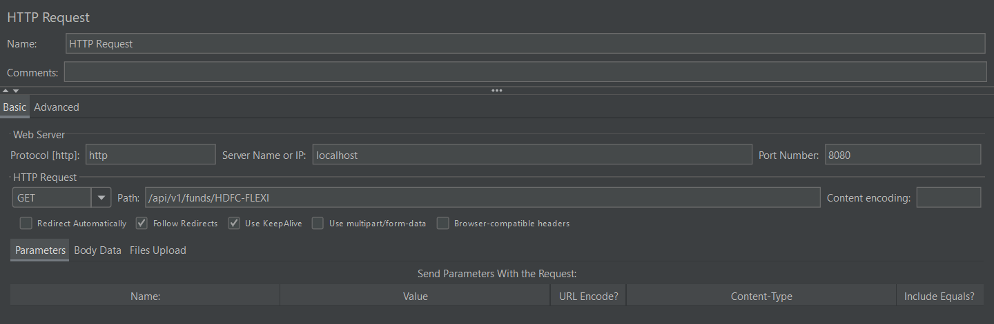

Summary Report
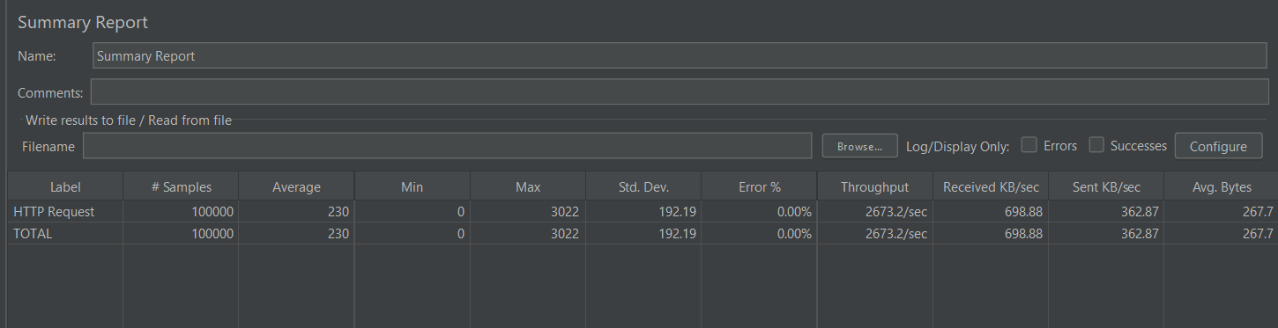

Aggregate Report
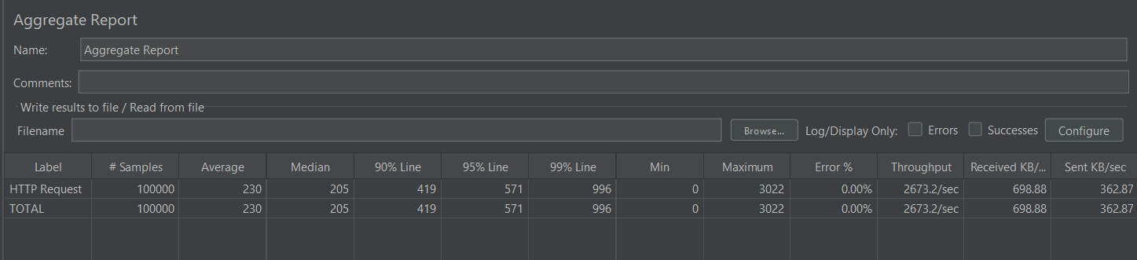

Performance Results
Metric | Result
Samples | 100,000
Average | 230 ms
Median | 205 ms
P90 | 419 ms
P95 | 571 ms
P99 | 996 ms
Minimum | 0 ms
Maximum | 3,022 ms
Std. Deviation | 192.19 ms
Error % | 0.00%
Throughput | 2,673.2 req/sec
Received | 698.88 KB/sec
Sent | 362.87 KB/sec
Avg. Bytes | 267.7 bytes

Result: 100,000/100,000 successful
Test 2 — High Iteration
Configuration | Value
HTTP Method | GET
Endpoint | /api/v1/funds/HDFC-FLEXI
Threads | 100
Loop Count | 1,000
Total Requests | 100,000
Ramp-Up | 10 sec
Request Body | None

JMeter Test Evidence — Test 2
Summary Report
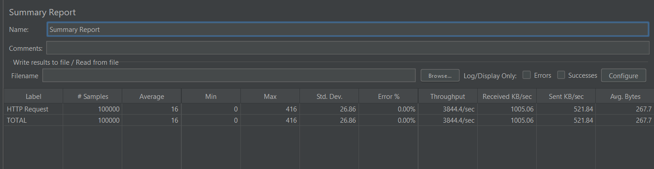

Aggregate Report
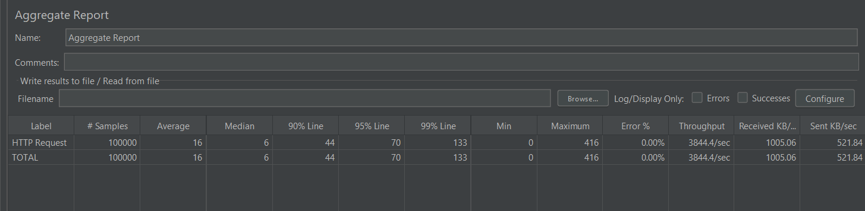

Performance Results
Metric | Result
Samples | 100,000
Average | 16 ms
Median | 6 ms
P90 | 44 ms
P95 | 70 ms
P99 | 133 ms
Minimum | 0 ms
Maximum | 416 ms
Std. Deviation | 26.86 ms
Error % | 0.00%
Throughput | 3,844.4 req/sec
Received | 1,005.06 KB/sec
Sent | 521.84 KB/sec
Avg. Bytes | 267.7 bytes

Result: 100,000/100,000 successful
Test Comparison
Metric | High Concurrency | High Iteration | Better
Threads | 1000 | 100 | —
Loops | 100 | 1000 | —
Total Requests | 100,000 | 100,000 | —
Average | 230 ms | 16 ms | High Iteration
Median | 205 ms | 6 ms | High Iteration
P90 | 419 ms | 44 ms | High Iteration
P95 | 571 ms | 70 ms | High Iteration
P99 | 996 ms | 133 ms | High Iteration
Min | 0 ms | 0 ms | =
Max | 3,022 ms | 416 ms | High Iteration
Std. Dev. | 192.19 ms | 26.86 ms | High Iteration
Error % | 0% | 0% | =
Throughput | 2,673.2/sec | 3,844.4/sec | High Iteration
Received | 698.88 KB/s | 1,005.06 KB/s | High Iteration
Sent | 362.87 KB/s | 521.84 KB/s | High Iteration

Analysis
- The endpoint handled 100,000 requests with 0% errors in both workload scenarios.
- The high-iteration workload produced substantially lower latency: 16 ms average compared with 230 ms under high concurrency.
- High iteration also achieved higher throughput: 3,844.4 requests/sec compared with 2,673.2 requests/sec.
- Tail latency was considerably lower in the high-iteration test, with P95 = 70 ms and P99 = 133 ms, compared with 571 ms and 996 ms under high concurrency.
- Response-time variability was lower under high iteration, with a standard deviation of 26.86 ms versus 192.19 ms.
Best overall result
Test 2 — High Iteration
16 ms average | 6 ms median | 70 ms P95 | 133 ms P99 | 3,844.4 req/sec | 0% errors
Final Status
GET /api/v1/funds/{symbol} — TESTED & RECORDED
Both workload patterns passed successfully.

