JMeter Performance Testing Report
SIP & NAV Allocation Engine
Endpoint — GET /api/v1/sips/user
Purpose: Retrieve all SIP records.
Test 1 — High Concurrency
Configuration | Value
HTTP Method | GET
Endpoint | /api/v1/sips/user
Threads | 1000
Loop Count | 100
Total Requests | 100,000
Ramp-Up | 10 sec
Request Body | None
JMeter Test Evidence — Test 1
HTTP Request Configuration
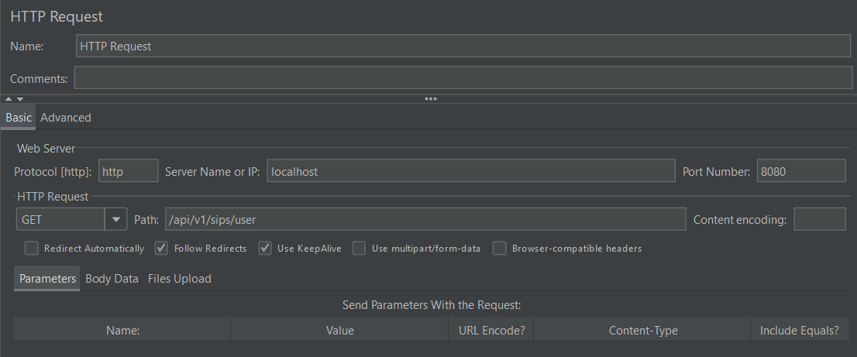
Summary Report
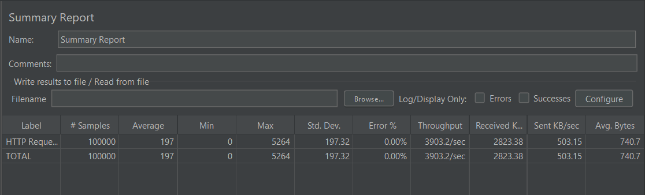
Aggregate Report
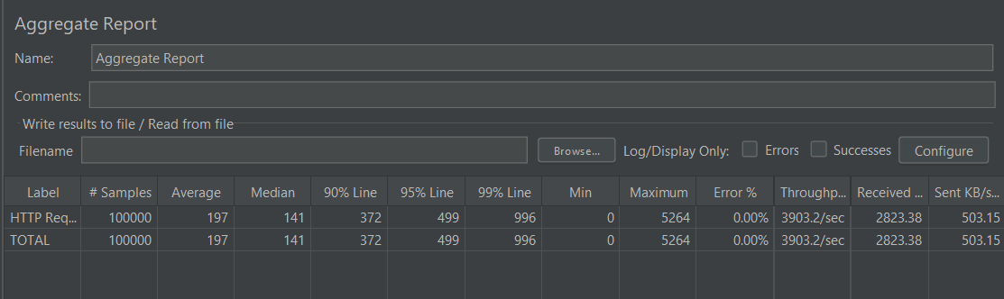
Performance Results
Metric | Result
Samples | 100,000
Average | 197 ms
Median | 141 ms
P90 | 372 ms
P95 | 499 ms
P99 | 996 ms
Minimum | 0 ms
Maximum | 5,264 ms
Std. Deviation | 197.32 ms
Error % | 0.00%
Throughput | 3,903.2 req/sec
Received | 2,823.38 KB/sec
Sent | 503.15 KB/sec
Avg. Bytes | 740.7 bytes
Result: 100,000/100,000 successful
Test 2 — High Iteration
Configuration | Value
HTTP Method | GET
Endpoint | /api/v1/sips/user
Threads | 100
Loop Count | 1,000
Total Requests | 100,000
Ramp-Up | 10 sec
Request Body | None
JMeter Test Evidence — Test 2
HTTP Request Configuration
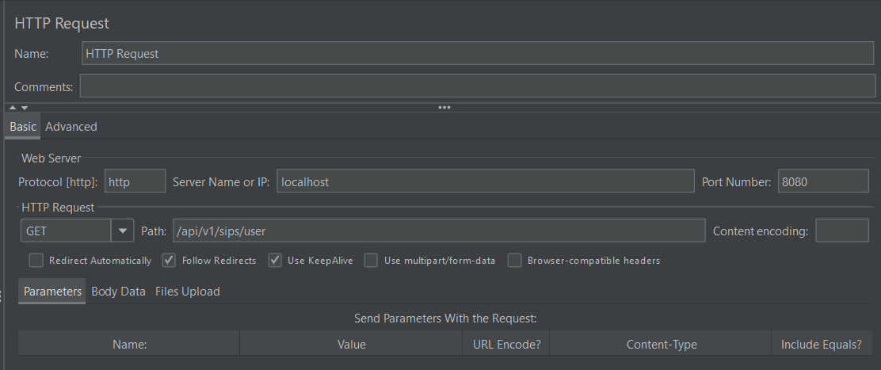
Summary Report
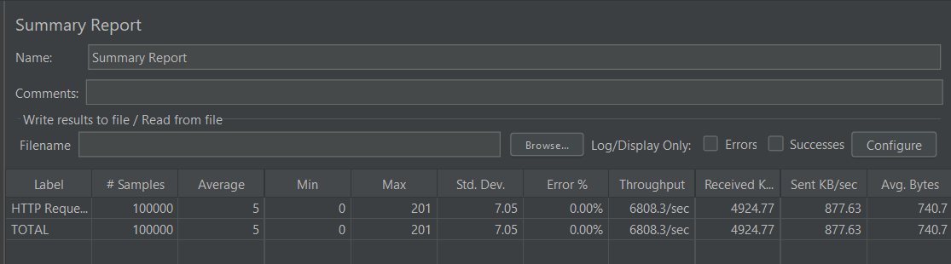
Aggregate Report
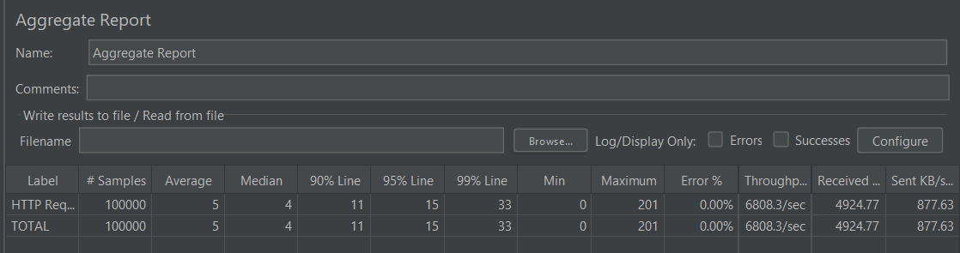
Performance Results
Metric | Result
Samples | 100,000
Average | 5 ms
Median | 4 ms
P90 | 11 ms
P95 | 15 ms
P99 | 33 ms
Minimum | 0 ms
Maximum | 201 ms
Std. Deviation | 7.05 ms
Error % | 0.00%
Throughput | 6,808.3 req/sec
Received | 4,924.77 KB/sec
Sent | 877.63 KB/sec
Avg. Bytes | 740.7 bytes
Result: 100,000/100,000 successful
Test Comparison
Metric | High Concurrency | High Iteration | Better
Threads | 1000 | 100 | —
Loops | 100 | 1000 | —
Total Requests | 100,000 | 100,000 | —
Average | 197 ms | 5 ms | High Iteration
Median | 141 ms | 4 ms | High Iteration
P90 | 372 ms | 11 ms | High Iteration
P95 | 499 ms | 15 ms | High Iteration
P99 | 996 ms | 33 ms | High Iteration
Min | 0 ms | 0 ms | =
Max | 5,264 ms | 201 ms | High Iteration
Std. Dev. | 197.32 ms | 7.05 ms | High Iteration
Error % | 0.00% | 0.00% | =
Throughput | 3,903.2/sec | 6,808.3/sec | High Iteration
Received | 2,823.38 KB/s | 4,924.77 KB/s | High Iteration
Sent | 503.15 KB/s | 877.63 KB/s | High Iteration
Analysis
• Both workloads completed 100,000 requests with a 0.00% error rate, indicating successful request processing in both tests.
• The high-concurrency test produced an average response time of 197 ms and P99 of 996 ms.
• The high-iteration test produced a much lower average response time of 5 ms and P99 of 33 ms.
• Observed throughput was higher in the high-iteration workload: 6,808.3 requests/sec versus 3,903.2 requests/sec.
• Response-time variability was also much lower in Test 2, with standard deviation of 7.05 ms versus 197.32 ms.
Best Overall Latency Result
Test 2 — High Iteration
5 ms average | 4 ms median | 15 ms P95 | 33 ms P99 | 0% errors
Highest Throughput
Test 2 — High Iteration
6,808.3 requests/sec | 0% errors
Final Status
GET /api/v1/sips/user — TESTED & RECORDED
Both workload patterns completed successfully.

