JMeter Performance Testing Report
SIP & NAV Allocation Engine
Endpoint #4 — GET /api/v1/sips/user/{userId}

Purpose
This report evaluates the performance of the user-specific SIP retrieval endpoint GET /api/v1/sips/user/{userId} under two 100,000-request JMeter workloads. The endpoint was tested using userId 101, with zero errors recorded in both tests.

Test 1 — High Concurrency
The first workload used 1,000 concurrent threads with 100 iterations per thread, for a total of 100,000 HTTP requests.
Configuration | Value
Endpoint | GET /api/v1/sips/user/101
Protocol | HTTP
Host | localhost
Port | 8080
Threads | 1,000
Loops per Thread | 100
Total Requests | 100,000
Ramp-Up | 10 seconds

JMeter Test Evidence — Test 1
1. HTTP Request Configuration
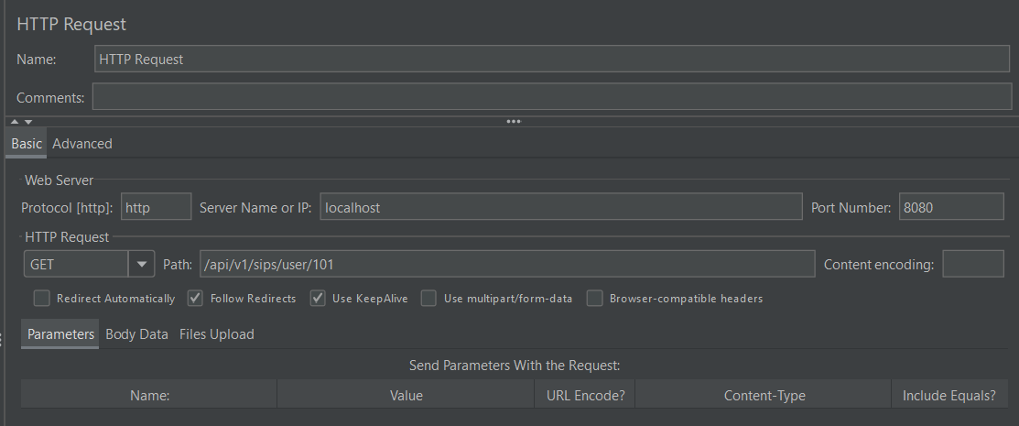

2. Summary Report
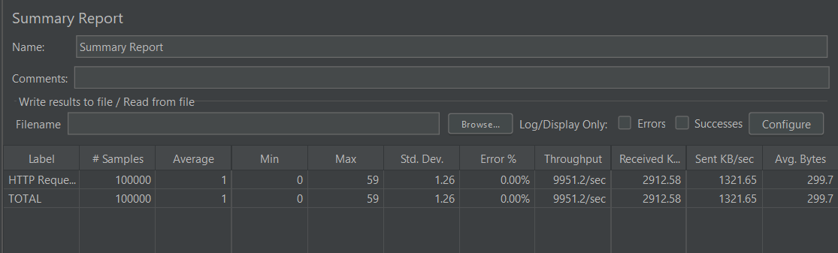

3. Aggregate Report
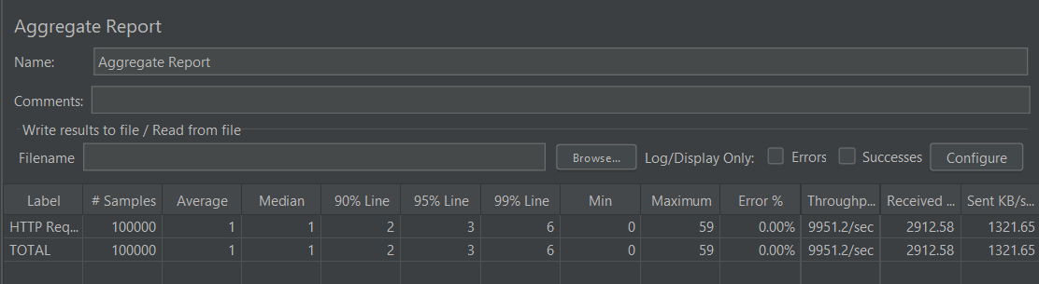

Performance Results — Test 1
Metric | Result
Samples | 100,000
Average | 1 ms
Median | 1 ms
90th Percentile | 2 ms
95th Percentile | 3 ms
99th Percentile | 6 ms
Minimum | 0 ms
Maximum | 59 ms
Standard Deviation | 1.26 ms
Error Rate | 0.00%
Throughput | 9,951.2 req/sec
Received | 2,912.58 KB/sec
Sent | 1,321.65 KB/sec
Average Bytes | 299.7 bytes

Test 2 — High Iteration
The second workload used 100 threads with 1,000 iterations per thread, again generating a total of 100,000 HTTP requests.
Configuration | Value
Endpoint | GET /api/v1/sips/user/101
Protocol | HTTP
Host | localhost
Port | 8080
Threads | 100
Loops per Thread | 1,000
Total Requests | 100,000
Ramp-Up | 10 seconds

JMeter Test Evidence — Test 2
1. HTTP Request Configuration
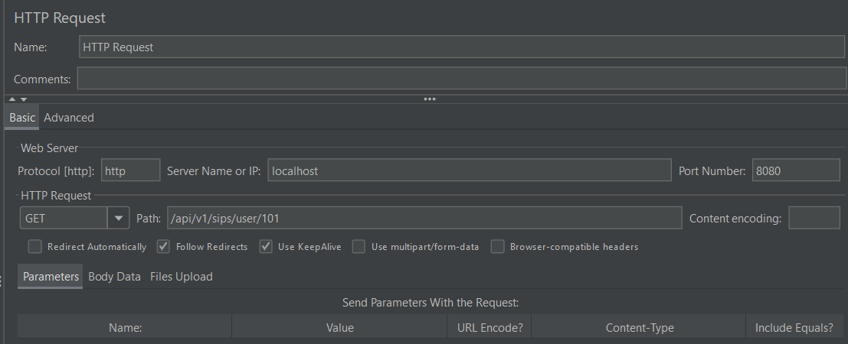

2. Summary Report
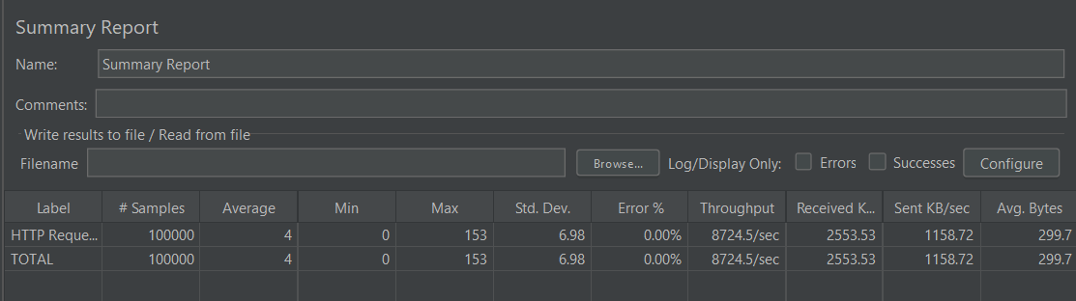

3. Aggregate Report
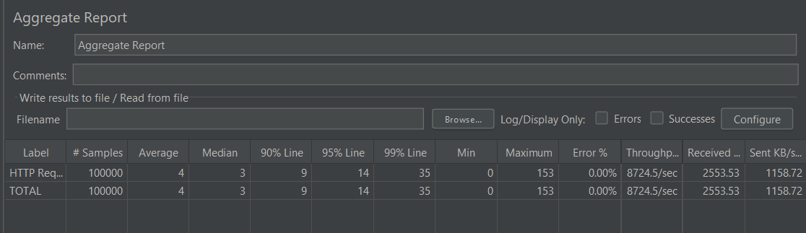

Performance Results — Test 2
Metric | Result
Samples | 100,000
Average | 4 ms
Median | 3 ms
90th Percentile | 9 ms
95th Percentile | 14 ms
99th Percentile | 35 ms
Minimum | 0 ms
Maximum | 153 ms
Standard Deviation | 6.98 ms
Error Rate | 0.00%
Throughput | 8,724.5 req/sec
Received | 2,553.53 KB/sec
Sent | 1,158.72 KB/sec
Average Bytes | 299.7 bytes

Test Comparison
Metric | Test 1 — 1000×100 | Test 2 — 100×1000
Samples | 100,000 | 100,000
Average | 1 ms | 4 ms
Median | 1 ms | 3 ms
P90 | 2 ms | 9 ms
P95 | 3 ms | 14 ms
P99 | 6 ms | 35 ms
Maximum | 59 ms | 153 ms
Error Rate | 0.00% | 0.00%
Throughput | 9,951.2 req/sec | 8,724.5 req/sec

Analysis
- Both workloads completed all 100,000 requests successfully with a 0.00% error rate.
- Test 1 produced the stronger latency profile, with a 1 ms average, 2 ms P90, and 6 ms P99.
- Test 2 remained very fast, but its average latency increased to 4 ms and P99 to 35 ms.
- Test 1 also recorded the higher throughput at 9,951.2 requests/sec versus 8,724.5 requests/sec in Test 2.
- The results show that this user-specific retrieval endpoint handled both the higher-concurrency and higher-iteration workloads successfully in the tested local environment.

Best Overall Latency Result
Test 1 — High Concurrency (1,000 threads × 100 loops) delivered the best overall latency, with 1 ms average latency, 1 ms median latency, 2 ms P90, 3 ms P95, and 6 ms P99.

Highest Throughput
Test 1 — High Concurrency achieved the highest measured throughput at 9,951.2 requests/sec, while maintaining a 0.00% error rate.

Final Status
PASS
GET /api/v1/sips/user/{userId} successfully processed 100,000 requests in each of the two JMeter workloads without errors. The measured latency and throughput were strong in both scenarios, with Test 1 providing the best overall result.

