JMeter Performance Testing Report
SIP & NAV Allocation Engine
Endpoint #5 — POST /api/v1/funds
Create Fund

Purpose
This report evaluates the performance and stability of the Create Fund REST endpoint under two 100,000-request JMeter workloads. The endpoint was tested using unique fund symbols generated with JMeter's ${__UUID()} function so that each POST request represents a valid fund-creation operation without violating the database uniqueness constraint.

Test 1 — High Concurrency
Configuration | Value
Endpoint | POST /api/v1/funds
Threads (Users) | 1000
Loop Count | 100
Total Requests | 100,000
Ramp-Up Period | 10 seconds
Request Body | JSON
Unique Symbol | FUND-${__UUID()}

JMeter Test Evidence — Test 1
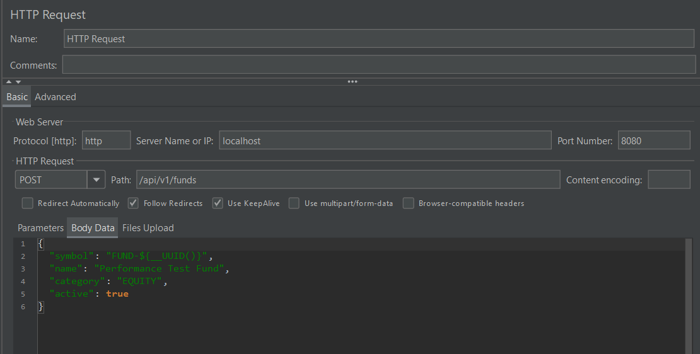
Figure 1 — HTTP Request Configuration

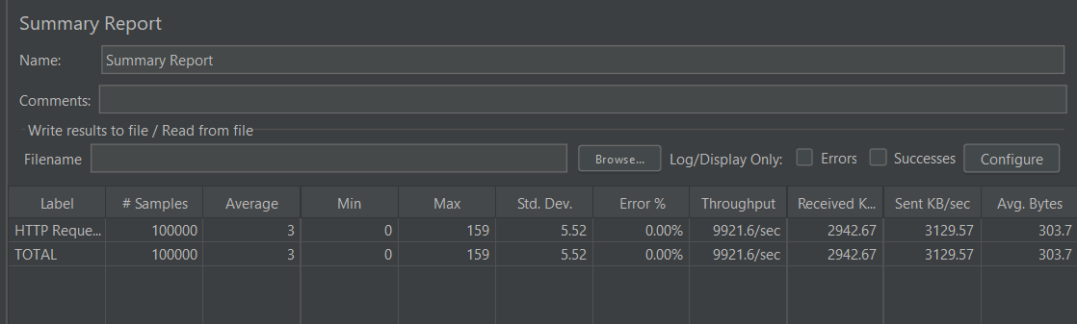
Figure 2 — Summary Report

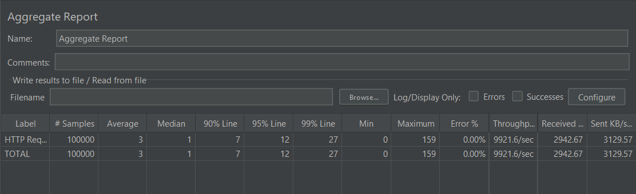
Figure 3 — Aggregate Report

Performance Results — Test 1
Metric | Result
Samples | 100,000
Average | 3 ms
Median | 1 ms
90% Line (P90) | 7 ms
95% Line (P95) | 12 ms
99% Line (P99) | 27 ms
Minimum | 0 ms
Maximum | 159 ms
Standard Deviation | 5.52 ms
Error % | 0.00%
Throughput | 9,921.6 req/sec
Received | 2942.67 KB/sec
Sent | 3129.57 KB/sec
Average Bytes | 303.7 bytes

Test 2 — High Iteration
Configuration | Value
Endpoint | POST /api/v1/funds
Threads (Users) | 100
Loop Count | 1000
Total Requests | 100,000
Ramp-Up Period | 10 seconds
Request Body | JSON
Unique Symbol | FUND-${__UUID()}

JMeter Test Evidence — Test 2
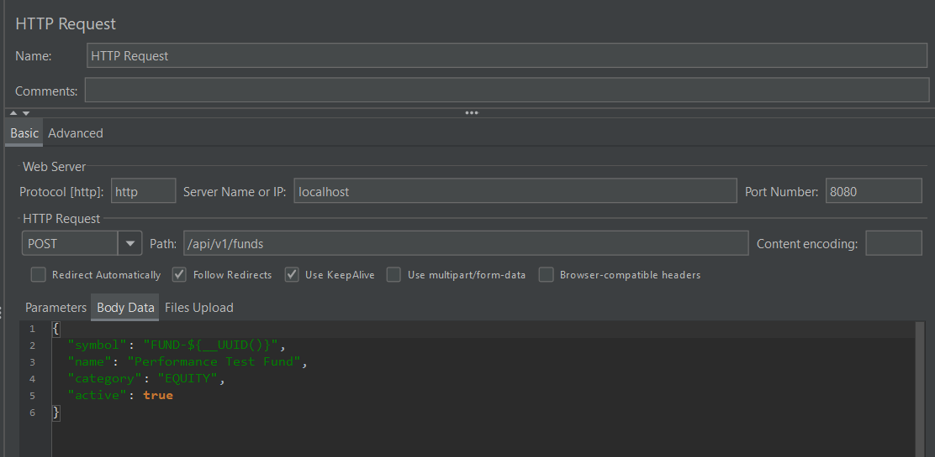
Figure 4 — HTTP Request Configuration

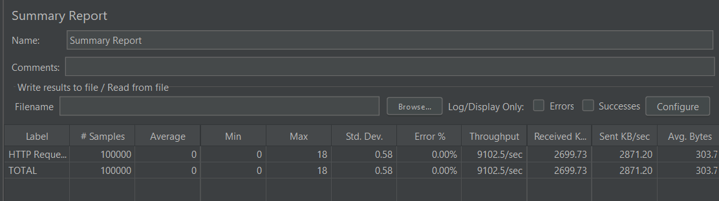
Figure 5 — Summary Report

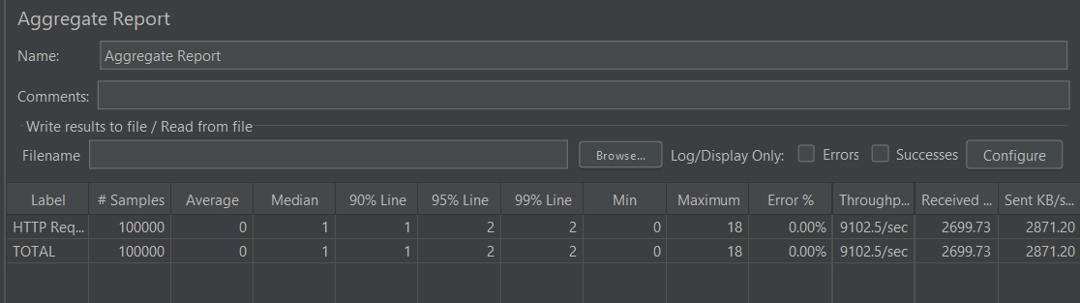
Figure 6 — Aggregate Report

Performance Results — Test 2
Metric | Result
Samples | 100,000
Average | 0 ms
Median | 1 ms
90% Line (P90) | 1 ms
95% Line (P95) | 2 ms
99% Line (P99) | 2 ms
Minimum | 0 ms
Maximum | 18 ms
Standard Deviation | 0.58 ms
Error % | 0.00%
Throughput | 9,102.5 req/sec
Received | 2699.73 KB/sec
Sent | 2871.20 KB/sec
Average Bytes | 303.7 bytes

Test Comparison
Metric | 1000 × 100 | 100 × 1000
Total Requests | 100,000 | 100,000
Average | 3 ms | 0 ms
Median | 1 ms | 1 ms
P90 | 7 ms | 1 ms
P95 | 12 ms | 2 ms
P99 | 27 ms | 2 ms
Maximum | 159 ms | 18 ms
Error % | 0.00% | 0.00%
Throughput | 9,921.6 req/sec | 9,102.5 req/sec

Analysis
- Both workloads completed the full 100,000 requests with a 0.00% error rate.
- The High Concurrency test achieved the highest throughput at 9,921.6 requests/sec.
- The High Iteration test produced the lowest observed latency, with a P99 of 2 ms and a maximum of 18 ms.
- The High Concurrency test showed slightly higher latency under 1000 concurrent threads, reaching a P99 of 27 ms and a maximum of 159 ms.
- The results indicate that the endpoint remained stable under both concurrency-heavy and iteration-heavy workloads.
- The request payload used a UUID-based symbol, allowing each POST to create a distinct fund while preserving the database uniqueness constraint.

Best Overall Latency Result
Test 2 — 100 threads × 1000 loops achieved the best overall latency profile: P99 = 2 ms and maximum = 18 ms.

Highest Throughput
Test 1 — 1000 threads × 100 loops achieved the highest measured throughput of 9,921.6 requests/sec.

Final Status
PASSED — Both JMeter workloads successfully processed 100,000 requests with 0.00% errors. The Create Fund endpoint demonstrated low latency and high throughput under both test configurations.

