JMeter Performance Testing Report
SIP & NAV Allocation Engine
Endpoint #6 — POST /api/v1/nav
Purpose
This performance test evaluates the NAV creation endpoint under two load patterns: high concurrency and high iteration. Each test executes 100,000 POST requests against the Spring Boot backend. The JMeter evidence and measured results are documented below.
Test 1 — High Concurrency
Endpoint | POST /api/v1/nav
Threads | 1000
Loop Count | 100
Ramp-Up | 10 seconds
Total Requests | 100,000
JMeter Test Evidence — Test 1
1. HTTP Request Configuration
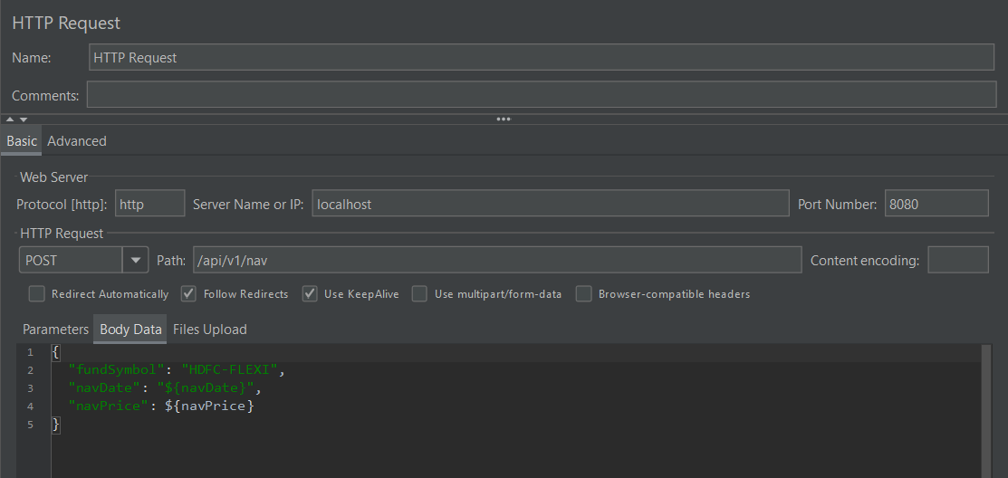
2. JSR223 PreProcessor Configuration
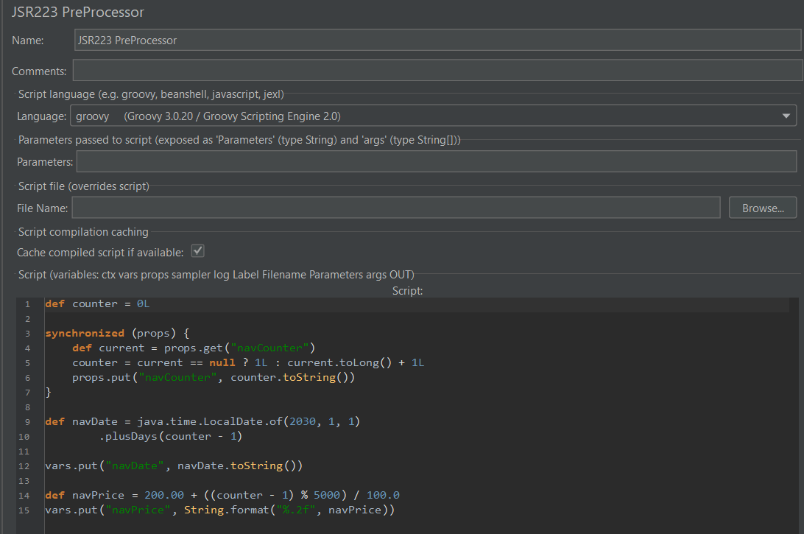
3. Summary Report
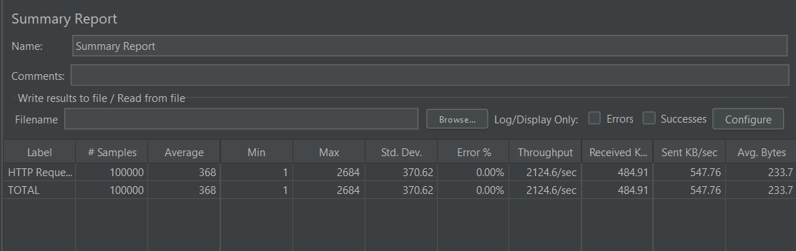
4. Aggregate Report
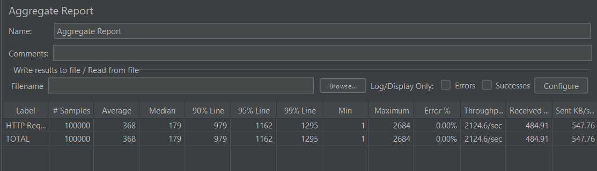
Performance Results — Test 1
Total Requests | 100,000
Average | 368 ms
Median | 179 ms
P90 | 979 ms
P95 | 1162 ms
P99 | 1295 ms
Minimum | 1 ms
Maximum | 2684 ms
Std. Dev. | 370.62 ms
Error Rate | 0.00%
Throughput | 2124.6 req/sec
Received | 484.91 KB/sec
Sent | 547.76 KB/sec
Average Bytes | 233.7 bytes
Test 2 — High Iteration
Endpoint | POST /api/v1/nav
Threads | 100
Loop Count | 1000
Ramp-Up | 10 seconds
Total Requests | 100,000
JMeter Test Evidence — Test 2
1. HTTP Request Configuration
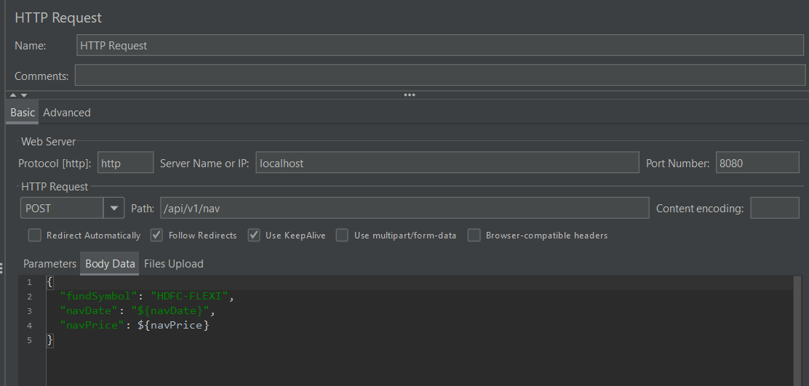
2. JSR223 PreProcessor Configuration
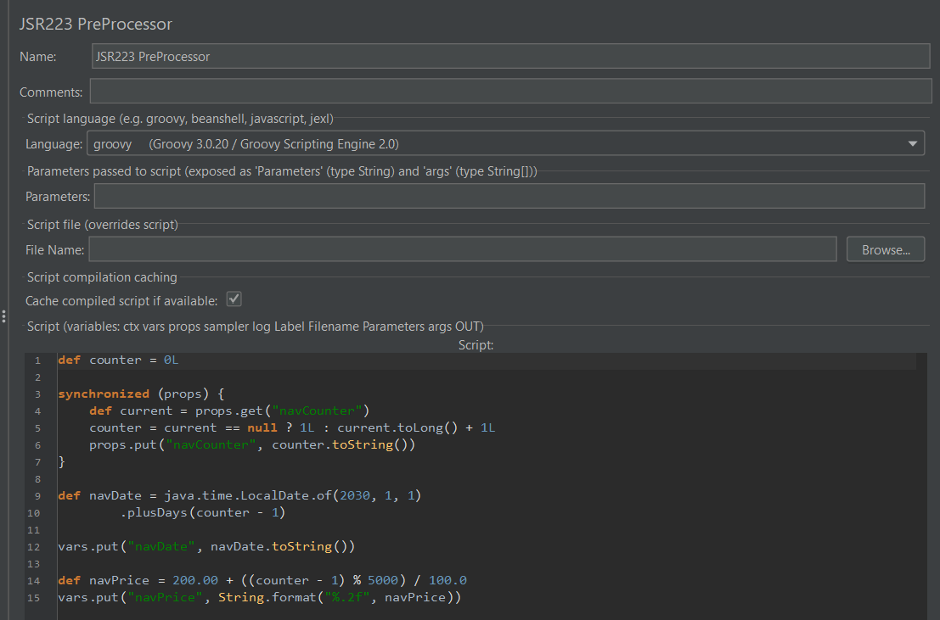
3. Summary Report
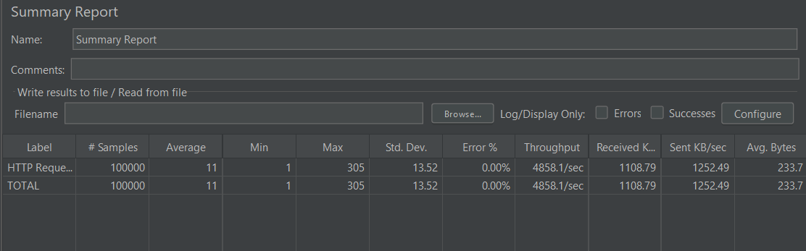
4. Aggregate Report
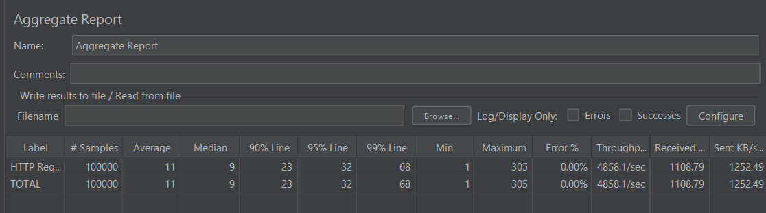
Performance Results — Test 2
Total Requests | 100,000
Average | 11 ms
Median | 9 ms
P90 | 23 ms
P95 | 32 ms
P99 | 68 ms
Minimum | 1 ms
Maximum | 305 ms
Std. Dev. | 13.52 ms
Error Rate | 0.00%
Throughput | 4858.1 req/sec
Received | 1108.79 KB/sec
Sent | 1252.49 KB/sec
Average Bytes | 233.7 bytes
Test Comparison
Metric | Test 1 — 1000×100 | Test 2 — 100×1000
Average | 368 ms | 11 ms
Median | 179 ms | 9 ms
P90 | 979 ms | 23 ms
P95 | 1162 ms | 32 ms
P99 | 1295 ms | 68 ms
Minimum | 1 ms | 1 ms
Maximum | 2684 ms | 305 ms
Std. Dev. | 370.62 ms | 13.52 ms
Error Rate | 0.00% | 0.00%
Throughput | 2124.6 req/sec | 4858.1 req/sec
Analysis
Both load tests completed 100,000 requests with a 0.00% error rate, demonstrating successful request processing under both load patterns.
The high-concurrency test recorded 368 ms average latency and 1295 ms P99 latency.
The high-iteration test recorded substantially lower latency at 11 ms average and 68 ms P99.
Throughput was higher in the high-iteration test at 4858.1 requests/sec compared with 2124.6 requests/sec in the high-concurrency test.
The endpoint therefore showed better latency and throughput when the same total workload was distributed across fewer concurrent threads with more iterations per thread.
Best overall latency result: Test 2 — 11 ms average latency, 9 ms median, and 68 ms P99.
Highest throughput: Test 2 — 4858.1 requests/sec.
Final Status
PASS — Both tests completed 100,000 requests with 0.00% errors. The POST /api/v1/nav endpoint successfully handled both high-concurrency and high-iteration workloads.

