**Problem Statement**

As a part of developing an e-commerce web application, the admin backend requires a module that can retrieve product information based on the product ID.

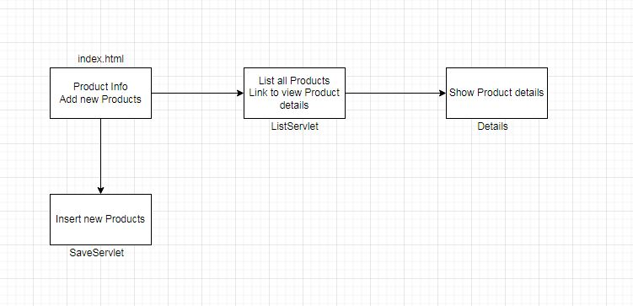**Flow of the Program**