**Problem Statement**

As a part of developing an e-commerce web application, you have to create a database table for storing product information. A form is needed to add new products. The form submission is validated, and a new record is created in the product table.

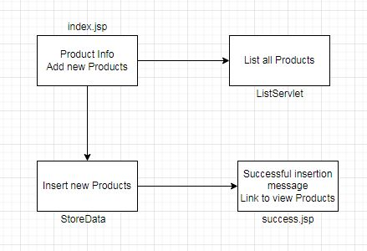**Flow of the Program**