**Problem Statement**

As a part of developing an ecommerce web application, you have to prototype a form for adding products into the system entered by the users. There is no database involved here, so the product is just captured and displayed without storing it anywhere.

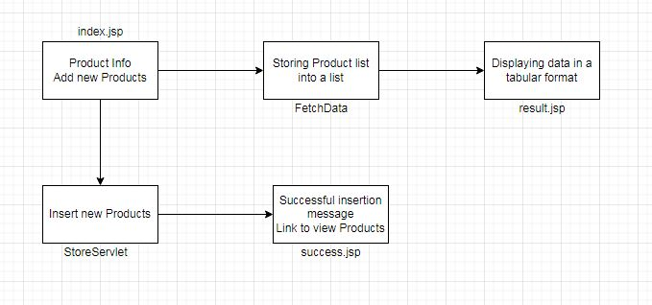**Flow of the Program**