SMART CITY GUIDE
Capstone Project Report
A desktop application for exploring cities — built with Java Swing and MySQL.

Author
Anurag Pandey
Contact: anuragpandeygct@gmail.com
Version 1.0

Table of Contents

1. Project Overview
Smart City Guide is a desktop application that gives travellers and residents one place to look up everything they need to navigate a city — facts about the city itself, where to stay, what to see, where to eat, how to get around, and where to shop.
The application is delivered as a single self-installing Windows package with its own bundled Java runtime. Users only need a local MySQL Server. On first launch, the application prompts for MySQL credentials, automatically creates its database, seeds twenty cities of data, and is immediately usable.

Goals
- Single self-contained executable; no Java install required on the end user's machine.
- Zero manual database setup. The schema and seed data are created automatically on first launch.
- Consistent dark-themed UI across every screen.
- Real input validation, hashed passwords, and externalised credentials.
- Clear separation between presentation, navigation, services, and data access.

Intended Users
Travellers planning a trip; residents looking up local services; demonstration audiences such as evaluators of a capstone project. The application is designed for a single user per machine and is not multi-tenant.

2. Technology Stack
Every part of the stack was chosen to maximise portability and minimise dependencies on third-party libraries.

Layer | Technology | Reason
Language | Java 11 (compiled), JDK 17+ (packaging) | Mature, cross-platform, available on every target machine.
UI framework | Java Swing with Nimbus L&F | Bundled with the JDK. No external GUI dependency.
Database | MySQL Server 5.7 or 8.x | Free, widely available, well-known SQL dialect.
JDBC driver | MySQL Connector/J 9.2.0 | Official driver. Bundled inside the fat JAR.
Password hashing | PBKDF2-HMAC-SHA256 (built into JDK) | OWASP-recommended; no external dependency.
Packaging | jpackage (JDK 17+) | Produces a Windows app-image with a bundled JRE.
Build scripts | Windows batch (build.bat, package.bat) | Zero build-tool dependency. Re-run anywhere with a JDK.

3. System Architecture
Smart City Guide is organised into four horizontal layers. Each layer talks only to the one immediately below it; nothing reaches across the diagram. This keeps the codebase easy to read and isolates concerns.
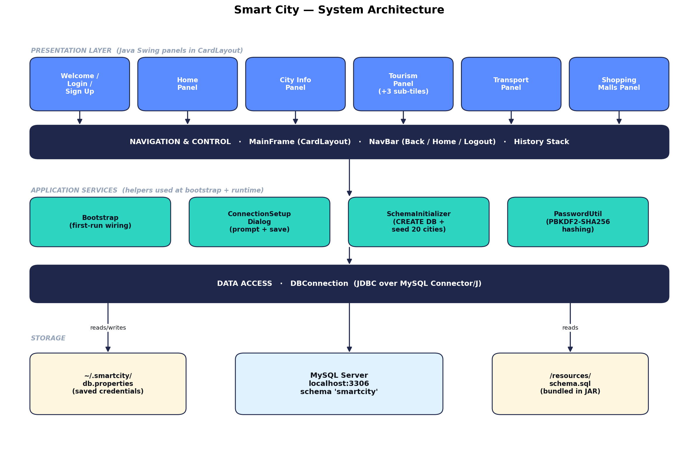
Figure 1 — System architecture: presentation, navigation, services, data access, and storage.

Presentation Layer
All user-visible screens are Java Swing JPanels held in a CardLayout. The same Welcome, Login, Sign Up, Home, City Info, Tourism (with three sub-tiles), Transportation, and Shopping Malls panels are registered once and switched into view as the user navigates.

Navigation & Control
MainFrame hosts the CardLayout. The NavBar contains Back, Home, and Logout buttons plus a breadcrumb. A simple in-memory navigation history stack supports the Back action — each forward navigation pushes the prior card; Back pops and re-displays it.

Application Services
Four helpers used at bootstrap and runtime: Bootstrap orchestrates the first-run sequence; ConnectionSetupDialog is the modal that collects MySQL credentials; SchemaInitializer creates and seeds the database from the bundled schema.sql; PasswordUtil produces PBKDF2-HMAC-SHA256 hashes for user passwords.

Data Access
A single DBConnection class is the only code that touches JDBC. It exposes two connection modes: a server-mode connection (no schema selected, used during bootstrap), and a database-mode connection scoped to the smartcity schema (used by every panel).

Storage
Three external pieces of state: MySQL Server at localhost:3306 holds the smartcity schema with all data; ~/.smartcity/db.properties stores the saved MySQL credentials per user; and /resources/schema.sql lives inside the JAR, consumed once by SchemaInitializer on first launch.

4. Navigation Flow
Every screen is one card in a CardLayout. From the user's perspective the app is a tree rooted at the Home dashboard, with sub-trees under Tourism. The NavBar's Back button reverses one step at a time using an internal history stack.
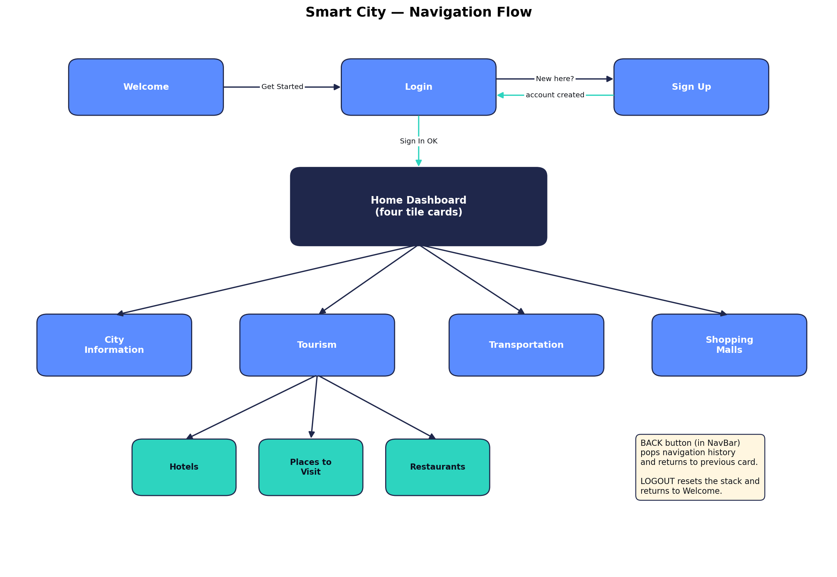
Figure 2 — Navigation flow between cards.

Authentication Sub-tree
The initial Welcome screen leads to Login. Login offers a link to Sign Up; successful account creation returns the user to Login. Successful sign-in resets the history stack and switches to Home with the Navigation Bar revealed.

Main Sub-tree
From the Home dashboard, four tile cards lead to City Information, Tourism, Transportation, and Shopping Malls. Tourism is itself a hub of three sub-tiles: Hotels, Places to Visit, and Restaurants.

Back and Logout Semantics
The Back button is enabled only when there is at least one card on the history stack and the user is not currently on a root card (Welcome, Login, Sign Up, or Home). Logout always clears the history stack and returns to Welcome, hiding the Navigation Bar in the process.

5. First-Run Bootstrap
The Bootstrap class runs before MainFrame appears. Its job is to make sure the application has a working MySQL connection and that the smartcity database exists with seeded data.
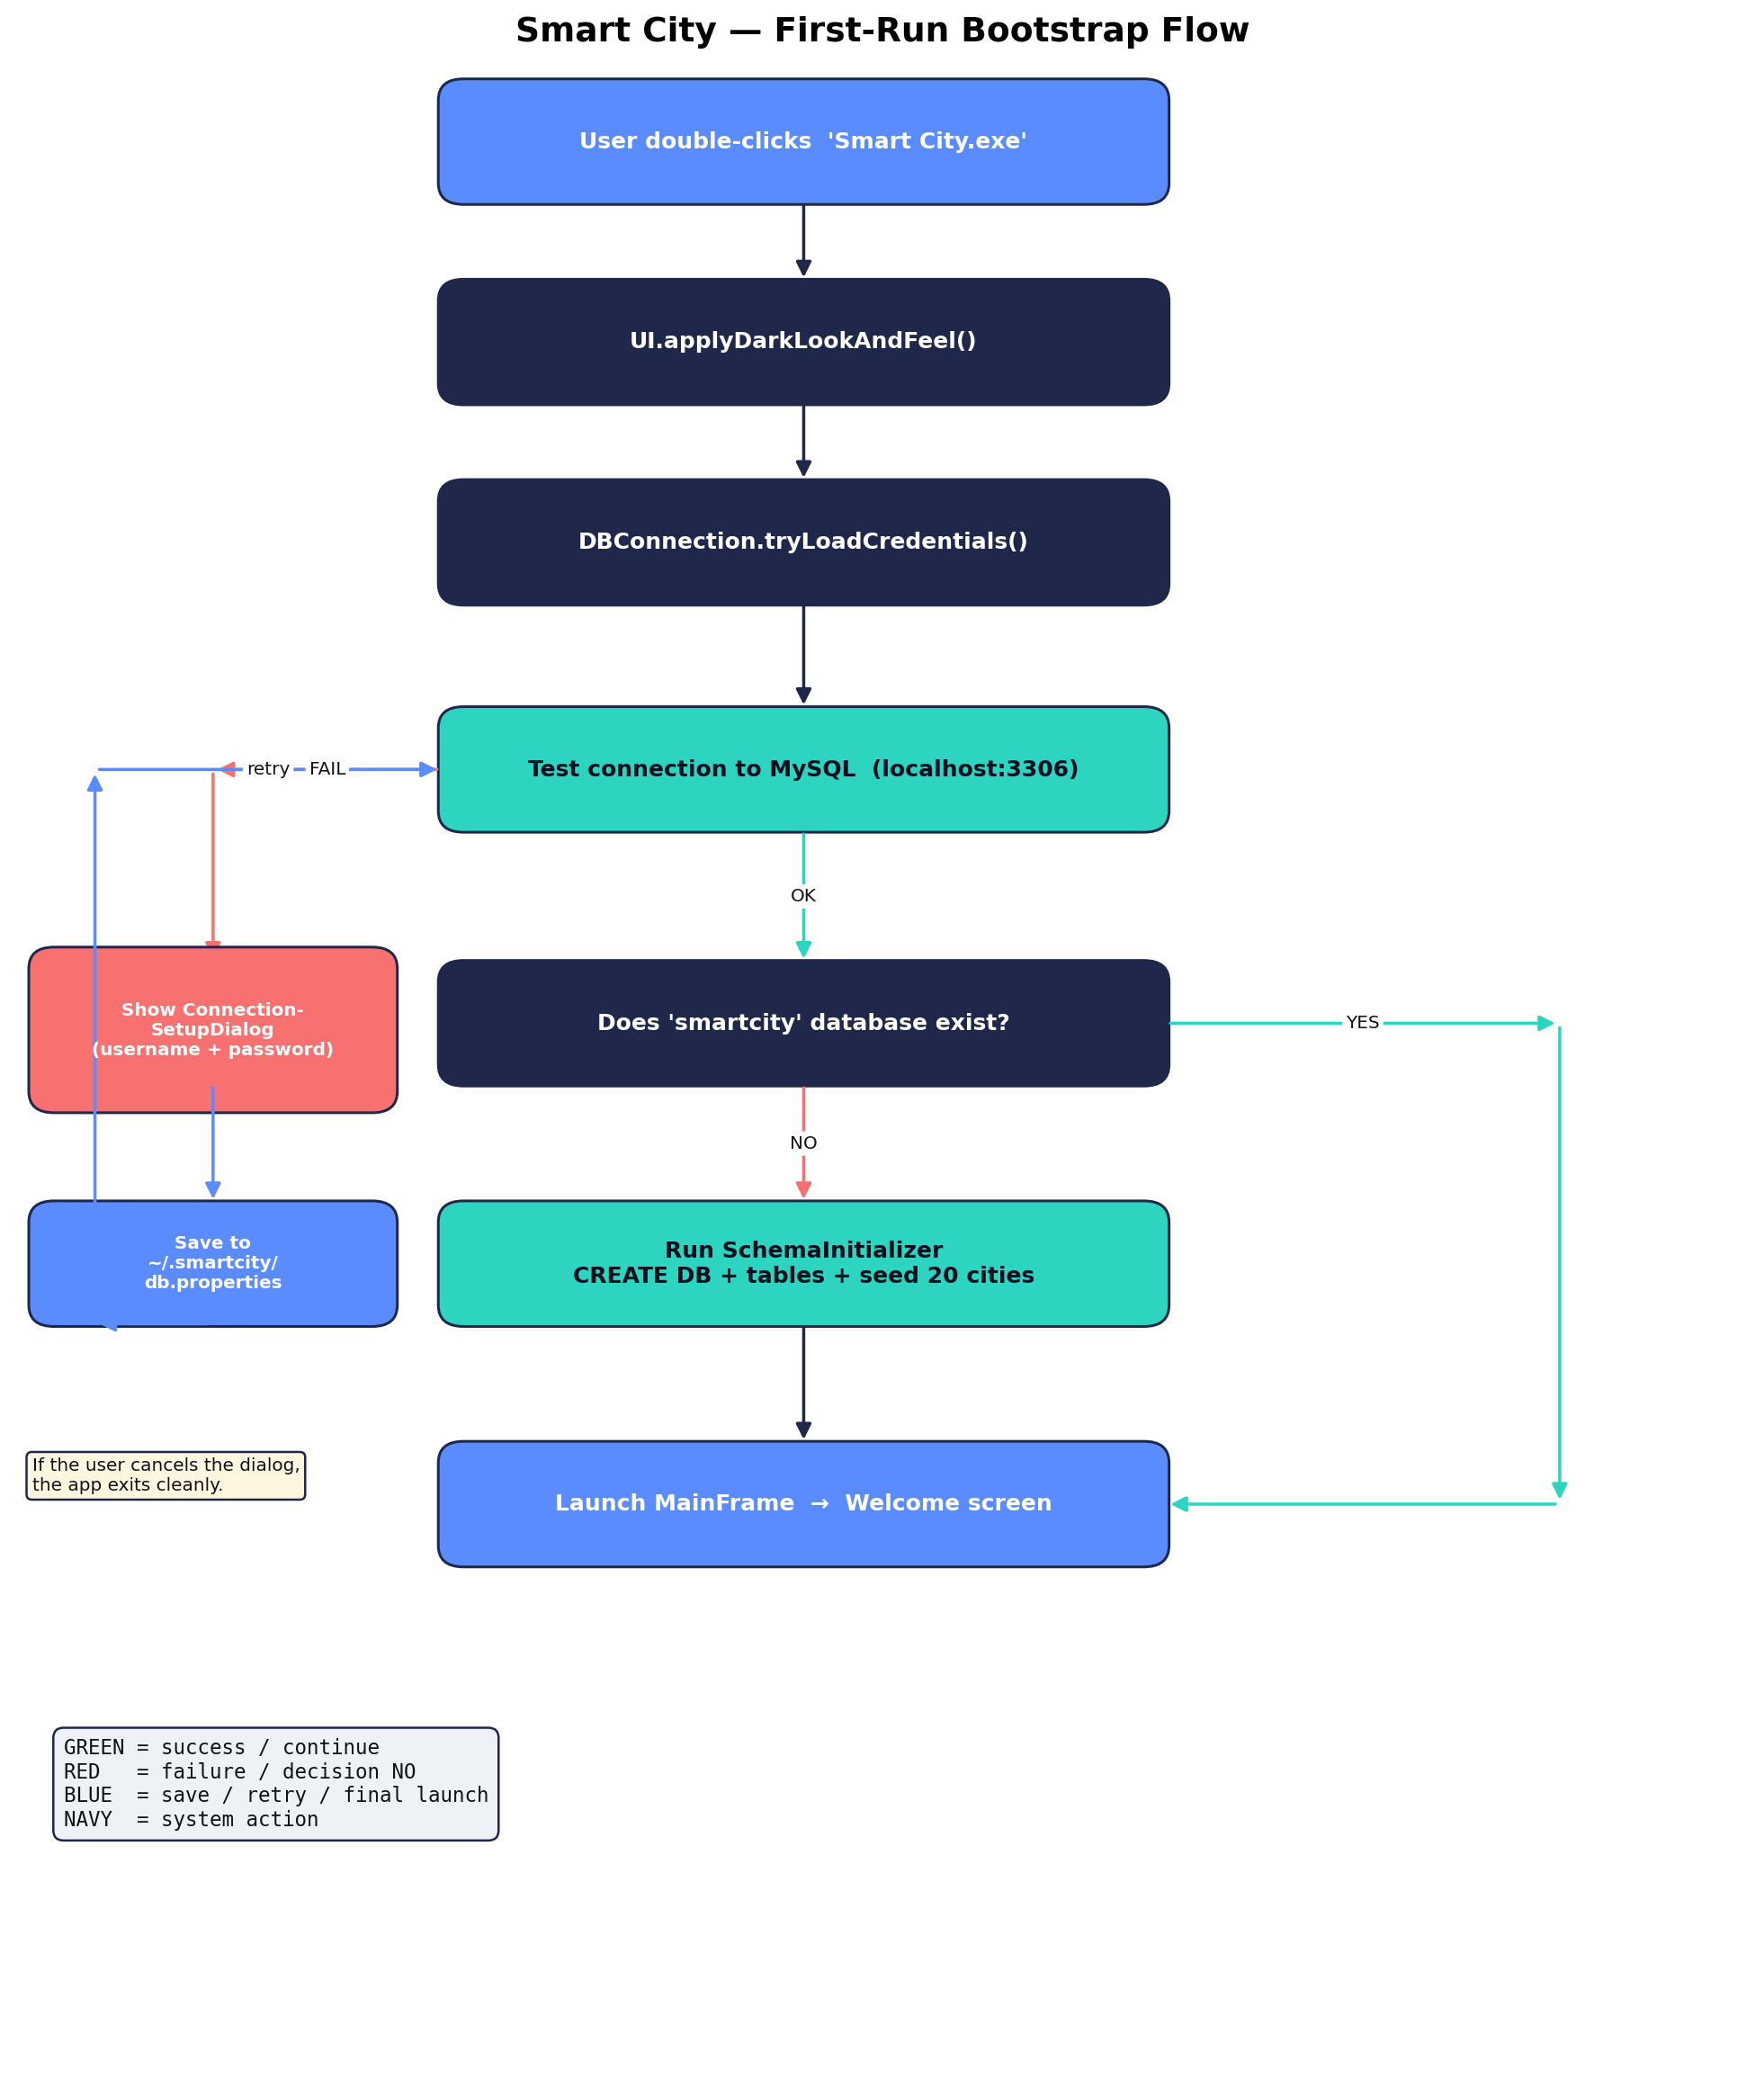
Figure 3 — First-run bootstrap sequence.

Step-by-Step
1. The user double-clicks Smart City.exe (or runs the JAR via java -jar).
2. UI.applyDarkLookAndFeel() installs Nimbus and overrides UIManager defaults so every dialog spawned from this point onward is themed correctly.
3. DBConnection.tryLoadCredentials() looks for ~/.smartcity/db.properties first, then ./db.properties as a development override. On first launch neither exists, so this returns false.
4. Bootstrap tests the loaded credentials against MySQL. If the test fails (no credentials, wrong credentials, or server not reachable), it shows the ConnectionSetupDialog.
5. The user enters a MySQL username and password. The dialog tests them on a background thread (no UI freeze) and, on success, writes them to ~/.smartcity/db.properties. The loop then re-tests the connection.
6. With a working connection, Bootstrap checks information_schema for a database named smartcity. If it does not exist, SchemaInitializer loads /resources/schema.sql from the JAR, splits it into individual SQL statements (respecting quoted strings), and executes each one against the server connection. This creates the database, all seven tables, and seeds twenty cities of data plus the related hotels, restaurants, tourist places, transport routes, and shopping malls.
7. Control returns to MainFrame.main(), which creates the main window and shows the Welcome screen.
Subsequent launches skip steps 4 and 6 entirely and land on Welcome in under one second.

6. Database Schema
The smartcity database contains seven tables. Each panel issues a single WHERE-LIKE query against exactly one table — there are no cross-table joins at runtime, which keeps query plans trivial.
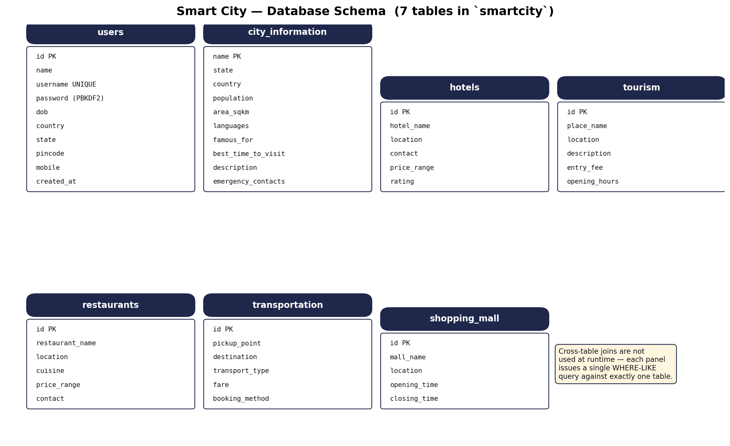
Figure 4 — Smart City database schema (7 tables).

Tables at a Glance
Table | Purpose | Primary lookup
users | Account records for sign-in (hashed passwords) | username (exact)
city_information | City profile (population, languages, attractions, contacts) | name (exact)
hotels | Hotels available for stay | location (LIKE)
tourism | Places to visit / attractions | location (LIKE)
restaurants | Restaurants by cuisine and price | location (LIKE)
transportation | Pickup → destination routes with fare | (pickup, destination) exact
shopping_mall | Malls with opening/closing hours | location (LIKE)

Notable Schema Choices
- password is VARCHAR(255) — sized to hold a PBKDF2 record (scheme$iterations$saltB64$hashB64, ~120 chars).
- pincode is VARCHAR(10) — string-typed to preserve leading zeros that an INT would silently drop.
- city_information.name is the primary key (not a synthetic id) — the City Info panel always looks up by name.
- Each searchable table has an index on the location column to keep LIKE-prefix queries fast even with many rows.

7. Module Breakdown
The Java code is contained in 17 source files under com.smartcity. The table below summarises each.

File | Responsibility
MainFrame.java | Application entry point; single window hosting the CardLayout; navigation history stack.
NavBar.java | Top navigation bar (Back, breadcrumb, greeting, Home, Logout).
UI.java | Central theme — palette, fonts, spacing, button factory, card factory, dark L&F installer.
Bootstrap.java | First-run orchestrator (load creds → test → prompt loop → init schema).
ConnectionSetupDialog.java | Modal that collects + tests + persists MySQL credentials.
SchemaInitializer.java | Loads bundled schema.sql, splits SQL statements, executes against MySQL.
DBConnection.java | JDBC connection factory; credential loader; server-mode and DB-mode connections.
PasswordUtil.java | PBKDF2-HMAC-SHA256 password hashing and constant-time verification.
WelcomePanel.java | Landing screen with Get Started button.
LoginPanel.java | Sign-in form; validates credentials against users table.
SignUpPanel.java | Registration form with full input validation (DOB, pincode, mobile, password).
HomePanel.java | Post-login dashboard; four tile cards routing into sections.
CityInfoPanel.java | Rich city profile renderer (facts grid + HTML description + emergency callout).
TourismPanel.java | Tourism hub with three sub-tile cards.
SearchableTablePanel.java | Abstract base for any location-based search-and-table screen.
HotelsPanel / RestaurantsPanel / TouristPlacesPanel / ShoppingMallsPanel | Thin subclasses of SearchableTablePanel: just config + result mapping.
TransportationPanel.java | Pickup + destination dropdowns; renders results as cards.

8. Current Location Coverage
The seed data ships with twenty cities, picked to give a mix of large Indian metros, regional capitals, hill stations, heritage cities, and a few international hubs that the app can demonstrate end-to-end.

Indian Metros
Mumbai (Maharashtra), Bengaluru (Karnataka), Delhi (Delhi), Chennai (Tamil Nadu), Kolkata (West Bengal), Hyderabad (Telangana), Pune (Maharashtra), Ahmedabad (Gujarat).

Heritage & Tourist Cities
Jaipur (Rajasthan — the Pink City), Udaipur (Rajasthan — the City of Lakes), Varanasi (Uttar Pradesh — spiritual capital), Goa (Goa — beaches and Portuguese heritage), Kochi (Kerala — backwaters).

Hill Stations
Shimla (Himachal Pradesh — former British summer capital), Manali (Himachal Pradesh — snow sports), Darjeeling (West Bengal — tea estates and the toy train).

International
Singapore (city-state), Dubai (United Arab Emirates).

Synthetic / Demo
Springfield (Illinois, USA) — included so that the Transportation routes referencing Springfield as a destination resolve to a real city profile. TechVille — a fictional technology township that anchors several of the seeded transport routes (Bike Station → TechVille, Scooter Stand → TechVille).

Transport Network
The transportation table contains 30 routes connecting 10 pickup points (Central Station, Airport, Metro Station, Railway Station, Uptown, Harbor, Bike Station, Scooter Stand, Hotel, Downtown) to 8 destinations (Downtown, City Center, TechVille, Springfield, Old Town, Coastal Town, Airport, Any Destination), each with a transport type, fare, and booking method.

Adding More Locations
New locations are added by inserting rows into the relevant tables. No application code change is required — the panels render whatever rows the queries return. The intent is for future versions to add at least a dozen more cities and expand transport routes to cover intra-city routes within each city.

9. Security Posture

Password Hashing
User passwords are never stored in plain text. PasswordUtil.hash() generates a 16-byte cryptographically random salt, runs PBKDF2-HMAC-SHA256 with 120,000 iterations (OWASP 2023 floor), and stores the result as a single string of the form pbkdf2_sha256$120000$<base64Salt>$<base64Hash>. Verification uses a constant-time byte comparison to prevent timing attacks.

Credential Externalisation
The MySQL username and password are never hardcoded in source. They live in ~/.smartcity/db.properties, written only after a successful connection test. The file is created with restrictive permissions on POSIX systems. db.properties is included in .gitignore so it can never accidentally be committed.

Prepared Statements
Every SQL query in the application uses PreparedStatement with parameter binding. There is no string concatenation of user input into SQL, eliminating the standard class of SQL-injection attacks.

Resource Hygiene
Every JDBC Connection, PreparedStatement, and ResultSet is opened inside try-with-resources, guaranteeing release even when an exception is thrown mid-operation. There are no connection leaks anywhere in the codebase.

10. Limitations
Honest list of what this application does NOT do, so that evaluators and future contributors have realistic expectations.
- Requires MySQL Server installed locally on every machine the app runs on. The bundled JRE eliminates the Java install requirement, but not the MySQL install requirement. An embedded database such as SQLite or H2 would remove this dependency but was not pursued in this version.
- Windows-only deployment. The packaged installer is built with jpackage targeting Windows x64. Building Mac or Linux installers would require running jpackage on each respective platform.
- No network/multi-user mode. The application assumes a single user per machine; there is no support for remote MySQL servers, role-based access, or concurrent users.
- Read-only catalog. Users cannot add hotels, restaurants, or transport routes through the UI — only sign up as a user. Catalog rows are inserted directly via the seed script.
- Twenty cities in the seed data. Not a global catalog — coverage is illustrative, not exhaustive.
- Search is exact-match for City Information (case-sensitive) and substring-LIKE for hotels/restaurants/places/malls. There is no fuzzy matching, no spell correction, and no autocomplete.
- DOB is parsed strictly as YYYY-MM-DD. No date picker widget.
- Saved credentials are stored in a properties file in the user's home directory. They are not encrypted at rest — anyone with read access to the file can see the password. A real production app would use the OS credential store (DPAPI on Windows, Keychain on macOS).
- Swing's dark theming via Nimbus is imperfect: some native dialogs and combo-box popups may show a sliver of light colour on certain Windows builds. A drop-in FlatLaf jar would resolve this if absolute polish becomes a priority.
- No automated tests. The project relies on manual smoke testing of each panel after changes.

11. Deployment
Two scripts under the project root produce the deliverable. They assume a JDK 17+ is installed and on PATH.

Building the Fat JAR
Run build.bat. It compiles the Java sources, unpacks the MySQL Connector/J jar into the build directory, copies schema.sql onto the classpath under /resources/, and produces dist/SmartCity.jar — a single self-contained jar of roughly 3 MB. The JAR can be run on any machine with Java installed via: java -jar SmartCity.jar

Building the Windows Installer
Run package.bat after the JAR exists. It invokes jpackage with --type app-image to produce installer/Smart City/Smart City.exe, a launcher that uses a private JRE in the same folder. End users do not need Java installed. The folder is around 180 MB (most of it the JRE).

Distribution
Zip the installer/Smart City/ folder, share it. The recipient unzips it, double-clicks Smart City.exe, enters their MySQL credentials on first launch, and the app self-configures.

12. Future Work
- Replace MySQL with an embedded database (SQLite or H2) so the end user has zero external dependencies.
- Add an admin panel for inserting / editing hotels, restaurants, transport routes, and cities through the UI.
- Encrypt saved credentials at rest using the OS credential store (DPAPI on Windows).
- Replace exact-match City Information search with substring matching, case-insensitive comparison, and fuzzy-match suggestions.
- Add a date picker for the DOB field in Sign Up.
- Add Mac and Linux installer builds by running jpackage on those platforms.
- Add automated tests (JUnit) for SchemaInitializer, PasswordUtil, and SearchableTablePanel parameter binding.
- Add localisation support so the UI can be displayed in Hindi or other languages.

13. Author & Contact
Author: Anurag Pandey
Email: anuragpandeygct@gmail.com
Bug reports, suggestions, or contributions are welcome by email.

