Anurag Rachcha SQL 1 :

Answer 1) What authors are in California?

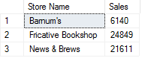

Answer 2) List the titles and author names

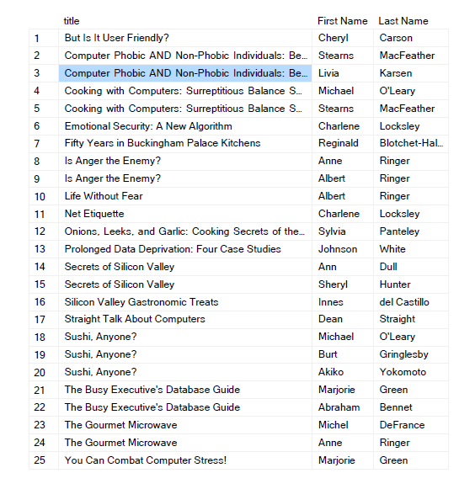

Answer 3) List all employees and their jobs

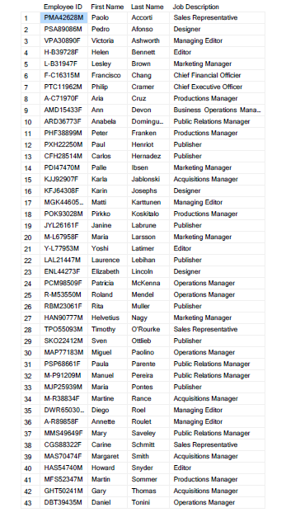

Answer 4) List the titles by total sales price

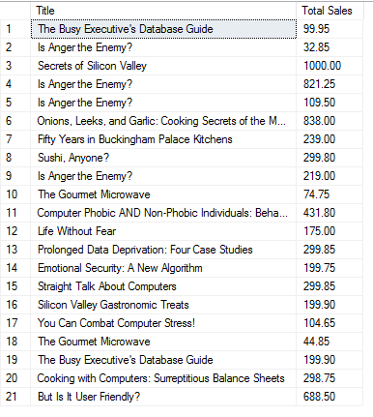

Answer 5) Find the sales for stores in California

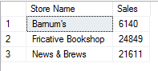

Answer 6)  Use SSMS to generate a script to create the authors table describe what the script does



P.S. Description of answer 6 has been given on the next page

Answer 6) (Continued..)  
The script creates a table named “authors1”. It has been called from ‘dbo’ as the  
Schema ‘dbo’ is a container that is holding the objects in the database. It has also   
Been given a constraint called “[UPKCL_audind1]” with ‘PRIMARY KEY CLUSTERED’  
which refers to a clustered index to define the physical storage of rows. The ‘ID’  
and ‘zip’ have also been given validation for input.

Answer 7) Describe what the au_id is using for a data type  
  
‘au_id’ is using a user defined data type pubs.dbo.id(varchar(11), not null)  
The system data type used here is ‘varchar(11)’ while also setting it to never being NULL.

Answer 8)  List the store name, title title name and quantity for all stores that have net 30 payterms

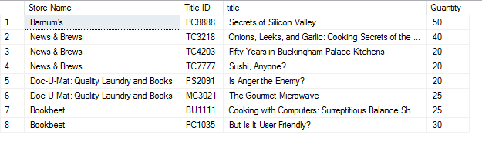

Answer 9) Find the titles that do not have any sales show the name of the title

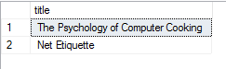

Answer 10) Do previous question another way

