Name : Anurag Rachcha

NUID : 001375637

--7 Create a function to change the case of a string. As Follows.  
          This is A TEST String  
          becomes           
          tHIS IS a test sTRING

-- 8 Create a function to return the gender of an employee based on the emploee id (gender is Male / Female)

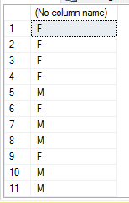

-- 9 Create a table function that returns the employee columns and a new row called gender (again Male / Female)

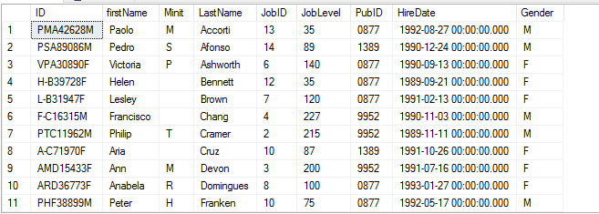

-- 10 Write a function to calculate age in years take into account the birth date



--11 Create a SQLprocedure to insert a record into the jobs table in pubs.  The procedure should validate the input before doing the insert.

