**Project Name: Sales Analysis**

**Candidate Name :Anurag Reddy**

**Problem Statement:The dataset is from a Global Enterprise that deals with sales of various products.**

**Get Data loaded-up and working.**

**Use Power Query for Data Cleansing**

**Create various Reports for Sales Analysis.**

**- Sales by Age, Gender, Marital Status, Territory, Category + Territory, Total sales: year wise and month wise etc.**

**Publish The Report.**

**Create a dashboard.**

**Software Requirement Details:**

**Power BI is a collection of software services, apps, and connectors that work together to turn your unrelated sources of data into coherent, visually immersive, and interactive insights. Your data may be an Excel spreadsheet, or a collection of cloud-based and on-premises hybrid data warehouses. Power BI lets you easily connect to your data sources, visualize and discover what's important, and share that with anyone or everyone you want.**

**Power BI consists of several elements that all work together, starting with these three basics:**

* **A Windows desktop application called Power BI Desktop.**
* **An online SaaS (Software as a Service) service called the Power BI service.**
* **Power BI mobile apps for Windows, iOS, and Android devices.**

**These three elements—Power BI Desktop, the service, and the mobile apps—are designed to let you create, share, and consume business insights in the way that serves you and your role most effectively.**

**Beyond those three, Power BI also features two other elements:**

* **Power BI Report Builder, for creating paginated reports to share in the Power BI service. Read more about** [**paginated reports**](https://docs.microsoft.com/en-us/power-bi/fundamentals/power-bi-overview#paginated-reports-in-the-power-bi-service) **later in this article.**
* **Power BI Report Server, an on-premises report server where you can publish your Power BI reports, after creating them in Power BI Desktop. Read more about** [**Power BI Report Server**](https://docs.microsoft.com/en-us/power-bi/fundamentals/power-bi-overview#on-premises-reporting-with-power-bi-report-server) **later in this article.**

**Project Description:**

**The aim of this project is to generate a comprehensive sales report of the product transactions of a global enterprise in power bi utilising the data provided to us by the enterprise.**

**The dataset consists of eight different tables namely Customer, Date, Geography, Product, ProductCategory, ProductSubCategory, SalesTerritory and FactInternetSales containing information about the customer, the date of purchase, region the customer belongs to, details about the product, names of the different categories, names of the different subcategories, sales in different region and the transaction details.**

**First, we study the sales in terms of the age,gender and marital status of the customer by plotting age on the x axis and the sales amount on the y axis. A card is used to display the sales amount and slicer to select the range of age and analysis is performed.**

**Secondly, sales with respect to years and months is analysed.A tree map is used to select and display the year, a card to display the amount of sales and another one to show the number of orders received that particular year or month, a column chart to represent sales in terms of months (columns are coloured denoting the semester of the year they were purchased in),a bar chart showing the sales in each month in the descending order and a slicer to select the fiscal quarter.**

**Next, we evaluate the purchase patterns with regards to the product category and territory with a funnel chart for sales in terms of territory and a column chart for category where we can drill down to the specific product**

**Furthermore, we assess sales with respect to occupation and income and then commute distance with slicers to pick the particular range of values**

**In closing, we bundle all the elements together to get a holistic understanding of how different factors affect the total sales individually and collectively**

**Results and conclusions** :

**Sales by year and month**

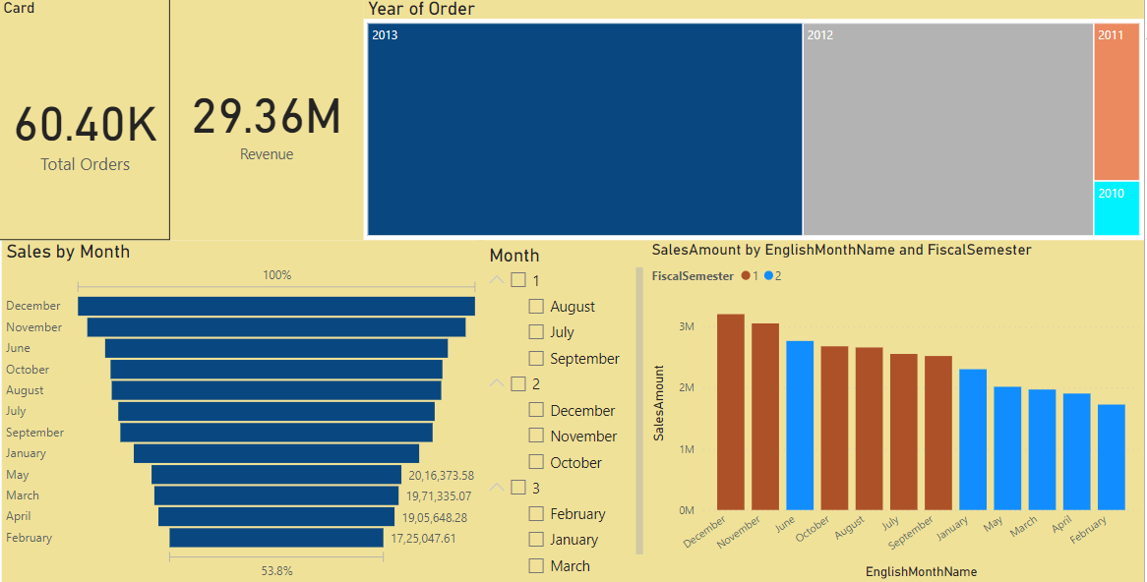

**The sales peak in the month of december and we can also see that the 1st semester sales (in the months of december, november, july august, september and october) exceed the 2nd semester sales by a decent margin.**

**A possible explanation for this could be the fact that the weather is more suited for bike riding in these months (summer and fall) in comparison to 2nd semester( rainy and winter)**

**As far as years go, 2013 and 2012 bring in the most sales followed by 2011 and 2010. There is a linear increase in sales but if we look further into the distribution of sales in terms of months we find that in the year 2013 most of the sales happen in the 1st semester and in the year 2010 sales are concentrated in the 2nd**

**Sales by age :**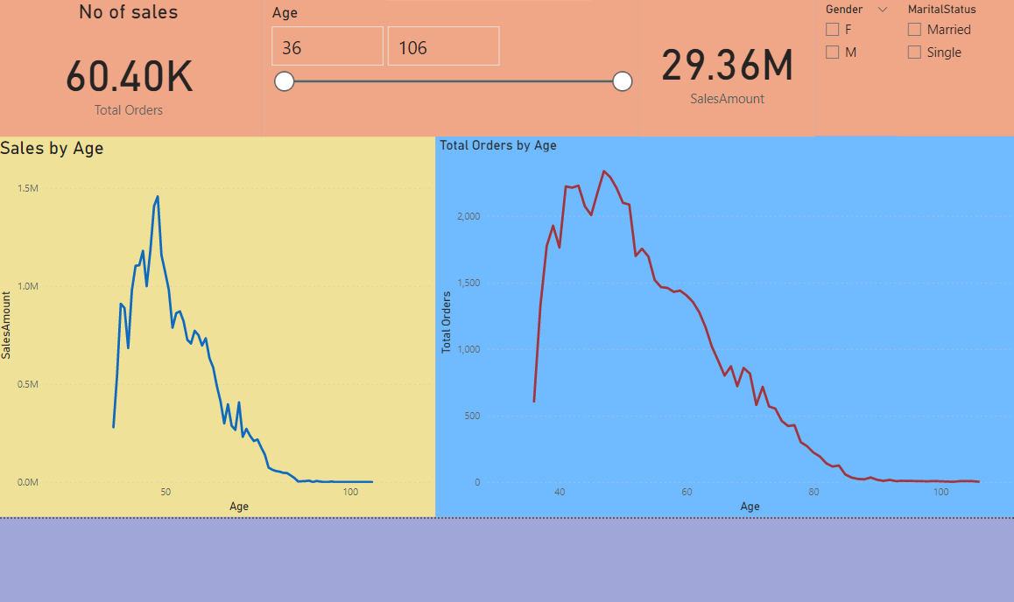

**It is clear from the graphs that maximum amount of sales occur a the age of 47 and it also seems to be the inflection point where the sales increase upto the age 48 and following which there is a steep decline. A similar trend is noticed for the orders receive with a slight variation in the upward section of the graph where we notice a bit more even distribution between the ages 40 and 48 whereas it is a bit more mountain like distribution for sales amount in that range**

**Sales are split halfways for both gender and marital status categories suggesting there is not much differentiation for these factors, hence there is no insight we can draw from there**

**Sales by category and territory :**

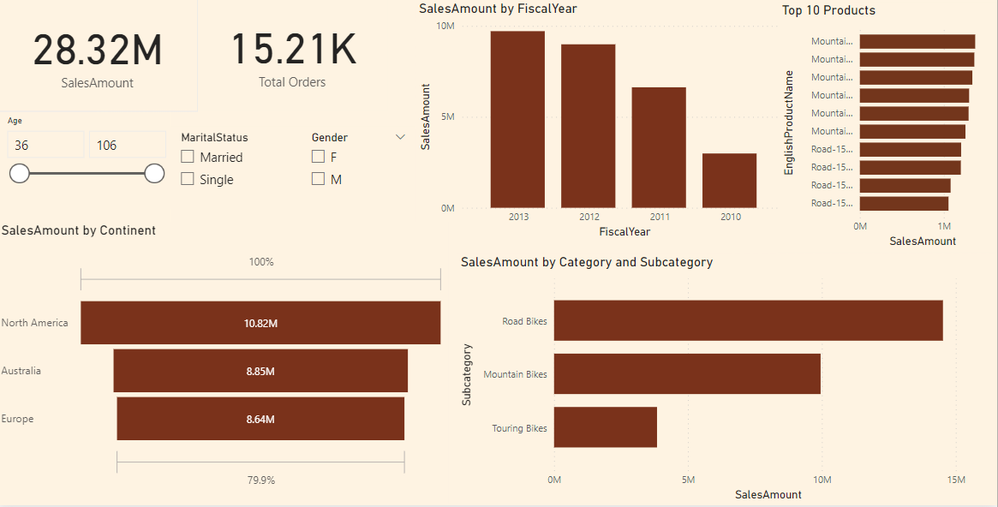

**We can see from the graph that Australia ranks the highest in terms of sales by territory and the lion’s share of the revenue generated is from bike sales. If we drill down further, we find that the sales of road bikes go down in the years 2012 and 2013 respectively due to a decrease in the popularity of its newer models road-250,350,450 and 550 in comparison to road-150 ( the model that accounted for the maximum proportion of the road bikes sales which was only sold in the years 2010 and 2011 ) and the opposite is the case for the sales of mountain bikes where we see an increase in the years 2012 and 2013 due to the success of it’s most popular model mountain-200 in theses years (the model was introduced in 2011 but saw an upswing in sales in the years 2012 and 2013).Also, the first model of the mountain bikes mountain-100 did not fare well in the market.if drill down to the states we find that sales in Tasmania( Australia ) go down by 100% from the year 2012 to 2013 and Saarland, the state with the least population and the least area in Germany generates the most revenue in the country(therefore it would be advantageous to invest more into this place).**

**West coast states dominate sales in north america with almost all of the sales coming from British Columbia,Oregon,California and Wasington.Hence, the company should work on an advertising and marketing strategy to expand across the continent.**

**We can also see the top 10 products sold by revenue for each category and in differnet regions**

**Accessories and clothing are most sold in north america and there is a decrease in sales of bikes in the year 2013 for australia which is an exception**

**Since there is not much we can derive from the categories mentioned in the problem statement, we have included more features such as income, occupation and commute distance to get more insight into the purchase patterns.**

**Sales by occupation and income :**

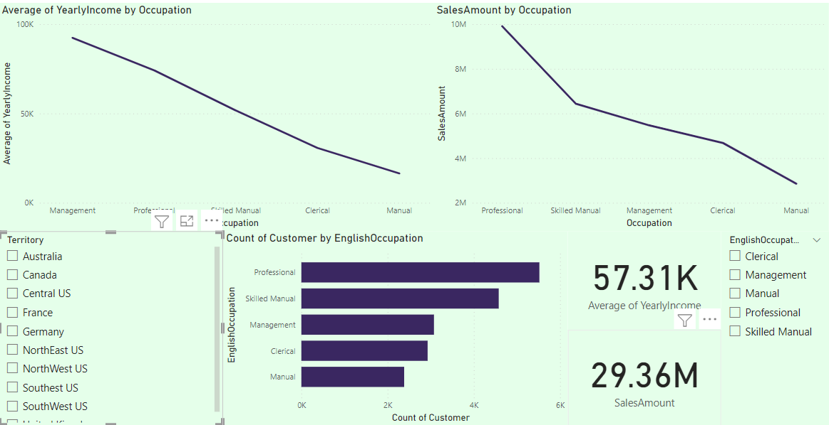

**Customers from professional occupation bring in the most in revenue overall whereas manual occupation accounts for the least in saless**

**This more or less parallels the trend of income where we can see thet professions that earn the most bring in the most sale amount overall**

**if we drill down to a specific country there are slight variations, for example management brings in more revenue in australia whereas customers who hold skilled manual jobs are the prime spenders in canada**

**Clerical and Manual job holders contribute to most of the sales in europe which is surprising considering they athe least earners.**

**Sales by commute distance :**

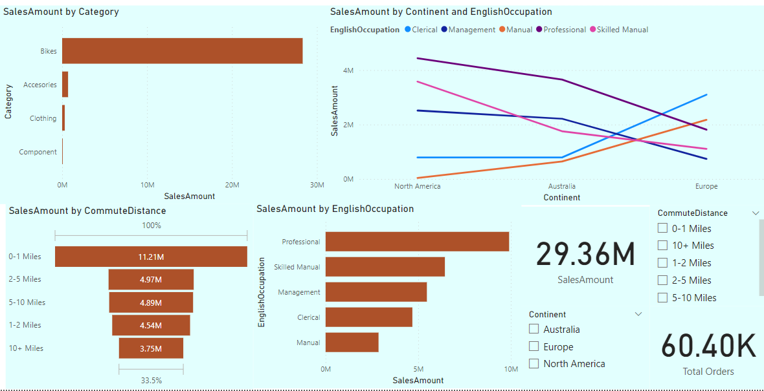

**The most essential insight of this sales analysis comes from including the continent category due to which we can clearly see the differentiation of the purchase patterns of the customers in europe from the customers in north america and australia.**

**Customers who hold clerical and manual positions spend the most in europe by a significant margin despite earning less indicating that these customers use bikes as a primary mode of transportation to their work place. This observation is further strengthened by the fact that majority of thes customers have commute distance of less than 2 miles and mainly between 0-1 miles and there are no customers of these professions for over 5 miles.Customers with management jobs in europe have the highest average salary there out of any profession in any country yet spend the least of any group indicating either a class bias towards purchasing bikes in this continent or the lack of popularity of this among the upper class.**

**Same is not the case for australia and north america where sales are in direct relation to the income of the customers which makes sense since majority of the customers have commute distance of more than 5 miles suggesting that most of these costumers use bikes for recreational purposes sine the customers with commute distance account for 50% of the total sales in bikes**

**In north america, customers with commute distance between 2 to 5 miles bring in the most sales follwe by 0-1 and 1-2 miles. Commute distances of over 5 miles bring in the least customers showing a similar trend to europe.**

**Since, customers in europe who hold clerical and manual jobs use bikes on a near daily basis, they are more likely to buy these products more, therefore the company should invest more in advertising channels directed towards these bracket of customers.**

**Final Sales Analysis :**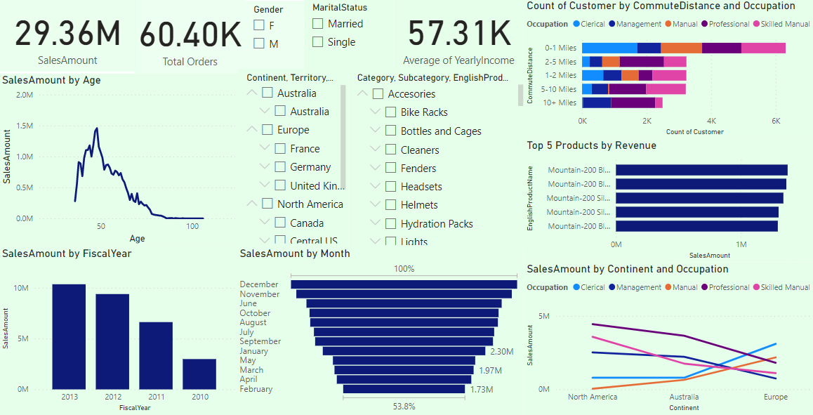

**All the various components of the analysis are collectively studied in the final report. We can see how a particular product’s sales vary in a specific country with respect to year, occupation, commute distance, gender and age.**

**For instance, if we look at the purchase patterns of road-150 Red,44 in Canada, we find that most of the sales happen in september, nearly double of that in december,june and october(the second most busy months) but some interesting points emerge if we drill down further into the purchases of this product with respect to the occupation of the customers. We observe that customers who hold skilled manual jobs ( who bring in the most revenue in canada) have no purchases in the month of october and similarly customers with professional jobs( who bring in the most revenue in road bikes sales in canada) make no orders in the month of december.**

**A similar pattern can be found for the model Road-150 Red,56 in Australia where the joint most busy month for sales ie June has no orders received from management profession.(one of the prime purchasers of this model)**

**Such anomalies can be observed and the reasons for it can be ascertained by studying this comprehensive analysis of the product transactions.**

**We can also see the top 5 products that bring in the most revenue for every category and how their sales increase or decrease year over year.In australia, the top 5 bike products are 3 road-150 models followed by 2 mountain-200 models whereas for europe all the top 5 bike products are mountain-200’s and north america has 3 mountain 200 models and 2 road 150 models in its top 5. The sales of bikes in north america is more for the customers in the age group of 48-60 than for the ones in the ages between 36 and 48 which is in contradiction to europe and north america**

**In accesories, all the continents have the same top 3 products, Sports-100 Helmet black,blue and red which are sold in the years 2012 and 2013 and the sales go up from 2012 to 2013 for all these products.In terms of age, in europ e there is a steady increase from 36 to 46 and then there is a sharp decline whereas for australia and europe, there is a bit more activity between the ages 46-55.**

**As far as clothing items are concerned, in north america, Womens Mountain Shorts and Long Sleeve Logo Jersey are the most popular buys majorly consumed by customers of the professional and skilled manual occupations**

**In australia, Short Sleeve Classic Jersey’s bring in the most in revenue spread more or less evenly across all occupations and in europe, Long Sleeve Logo Jersey’s are the most purchased item bought mostly by clerical and manual professions.Another things that we can observe looking at the sales by age graph is that there is much clearer differentiation in sales by age for australia and north america compared to europe.**

**Since the low earning professions(Clerical and Manual) spend the most in europe in all the categories it would be a good idea to give a healthy discount on sports helmet 100(the most frequently purchased accesory item) and Long-Sleeve Logo Jersey( the most popular clothing item) on purchase of Mountain 200’s(the most purchased bikes) to increase the sales.**

**It would also be beneficial for the sales of Road-350’s(newer version showing good promise in the market) to provide a big discount(40%-50%) on Long-Sleeve Logo Jersey’s on purchase of the bike since both the products are relatively cheap.**

**In conclusion, the most vital insight extracted from the analysis is that the purchase habits of customers in europe vary significantly from those in North America and Austraila from different categories of the products especially in terms of occupation and this can help inform the advertising and marketing decision making process and the channels the company should be investing in.**