**IFT 458/598: Middleware Prog & Database Security**

Anurag Shahare

Module 2 Assignment: JavaScript language

Dinesh Sthapit

September 10, 2022

**Introduction to JavaScript -1**

**JavaScript Function Refactoring 2**

**JavaScript Refactoring 3**

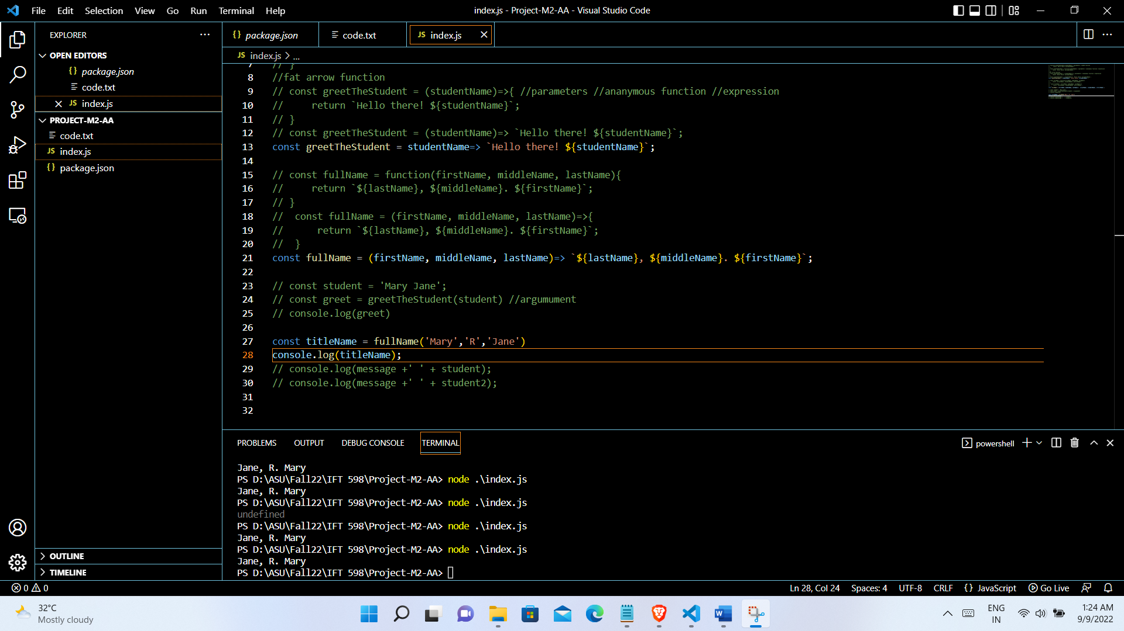

**JavaScript Variables 4**

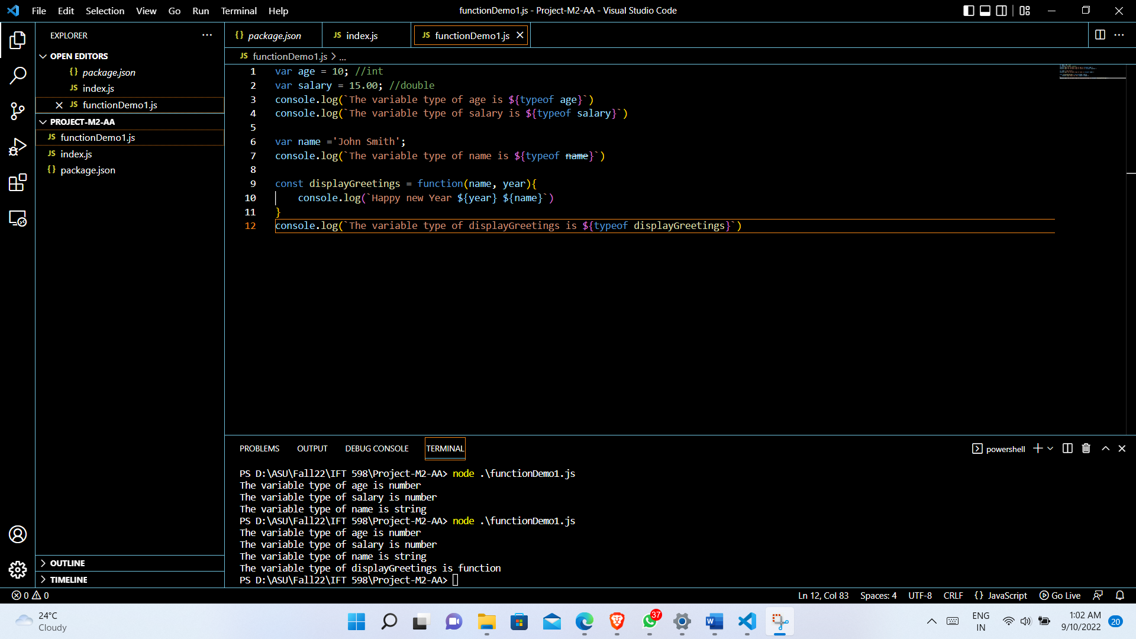

**JavaScript Objects 5**

**JavaScript Parameter (Function as a parameter) 6**

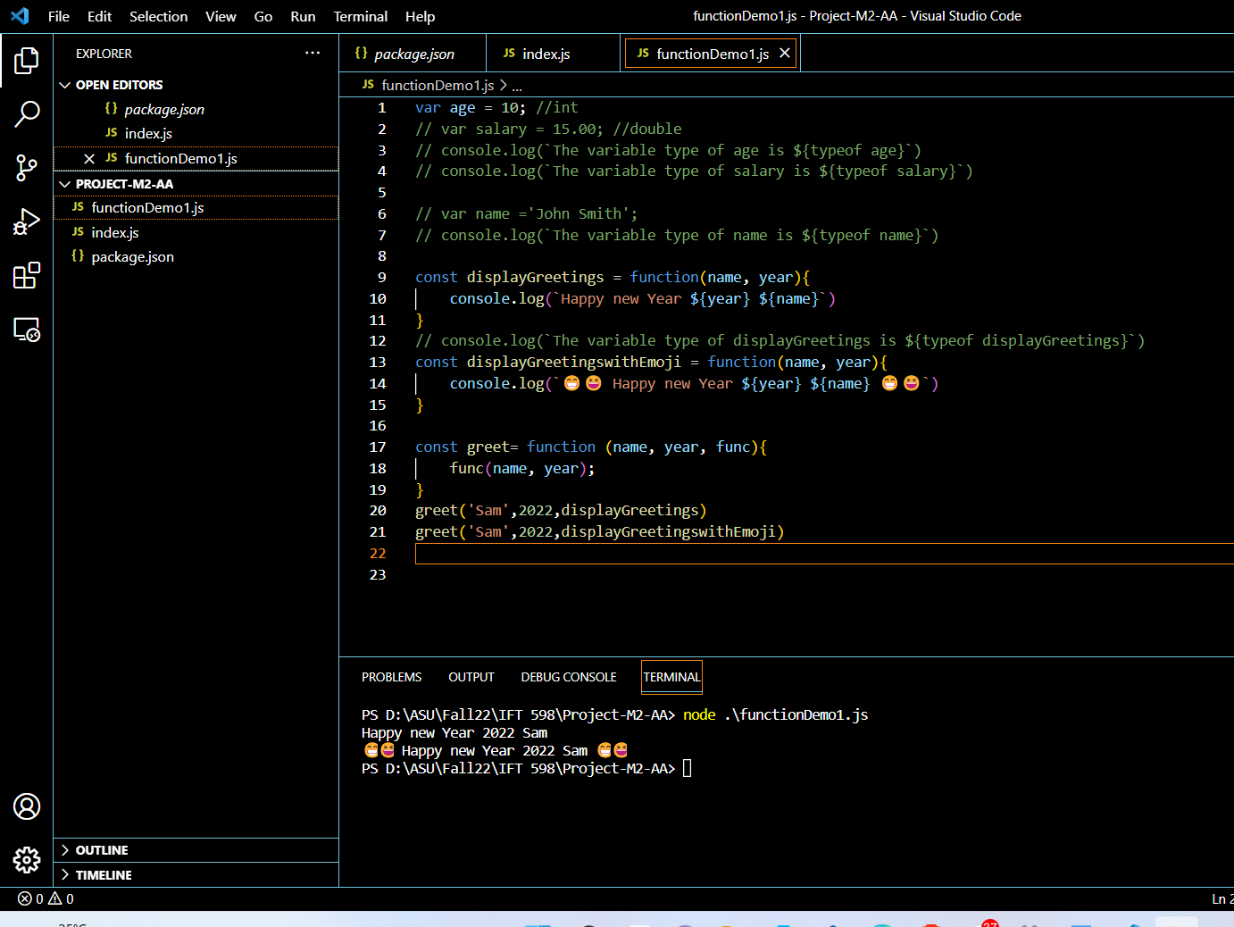

**JavaScript Master Document Reference (required) 7**

**JavaScript Objects II 8**

**JavaScripts Arrays 9**

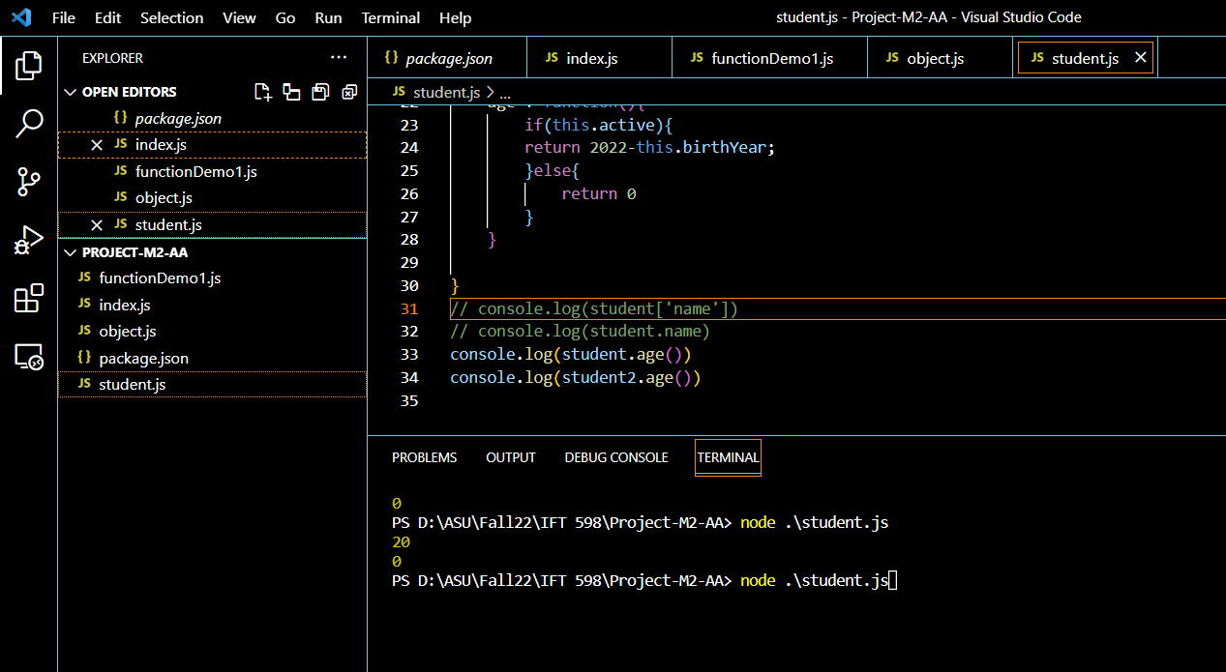

**Accessing Elements of JavaScript Object Arrays 10**

**References**

(<https://developer.mozilla.org/en-US/docs/Web/JavaScript/Reference/Functions>).