ABS ECU Design Document
EV Multi-ECU Vehicle Simulator using STM32F407G
Internship-Level Embedded Automotive Project

1. Project Overview
This project implements an Electric Vehicle (EV) Multi-ECU simulator using multiple STM32F407G Discovery boards connected over a CAN bus network.
The project simulates a distributed automotive electronic architecture consisting of eight Electronic Control Units (ECUs).
The ABS ECU is responsible for wheel speed monitoring, slip ratio calculation, brake modulation simulation, and CAN communication with other ECUs.

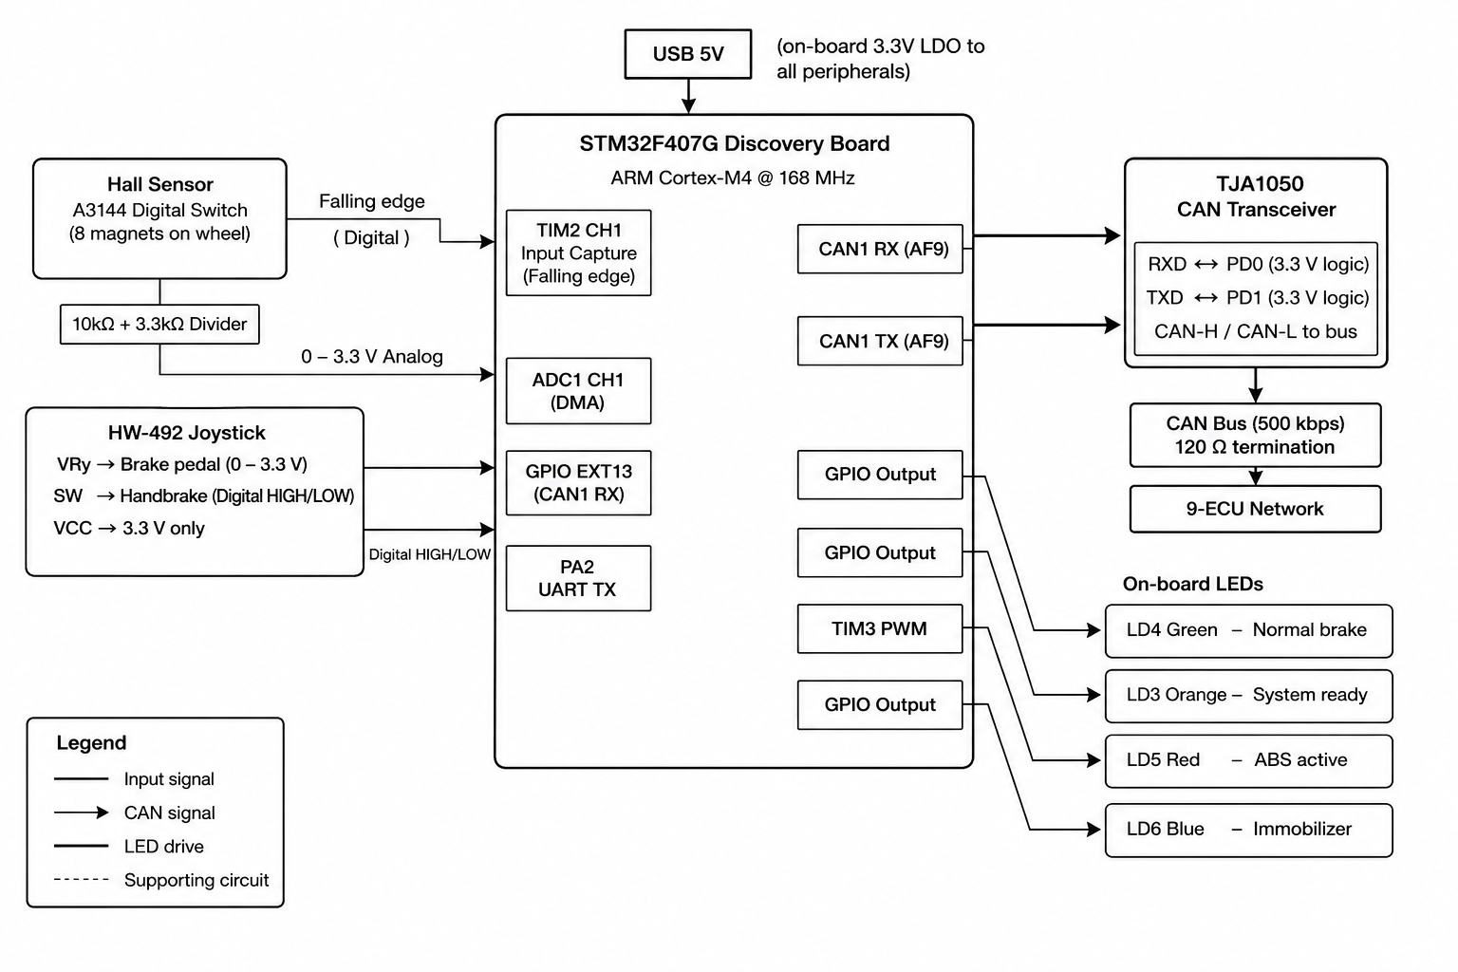

2. Final ECU Network
1. Engine ECU – Auxiliary power generation control, battery charging management, motor RPM simulation, and regenerative support logic.2. Transmission ECU – Gear logic and drivetrain simulation
3. ABS ECU – Wheel speed, slip ratio, braking control
4. BCM ECU – Lighting and body functions
5. Infotainment ECU – Vehicle dashboard display
6. BMS ECU – Battery management and monitoring
7. Telematics ECU – Diagnostics and communication
8. Airbag/SRS ECU – Crash and safety event simulation

3. ABS ECU Hardware
Microcontroller: STM32F407G Discovery Board
Core: ARM Cortex-M4 @ 168 MHz
Development Environment: STM32CubeIDE + STM32CubeMX
RTOS: FreeRTOS
CAN Transceiver: TJA1050
Wheel Speed Sensor: KY-003 A3144 Hall Effect Sensor
Brake Input: KY-023 Joystick Module
Wheel Simulation: DC Motor (90–100 RPM)
Magnets Used: 4 magnets equally spaced on wheel disc

4. GPIO and Peripheral Mapping
PA0 -> TIM2_CH1 -> Hall Sensor Input
PA1 -> ADC1_IN1 -> Joystick Brake Input
PA3 -> EXTI3 -> Handbrake Button
PD0 -> CAN1_RX
PD1 -> CAN1_TX
PD12 -> LD4 Green LED
PD13 -> LD3 Orange LED
PD14 -> LD5 Red LED
PD15 -> LD6 Blue LED
PA2 -> USART2_TX Debug UART

5. Hall Sensor Design
The ABS ECU uses a KY-003 Hall Effect Sensor module based on the A3144 digital Hall switch.
The module operates directly at 3.3V and is connected safely to the STM32 GPIO without external voltage dividers.
Four magnets are attached equally around the wheel disc to generate four pulses per revolution.
TIM2 Input Capture mode is configured for FALLING edge detection because the A3144 output is active-LOW.

6. Wheel Speed Calculation
Wheel Radius = 0.0254 m
Magnets per Revolution = 4
RPM = (60 × 1,000,000) / (Pulse_Period × PPR)
Vehicle speed is calculated from wheel circumference and RPM.
The DC motor rotates approximately between 90–100 RPM for testing purposes.

7. ABS Algorithm
The ABS ECU uses a threshold-based Anti-lock Braking System algorithm.
The system continuously monitors wheel speed and calculates slip ratio.
Slip Ratio Formula:
λ = (Vref - Vwheel) / Vref × 100%
ABS activates when slip ratio exceeds 20%.
The controller performs:
1. HOLD phase
2. RELEASE phase
3. REAPPLY phase
The ABS logic runs every 5 ms using a FreeRTOS periodic task.

8. LED Indication Logic
LD3 Orange -> System Ready / Fault
LD4 Green -> Normal Braking
LD5 Red -> ABS Active
LD6 Blue -> Emergency Brake / Safety Event
Red LED blink speed changes according to slip ratio intensity.

9. CAN Bus Communication
CAN Standard: CAN 2.0B
Frame Type: Standard 11-bit IDs
Bus Speed: 500 kbps
CAN Peripheral: bxCAN1
Transceiver: TJA1050
ABS ECU Transmission:
0x101 -> Wheel Speed and RPM
0x102 -> ABS Status, Slip Ratio, Temperature, Fault Flags
ABS ECU Receives:
0x103 -> Engine Extender
0x104 -> Transmission Status
0x105 -> Battery Status + RPM
0x106 -> BCM Status
0x107 -> Diagnostic Requests
0x108 -> Infotainment Commands
0x100 -> Airbag Crash Signal

10. FreeRTOS Task Architecture
Task Name Period
Wheel Speed Task 5 ms
ABS Control Task 5 ms
CAN TX Task 50 ms
CAN RX Task 10 ms
Brake Temperature Task 100 ms
UART Debug Task 500 ms
LED Control Task 20 ms
Fault Monitoring Task 100 ms

11. Safety and Fault Handling
The ABS ECU includes multiple safety mechanisms:
• Hall sensor timeout detection
• CAN timeout monitoring
• Overspeed detection
• Wheel lock detection
• Emergency braking state
• Fault logging
• Fail-safe operation
If the Hall sensor stops generating pulses for more than 500 ms, the wheel is considered stopped or faulty.

12. EV Regenerative Braking Integration
Since the project simulates an EV architecture, the ABS ECU coordinates with regenerative braking concepts.
During heavy braking, regenerative braking torque would normally be reduced when ABS activates to prevent wheel lock.
The simulator models this interaction conceptually through CAN status messages.

13. Wiring Connections
KY-003 Hall Sensor:
VCC -> 3.3V
GND -> GND
Signal -> PA0
KY-023 Joystick:
VRy -> PA1
SW -> PA3
VCC -> 3.3V
GND -> GND
TJA1050:
TXD -> PD1
RXD -> PD0

14. Testbench and Validation
The wheel is simulated using a low-speed DC motor rotating at approximately 90–100 RPM.
The Hall sensor measures wheel pulses generated by four magnets.
The joystick module simulates brake pressure.
Multiple STM32 boards communicate using CAN bus for complete ECU interaction testing.
Validation Tests:
• RPM accuracy test
• Slip ratio verification
• CAN communication test
• ABS activation test
• Fault injection test
• UART debug monitoring

15. Conclusion
The ABS ECU successfully demonstrates real-time embedded automotive control using STM32F407G hardware, FreeRTOS scheduling, CAN communication, and sensor-based wheel speed monitoring.
The project simulates important automotive safety concepts including slip ratio monitoring, ABS modulation, fault handling, and EV braking integration in a professional internship-level embedded systems environment.

