**In the Given Below Assignment We are having 2 Application and A Shared Library**

**1: SOAP Application:** Which accepts SOAP data and converts that SOAP Data into Fixed Length data using Fixed -Length DFDL and then call An HTTP Fixed-Length Backed Application, which only accepts fixed length data and send fixed-length response back to the caller service.

**2: HTTP Application:** The backend Service receives Fixed length Data in BLOB FORMAT (as no parser is selected in the HTTP Input Node) then it parses as well as validates the blob data using Request DFDL, then writes all the data into database, then fetch the required columns from database again parse and validates using Fixed-Length Response DFDL and send the out in DFDL format (means fixed length Format).

**Note:** A logging library is used in SOAP And HTTP Application as an Shared Library in (Showing as subflow), this Logging flow is writing the SOAP Request & Response and Fixed-Length Request-Response in the Database.

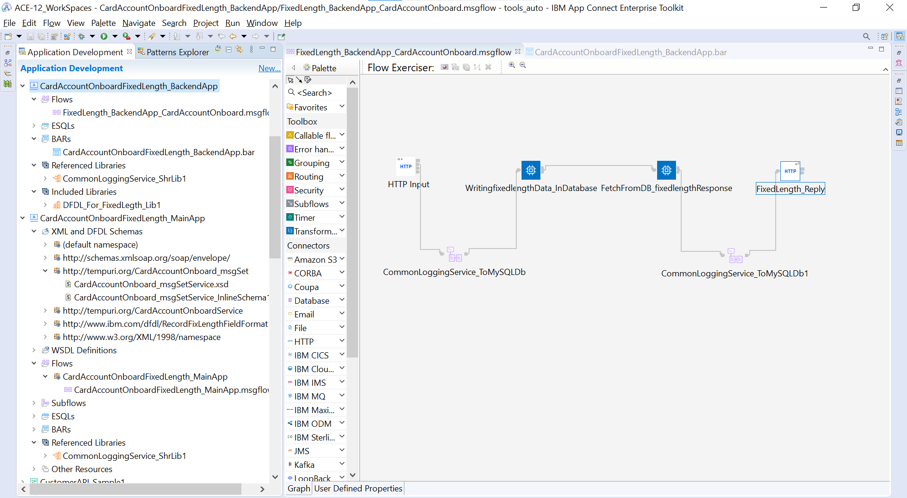

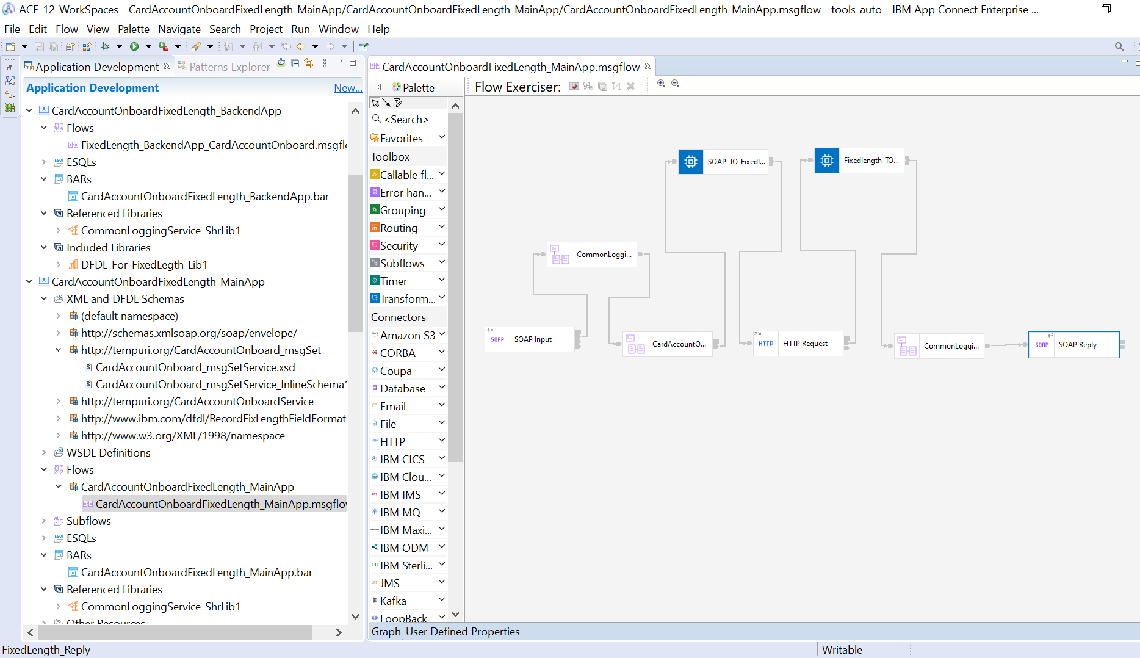

The Shared library is not deploying Separately instead its added in the bar fill of the application when bar was created. As Shown below:

Bar file for Fixed-Length Backend Service:

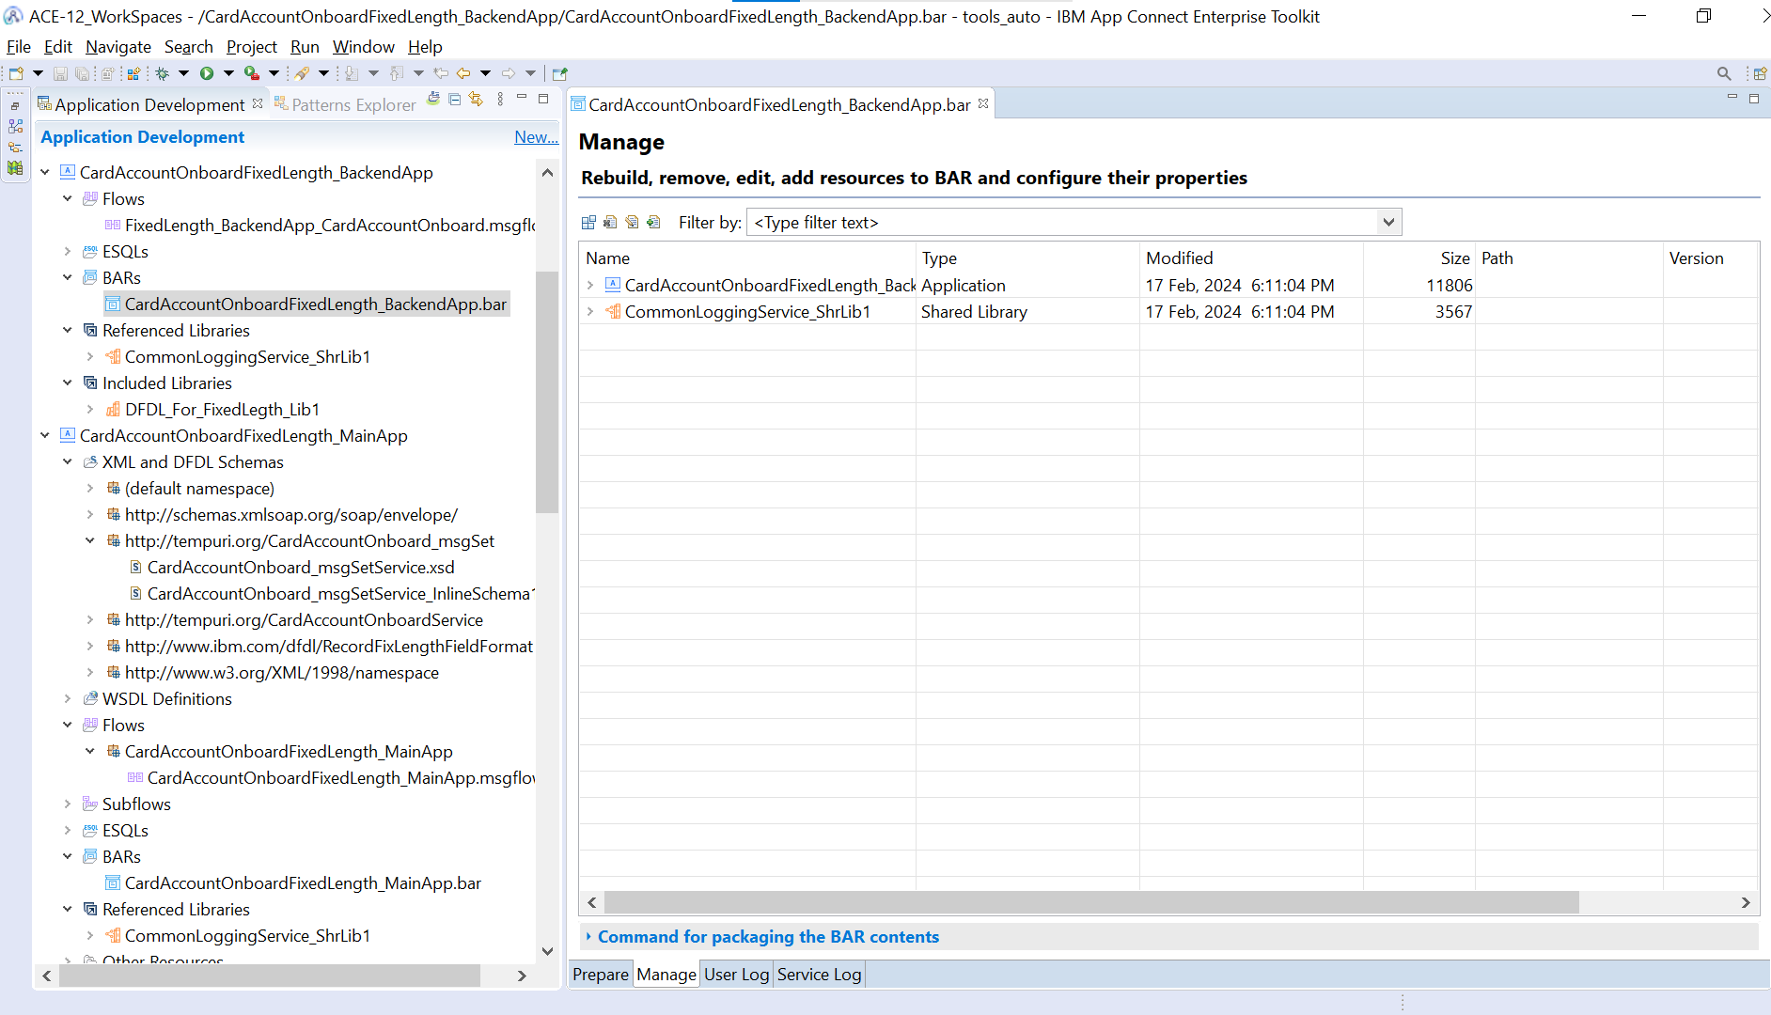

Input and Output For Fixed-Length Backed Service:

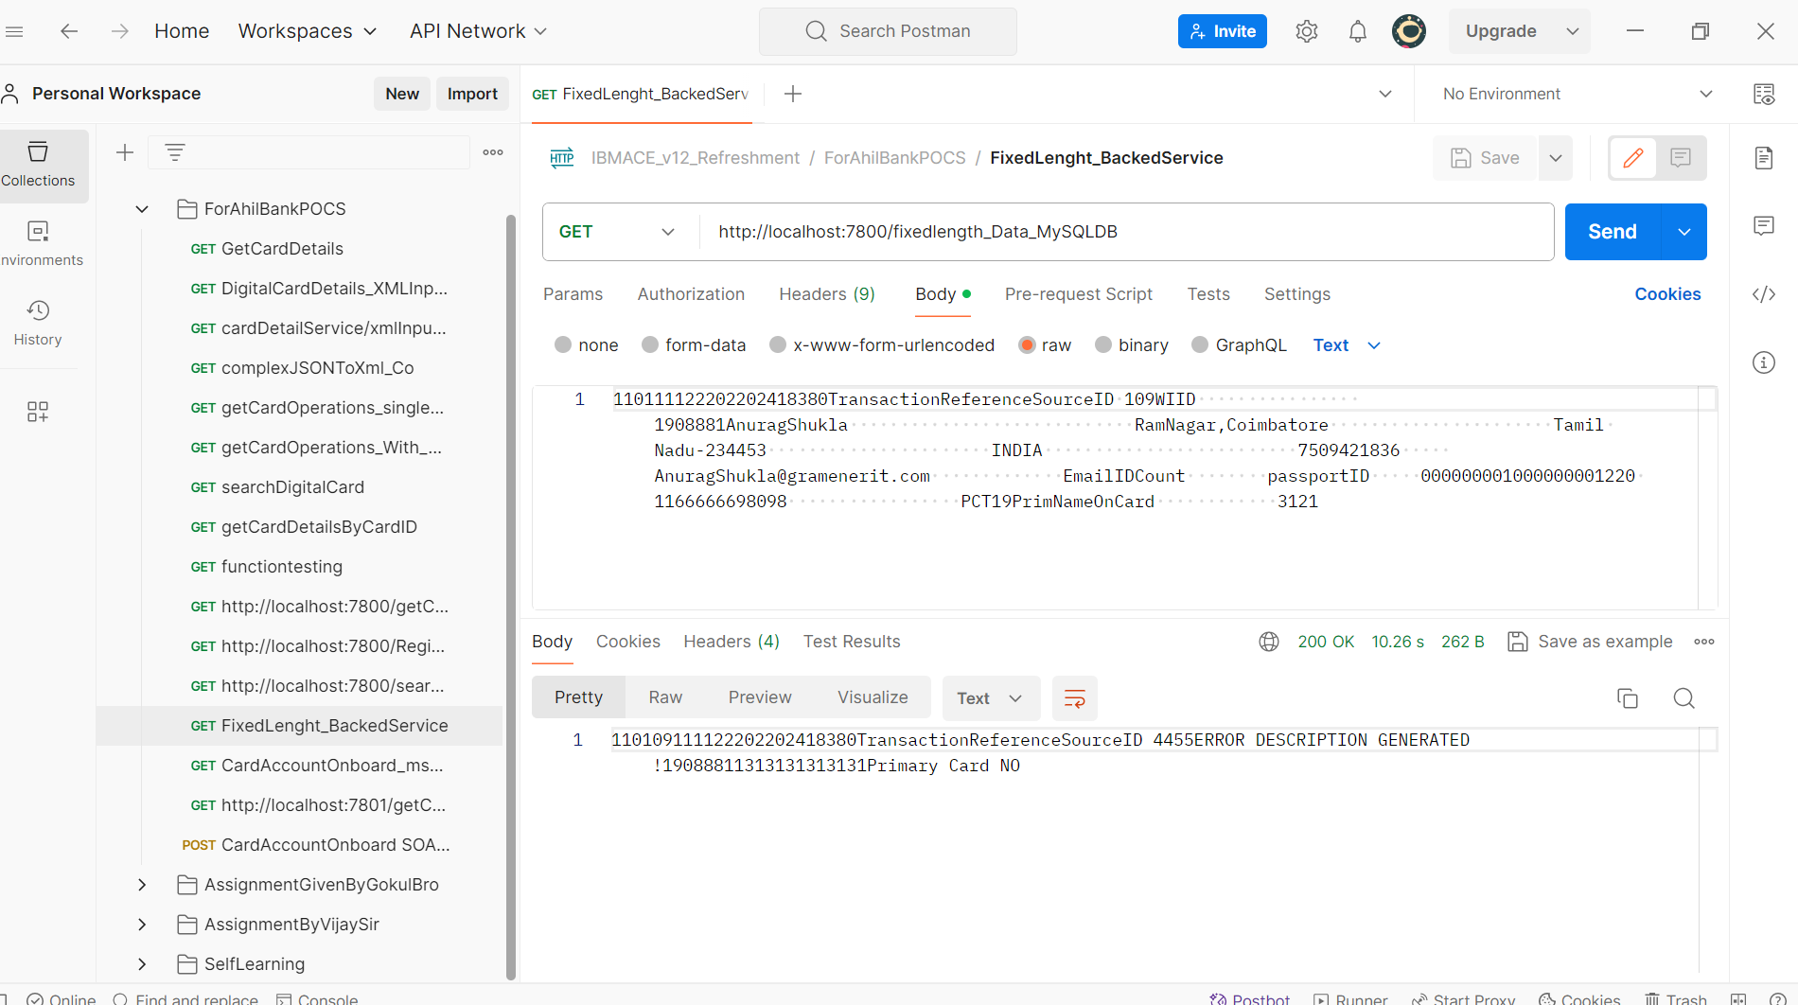

How Database Record Look like for the above fixed-length data:

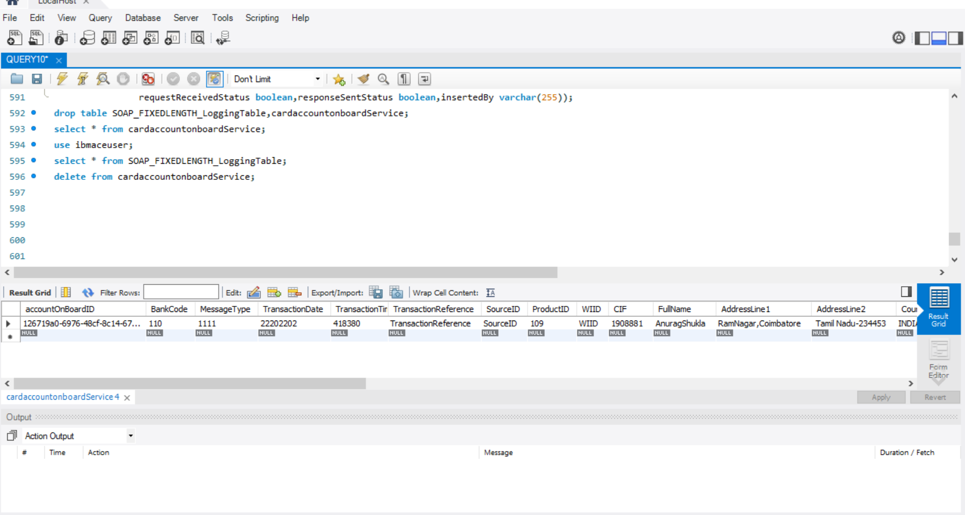

How to create the Table: Follow given below SS for DB table details

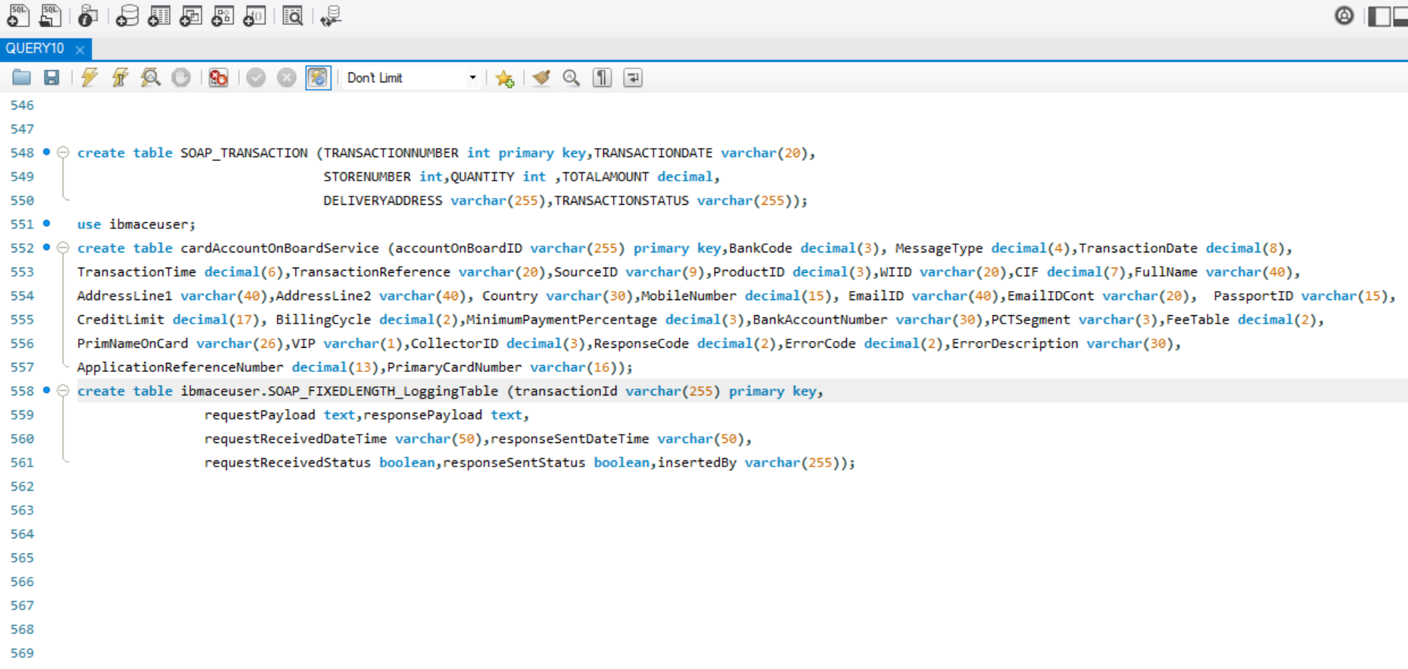

Bar File of SOAP Service or Main Service

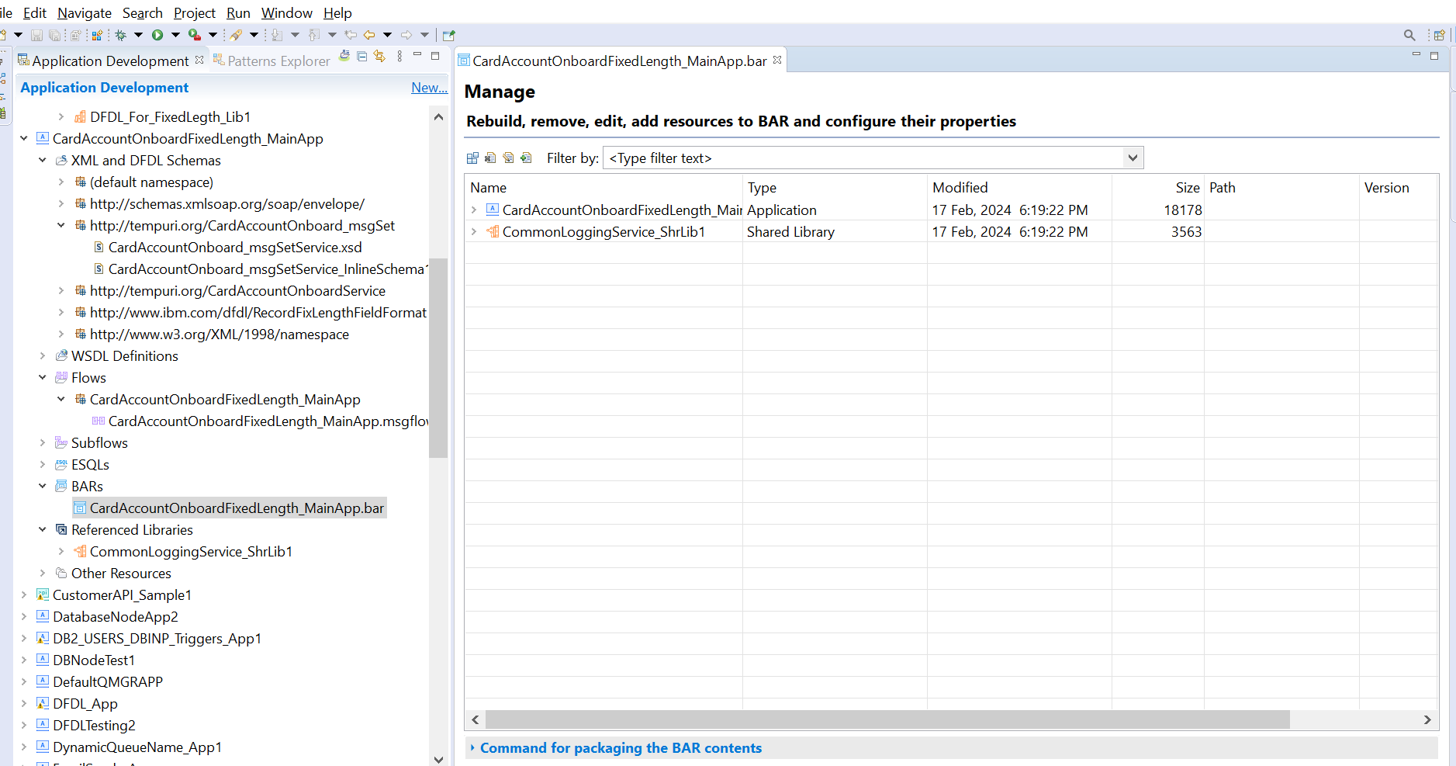

Input and output for the SOAP Service Look like the below given SS:

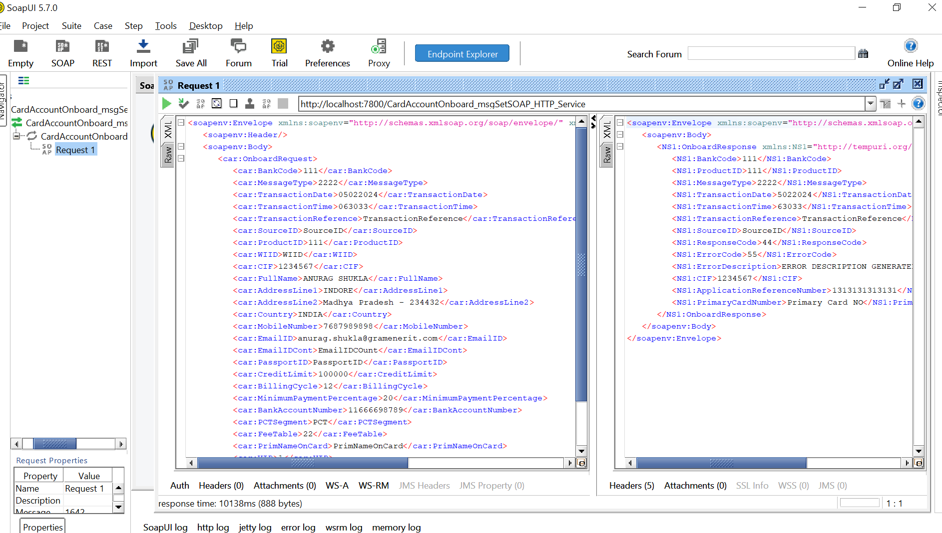

How to Database Table look like after this Service called and all these data are inserted into DB:

