**How to Configure Database Nodes in IBM ACE 12**

How to open Db2 Console: Should have admin rights:

Follow the given below SS:

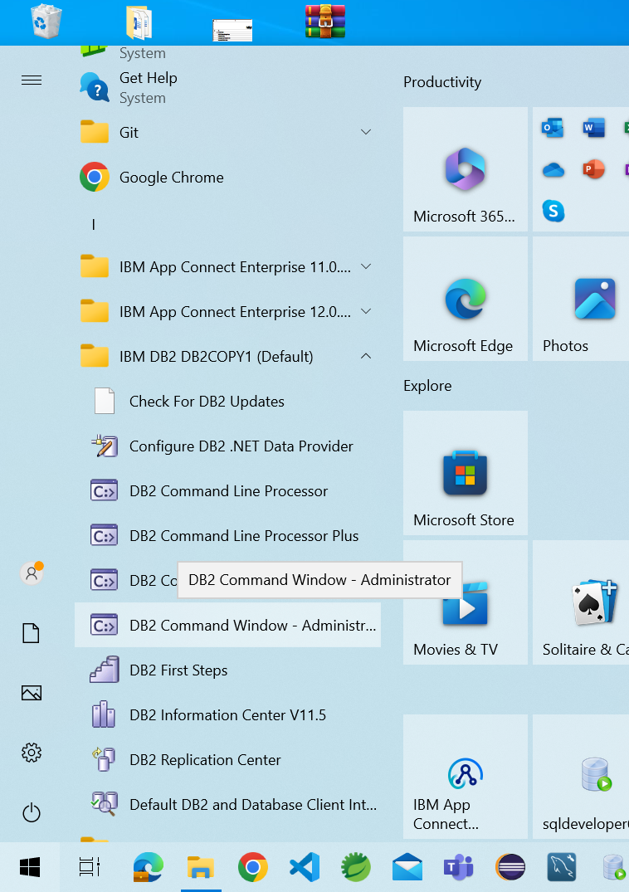

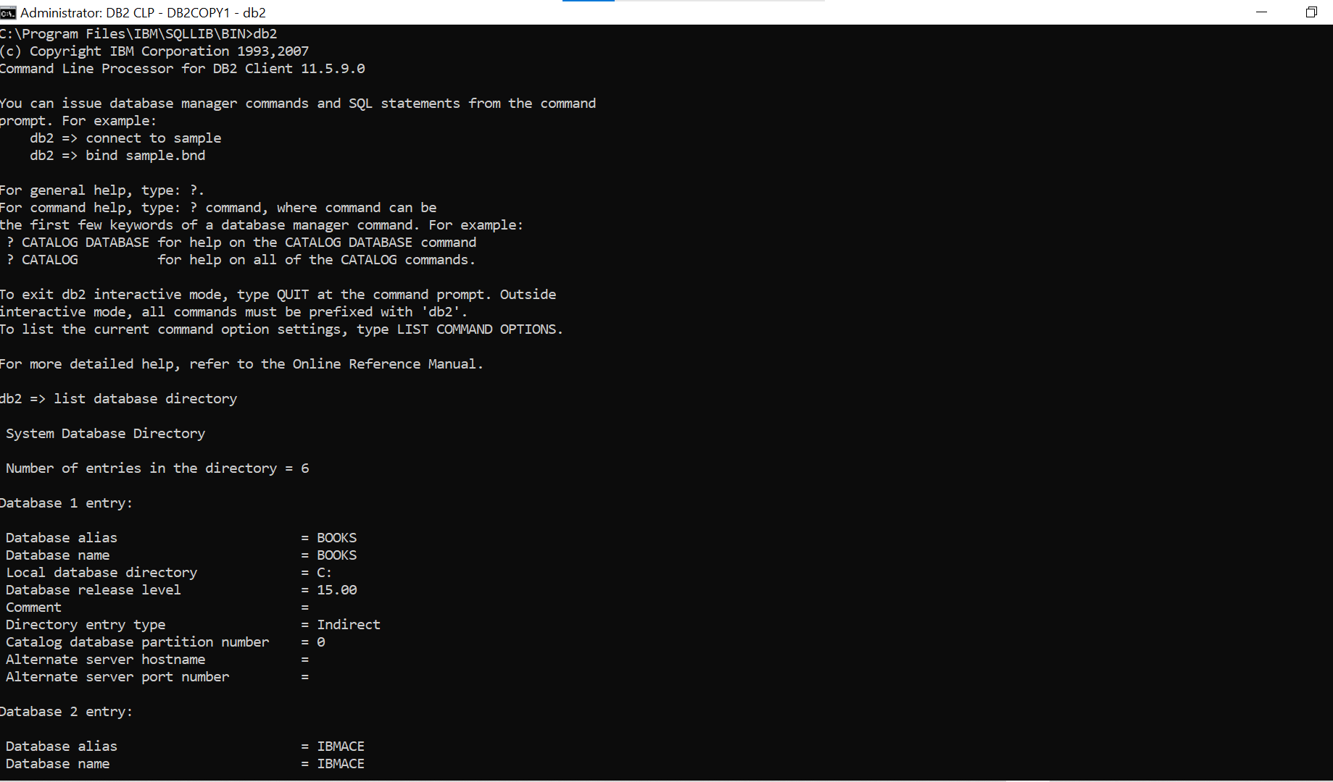

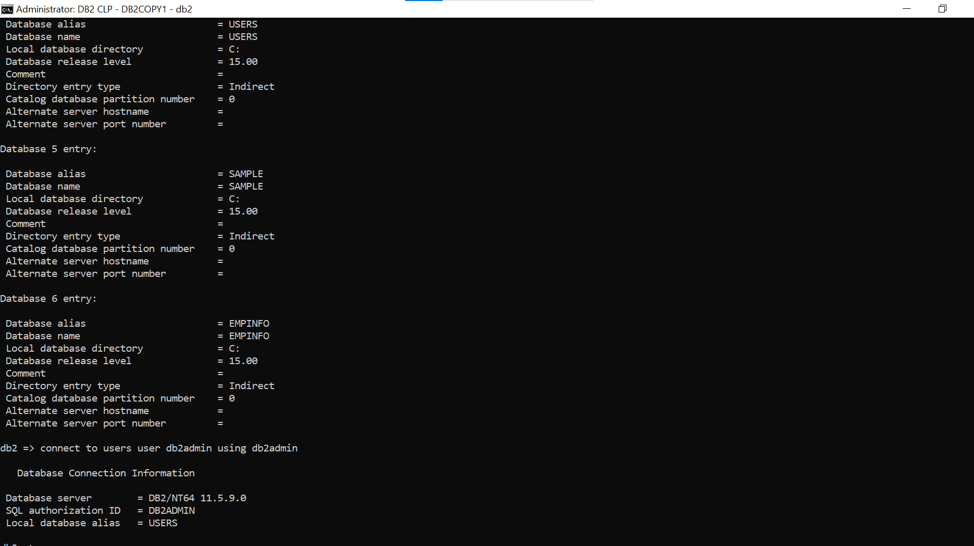

Below Given are the Application and Event tables:

1. Employees: Application Table
2. Events : Event table

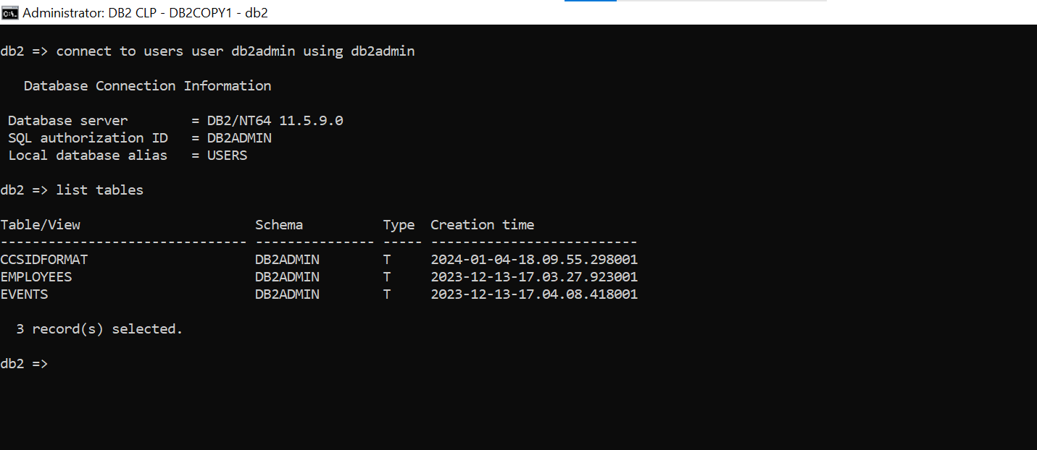

SQL Command to create tables: Follow Below cmds

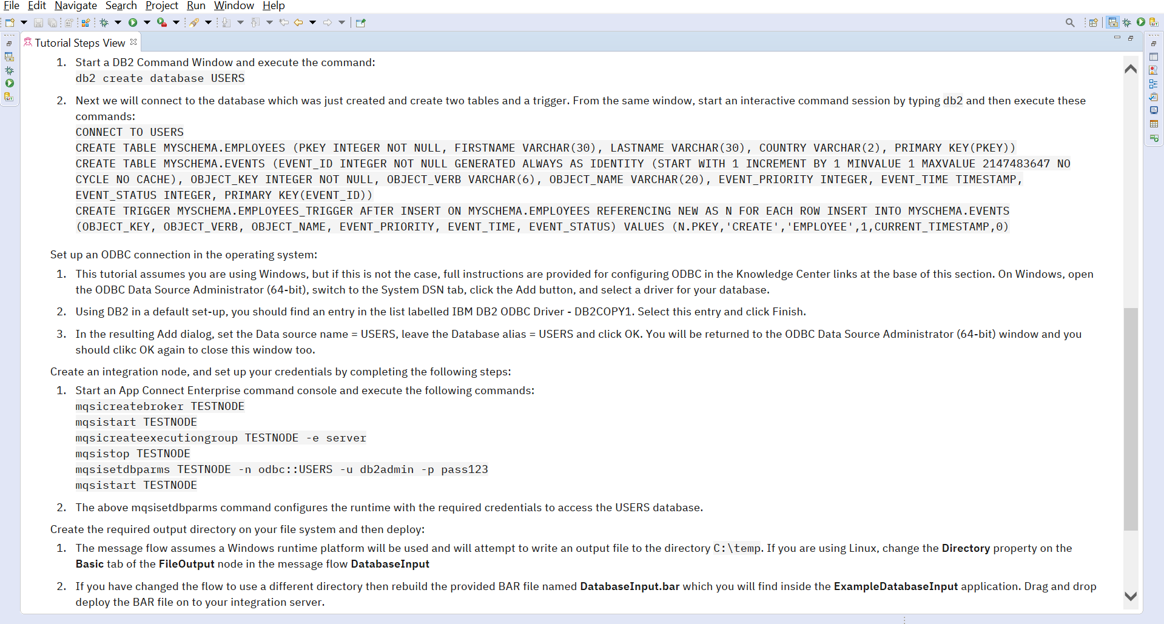

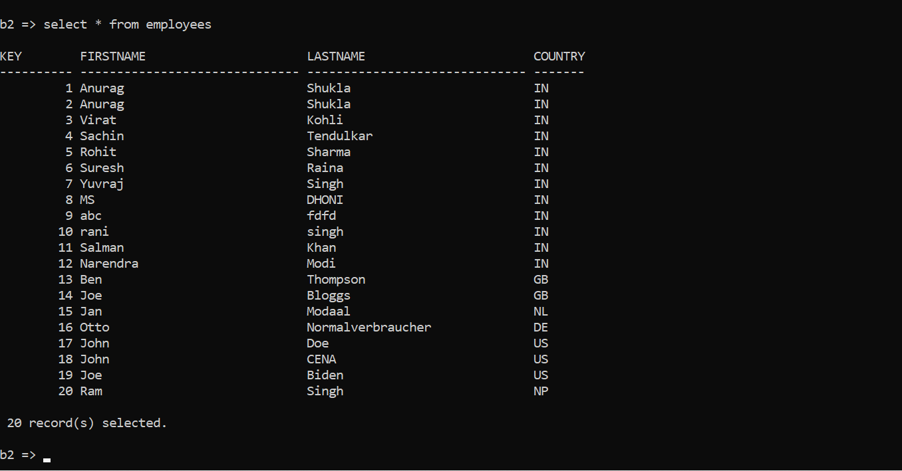

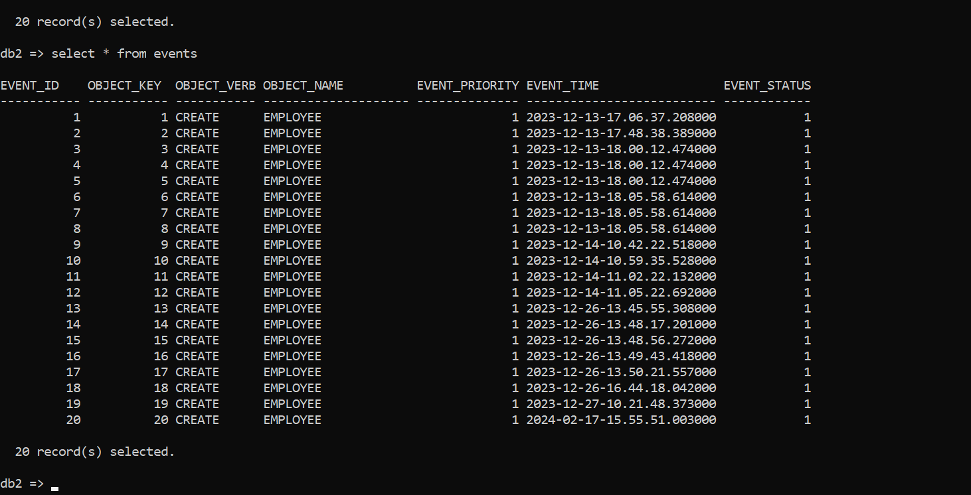

How will we write in the DB2 node using Database Nodes

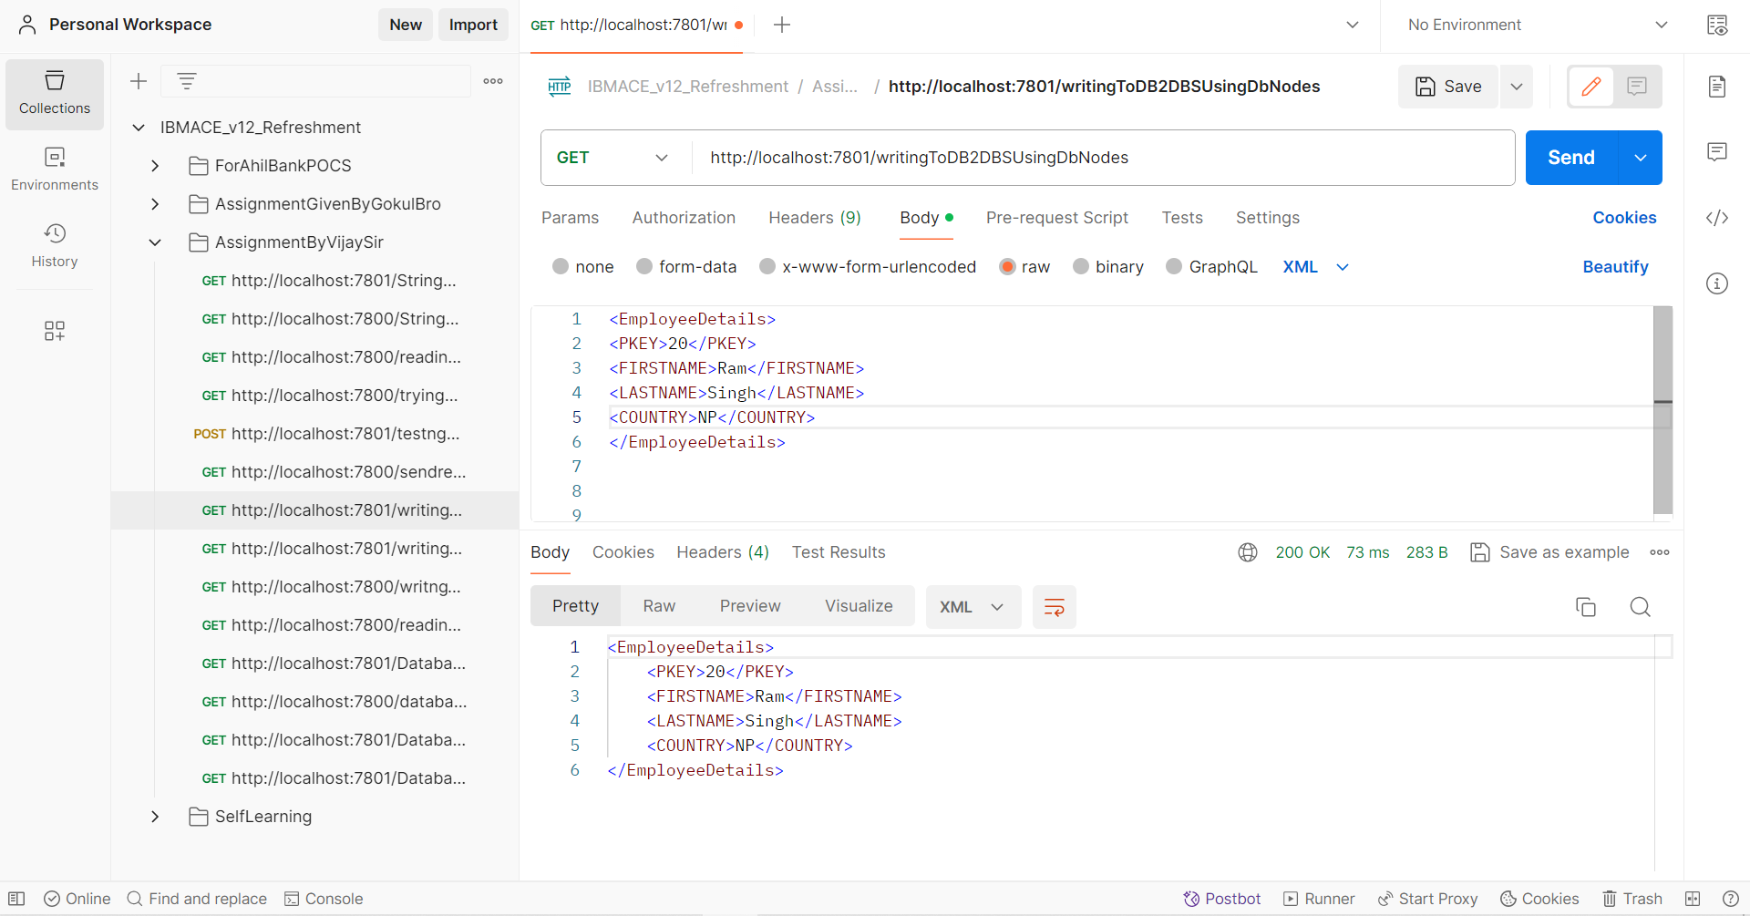

How to Test the Database Route Flow: Given below is the Input And out for the given Application:

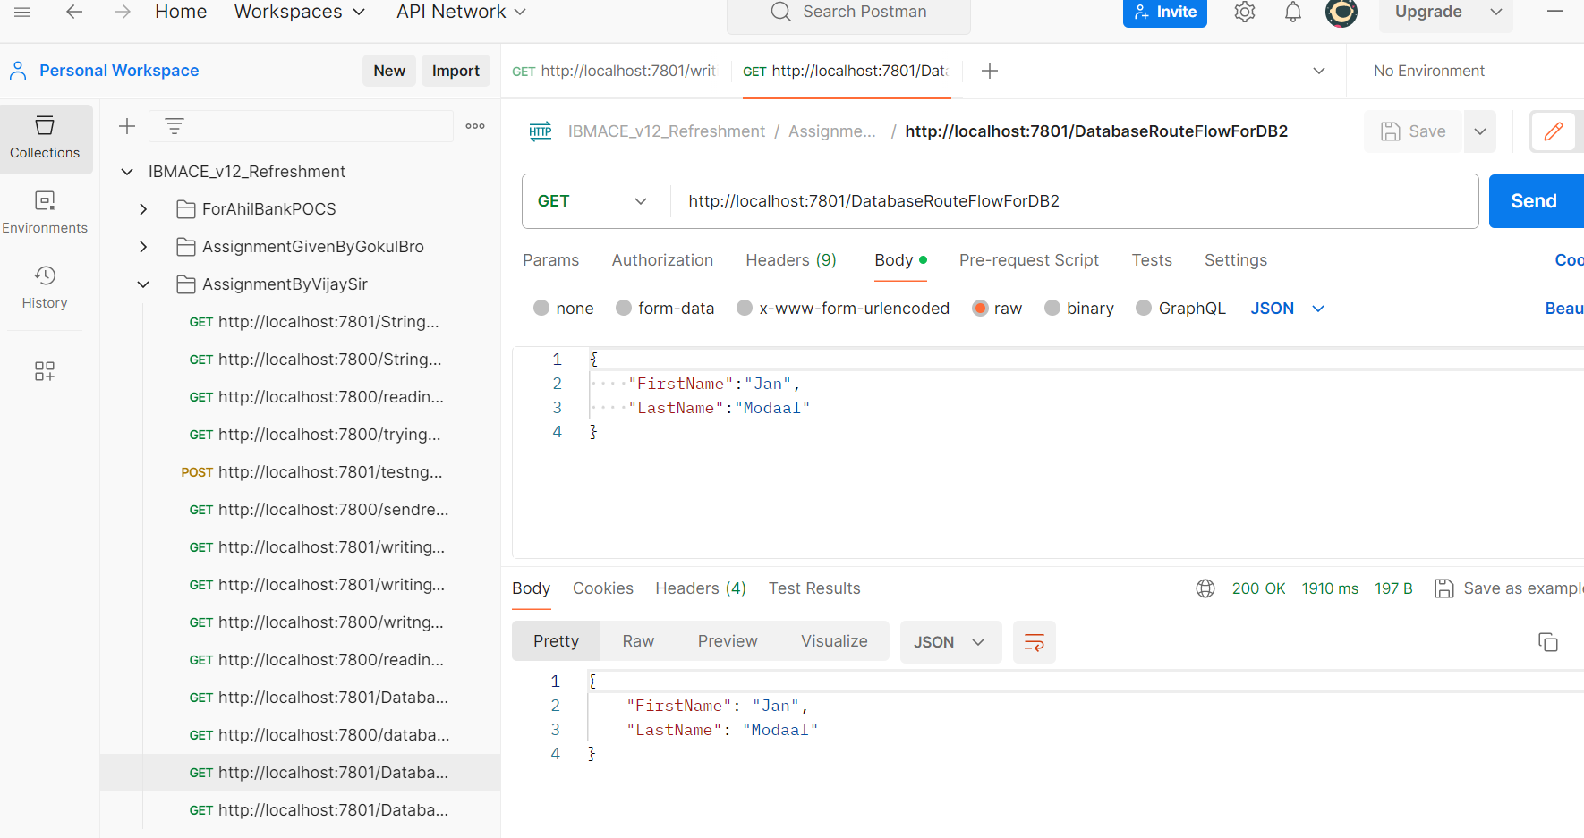

How to Test the DatabaseRetrieve Flow : Given below is the Input And out for the given Application:

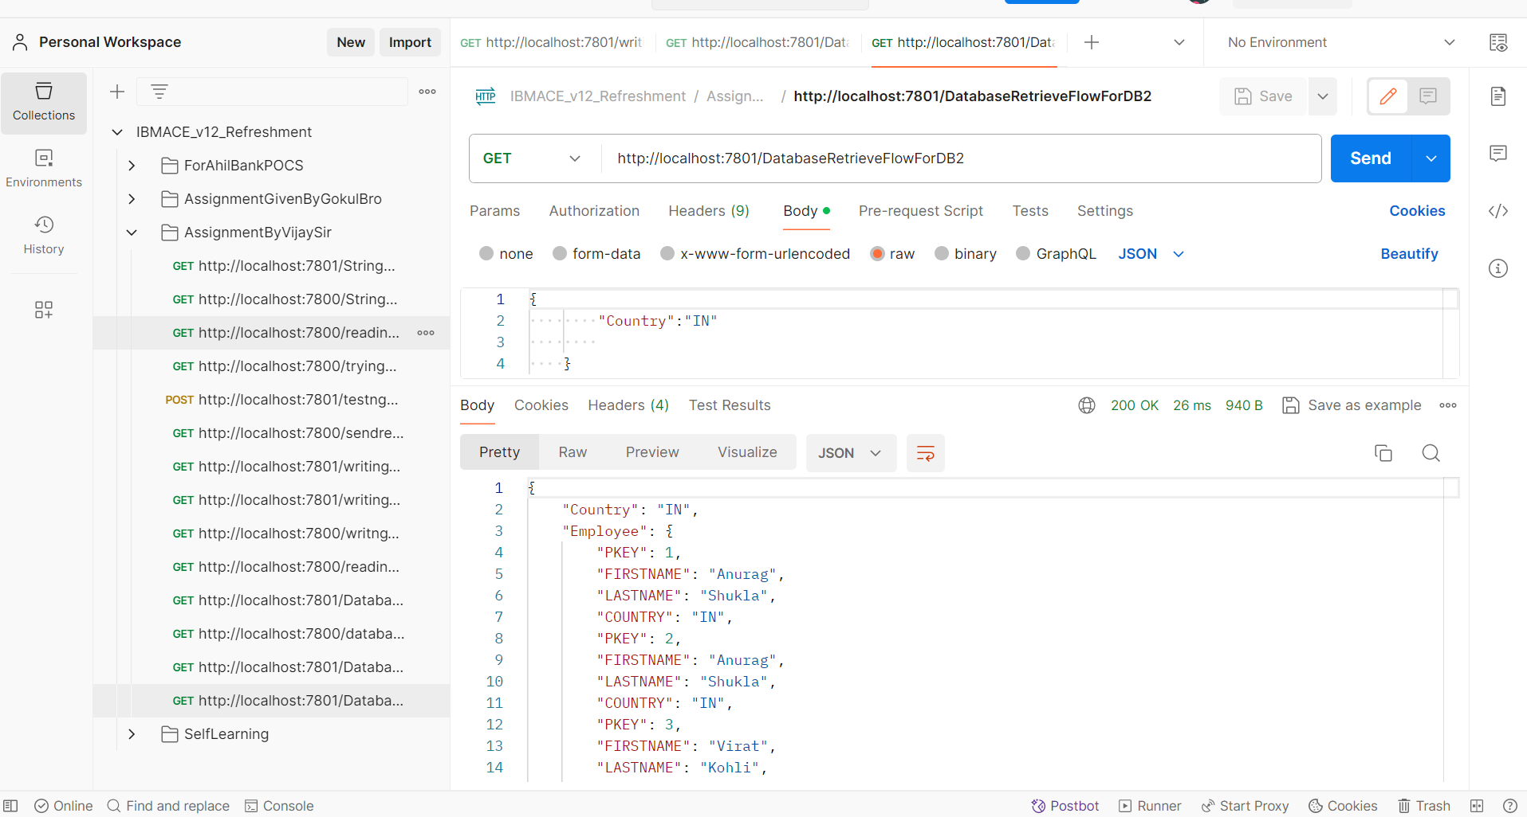

How to Create JDBC Policy:

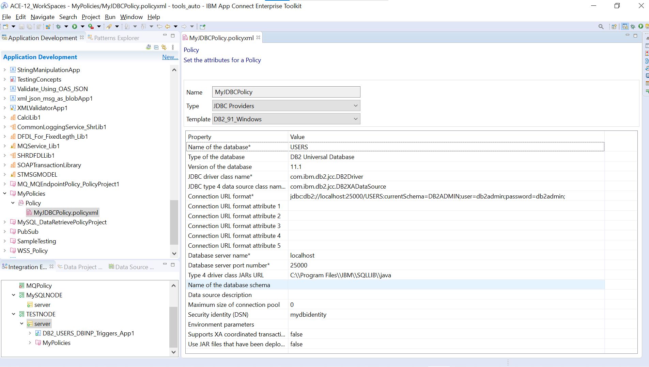

How to Configure DB2 Database Users, Tables, and Intergration nodes: Follow the Sample

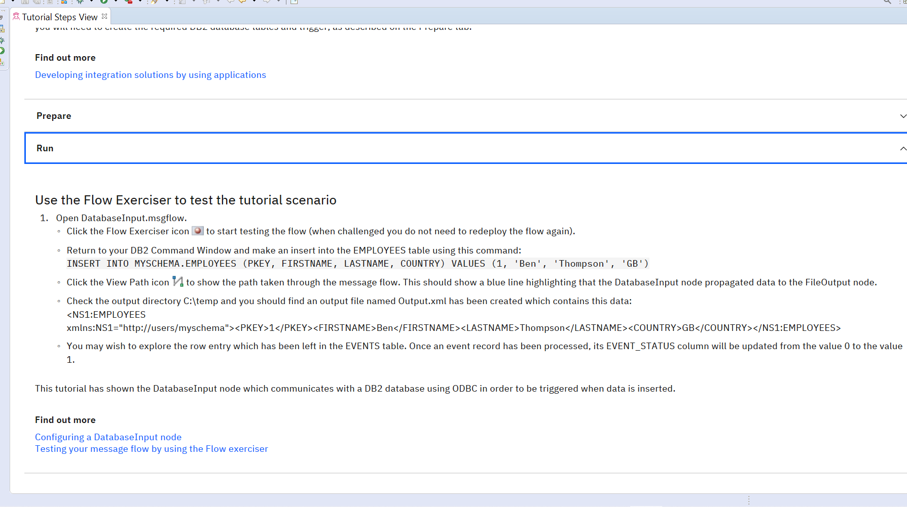

How will we test the Application: Sample One



Then create the Bar file as given below and then deploy the bar file and test the app.

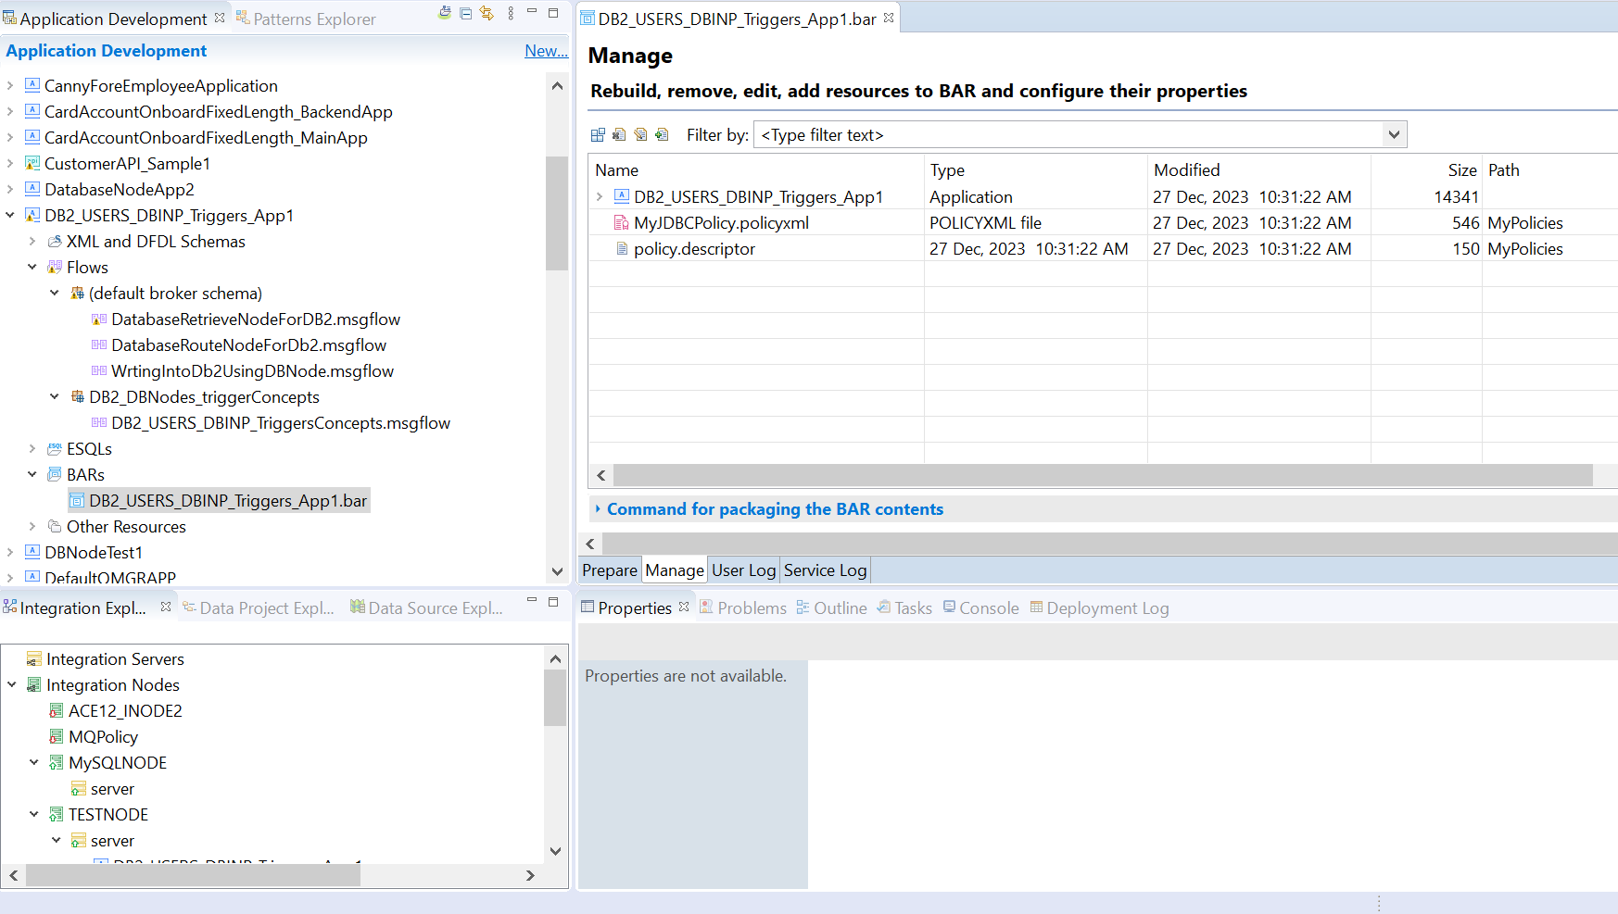

Generated files Look like this.

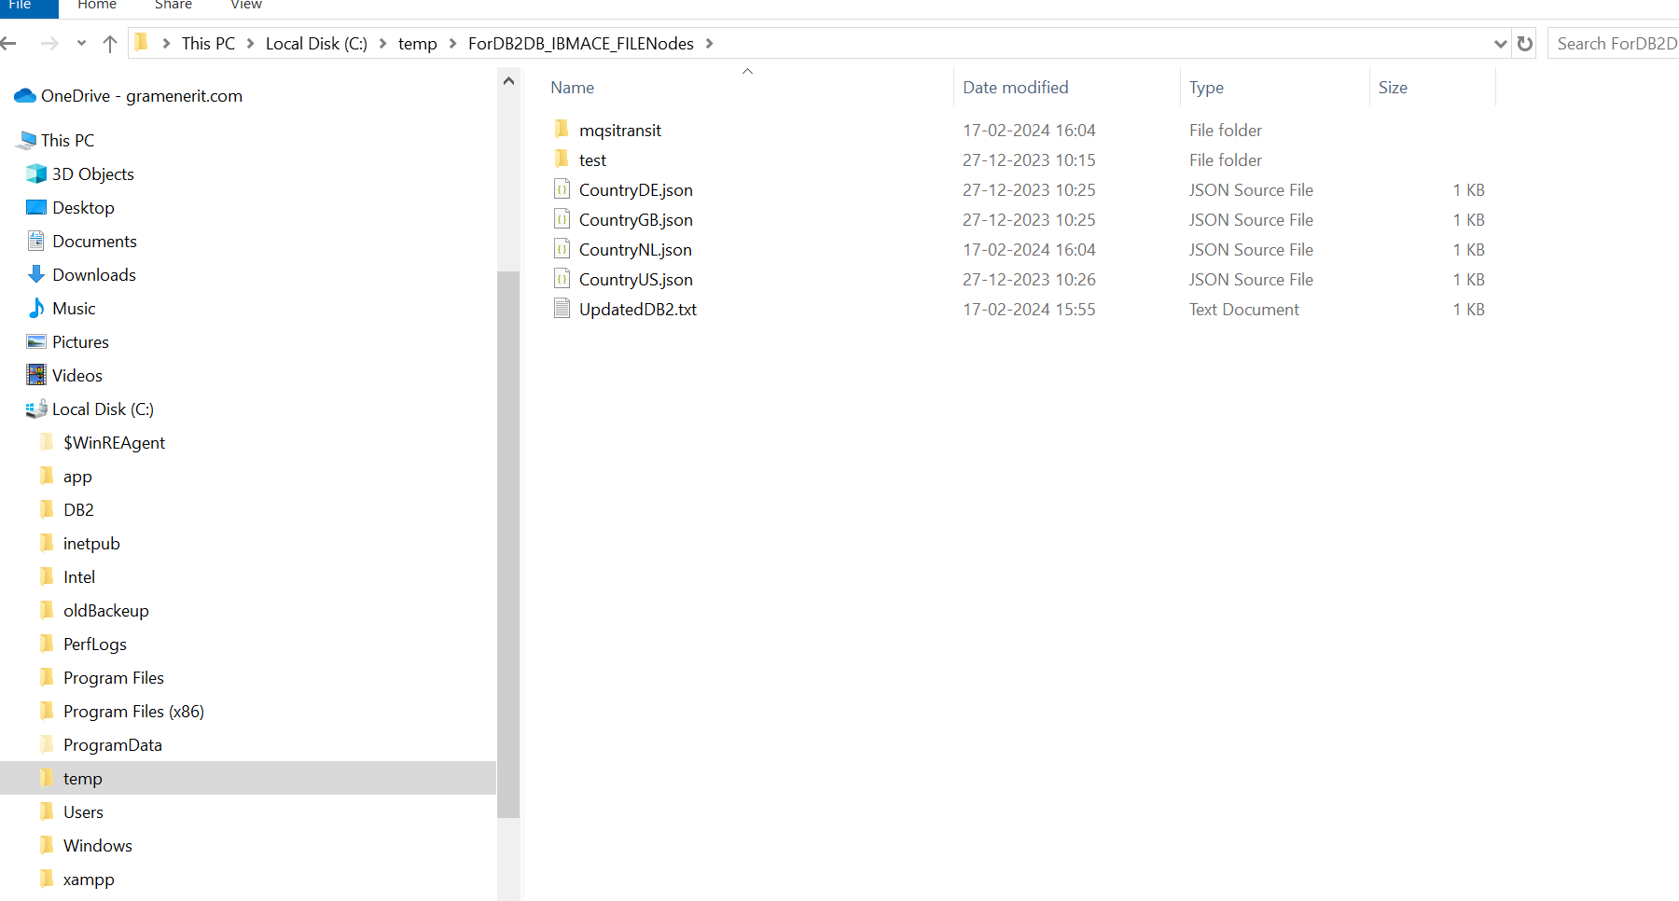

How the data inside UpdatedDb2.txt files data look like, every new record inserted into will be added in the file . This file will be generated as we have given in the DatabaseInput node flow.

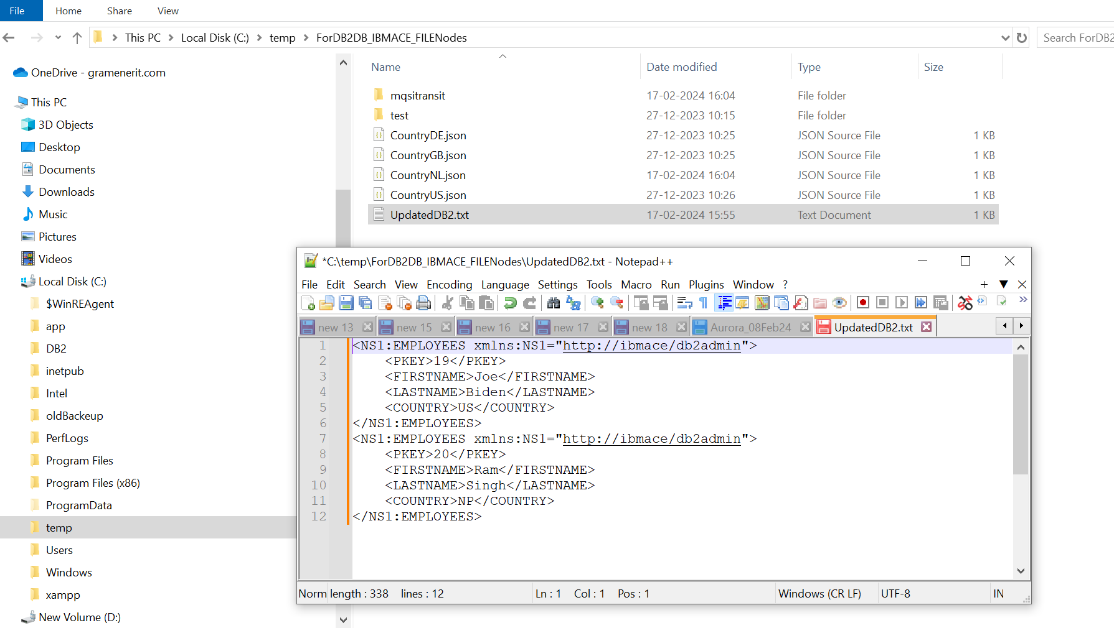

**DONE**