**HOW TO USE MQENDPOINT POLICY IN MQ APPLICATION**

How to Configure MQEND Point Policy:

Create a simple Policy Project as shown in the below given image and provide the information as given:

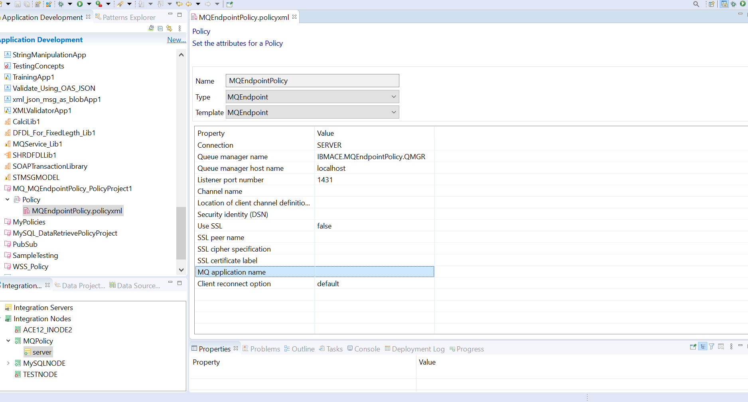

1.Select the Type as MQEndPoint (will get a template for that).

2. Provide the QMGR name and host name(if MQ is in your local machine give local host as given or we can give IP Address also).

3. Provide the Listener Port Number of QMGR, if don’t know how to check that flow the given below image.

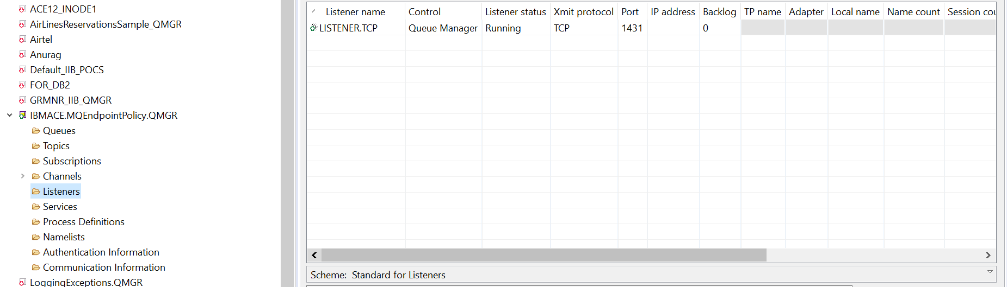

That’s All Your MQ End Point Policy is ready.

How to Create MQ Application and Use the above created Policy project in that Application:

MQ Input Node: Proved only QUEUE name and in policy given Policy Project Name and select any parser according to your requirement.

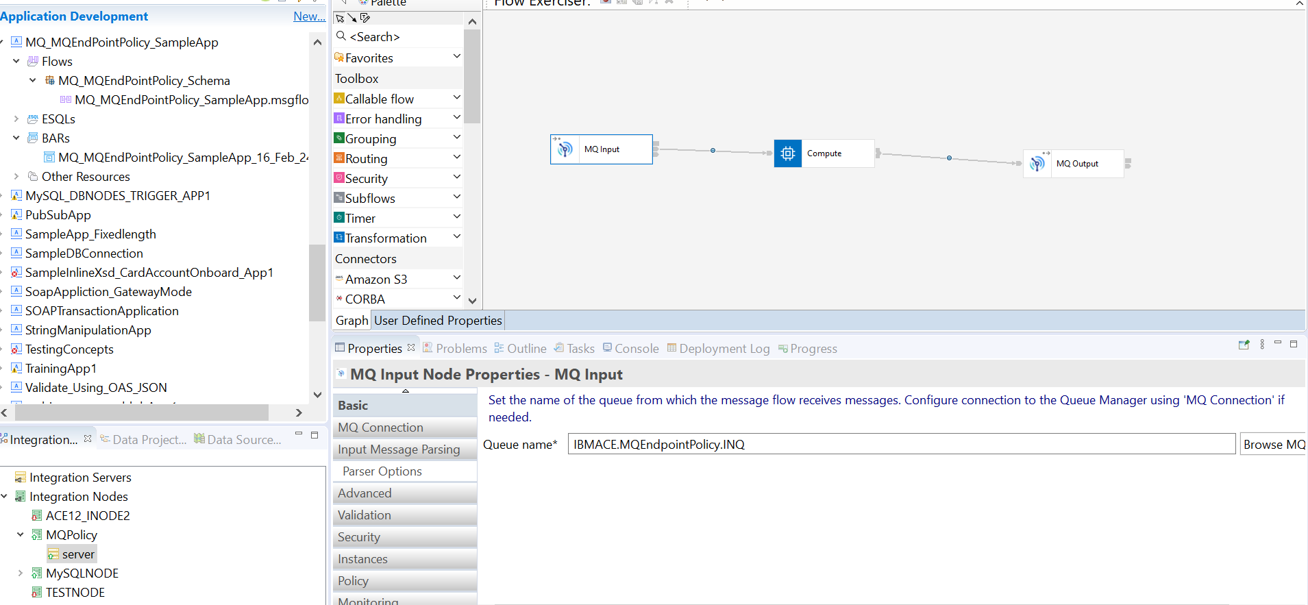

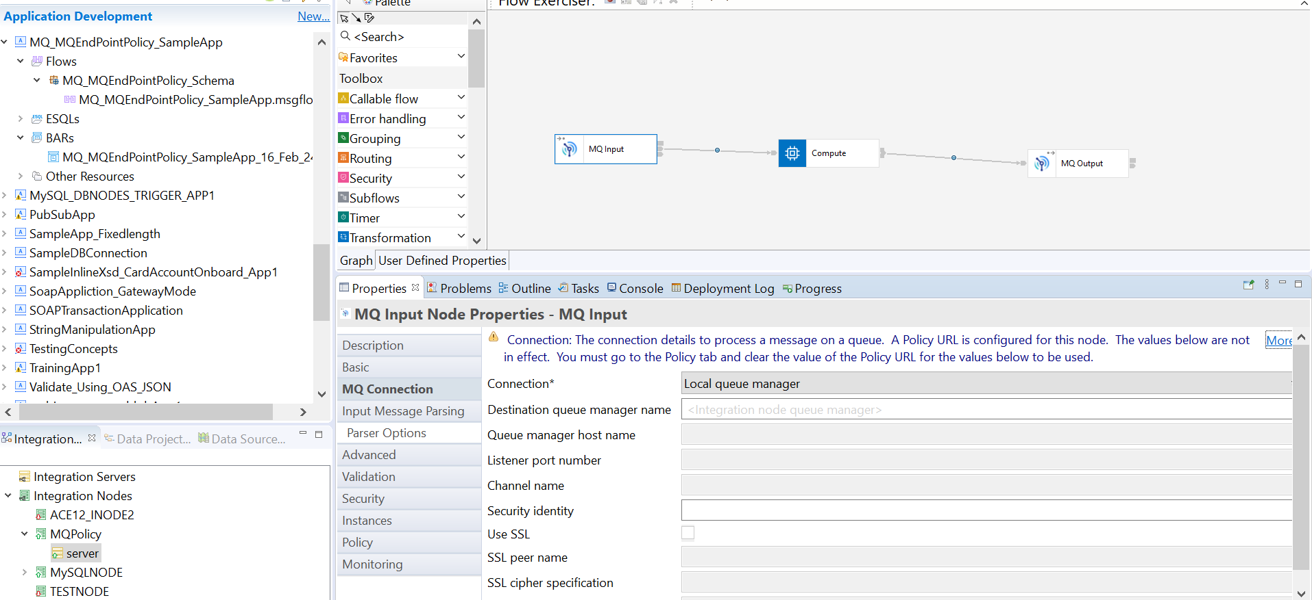

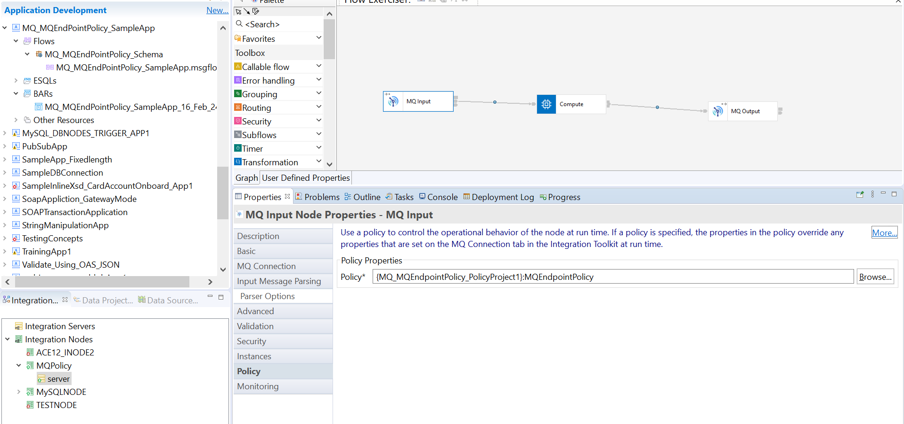

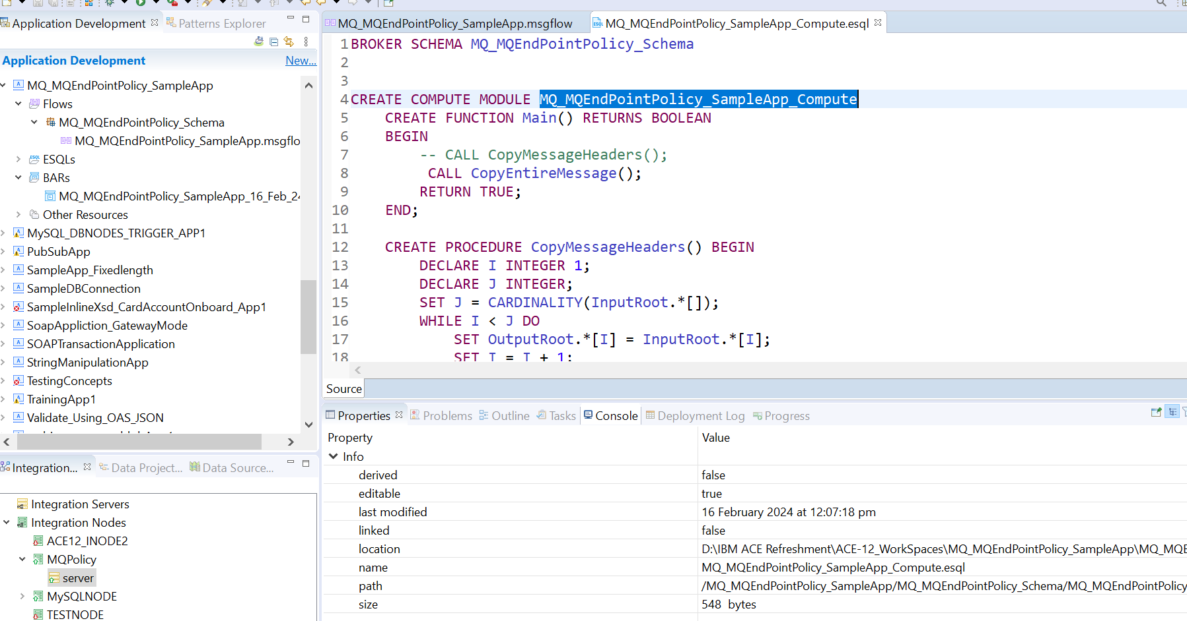

MQ Output Node: Provide only QUEUE name and in policy given Policy Project Name.

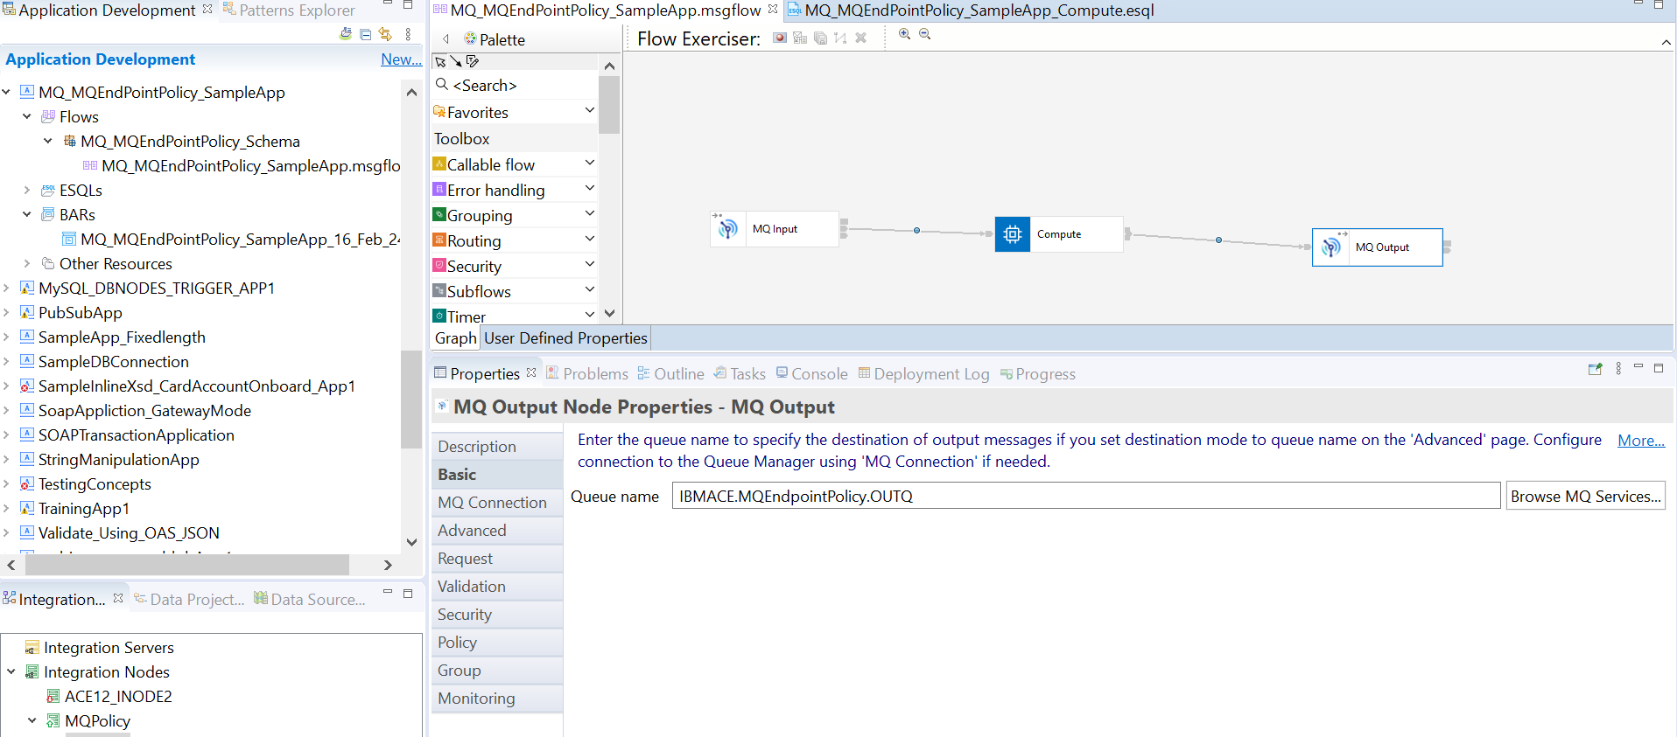

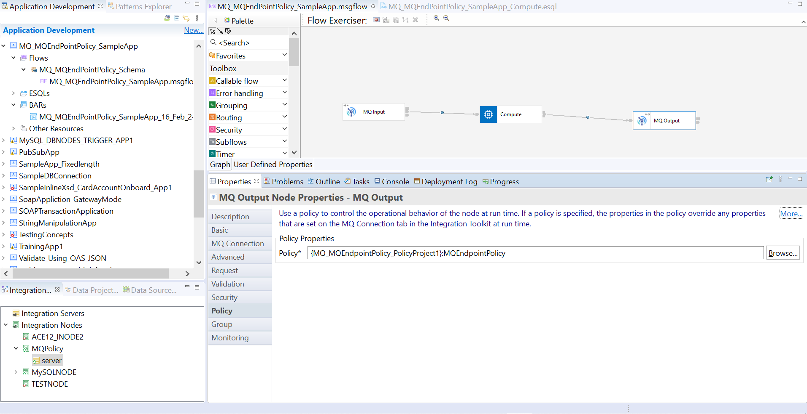

How to create a bar file and associate the policy project:

Create a simple Bar file for your MQ Application and add the policy project in the same bar as shown below:

Right Click on your MQ Application select bar select the same application as container name(as shown below) and give the details as given below. After bar created selected your application and MQ policy (see all the below given SS).

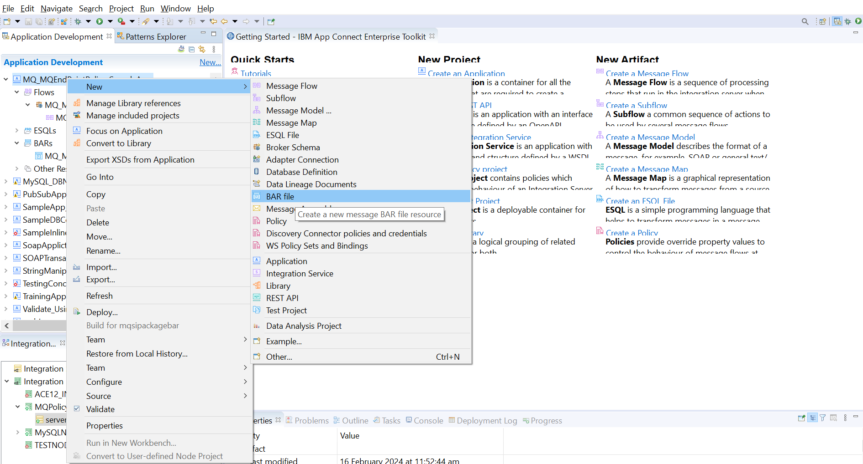

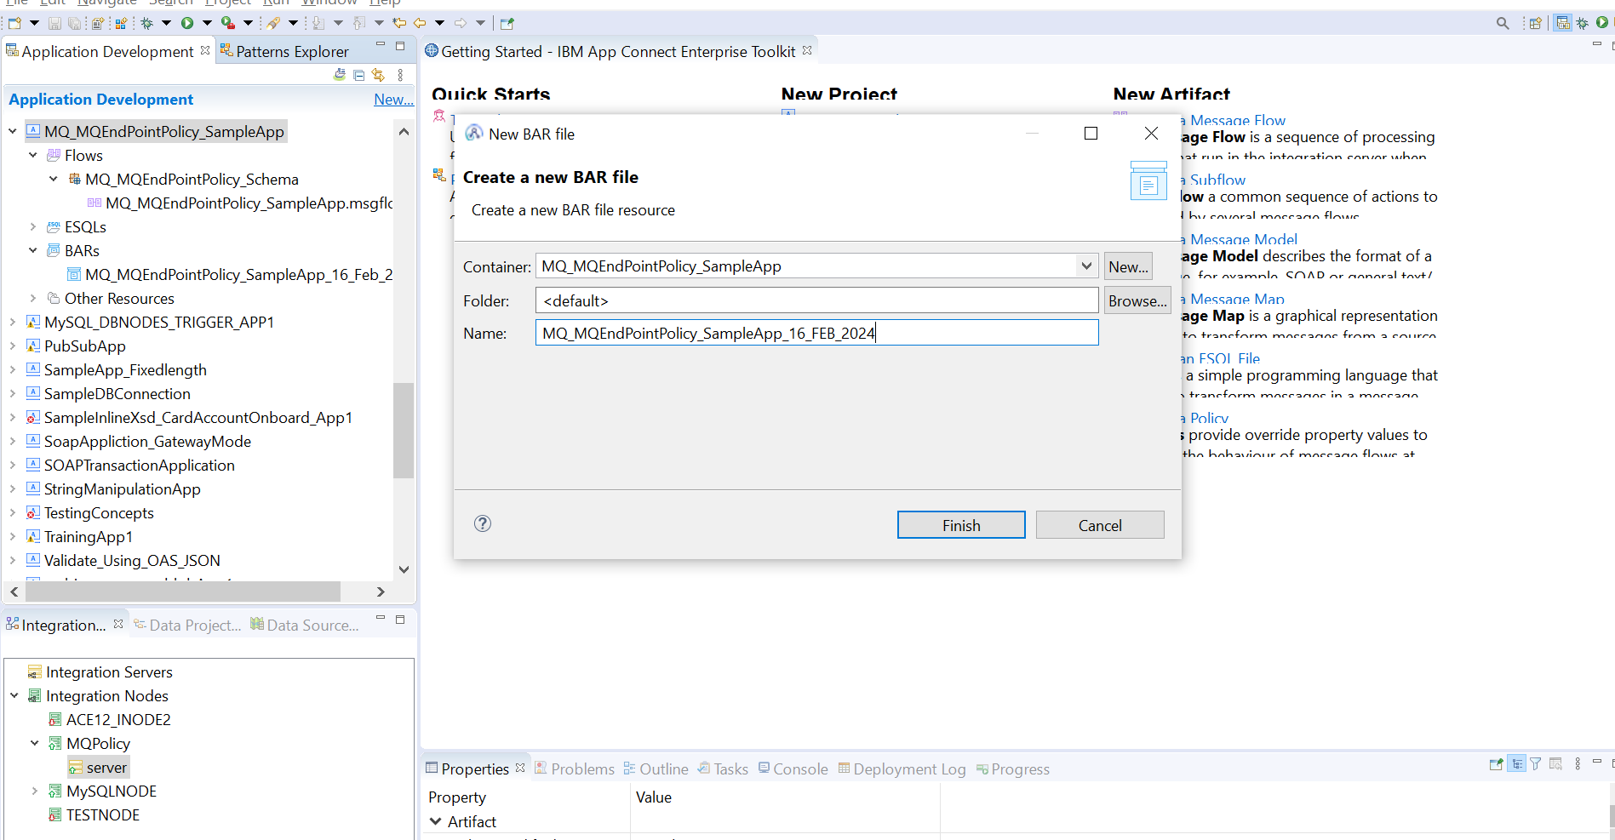

See below to select your application and then select policy.

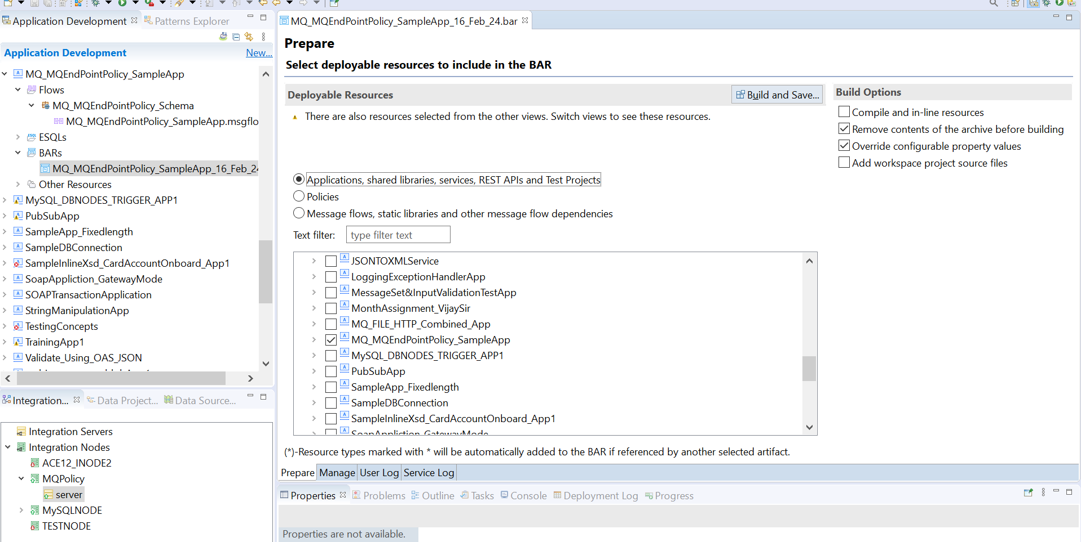

Select MQ Endpoint Policy.

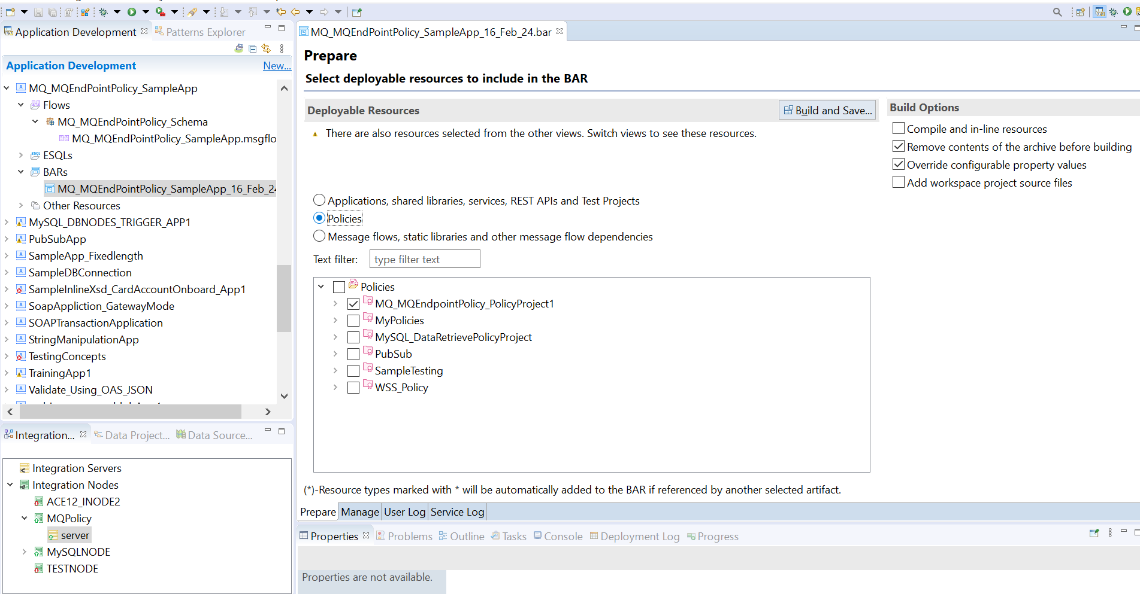

Now your bar file will look like the below given SS.

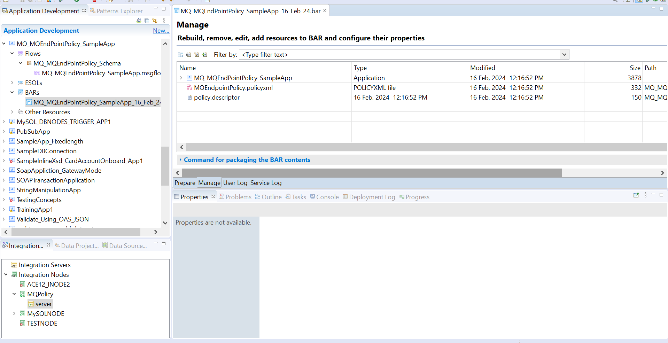

That’s All Now Deploy your bar file and test it.