**A Hydrocephalus MRI compression using an autoencoder**

Debkumar Chowdhury1*, Tirtharaj Sinha1, Arnobrata Ghosh1, Anurag Unnikannan1, Susmit De1

1University of Engineering and Management, Kolkata, India

1[debkumar.cse@gmail.com](mailto:debkumar.cse@gmail.com), 1[sinhatirtharaj@gmail.com](mailto:sinhatirtharaj@gmail.com) ,1[ghosharnobrata@gmail.com](mailto:ghosharnobrata@gmail.com),1[anuragunnikannan7@gmail.com](mailto:anuragunnikannan7@gmail.com),1[desusmit101@gmail.com](mailto:desusmit101@gmail.com)

**Abstract.** Image compression is a terminology which is defined by encoding an image file in such a way that the encoded file takes lesser storage than the original file. The objective of the MRI compression is to reduce the size of multiple MRI and to upload them to the cloud so that they can securely store in the web and retrieve from there when needed. For the last few decades, various MRI compression strategies have been proposed by different researchers to satisfy the demand of the medical society. This article demonstrates an encoding and decoding MRI compression methodology which is applied on Hydrocephalus MRI dataset. The compression methodology begins with a MRI preprocessing step where the raw input MRI taken from the custom dataset is resized, converted to specific format and customize so that it can be delivered to the constructed model as input. In the next steps, custom dataset is segregated into training and testing set, so that the proposed model can be trained and tested. In the next phase, each Hydrocephalus MRI, taken from the custom dataset, is compressed by the trained proposed autoencoder architecture. The performance of the proposed autoencoder architecture for the MRI compression is tested in terms of multiple parameters. Existing image compression algorithms are compared with the proposed compression architecture with respect to various compression measuring metrics. From this comparative study it can be concluded that the proposed compression architecture dominates other compression approaches and reached to the level of state of art performance. A unique compression technique, an efficient parametric performance, and its application on Hydrocephalus custom MRI dataset shows the proposed model uniqueness. In future, the application of the proposed compression architecture on a cloud based environment may be expected.

**Keywords:** Hydrocephalus MRI**,** Autoencoder based compression architecture, MRI Preprocessing, Lossless and Lossy MRI compression, Compression Ratio

# Introduction

Image compression is a terminology which is defined by encoding an image file in such a way that the encoded file takes lesser storage than the original file. The objective of the image compression is to reduce the size of images efficiently so that it can be transmitted over the internet platforms, uploaded on the cloud, and serves image restoration purpose meaningfully for the future use. Image compression technique can be categorized into two sub categories, popularly known as lossless and lossy compression technique. Both of the techniques are classified into multiple categories based on the way of compression. A full pictorial representation of image compression classification can be observed with the help of **Figure. 1.**



**Figure. 1** Shows various image compression classification techniques

The advantage of image compression is that it enables us to store more images with less storage usage conveniently in personal computers or servers and retrieve it as and when required. There are also several disadvantages of image compression such as degraded image quality, and important details in the image are lost that might be hard to recover. Data is also lost by a significant amount while compressing images, and this might prove to be a determent to us in some cases. In a dataset all the images need to be compressed keeping the same compression rate in mind. Variable compression rates for different images may not be useful for us when training the model. During and after image compression, multiple challenges maybe faced by the researchers. When an image is compressed the finer details of colour, contrast and sharpness are reduced. Hence, the encoded image quality may drastically reduce in comparison with the original image. It may be observed that even after decoding, the decoded image may not remain the same as the original image as ideally it should be. One such observation can be noticed in the **Figure. 2** given below.

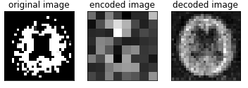

**Figure. 2** Shows a brain MRI compression result (a) original image (b) encoded image (c) decoded image

For the diagnosis of various brain disease patients in the government, public and private hospitals multiple MRI or CT images are generated. One such brain disease is hydrocephalus. When an MRI scan is done on a hydrocephalus suspected patient, lots of images are produced as a result. These images are of extremely high quality, and hence consume a lot of space. Thus, each set of images, for just one scan on a particular area of a patient’s body, is going to consume a lot of space in the given storage medium. Our objective is to build a MRI compression model so that the MRI images of hydrocephalus suspected patients can be compressed and archived easily, effectively and efficiently. It has been found that majorly the hospitals and medical centers in the rural areas are using outdated devices, or devices having low end specifications to store MRI images of the hydrocephalus or other brain disease patients as a result of low budget and lack of funding. In this situation, we can going to propose a new auto encoding-decoding based MRI compression model, which maybe prove to be beneficial for archiving and compressing MRI images of hydrocephalus patients. Our proposed model is capable of compressing hydrocephalus MRI images at a faster rate. Compressed images take very less time for transmission on the web, over the cloud and the server. Our model utilizes less storage space, which in turn helps us to store more images in the hard disk (or any other storage medium). When transferring these compressed images, less bandwidth is consumed due its smaller file size, and as a result less cost is incurred.

This article is divided into various sections. In section 2, some of the latest work allied to the proposed article title and some of the major and popular compression techniques as mentioned in **Figure. 1** is highlighted and briefly explained. The section 3 of the article, highlights proposed methodology, built-in architecture and the flow of the overall procedure. The section 4 of the article portrays various tables, graphs and outputs to establish the performance of the compression model in comparison with some of the other popular and established compression methodologies.

1. **Literature Survey**

This section represents various pre-existing methods [1] [2] [3][5], along with their advantages and disadvantages as shown in the analysis Table (**Table. 1**). All these methods are well appreciated but in context with our problem the results can be improved. In-depth analysis of these methodologies has proven to be very competent to identify the downsides. Identification of these drawbacks helps us to update, modify our algorithm and code and to calculate the performance parameters. The Survey Table is given below:

**Table. 1.** Existing Methodology Analysis Table

|  |  |  |
| --- | --- | --- |
| **Methodology** | **Advantages** | **Disadvantages** |
| LZW Compression [1][3] | It provides greater compression ratio and appropriate for larger data. | Requires more compression  and decompression time and inappropriate for smaller data. |
| Huffman Coding [1][3] | Requires less compression  and decompression time and appropriate for smaller data. | It provides less compression ratio and inappropriate for larger data. |
| Embedded Zerotree Wavelet (EZW) [2] | User can control desired bit rate. | Properties of the image affects the performance. |
| Shannon–Fano Encoding [3][4] | For Shannon Fano coding procedure we do not need to build the entire codebook. | Shannon–Fano Encoding sometime fails to produce an optimal tree. |
| Run-length encoding [3] | It works well when an image contains long runs of identical samples that usually do not appear in an authentic image. | It’s inappropriate for larger data.[9] |
| Arithmetic coding [3][5] | provides a better compression ratio. | It can corrupt the whole image for a minute error because it has very poor error resistance. |

1. **Proposed Methodology**

Our proposed methodology focused on medical image compression from a custom hydrocephalus dataset using image compression algorithm using a convolutional approach. We have proposed a block diagram to show the main concept of the methodology at a glance as shown in **Fig. 1.**

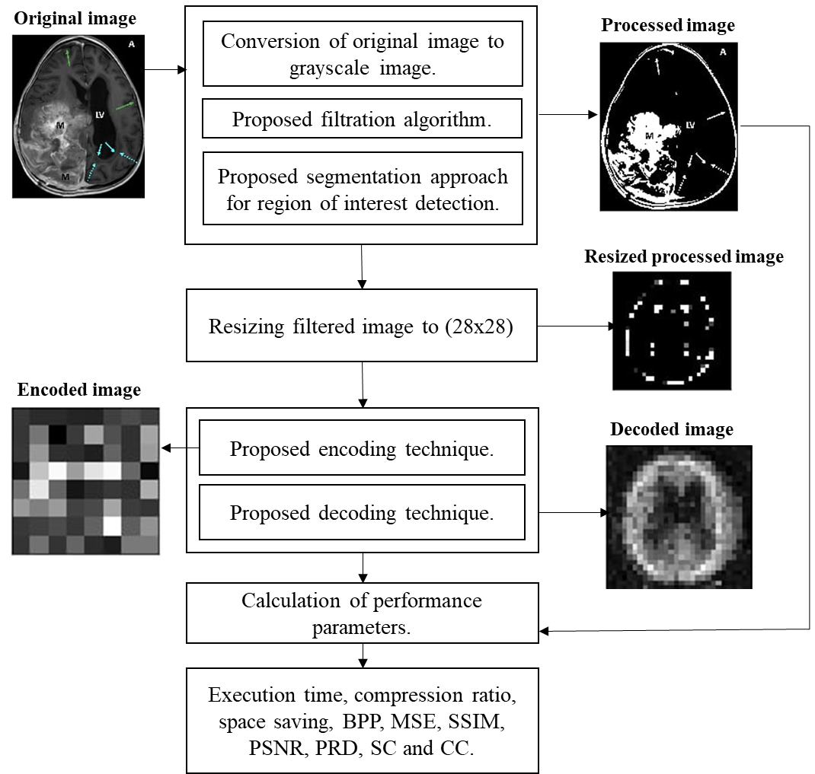

**Fig. 1.** The built-in architecture of MRI compression technique using a convolutional approach

* 1. **Algorithm**

Our algorithm is divided into 8 steps. The algorithm takes a custom hydrocephalus dataset, $I(u,v)$ as an input from the dataset [10] and produces an encoded image and a decoded image. The algorithm is as follows:

**Algorithm:** An unstructured MRI compression technique using a convolutional approach

**Input: $I(u,v)$**

**Output:**  encoded image and decoded image

1. Read an image $I(u,v)$ from the dataset.
2. Convert the image to a grayscale image, $G(u,v)$.
3. Preprocessed $G(u,v)$ using the following formula and 5x5 kernel:

$G_{1}\left(u,v\right)= \frac{1}{2πd^{2}}e^{\frac{-u^{2}+v^{2}}{2d^{2}}}$ (1)

Where,

$G_{1}\left(u,v\right)$ = Processed Image

$d$ = Standard Deviation

$u$ = $u$ th row in the grayscale image

$v$ = $v$ th column in the grayscale image

1. Perform segmentation on $G_{1}\left(u,v\right)$ using the following equation:

If pixel $\left(u,v\right) ≥ τ$ then,

$\left(u,v\right) ←1$,

Otherwise,

$\left(u,v\right) ←0$, provided maximum pixel value = 255

Where,

$G_{1}\left(u,v\right)$ = grayscale image

$\left(u,v\right)$ = a pixel of an image in $\left(u,v\right)$ position

$τ$ = selected threshold value in our algorithm. It is tested after the trial-and-error method.

1 = Light

0 = Dark

1. Resize $G_{4}(u,v)$ into a 28 X 28 image.
2. The proposed convolutional architecture each has an input x of size 28x28x3 is feed into it. In the convolutional architecture following layers are observed:
   1. Encoder Architecture
   2. One input layer which accepts input of size 784.
   3. One dense layer of output size 300 with an activation leakyReLU function.
   4. One dense layer of output size 64 with an activation leakyReLU function.
   5. Decoder Architecture
      1. One input layer which accepts input of size 64.
      2. One dense layer of output size 300 with an activation leakyReLU function.
      3. One dense layer of output size 784 with an activation leakyReLU function.
3. Segregate the whole dataset [10] into two sections. We select 80% MRI from the dataset [10] for training purposes and 20% MRI from the dataset [10] for testing purposes.
4. We feed the training and testing data into the designed convolutional model architecture to generate result.

**3.2 Model Architecture**

Training and testing phase can be explained with the help of a model architecture as shown in **Fig.2.** the architecture accepts preprocessed MRI image and displays encoded and decoded images along with performance parameters for the same.

~~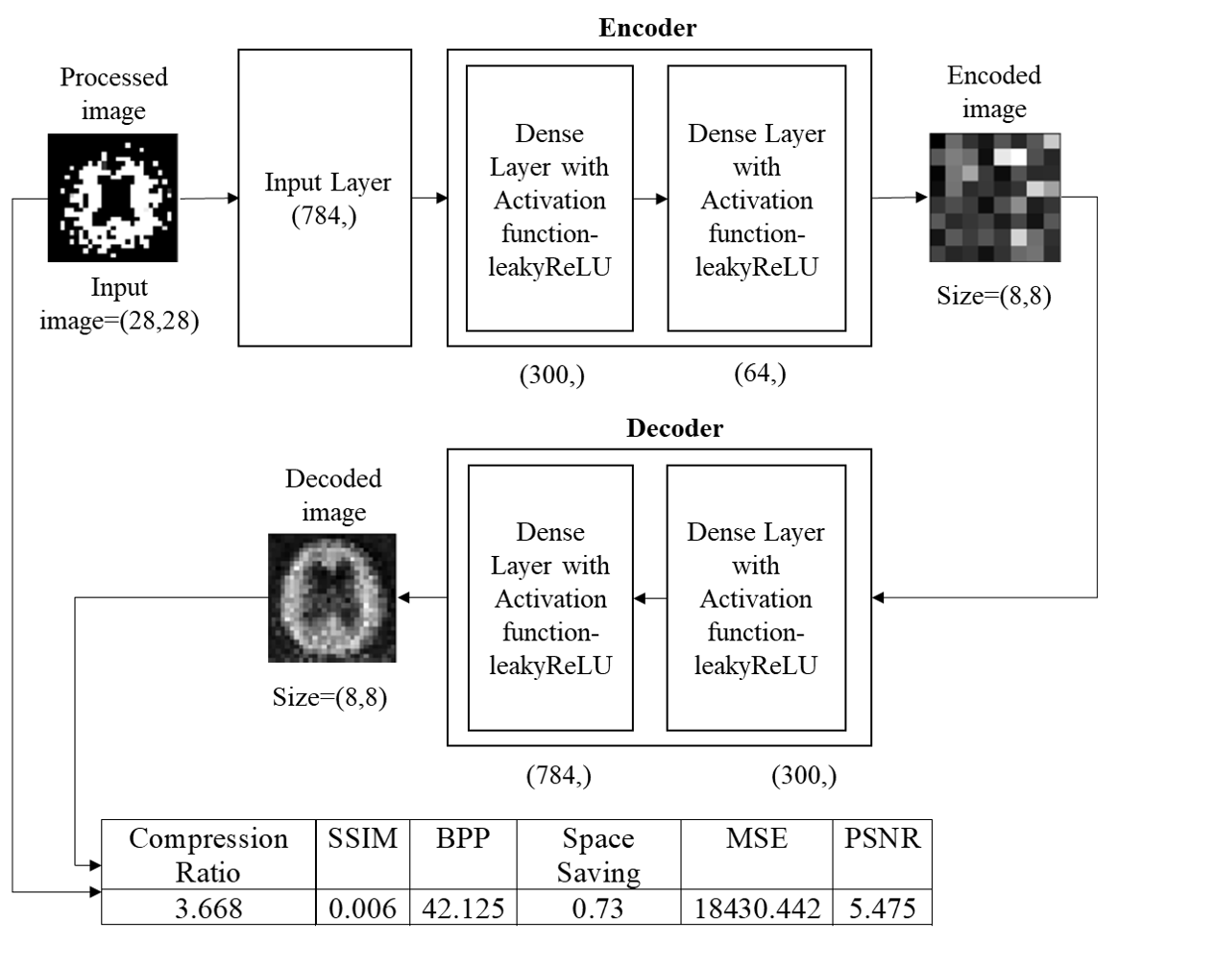~~

**Fig.2.** Training and testing phase using proposed model architecture

1. **Experimental results**

We consider a custom hydrocephalus dataset, which contains 132 images. The size, colour, and format of images in the dataset are similar in nature, whereas the resolutions of the images are different. The format of the images is ‘.jpg’ by nature.

We have applied our algorithm in the python environment, version 3.8, with the hardware configuration of the Intel Core i3 5th Generation processor,4GB DDR3 primary memory (RAM), and an integrated graphics card. Anaconda as a distributor of Python version 3.8 is used. jupyter notebook version 6.3.0 as an open web interface is used as a programming platform for the implementation of our algorithm.

After reading the images from the local machine we have achieved the following results as shown in **Fig. 3.**

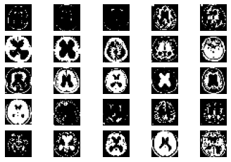

**Fig. 3.** Samplesof hydrocephalus dataset

After reading all the images from the dataset each image will pass through the various steps of the algorithm as shown in **Fig. 5.**

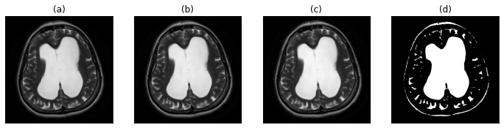

**Fig. 5.** (a) original image (b) gray-scale image (c) image after applying proposed filtration method (d) proposed segmentation approach for the region of interest detection

We are splitting our dataset [10] into training and testing sets. 80% of the MRIs are used for training and the rest is used for testing. After the execution of our proposed algorithm, we observed that the number of training samples are 104, number of testing samples are 26 whereas training shape values are (104, 28, 28). Our proposed convolutional layered architecture is trained. It is used to train on n number of samples (104 in our case). With the changes of several iterations or epochs, the total time consumed by the algorithm is calculated.

**Table 2:** An example of the training phase.

|  |  |  |  |  |
| --- | --- | --- | --- | --- |
| **SNo.** | **Epoch No.** | **Time Taken (s)** | **Loss** | **Value Loss** |
| 1. | 1 | 1 | 0.2193 | 0.1604 |
| 2. | 2 | 0 | 0.1407 | 0.1219 |
| 3. | 3 | 0 | 0.1159 | 0.1086 |
| . | . | . | . | . |
| . | . | . | . | . |
| . | . | . | . | . |
|  |  |  |  |  |
| 18. | 18 | 0 | 0.0517 | 0.0842 |
| 19. | 19 | 0 | 0.0494 | 0.0835 |
| 20. | 20 | 0 | 0.0473 | 0.0831 |

* 1. **Performance parameters**

In this work, the compression techniques use a wide number of performance measures to compute their efficiency and performance.

**Table 3:** Various performance parameters

|  |  |  |
| --- | --- | --- |
| **Serial No**. | **Name of the performance parameter** | **Equation** |
| 1. | Compression Ratio [10][1] | CR = $\frac{Size of original image}{size of compressed image}$ |
| 2. | Mean Square Error [10] | MSE= $\frac{1}{MN}\sum_{j=1}^{M}{\sum_{k=1}^{N}{{(X_{j,k}- X_{j,k}^{'})}^{2}}}$ |
| 3. | Bits per Pixel [10] | CR = $\frac{Size of compressed image}{Total no. of pixel in the image}$ |
| 4. | Structure Similarity Index [10] | SSIM = $\frac{({2µ}_{f}µ_{-f}+C_{1})({2 γ}_{f}+C_{2})}{(µ_{f}^{2}+µ_{-f}^{2}+C_{1})(γ_{f}^{2}+γ_{-f}^{2}+C_{2})}$ |
| 5. | Correlation coefficient [10] | CC = $\frac{\sum_{x=1}^{M}{\sum_{y=1}^{N}{f\left(x, y\right) ×f^{'}\left(x, y\right)}}}{\sqrt{\sum_{x=1}^{M}{\sum_{y=1}^{N}{{\left(f\left(x, y\right)\right)}^{2}}}}\sqrt{\sum_{x=1}^{M}{\sum_{y=1}^{N}{{\left(f^{'}\left(x, y\right)\right)}^{2}}}}}$ |
|  | Peak Signal to Noise Ratio [10] | PSNR=20 $log⁡(\frac{2^{B}-1}{MSE})dB$ |
| 7. | Percent rate of distortion [10] | PRD = $\sqrt{\frac{\sum_{x=1}^{M}{\sum_{y=1}^{N}{{[f\left(x, y\right)-f^{'}(x, y)]}^{2}}}}{\sum_{x=1}^{M}{\sum_{y=1}^{N}{{[f\left(x,y\right)]}^{2}}}}} ×100$ |
| 8. | Structural Content [10] | SC = $\frac{\sum_{j=1}^{M}{\sum_{k=1}^{N}{X_{j, k}^{2}}}}{\sum_{j=1}^{M}{\sum_{k=1}^{N}{X_{j, k}^{'2}}}}$ |

**Table 4:** Calculation ofperformance parameters for each image

|  |  |  |  |  |  |  |  |  |
| --- | --- | --- | --- | --- | --- | --- | --- | --- |
| **SNo** | **BPP** | **Compression Ratio** | **MSE** | **SSIM** | **PSNR** | **PRD** | **Structural Content** | **CC** |
| 1. | 338 | 1.538 | 17142.986 | 0 | 5.79 | 99.665% | 10.081 | 0.0040 |
| 2. | 333 | 2.261 | 1421.007 | 0 | 16.605 | 99.55% | 475.408 | 0.0065 |
| 3. | 333 | 1.967 | 3585.557 | 0 | 12.585 | 99.541% | 129.134 | 0.0072 |
| . | . | . | . | . | . | . | . | . |
| . | . | . | . | . | . | . | . | . |
| . | . | . | . | . | . | . | . | . |
| 25. | 341 | 1.757 | 37420.317 | 0 | 2.4 | 99.659% | 4.243 | 0.0020 |
| 26. | 339 | 1.664 | 35073.048 | 0 | 2.681 | 99.625% | 3.669 | 0.0023 |

**Table 4** displays performance parameters of 26 randomly selected original samples from the dataset. At the end, we have found that our proposed algorithm can be used for medical image compression from MRIs. As the data is balanced, we are considering the results to be satisfied. Comparing it with other existing methodologies a satisfactory result is observed as shown in **Table 5.** We can conclude that our proposed methodology overpowers the existing compression algorithms.[1][2][3][5]

**Table 5:** Comparison chart

|  |  |  |
| --- | --- | --- |
|  |  |  |
| **Serial No**. | **Name of the compression algorithm** | **Compression ratio** |
| 1. | LZW [1] | 5.319% |
| 2. | Huffman coding [1] | 2.203 % |
| 3. | EZW [2] | 1.6647% |
| 4. | RLE [3] | 1.5766% |
| 5. | Shannon–Fano [3] | 1.9825% |
| 6. | Arithmetic coding [3][5] | 2.2059% |
| **7.** | **Proposed methodology** | **1.4593%** |

1. **Conclusion**

In this paper, we have proposed an Autoencoder algorithm. This algorithm is capable of compressing and storing generated images from medical equipment contained in the Custom hydrocephalus dataset, collected from the web resource. It is responsible for encoding the original image, and decoding the image, and finally comparing the decoded and original image. In addition, we have also generated BPP, Compression ratio, MSE, SSIM, PSNR, PRD, Structural content and CC values, through which we can compare our proposed method with existing methods [1] [2] [3] [5]. The experimental result shows that after applying the proposed and existing methods [1] [2] [3] [5] on the Custom hydrocephalus dataset, our technique is producing a Compression ratio of 1.4593%. This result is considered to be satisfactory, and based on this result we can say that the proposed algorithm overpowers the efficiency of the existing method. Due to high performance, novelty, ease of use, our proposed method is useful to develop any mobile or web applications in the future. Our method can be tested on various medical equipment generated images datasets to identify the generic performance of the proposed method in the future. The performance of our method may be increased by making necessary modifications in the algorithm.

# References

1. Gajendra Sharma, “Analysis of Huffman Coding and Lempel–Ziv–Welch (LZW) Coding as Data Compression Techniques,” International Journal of Scientific Research in Computer Science and Engineering, Vol.8, Issue.1, pp.37-44, 2020.
2. A.M.Raid, W.M.Khedr, M. A. El-dosuky and Wesam Ahmed, “Image compression using embedded zerotree wavelet” Signal & Image Processing : An International Journal (SIPIJ) Vol.5, No.6, December 2014, pp. 33-39, doi : 10.5121/sipij.2014.5603
3. Rahman, Md. A., and Mohamed Hamada. 2019. "Lossless Image Compression Techniques: A State-of-the-Art Survey" Symmetry 11, no. 10: 1274. doi : 10.3390/sym11101274
4. S. S. Yu, M. N. Wernick and N. P. Galatsanos, "Lossless compression of multi-dimensional medical image data using binary-decomposed high-order entropy coding," Proceedings of 1st International Conference on Image Processing, 1994, pp. 351-355 vol.2, doi: 10.1109/ICIP.1994.413590.
5. G. Langdon and J. Rissanen, "Compression of Black-White Images with Arithmetic Coding," in IEEE Transactions on Communications, vol. 29, no. 6, pp. 858-867, June 1981, doi: 10.1109/TCOM.1981.1095052.
6. A. K. Jain, "Image data compression: A review," in Proceedings of the IEEE, vol. 69, no. 3, pp. 349-389, March 1981, doi: 10.1109/PROC.1981.11971.
7. P. Roos, M. A. Viergever, M. C. A. van Dijke and J. H. Peters, "Reversible intraframe compression of medical images," in IEEE Transactions on Medical Imaging, vol. 7, no. 4, pp. 328-336, Dec. 1988, doi: 10.1109/42.14516.
8. Z. Xiao and C. Zheng, "Medical Image Fusion Based on the Structure Similarity Match Measure," 2009 International Conference on Measuring Technology and Mechatronics Automation, 2009, pp. 491-494, doi: 10.1109/ICMTMA.2009.558.
9. Amin Mubarak Alamin Ibrahim* et al. ,(IJITR) INTERNATIONAL JOURNAL OF INNOVATIVE TECHNOLOGY AND RESEARCH, Volume No.3, Issue No.1, December – January 2015, 1808 – 1812.
10. Pardeep Kumar, Ashish Parmar, Versatile Approaches for Medical Image Compression: A Review, Procedia Computer Science, Volume 167, 2020, Pages 1380-1389, ISSN 1877-0509, doi : 10.1016/j.procs.2020.03.349