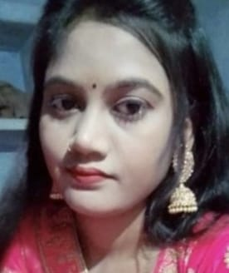**KUMARI PUSHPANJALI**

**Career Objective**: To get an opportunity where I can make the best of my potential and contribute to the Organization’s growth and update myself with latest Trends of the Industry.

|  |  |  |
| --- | --- | --- |
| Email Icon Black Simple transparent PNG - StickPNGGraphic Download Black And White Smartphone Clipart - Mobile Phone - Png  Download - Full Size Clipart (#921506) - PinClipart91-9569343220 | pushpanjalis892@gmail.com |  |

**Educational Qualification**

* Pursuing Master’s of Arts in Home Science with aggregate of 62% from Maa ShivDevi PG college.
* Bachelors of Arts in Home Science with aggregate of 61% from Maa ShivDevi PG college in 2021.
* 12th from U.P Board with 74% in year 2018, from Hanshwani Intercollege.
* 10th from U.P Board with 66% in year 2016, from Hanshwani Intercollege.

**Technical Skills**

* MS Office
* MS Excel
* Tally
* HTML
* Typing(26wpm)

**Interpersonal Skills**

* Versatile
* Communication Skill
* Punctual
* Confident.

**Language Known**

* English (professional)
* Hindi (Native)

**Hobbies**

* sewing
* Cooking.
* Photography.

**Personal Details**

Date of Birth: 27-June-2001

Father’s Name: Mr. Vinod Shukla

Nationality: INDIAN

Marital Status: Unmarried

**Address:** HariharPur, Oiri distt.

Sonbhadra Uttar Pradesh 231216

**Personal Detail**

* Date of Birth
* Father’s Name
* Passport Details

**EXPERIENCE:**

* Works At Aqua purifier Company as Coordinator.
* Duration- 4 months

**Certifications**

* CCC certification From Star Computer Center
* ADCA certification From Star Computer Center

**Achievements**

* 1st position in Dance Competition at College Level Annual Function.
* 2nd position in Dance Competition at School Level Dance Function

**Project**

* Portfolio Website Using HTML.
* [**https://pushpanjali/**](https://pushpanjali/)**portfolio/**

I hereby declare that the above information is correct to best of My

Knowledge.

**Date**

**Kumari Pushpanjali.**

**Date: 03-June-2023**