CUET General Test - Quantitative Aptitude
Slot: CUET_SLOT_1 | Section: QUANT | Subject: MATHEMATICS
Upload this Word file together with the matching Excel mapping file.
[COMPREHENSION: CUET-QUANT-CHART-001]
The bar chart represents practice questions solved by four study groups during one week. Group A solved 120 questions, Group B solved 150, Group C solved 180, and Group D solved 210. Use these values for Questions 1 to 3.
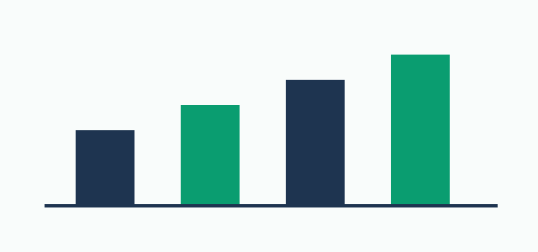
[END_COMPREHENSION]
[QUESTION: CUET-QUANT-TEST-001]
How many more questions did Group D solve than Group A?
CORRECT_OPTION:
ACCEPTED_ANSWERS: 90
NUMERIC_TOLERANCE: 0
CASE_SENSITIVE: FALSE
EXPLANATION: 210 minus 120 equals 90.
[END_QUESTION]
[QUESTION: CUET-QUANT-TEST-002]
What was the percentage increase from Group A to Group B?
CORRECT_OPTION:
ACCEPTED_ANSWERS: 25|25.0
NUMERIC_TOLERANCE: 0.01
CASE_SENSITIVE: FALSE
EXPLANATION: The increase is 30; 30 divided by 120 and multiplied by 100 equals 25%.
[END_QUESTION]
[QUESTION: CUET-QUANT-TEST-003]
Find the average number of questions solved by the four groups.
CORRECT_OPTION:
ACCEPTED_ANSWERS: 165
NUMERIC_TOLERANCE: 0
CASE_SENSITIVE: FALSE
EXPLANATION: (120 + 150 + 180 + 210) divided by 4 equals 165.
[END_QUESTION]
[END_COMPREHENSION_GROUP]
[QUESTION: CUET-QUANT-TEST-004]
The diagram shows a rectangle of length 12 cm and width 8 cm. What is its area?
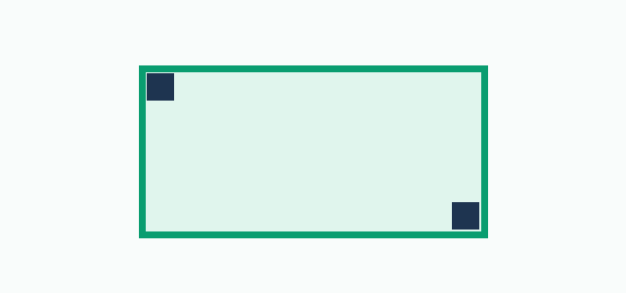
OPTION_A: 20 cm²
OPTION_B: 40 cm²
OPTION_C: 96 cm²
OPTION_D: 120 cm²
CORRECT_OPTION: C
ACCEPTED_ANSWERS:
NUMERIC_TOLERANCE:
CASE_SENSITIVE: FALSE
EXPLANATION: Area equals length multiplied by width: 12 × 8 = 96 cm².
[END_QUESTION]
[QUESTION: CUET-QUANT-TEST-005]
Name the quadrilateral shown in the diagram using one word.

CORRECT_OPTION:
ACCEPTED_ANSWERS: rectangle|Rectangle
NUMERIC_TOLERANCE:
CASE_SENSITIVE: FALSE
EXPLANATION: A quadrilateral with four right angles is a rectangle.
[END_QUESTION]

